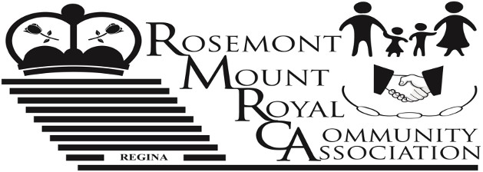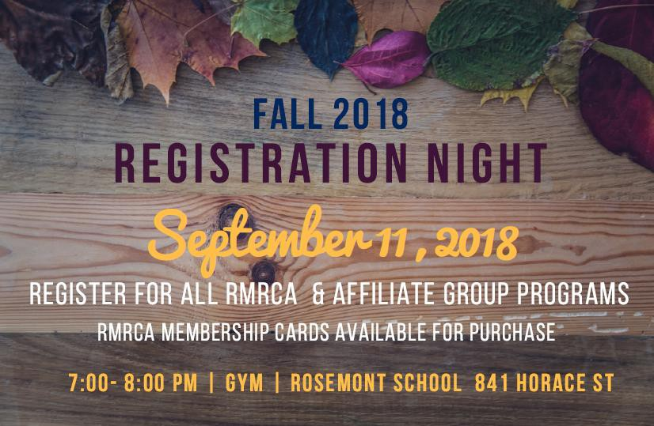

VOL. 62 Fall Newsletter September 2018

Inside This Issue:
• RMRCA 30th Anniversary BBQ 2
• Keeping Rosemont Safe ……….………………………………………………………. 3
• RMRCA Cookbook ………………………………………………..…………………. 3
• Fall Programs ………………………………………………………………………..…. 4
• Community Clean Up ….…………………………………………….………………… 6
• RMRCA Star Party ………… 7

www.rmrca.ca

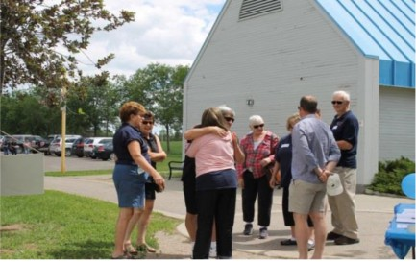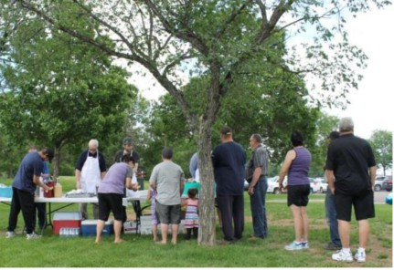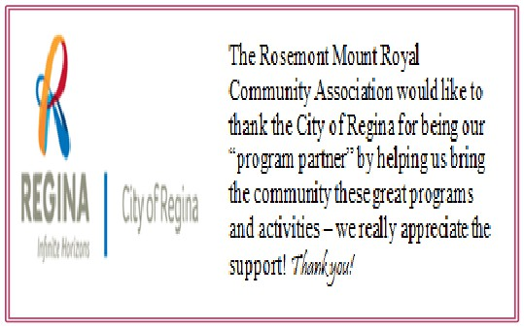RMRCA 30th Anniversary BBQ in the
Park!

I
t was a wonderful day at Rick Hansen Park on June 17t h where over 150 residents joined us to celebrate RMRCA’s 30th Anniversary.

A number of past RMRCA Board Members and Volunteers were on site to
mark the occasion. As well Councillor Mike O’Donnel, MP Trent
Wotherspoon and Bill Ursel from the City of Regina were on hand to bring
greetings on our Anniversary. It was a great day to reconnect with friends
and neighbors.

In 1988 two community associations, Rosemont and Mount Royal,
amalgamated to create one of the largest community associations in Regina
- Rosemont Mount Royal Community Association (RMRCA). As we
reflect on the work of the past 30 years, we look forward to the future and
take pride in our Community and in the knowledge that RMRCA is an
organization that represents the entire population within the designated
boundaries of our community and we are proud to call ourselves a
diversified neighborhood with many amenities and schools that continue to
attract new families to the area.

Thank you Rosemont Mount Royal for continuing to support your Community Association!
RMRCA Needs Volunteers!

or over 30 years, the Rosemont Mount Royal
Community Association has been powered by volunteers

3. Event Volunteers: Volunteers are needed to assist with
the community events that we hold. This can include set

F
who have worked to bring a variety of sport, recreation,
up/clean up, running registration tables, coordinating

culture and social programs to the people of this Community. Serving over 4,000 homes makes the RMRCA one of the
largest community associations in the City of Regina!

The RMRCA is always welcoming individuals that are
interested in helping to shape our community. There are a
number of Board positions available, as well as a need for event volunteers. All positions are for a term of 2 years. The
RMRCA Board meets the first Tuesday of each month, at
7:00 p.m. at the Rosemont Community School from September
to June.

Available positions are -
1. Directors: Directors are voting members of the Board that
can lead sub-committees based on their interest. The RMRCA Executive is also filled from the Board Directors such as Chair, Vice, Treasurer and Secretary.

2. Newsletter Editor (Contracted): Responsible for the
development of the community newsletter generated three times per year. (Email tmcquoid@rentvictory.com for more information)
vendors, etc. Volunteers can participate as available.
More detailed information for all RMRCA Board positions can be found on our website at www.rmrca.ca.

RMRCA represents the citizens of Rosemont and Mount Royal -
all community members are more than welcome to attend a
meeting.

www.rmrca.com Page 2

Keeping Rosemont and Mount Royal A Safe Place To Live!

R

ecently we have all heard the news about an increase in property crime within the City. Crime is
noticeably up this summer across Regina and like

• Be diligent in ensuring that your vehicle, garages, and
homes are securely locked when you are not attending
them.

other communities Rosemont Mount Royal is having their share in theft and mischief problems.
To go along with the recent statistics reported by the Regina
Police Service and the media, as an Association, we wanted
to give you a quick update on what has been going on in our
area in relation to crime. Alex Tkach, RMRCA Vice Chair
recently took some time to speak with our North West Zone
area Constable to get a better understanding of what trends
they are seeing and what we as a community can do to help
ourselves -
“As noted crime is up right now especially with property
thefts and vandalism so the best thing you can do to protect
yourself and your property is to take precautionary measures and practice good security habits. These steps will go a long way to prevent crimes of this nature. ” said Alex Tkach.
• Never leave items of value in your vehicle such as
phones, purses, keys, and wallets.
• Be alert to any suspicious activity in your area and
report these incidents by calling the Regina Police
Service Communications Center at 777-6500 or in an emergency call 9-1-1.
Reporting crimes is important. The Regina Police Services use a data driven system to track crime in the city. If crimes are not reported then the Police do not know where additional resources could be allocated. There are several easy ways to report, whether by phone or by visiting the website and
submitting an online report. “If we work together we can
limit the opportunities for crimes and eventually crimes of
this nature, with time, thieves and opportunists will move on” said Tkach
The City of Regina website provides statistics for all communities in greater detail on the Regina Police Service website http://www.reginapolice.ca/resources/crime/crime-
statistics/community-crime-report-2018/.

2018 RMRCA Student Volunteer Scholarship Awarded!

E

ach year, the This year, RMRCA is proud to present Margaret Wah Ta, a
RMRCA awards grade 12 student from M.C.O’Neill High School who lives
two scholarships to in our community with a $500 scholarship. Margaret has

students in our Community.
Students demonstrate their
exceptional volunteer efforts
in their school, community
and city. Scholarships, in
the amount of $500 each,
are to assist with post-
been accepted to the U of R, Faculty of Education, Bachelor of Education, Elementary, Pre-K to Grade 5 and will start classes this fall.
All the best Margaret!
RMRCA Student Volunteer Scholarship information can be

secondary education costs. found at www.rmrca.com

Get Your RMRCA Family Favorite Cookbook Now!

T
he 2nd Edition RMRCA Cookbook is here! Highly sought after, this cookbook showcases Family
Favorite Recipes from households in our community.
able to showcase over 200 recipes from residents in our community.

We had a lot of fun gathering recipes for this cookbook and

Available for only $10, the 2nd Edition RMRCA Cookbook
will be for sale at the RMRC Registration Night (see front
page for details). There is limited quantities - get yours now!
This cookbook was put together by the RMRCA Board to
commemorate its 30th anniversary and we are so happy to be
we thank everyone who submitted their family favourites.
Special thanks to Elaine Dittmann (RMRCA Promotions
Coordinator) and Carol Nichol (Community Volunteer) for all the work to make this cookbook a success!

www.rmrca.com Page 3

RMRCA Fall 2018 Program Registration
September 11, 2018 7:00 p.m. - 8:00 p.m.
Rosemont Community School  Gymnasium  841 Horace Street

HOW TO REGISTER FOR RMRCA PROGRAMS AND OTHER CITY WIDE PROGRAMS
1. Attend the RMRCA program registration for residents of Rosemont and Mount Royal
2. Become a Community Member ($5.00 per household). Membership valid from September 1, 2018 - August 31, 2019.
3. For RMRCA programs: Register and pay for program(s) at the RMRCA registration night.
4. For other programs (run by other community associations): Register for programs at the RMRCA registration but do not pay.
The sponsoring organization will contact you and collect the appropriate fees.

RMRCA REFUND POLICY: All requests for refunds for RMRCA programs must be submitted in writing to the Treasurer prior to the 3rd (third) class. Requests will be reviewed by RMRCA Executive and will be considered for special circumstances on a
prorated basis. All refunds are subject to a $10 administration fee. If classes are cancelled by RMRCA, a full refund will be issued. No refunds for membership. Submit to: RMRCA Treasurer 6109 5th Avenue, Regina, SK S4T 6R8

Need Help? Anyone requiring financial assistance in order to register for any RMRCA programs should submit their request in
wiring to: RMRCA 6109 5th Avenue Regina, SK. S4T 6R8 or helen.adams@sasktel.net

YOUTH PROGRAMS
BOUNCE & BALANCE 3-4 YEARS Dates: Saturdays. Sept 22 - Nov 24, 2018 Cost: $35.00
Time: 1:00 p.m. - 1:45 p.m.
Location: Rosemont Community School Gymnasium
NINJA GYM 5-6 YEARS
Dates: Saturdays, Sept 22 - Nov 24, 2018 Cost: $35.00
Time: 2:00 p.m. - 2:45 p.m.
Location: Rosemont Community School Gymnasium

GYM COMBO 7-8 YEARS
Dates: Saturdays, Sept 22 - Nov 24, 2108 Cost: $35.00
Time: 3:00 p.m. - 3:45 p.m.
Location: Rosemont Community School Gymnasium
YOGA 8-14 YEARS
Dates: Thursdays, Sept 27 - Nov 29, 2018 Cost: $40.00
Time: 7:00 p.m. - 8:00 p.m.
Location: Martin Collegiate Auditorium
ZUMBA 8-14 YEARS
Dates: Mondays, Sept 24 - Dec 3, 2018 (No class Oct 8) Cost: $40.00
Time: 7:00 p.m. - 8:00 p.m.
Location: Walker Elementary School Gymnasium

10 -14 YEARS
My Time offers a variety of fun activities, including: art,
cooking, crafts, drama, games, sports, theme nights and
more! My Time is a City of Regina program and is OPEN TO EVERYONE in our community.
Dates: Tuesdays & Thursdays Sept - Dec 2018 (dates TBA)

Cost: Free (Participant Forms required to participate) Time: 6:30 p.m. - 8:30 p.m.
Location: Rosemont Community School Gymnasium For additional Information: Call (306)777-7047

ADULT PROGRAMS
ZUMBA 18+ YEARS
Dates: Wednesdays, Sept 26 - Nov 28, 2018 Cost: $40.00
Time: 7:00 p.m. - 8:00 p.m.
Location: Martin Collegiate Auditorium
GENTLE YOGA 18+ YEARS
Dates: Mondays, Sept 24 - Dec 3, 2018 (No classes Oct 8) Cost: $40.00
Time: 7:00 p.m. - 8:00 p.m.
Location: Martin Collegiate Auditorium
YOGA FLOW 18+ YEARS
Dates: Mondays, Sept 24 - Dec 3, 2018 (No classes Oct 8) Cost: $40.00
Time: 8:15 p.m. - 9:15p.m
Location: Martin Collegiate Auditorium
BUTTS & GUTTS 18+ YEARS
Dates: Sundays, Sept 23 - Dec 9, 2018 (no classes Oct 7, Nov 11)
Cost: $40.00
Time: 10:00 a.m. - 11:00 a.m.
Location: Rosemont Community School Gymnasium
PIYO 18+ YEARS
Dates: Tuesdays, Sept 25 - Nov 27, 2018 Cost: $40.00
Time: 7:00 p.m. - 8:00 p.m.
Location: Martin Collegiate Auditorium

www.rmrca.com Page 4

55+ PROGRAMS
FOREVER... IN MOTION: This program includes endurance, strength, balance and flexibility activities which may be performed either in the sitting or standing positions. Registration at first class.
Two Class Options:
• Mondays, Sept 24 - Dec 3, 2018 (no class Oct 8) • Fridays, Sept 28 - Dec 6, 2018
Cost: Free (pre-registration preferred) Time: 10:00 a.m. - 11:00 a.m.
Locations: St. James Anglican Church

OTHER
BEGINNER SQUARE DANCING: Looking for fun, exercise and a chance to make some new friends - come out and learn to square dance! There is no commitment and the first 2 lessons are FREE!
Registration at first class.
Dates: Thursday classes Sept 13, 2018
Time: 6:30 p.m. - 8:00 p.m. (*pay Sept 28, 2017)
Location: Our Lady of Peace Parish Hall, 425 Broad Street
N. Regina.
For additional info: Call Francine 306-924-0574 or Phyllis 306-545-8579

COURT WHIST 18+ YEARS
Dates: Every 2nd Thursday, Start date TBA Cost: By Donation
Time: 7:30 p.m.
Location: Christ Lutheran Church
Contact Roberta (306)543-1958 for the start dates in September.
ESL (ENGLISH AS A SECOND LANGUAGE) 18+ YEARS Brought to you by the RMRCA for the residents of this Community. Registrations are required and will only be accepted until class is full, space is limited.
Dates: Tuesdays, Sept 25 - Nov 13, 2018
Cost: Free, Community Membership required. Pre-
registration required
Time: 6:30 p.m. - 8:30 p.m.
Location: Martin Collegiate, Elder’s Room

ARTS & CRAFTS
LEARN TO CROCHET 18+ YEARS
Dates: Wednesdays. Sept 16 - Nov 7, 2018 (No class Oct
31)
Cost: $40.00 plus supplies
Time: 7:00 p.m. - 8:30 p.m.
Location: Martin Academy, Elder’s Room
WEST ZONE PROGRAMS (COMMUNITY MEMBERSHIP REQUIRED)
REGINA WEST ZONE INDOOR SOCCER
Co-ed, no-cut recreational soccer for ages three to nineteen. Weekly games run late October to March. Age groups 4U-
10U receives shirts and team pictures and play in a winter tournament. All teams play an end of season tournament. Early registration assists league volunteers to organize the teams. Late registrations may not be accepted. Non- marking gym shoes and shin guards are required.
Cost: 4U $85; 6U-10U $95; 12U-19U $135 Register: Online registration closes Sept 23, 2018 Online: www.reginaindoorsoccer.ca
In Person: Saturday, September 8, 2018, 9:30 a.m. - 12:30 p.m. at the North West Leisure Centre
Mail: Mail or drop off at West Zone Board (located in North West Leisure Centre)
RWZISA
Box 35022, Sherwood Village RPO
Regina, Saskatchewan S4X 4C6
Payment: Cash only at the in-person registration on
September 8, 2018. All other off-line registrations must be
made by cheque. Community Membership required ($10.00)
Registration Inquiries: registrar@reginaindoorsoccer.ca
All teams must have volunteer coaches! Please sign up for coach and/or assistant positions. For more information on the rewards of coaching please visit our website,
www.reginaindoorsoccer.ca.

Our League runs on volunteer power! Parents, Persons or Groups needed to open/close gyms (daily honorarium paid). Contact call WZB (306) 791-0226 or
infor@reginaindoorsoccer.ca for more information.

LEARN TO SKATE 3-12 YEARS
Teaches children to stand and walk on skates and feel
comfortable on the ice. Skating/Hockey helmet with full face guard is mandatory.
Dates: Saturdays & Sundays Oct 6 - Dec 2, 2018 Ages: 3 - 12 years
Cost: $75.00/8 sessions. Plus community membership ($10.00)
Registration: Sept 5 - 14, 2018
See www.westzoneboard.ca for age groups, times, registration and location
FALL HOCKEY CAMP
West Zone Board is pleased to off the hockey players in our
community a quality and inexpensive hockey camp this fall.
Dates: 4 weekends (Saturdays & Sundays) Sept 8 -
September 30, 2018
Ages: 6 - 10 years
Location: Co-operators Centre
Cost: $160.00 plus community membership ($10.00) Registration is open until Sept 7th
See www.westzoneboard.ca for times, registration and rink assignment
Note: Full hockey equipment required.

www.rmrca.com Page 5

REGINA WEST ZONE TAEKWON-DO West Zone
Taekwon-Do offers classes focused towards a recreational
family program for fitness, co-ordination and self-discipline,
while learning the art of Taekwon-Do Self Defence. Instructed by Master Clint Norman (ITF 8th Dan Black Belt) and his
assistants provide instruction.
TRY OUT FOR FREE: Attend any class as a spectator or wear sweat pants and a t-shirt to participate as a beginner. Register anytime.
Fall Registration Sept 24 & 26, 2018
Cost: $300 (SFTI fee fundraising/Dobok/Manual incl.) Location: Henry Janzen School - 222 Rink Avenue Class Time: Beginner
Sunday: 1:00 - 2:00 pm
Monday: 6:00 - 7:00 pm
Wednesday: 6:00 - 7:00 pm

For further information contact Regina West Zone Taekwondo at wztaekwondo@gmail.com, 306-525-0005 or contact the
West Zone Board office at wzb@sasktel.net, 306-791-0226.
POWER SKATING:
Designed to improve and master skating techniques for both hockey and ringette players. Power skating is not only for straight line acceleration, but for all skating skill areas,
backwards skating, tight glide turns, forward and backward
crossovers, and more. Full hockey equipment required.
Registration: Online thru September 2018 www.rnwsa.caPrograms and Cost: $200-$300. Costs vary by level. Full list online. Community Association Membership required
($10.00).
Date: Starts late October

LEARN TO PLAY HOCKEY
This class teaches the fundamentals of hockey. This is not alearn to skate program. Child must know how to skate and be born in a 2012-2014 to register.
Dates: 18 weeks, Sundays from Nov 2018 - March 2019 Time: 1:15 - 2:15 p.m., 2:15 - 3:15 p.m., 3:15 - 4:15 p.m. Register: Online www.rnwsa.ca
Note: Full hockey equipment is required.
Cost: $260 (jersey and socks included)
Visit www.rnwsa.ca for more information

RMRCA Membership Card
Community Association Membership entitles you and your family to participate in numerous programs provided by our Community, other Communities, Zone Boards and Affiliated Groups.
One membership per family per year is required. Cost is $5. Forms available online, at Registration Night, or by mailing this form along with $5.00 to RMRCA Membership Coordinator, 1034 Campbell St. Regina, SK. S4T 5P4.
Name: _________________________________________________________________________________
Address: _______________________________________________________________________________
Postal Code:__________________________________ Phone: ____________________________________
Email: __________________________________________________________________________________
Do you want to receive RMRCA Newsletter and updates by email? Y N

Rosemont and Mount Royal Fall Community Clean Up!

MRCA loves our Community and this year we needed and assign bag drop spots. This clean-up is limited

R
would like to make sure our community is neat and to loose garbage only.

tidy before Old Man Winter arrives!
On September 29th RMRCA will be hosting a Fall Clean Up Day. The concept is simple - resident volunteers pick a
block (or 3!!) and walk the area picking up loose garbage. Many of us already do this within our immediate home but we can expand our efforts a little!
Sign up at the Fall Registration Night (see front page for details) where you can pick the area and find out more
details. RMRCA will provide garbage bags, gloves if
The City of Regina is also hosting their House Hold
Hazardous Waste Days Sept 29th 9:00 a.m. - 4:00 p.m., a
GREAT opportunity for residents to dispose of their
unwanted items. For more details check the website at
https://www.regina.ca/residents/waste/wastereduction/#hous
ehold
RMRCA Fall Clean Up Day September 29th
9:00 a.m. - Noon
Meet at Rosemont Community School

www.rmrca.com Page 6

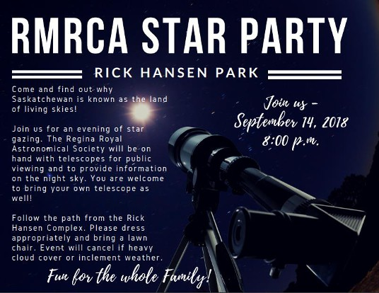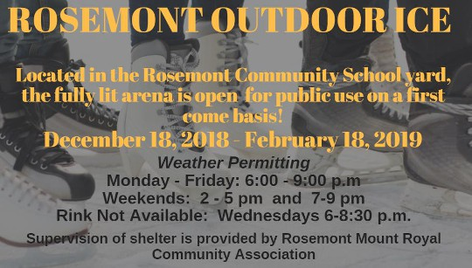

Pizza Party to follow

RMRCA Board of Directors - 2018/2019
Chairperson Theresa McQuoid 306-535-5595 tmcquoid@rentvictory.com
Vice Chair Alex Tkach alex.tkach@rqentertainment.ca
Secretary Donna Inverarity donna.inverarity@sasktel.net

www.rmrca.com Page 8

