Winter Registration Night Information Survey:

These are the results of the survey regarding our future plans for programs and what type of general events would the community be interested in participating in. For anyone who does not know what the form entailed, please follow the link to see for yourself.
https://forms.office.com/Pages/ResponsePage.aspx?id=7o4YdVINmEGdnFsJHb724xURCAsGdEJJi7hMXAlqt_VUQkw4WUI3TzRaNE9SSjdGQ0FMQzhVVE9aUC4u
Below are the general results based off of 27 submissions, all submitters were able to choose multiples. This is a good place to start and I am going to send this off to the greater community group. Additionally I would like to see all our forms available on our website in some way so people can fill them out if they visit. I will provide a more in depth analysis at our meeting but the easy to spot trends are as follows.

As for “1. What future community events would you be interested in participating in? (select all that apply)”, people seem most interested in family friendly events particularly those that revolve around seasonal activities. This could be simply because Winter is front of mind right now but the take away is people seem to want to see family events where they can come and do their own thing rather than directly interact with strangers or the board. My second take away from these results is that there are events that drew virtually no interest such as the community talent show, community meet and greets, and art trading cards. Also based on these results I think that organizing a games night and popups do have some interest and are worth further investigation.
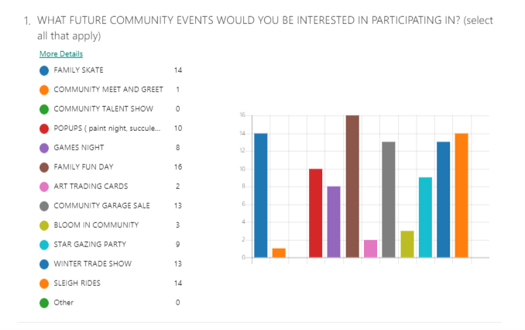

In regards to “2. what community programs would you like to see the rmrca try to organize in the future? (select all that apply)”, initial trends look like a continued interest in Health and Fitness programs and that we should also look to see opportunities with sports and recreation programs and cooking classes. Similarly as above there seems little to no interest in social gatherings or games and skill building programs. One major take away is that there is a desire to see programs centered around children, especially in regards to exercise and art programs. There is also a little interest for accreditation programs and technology training, the former of which I think can be achieved through collaboration with other communities.
