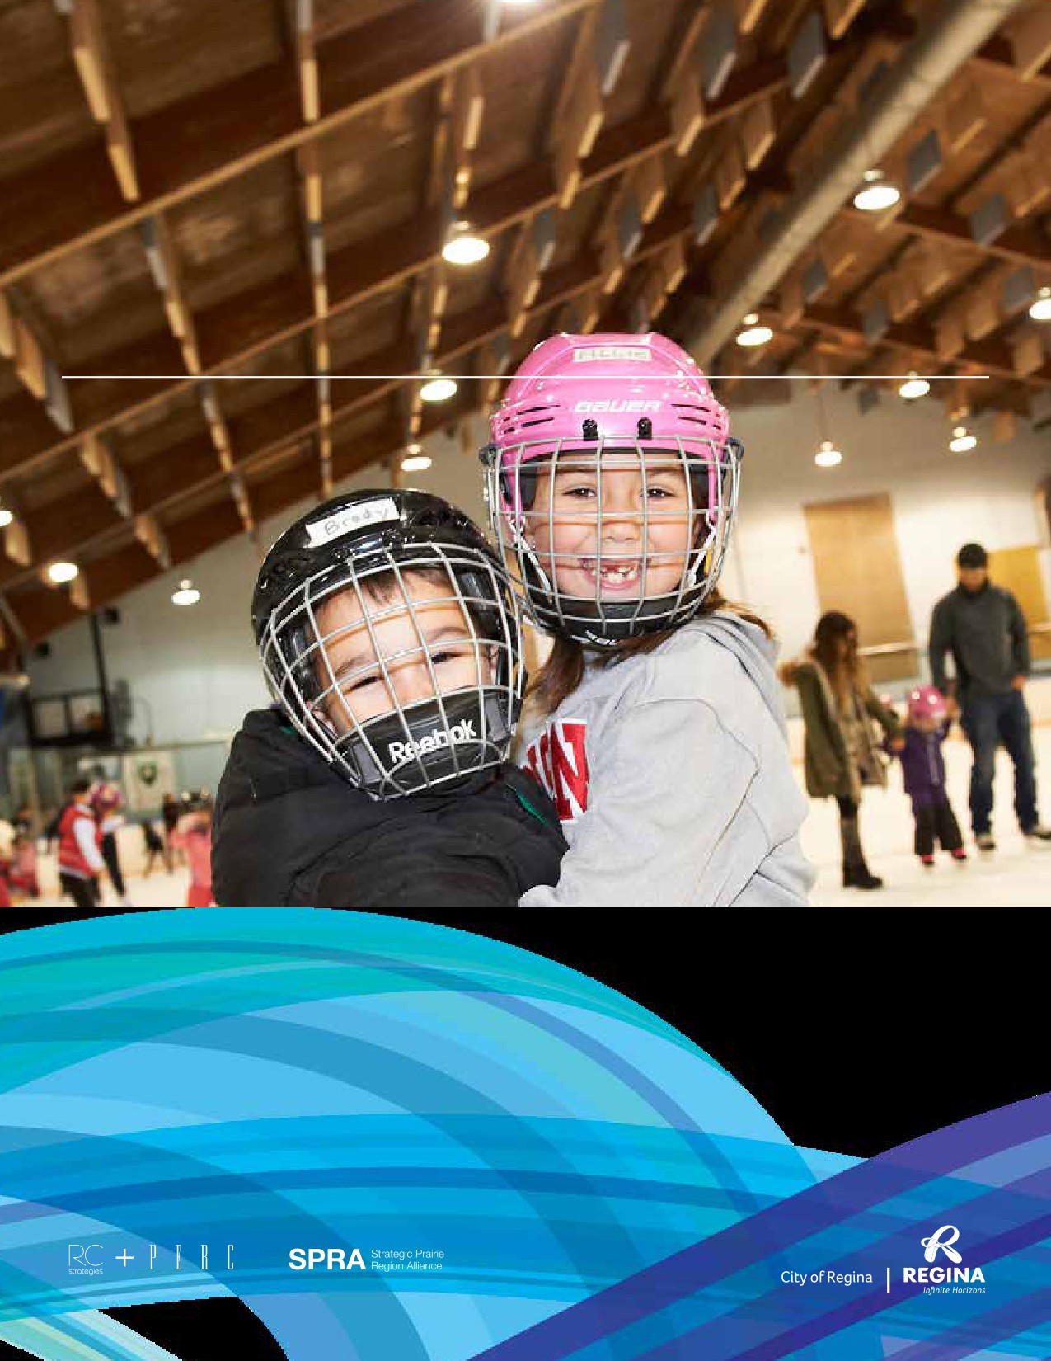
State of Recreation Report
City of Regina

January 2019
Final

State of Recreation Report

Table of Contents

1. INTRODUCTION 1 5. FACILITY INVENTORY 27

Research Overview 3

2. THE BENEFITS OF RECREATION 5

3. COMMUNITY PROFILE 11
Community Context 12
Demographics 12
Demographic Statistics 13
Population Projections 15

4. BACKGROUND REVIEW 17
Municipal Planning 18
Design Regina: Official Community Plan 18
Building the Foundation:
Strategic Plan 2014 - 2018 19
Recreation Facility Plan 2010 - 2020 19
The Open Space Management Strategy 20
Cultural Plan 21
Outdoor Pools Facility Plan 21
Neighbourhood Support Model 22
Transportation Master Plan 22
Provincial Planning 23
Saskatchewan Ministry of Parks, Culture,
and Sport Plan for 2015 - 2016 23
Saskatchewan Parks and Recreation
Association 2014 - 2019 Strategic Plan 23
SPRA’s Recreation Sector Public
Relations Strategy 24
Inter-Municipal Collaboration in Recreation 24
National Planning and Initiatives 24
A Framework for Recreation in Canada 2015:
Pathways to Wellbeing 24
Canadian Sport for Life 25
Truth and Reconciliation 25
Overview of City Facilities 28
Aquatic Centres 29
Ice Arenas 30
Fieldhouses 31
Arts Centres 32
Community Centres 33
Spray Pads 35
Outdoor Pools 37
Support Spaces 38
Sports Fields 40
Classes 40
Tennis Courts 41

Table of Contents

6. FACILITY UTILIZATION 43
Leisure Passes 44
Major Facility Leisure Pass Purchases:
2013 to 2017 44
Proportion of Bulk Admission Purchases
by Age: 2013 to 2017 44
Proportion of Monthly/Year Pass
Purchases by Age: 2013 to 2017 44
Ice Arenas 45
Definition of Prime Ice 45
Prime Ice Utilization: 2016 - 2017 Ice Season 45
Prime Ice Utilization: Annual Comparison 45
Utilization Breakdown: 2017 Dry-Pad Season 45
Aquatics 46
Aquatics Utilization: 2017 Visitation 46
Aquatics Utilization: Annual Visitation
Comparison 46
Lawson Aquatic Centre 47
North West Leisure Centre 47
Sandra Schmirler Leisure Centre 47
Sportplex Fieldhouse 47
Number of Hours Booked: Annual
Comparison 47
Head Counts: Annual Comparison 48
Utilization Breakdown: 2017 Fieldhouse
Hours Booked 48
Neighbourhood Centres 49
Neighbourhood Centre Utilization:
2017 Booked Hours 49
Arts Centres 49
Arts Centre Utilization: 2017 Booked Hours 49
Sports Fields 50
User Groups Averaging Over 1,000
Booked Hours Annually 50
Hours Booked by Field Classification in 2017 50
Total Hours Booked: Annual Comparison
2013 - 2017 51

Ball Diamonds 51
User Groups Averaging Over 1,000
Booked Hours Annually 51
Total Hours Booked:
Annual Comparison 2013 - 2017 52
Outdoor Rinks: 2017/2018 Bookings 52
Outdoor Pools 53
Picnic Sites: 2017 Bookings 53
Leisure Passes 54
Ice Arenas 54
Aquatics 54
Sportplex Fieldhouse 54
Recreation Centres 54
Sports Fields 54
Ball Diamonds 54
Outdoor Rinks, Outdoor Pools, Tennis Courts,
and Picnic Sites 55
City Square Plaza/Victoria Park
and FW Hill Mall 55

7. PROGRAM REVIEW 57
Direct Delivery: City of Regina 58
Indirect Delivery: Zone Boards and
Community Associations 59
Affordable Fun Program 59

8. PARTNERSHIP REVIEW 61
Delivering Recreation
Infrastructure and Amenities 63

Table of Contents

9. TRENDS 65
Participation 66
Physical Activity and Wellness Levels 66
Recreation and Quality of Life 67
Physical Activity Preferences 67
Aboriginal Youth 69
Unstructured Recreation 69
Flexibility and Adaptability 70
Barriers to Participation 70
Providing Recreation Opportunities 70
Partnerships 70
Changing Demographics 71
Social Inclusion 71
Community Development 72
Sport Tourism 72
Volunteerism 73
Infrastructure 74
Aging Infrastructure 74
Multi-Use Spaces 74
Integrating Indoor and Outdoor Environments 74
Ensuring Accessibility 74
Revenue Generating Spaces 75
Social Amenities 75
Food Options in Recreational Facilities 75
Urban Parks Systems 76
Benefits of Parks and Outdoor Spaces 76
Active Transportation 77

10. LEADING PRACTICES 79
Partnership Frameworks 80
Community Associations 80
Supporting Volunteerism 81
Outdoor Pools 81
Inventory Benchmarking 82

11. CONSULTATION 85
Household Survey 87
Top of Mind Thoughts 88
Description of Facilities, Programs and Events 89
Current Usage/Visitation 90
Barriers to Participation 91
Amount of Travel Time Acceptable 92
Willingness to Travel 92
Level of Agreement Statements 93
Satisfaction with Recreation Programs and
Services 94
Reasons for Being
Satisfied/Dissatisfied 94
Need for New and/or Upgraded
Recreation Facilities 95
Indoor Priorities 96
Outdoor Priorities 97
Improvements to Programming 98
Adequacy of Programming 99
Availability of Program Types 100
Development and Delivery of Recreation
Programs, Services, and Facilities 101
Site Selection Criteria 101
Tax Support and User Fees 102
Property Tax Statements 103
Information Source for Recreation Services
and Opportunities 104
Sources of Information 105
Respondent Profile 106
Stakeholder Group Survey 107
Community Organization Information 107
Expectations for Growth 107
Facilities and Spaces 108
New and Improved Recreation Spaces 108
Indoor Priorities 109
Outdoor Priorities 110

Table of Contents

11. CONSULTATION (CONTINUED) 85
Challenges 111
Support Needs 111
General Comments 112
Youth Survey 112
Recreation Participation 113
Barriers to Participation 114
New and Improved Recreation Spaces 114
Indoor Priorities 115
Outdoor Priorities 116
Programs 117
General Comments 117
Stakeholder Interviews 118

12. SUMMARY AND CONSIDERATIONS 123

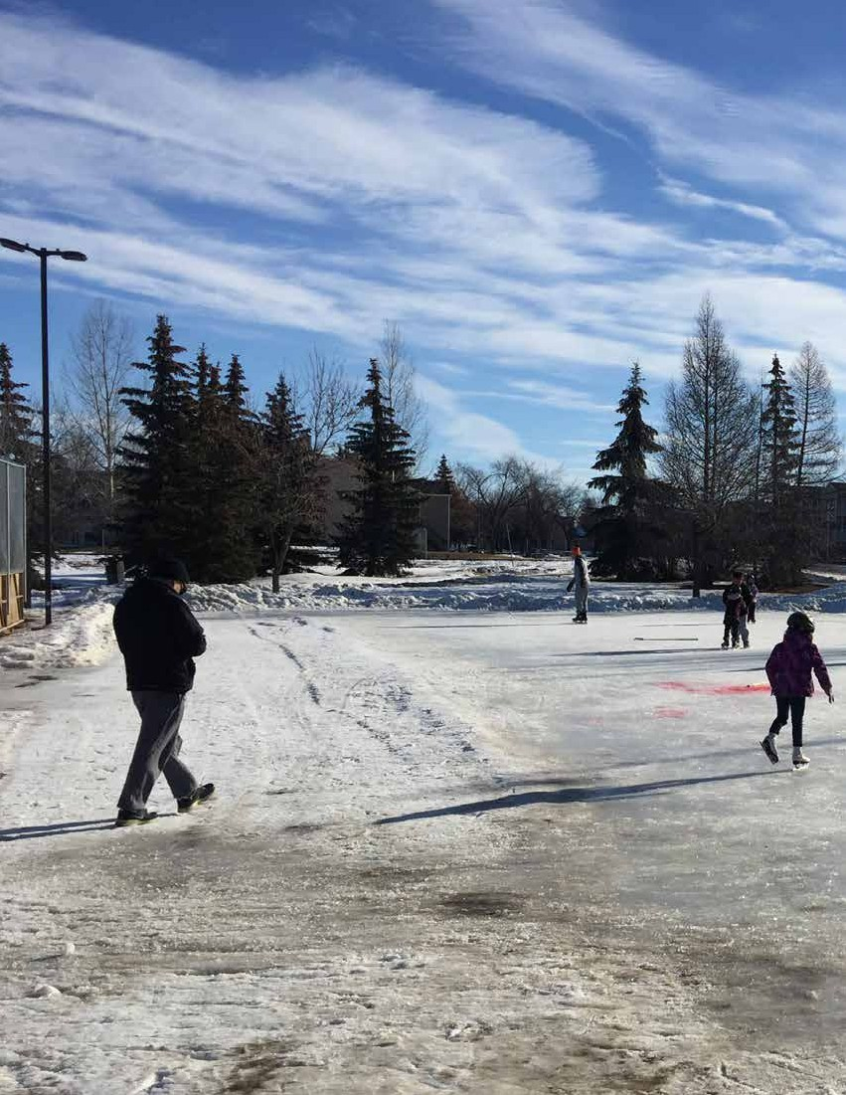

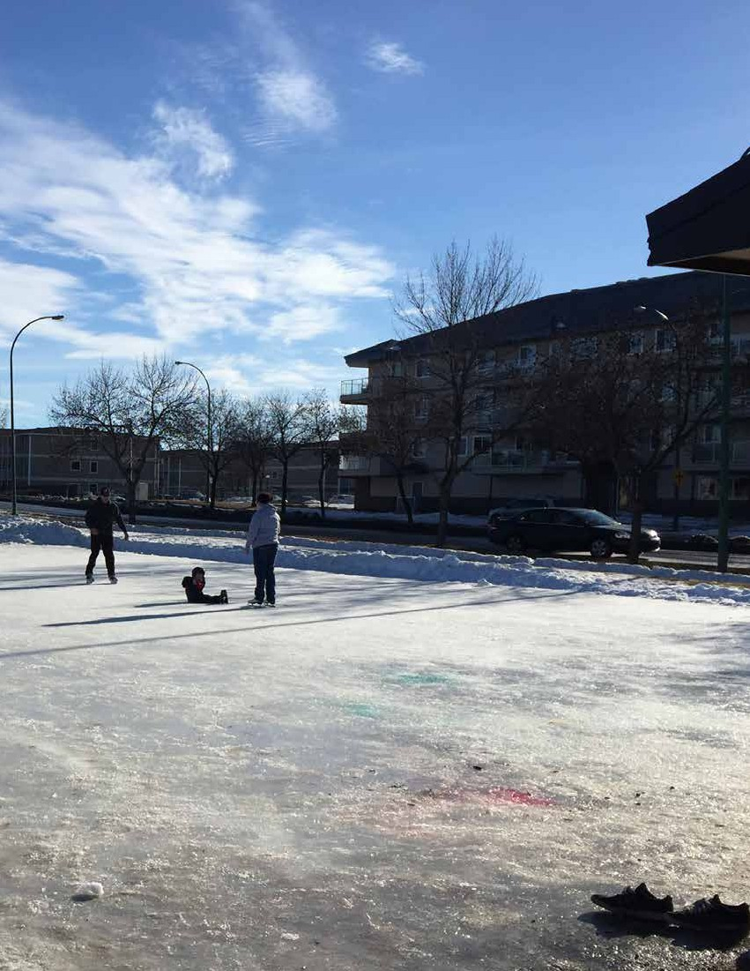

SECTION 1
Introduction
1

REGINA RECREATION MASTER PLAN

SECTION 1
Introduction

Recreation is an important, valued, and essential public
service in Regina. This is apparent through the City’s

investment in the array of programs and infrastructure
available to residents and visitors. It is also evidenced by the
active engagement of public, non-profit, and private sector
stakeholders throughout the City. While there are many
benefits accrued from public recreation service provision
in the Regina region, there may be opportunity to enhance,
improve, and expand these benefits. A Recreation Master
Plan is a tool used by decision-makers, administrators,
stakeholders, and volunteers to sustain existing services
efficiently and effectively (where appropriate) and identify
new and exciting services and delivery systems to further
accrue an even greater benefit.
The process implemented in developing the 2017
Recreation Master Plan will be employed to update the
City’s Recreation Facilities Plan (2010). The Master Plan
will demonstrate alignment with Design Regina, the City’s
Official Community Plan and other important initiatives like
the National Recreation Framework: Pathways to Wellbeing.
Ultimately it will guide public recreation service delivery
and investment for the next 20 years. The Master Plan will
aim to define service standards in an effort to deal with
a growing and changing community and its interests as
well as aging infrastructure. The Master Plan will provide
prioritized recommendations for City operated facilities.
The recommendations will also guide how the City will
work with partners in the community to achieve City goals
and aspirations while leveraging public investment. This
document, “The State of Recreation in Regina” presents
the research undertaken upon which the Master Plan itself
is developed. The Recreation Master Plan is presented under
a separate cover.
2
Recreation: A Renewed Definition
“Recreation is the experience that results
from freely chosen participation in
physical, social, intellectual, creative and
spiritual pursuits that enhance individual
and community wellbeing.”
—A Framework for Recreation in
Canada 2015: Pathways to Wellbeing

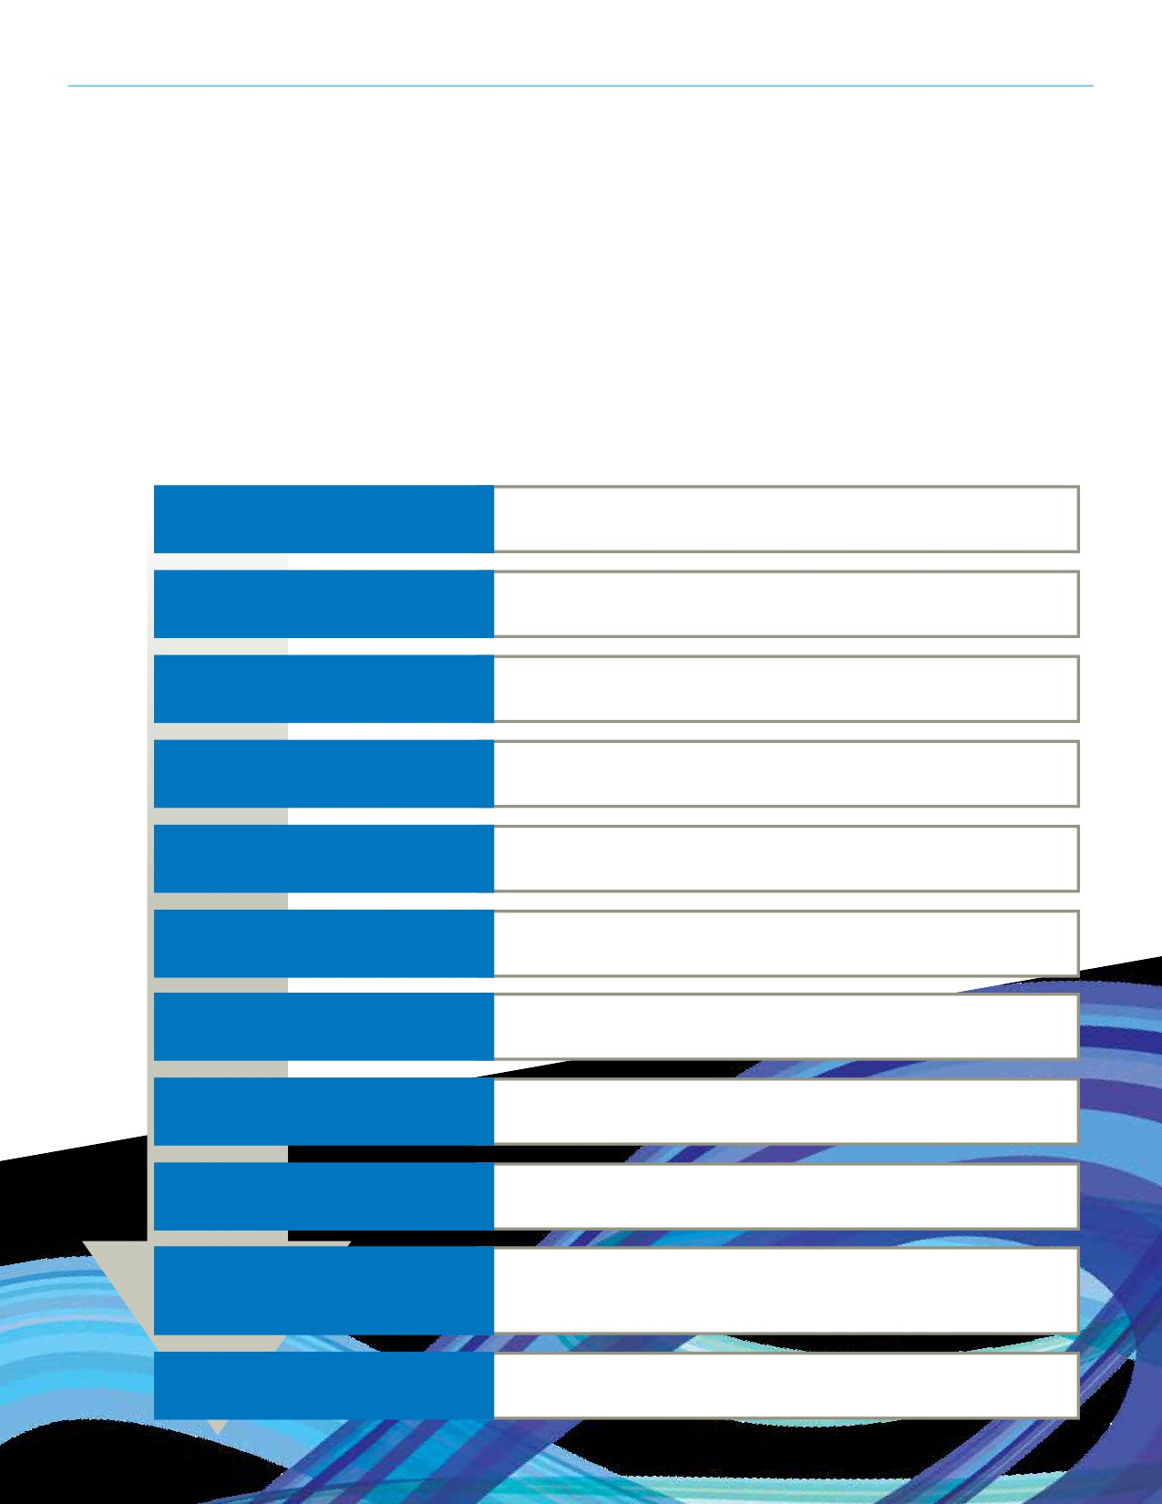SECTION 1: INTRODUCTION

Research Overview
This State of Recreation Report presents all the data gathered during the research process which will, in turn, inform the development
of the Recreation Master Plan. Before strategic direction can be set, information must be gathered and analyzed to understand the
current state of City supported recreation in Regina. Each component of this research report is described in the following chart.

The Benefits of Recreation

Community Profile

Background Review

Facility Inventory

Facility Utilization

Program Review

Partnership Review

Trends

Leading Practices

Consultation

Summary and Considerations

• Outlines eight key benefits of recreation
• To describe the value of recreation

• Overview of Regina and its demographics
• To set the context for the research and plan

• Review of previous planning efforts
• To ensure Master Plan alignment

• A list of Regina's recreation current spaces
• To identify the spaces residents currently use for recreation participation

• Presents utilization data from City operated recreation spaces
• To measure the extent to which current spaces are utilized

• A review of program types in Regina
• To identify the types of programs that are directly delivered

• Review of current partnerships
• To identify and analyze current partnerships

• Presentation of participation and infrastructure trends
• To be aware of potential needs

• Presentation of leading practices in recreation service delivery
• To learn from other municipalities in the province and beyond

• Presents findings from the household survey, group survey, youth survey,
and stakeholder interviews
• To understand the needs of local residents and service providers

• Summary of research and presentation of preliminary considerations
• Identifies areas of focus for the Recreation Master Plan
3

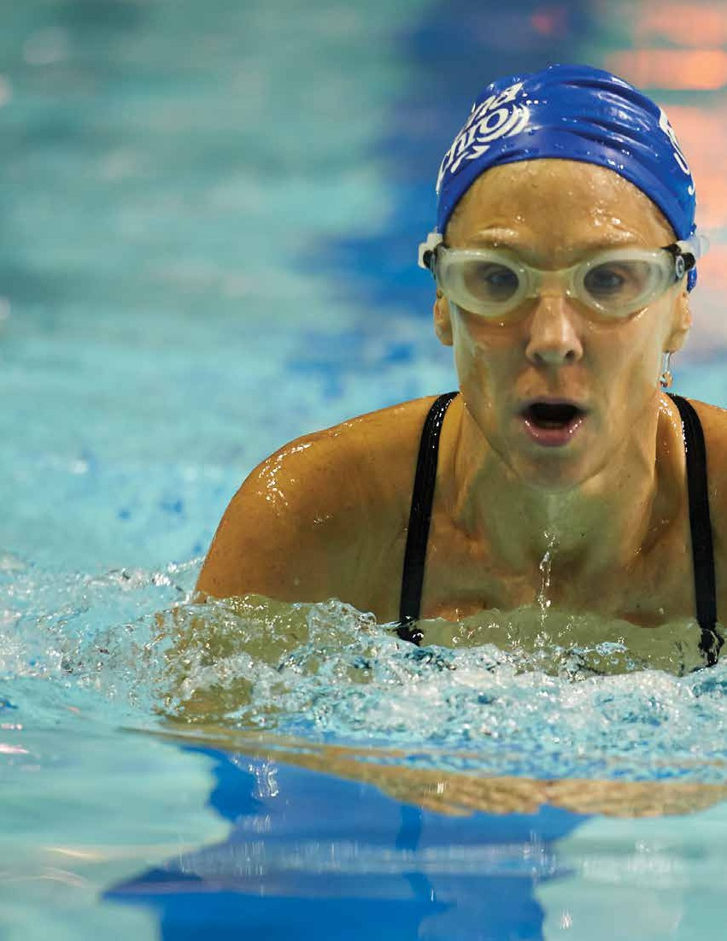
4

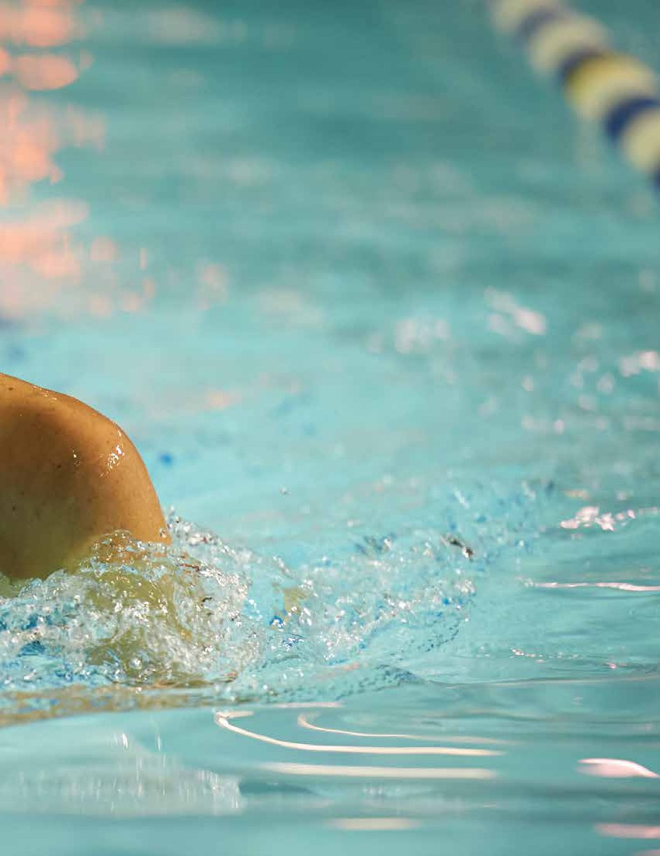

SECTION 2
The Benefits of Recreation
5

REGINA RECREATION MASTER PLAN

SECTION 2
The Benefits of Recreation

KEY FINDINGS FROM THIS SECTION
• Recreation is essential to personal health
and wellbeing.
• Recreation builds strong families and
healthy communities.
• Green spaces are essential to environmental
and ecological wellbeing.

The benefits associated with the provision of recreation
opportunities are extensive. These benefits are increasingly recognized by government and by the public. The following research substantiates these benefits presented by the National Benefits HUB (benefits.ca).
The National Benefits HUB¹ is a research database providing
access to numerous resources that identify the positive
impacts of recreation, sport, fitness, arts/culture, heritage,
parks and green spaces on a community. Identified below are
the eight key benefit categories from the National Benefits
HUB, with corresponding evidence identifying the positive
impacts upon a Regina and its residents.

1 benefitshub.ca
6

SECTION 2: THE BENEFITS OF RECREATION

Recreation is essential to personal health and wellbeing
• Increased leisure time and physical activity improves
life expectancy.¹
• Physical activity contributes to improved mental health
and reduced rates of depression.²
• Participation in physical activity can reduce workplace
related stress.³
• The provision of green spaces has been linked with a
number of health and wellbeing benefits including;
increased physical activity, reduced risk of obesity, minimized utilization of the healthcare system,
and stress reduction.⁴

1 Moore SC, et al. (2012) Leisure Time Physical Activity of Moderate to
Vigorous Intensity and Mortality: A Large Pooled Cohort Analysis. PLoS
Medicine 9 (11): e1001335. doi:10.1371/journal.pmed.1001335
2 Gallegos-Carillo, Katia et al. (2012). Physical Activity and Reduced Risk
of Depression: Results of a Longitudinal Study of Mexican Adults. Health Psychology. In press. doi: 10.1037/a0029276
3 Burton, James P. , Hoobler, Jenny M. and Scheuer, Melinda L. (2012)
Supervisor Workplace Stress and Abusive Supervision: The Buffering
Effect of Exercise. Journal of Business and Psychology.
4 Heinze, John. (2011). Benefits of Green Space - Recent Research.
Chantilly, Virginia: Environmental Health Research Foundation.

Recreation provides the key to balanced human development
• Regular physical activity is likely to provide children with the
optimum physiological condition for maximizing learning.⁵
• Low income students who are involved in arts activities
have higher academic achievement and are more likely to go to college.⁶
• The arts and other forms of creativity can have profound
individual social outcomes and generate a deeper sense
of place and local community.⁷
• Individuals that participate in physical activity in a social
setting have improved psychological and social health,
and often also benefit from increased self-awareness and personal growth.⁸

5 Marten, Karen. (2010). Brain boost: Sport and physical activity enhance
children’s learning. Crawley, Western Australia: University of Western
Australia.
6 Catteral, James S. (2012). The Arts and Achievement in At-Risk Youth:
Findings from Four Longitudinal Studies. Washington, District of
Columbia: National Endowment for the Arts
7 Mulligan, M. et al. (2006). Creating Community: Celebrations, Arts and
Wellbeing Within and Across Local Communities. Melbourne, Australia:
Globalism Institute, RMIT University
8 Eime, Rochelle M et al. (2013). A systematic review of the psychological
and social benefits of participation in sport for adults: informing
development of a conceptual model of health through sport.
International Journal of Behavioral Nutrition and Physical Activity.
10(35).
7

REGINA RECREATION MASTER PLAN

Recreation provides a foundation for quality of life
• The arts are seen as an important contributor to quality of
life in communities.⁹
• High quality public spaces can enhance the sense of
community in new neighbourhoods.¹⁰
• Community sport facilities have positive benefits related
to increased accessibility, exposure, participation,
perceptions of success, and improved sport experiences.¹¹

Recreation reduces self-destructive and anti-social behavior
• Youth participation in recreational activities such as
camps increases leadership and social capacities.¹²
• Participation in recreation and leisure related activities
by low income and other at risk children and youth populations can result in decreased behavioural/ emotional problems, decreased use of emergency services, and enhanced physical and psycho-social health of families.¹³
• Teen athletes are less likely to use illicit drugs, smoke,
or to be suicidal.¹⁴

9 Environics Research Group. (2010). The Arts and the Quality of Life. The
attitudes of Ontarians. Toronto, Ontario: Ontario Arts Council.
10 Francis, Jacinta et al. (2012). Creating sense of community: The role of
public space. Journal of Environmental Psychology. 32(4): 401- 409. http://dx.doi.org/10.1016/j.jenvp.2012.07.002
11 Henderson, K., Scanlin, M., Whitaker, L., et al. (2005) Intentionality and
Youth Development Through Camp Experiences. Canadian Congress on
Leisure Research. 11th, Nanaimo, British Columbia.
12 Henderson, K., Scanlin, M., Whitaker, L., et al. (2005) Intentionality and
Youth Development Through Camp Experiences. Canadian Congress on
Leisure Research. 11th, Nanaimo, British Columbia.
13 Totten, M. (2007). Access to Recreation for Low-Income Families in
Ontario: The Health, Social and Economic Benefits of Increasing Access
to Recreation for Low-Income Families; Research Summary Report. Toronto, Ontario: Ministry of Health Promotion.
14 Poway High School Library. (2001). Teens and sports: The perfect
combination? Better Nutrition, 63(9), 16.
8

Recreation builds strong families and healthy communities
• People with an active interest in the arts contribute more
to society than those with little or no such interest.¹⁵
• Evidence indicates that adults who attend art museums,
art galleries, or live arts performances are far more likely than non-attendees to vote, volunteer, or take part in community events.¹⁶
• Structured sport and recreational activities can help foster
a stronger sense of community among children and youth.¹⁷
Recreation reduces health care, social service and police/justice costs
• Physical inactivity has a number of direct and indirect
financial impacts on all levels of government.¹⁸
• Parks and recreation programming during non-school
hours can reduce costs associated with juvenile delinquency and obesity.¹⁹
• Increased fitness leads to lowered risk factors for
substance abuse among youth populations.²⁰

15 LeRoux, Kelly. (2012). Interest in Arts Predicts Social Responsibility.
Chicago:University of Illinois at Chicago. Press Release.
16 National Endowment for the Arts. (2009. Art-Goers in Their
Communities: Patterns of Civic and Social Engagement. Nea Research Note #98. Washington, D.C.: Author.
17 Hutchinson, Susan L. (2011). Physical Activity, Recreation, Leisure, and
Sport: Essential Pieces of the Mental Health and Well-being Puzzle.
18 Canadian Association for Health, Physical Education, Recreation and
Dance (CAHPERD). (2004) Physical Activity: Health benefits and costs to health care system. Ottawa, Ontario: Author.
19 Witt, Peter A and Cladwell, Linda L. (2010).The Scientific Evidence
Relating to the Impact of Recreation on Youth Development, in The
Rationale for Recreation Services for Youth: An Evidenced Based
Approach. Ashburn, Virginia: National Recreation and Parks Association.
20 Collingwood, Thomas R. et al. (2000). Physical Training as a Substance
Abuse Prevention Intervention for Youth. Journal of Drug Education. 30
(4): 435-451.

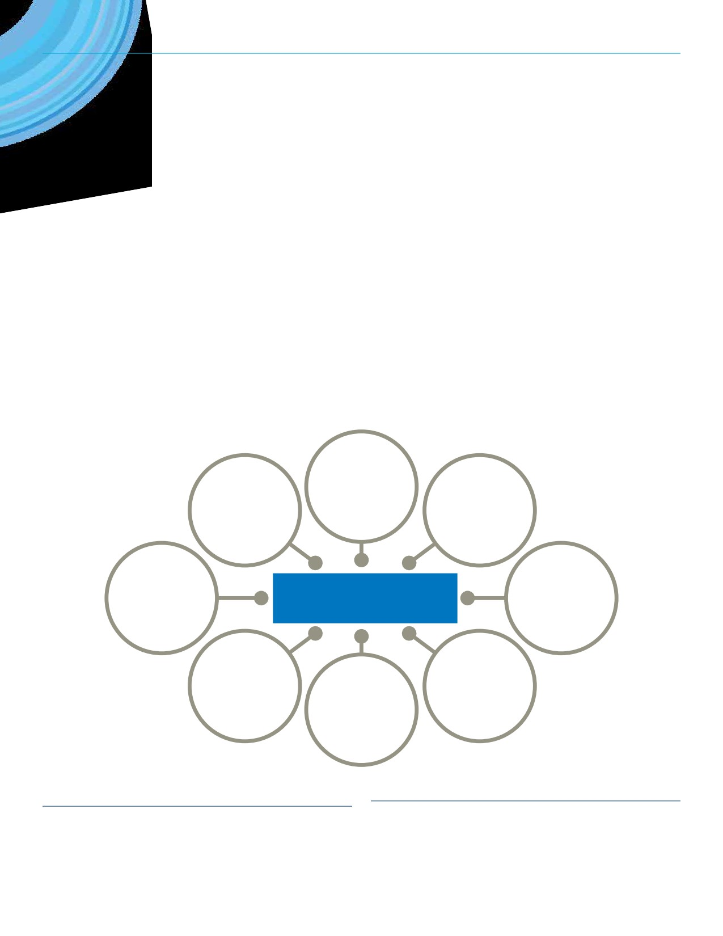SECTION 2: THE BENEFITS OF RECREATION

Recreation is a significant economic generator
• Recent Canadian research indicated that cultural activities
have the potential to be significant drivers of economic outputs and employment.²¹
• Evidence suggests that creative activity shapes the
competitive character of a city by enhancing both its
innovative capacity and the quality of place so crucial to attracting and retaining skilled workers.²²

Green spaces are essential to environmental andecological wellbeing
• Sustainable public green spaces provide crucial areas
for residents of all demographics to be physically and
socially active.²³
• Increasing green spaces in urban centres has a number
of positive environmental outcomes which can increase
sustainability and lower long term infrastructure costs.²⁴
• When children and youth have positive experiences
with parks and green spaces, they are more likely to have stronger attitudes towards conservation and preservation of the environment as adults.²⁵

Provides a
foundation

Is essential
to personal
health and
wellbeing.

Reduces health care,
social service, and
police/justice costs.

Is a significant
for quality Provides the
of life. key to balanced
human
development.

Reduces self-
Recreation Services destructive and
anti-social behaviour.

Green spaces
are essential

economic generator. Builds strong to wellbeing.
and healthy
communities.

21 Momer, Bernard. (2011) Our City, Ourselves: A Cultural Landscape
Assessment of Kelowna, British Columbia. Kelowna, British Columbia:
City of Kelowna Recreation and Cultural Services.
22 Gertler, M. (2004). Creative cities: What are they for, how do they work,
and how do we build them? Ottawa, Ontario: Canadian Policy Research
Network.

23 Cohen, D. et al. (2007). Contribution of Public Parks to Physical Activity.
American Journal of Public Health, 97(3), 509.
24 Groth, P. (2008). Quantifying the Greenhouse Gas Benefits of Urban
Parks. San Francisco, California: The Trust for Public Land.
25 Place, G. (2004). Youth Recreation Leads to Adult Conservation. Chicago,
Illinois: Chicago State University.
9

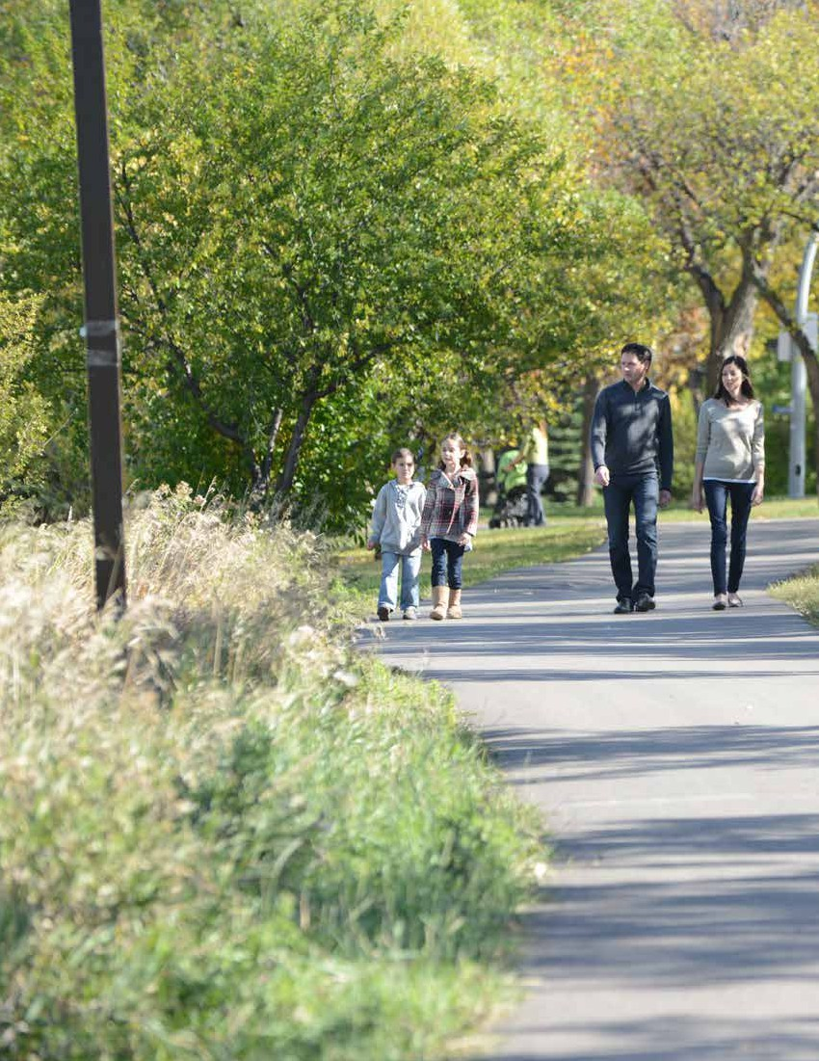
10

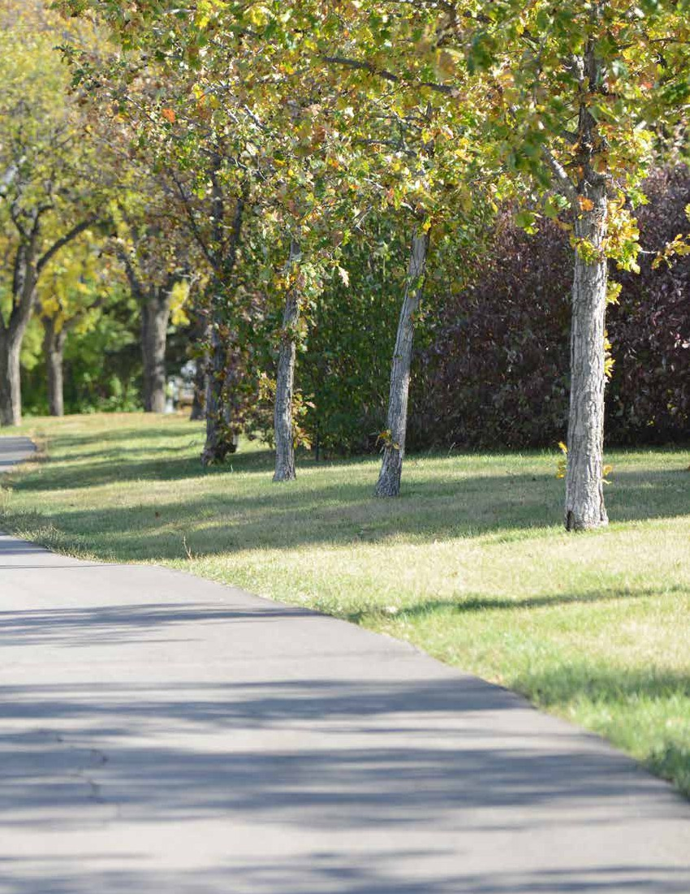

SECTION 3
Community Profile
11

REGINA RECREATION MASTER PLAN

SECTION 3
Community Profile

opportunities for recreation including multiple playgrounds, sport
courts, cross country ski trails and multi-use pathway systems

KEY FINDINGS FROM THIS SECTION
• The city’s population continues to grow.
The 2016 census identifies a population of
215,106 residents which is an 11.4% increase from 2011.
• By 2031, it is possible that the City of Regina
could be serving over 300,000 residents.
• The City is a regional hub serving a CMA
population of 236,481.
• 8,020 new Canadians moved to Regina from
2006 - 2011.
• Nearly 10% of Regina’s population identifies
as Indigenous (2011).
• The City is split into 5 Recreation Zones
and 27/30 Community Associations.
• Community Association populations range
from 675 to 28,485.

Having a thorough understanding of the current and
expected future demographic make-up of the City is
important as planning for recreation services is undertaken.
Recreation pursuit preferences are subjective; preference can
be based on local context, ethnicity and culture, and many
other factors. This section provides an understanding of the make-up of the community which impacts City decisions on recreation provision.
Community Context
Regina is the second largest city in Saskatchewan situated
in the south-central part of the province. The city sits in
the geographical centre of North America and as such is a
geographic hub. Indicative of Saskatchewan, Regina spreads over flat, broad plains that provide an abundance of greenery and recreational space. After becoming a City in 1903,
Regina settlers planted thousands of trees to decorate the
prairie city, designating areas that would eventually become
parks and green spaces. This appreciation of recreational
space is a virtue that is consistent through the history of
Regina and serves as an element of civic pride. Due to the
preserved spaces, Regina has a variety of low cost and free
12
winding throughout the community. Considering indoor facilities, Regina operates three major recreation centres and one major cultural centre: Sandra Schmirler Leisure Centre, North West Leisure Centre, Sportplex, and the Neil Balkwell Civic Arts Centre. These facilities, along with arenas and neighbourhood recreation centres, offer residents and visitors the opportunity to live an active lifestyle and engage socially with each other in a supportive environment.
The University of Regina is an integral part of the recreational
community with high quality programs, services, and facilities.
For grade schools, Regina is home to 45 elementary schools and
9 high schools with approximately 21,000 students in the public system. The Catholic school board operate 25 elementary schools and 4 high schools, with half as many students.
Demographics
The city of Regina has a population of 215,106; an 11.4% increase since 2011 (This is an annual average growth rate of 2.28% which greatly exceeds the provincial rate of 1.26%)¹. An additional 21,375 people live in region; as such the population of the census metropolitan area is 236,481.
The 2011 census recorded an Indigenous population of 18,750
which accounted for 9.9% of the city’s residents. Also in the 2011
census, it was reported that 21,180 new Canadians were living in
Regina, the majority from Asia and Europe. From 2006 to 2011,
8,020 additional new Canadians were reported to have found their
new home in Regina. The residence of new Canadians is more
concentrated in the South and East neighbourhoods of Regina.
In 2011 the highest concentrations of new Canadians reside in
Arcola East, Albert Park Dewdney East and AL Ritchie respectively.
There are several communities surrounding Regina. The most
populated regional communities are Emerald Park, White City
and Pilot Butte, which are all located east of the city. In addition,
the towns of Pense and Grand Coulee are located within
30 kilometres west of Regina. The economy throughout the region is diversified and focused on agriculture, oil and gas and other natural resources.

1 At the aggregate level, Saskatchewan cities grew 9.9% from
2011 - 2016.

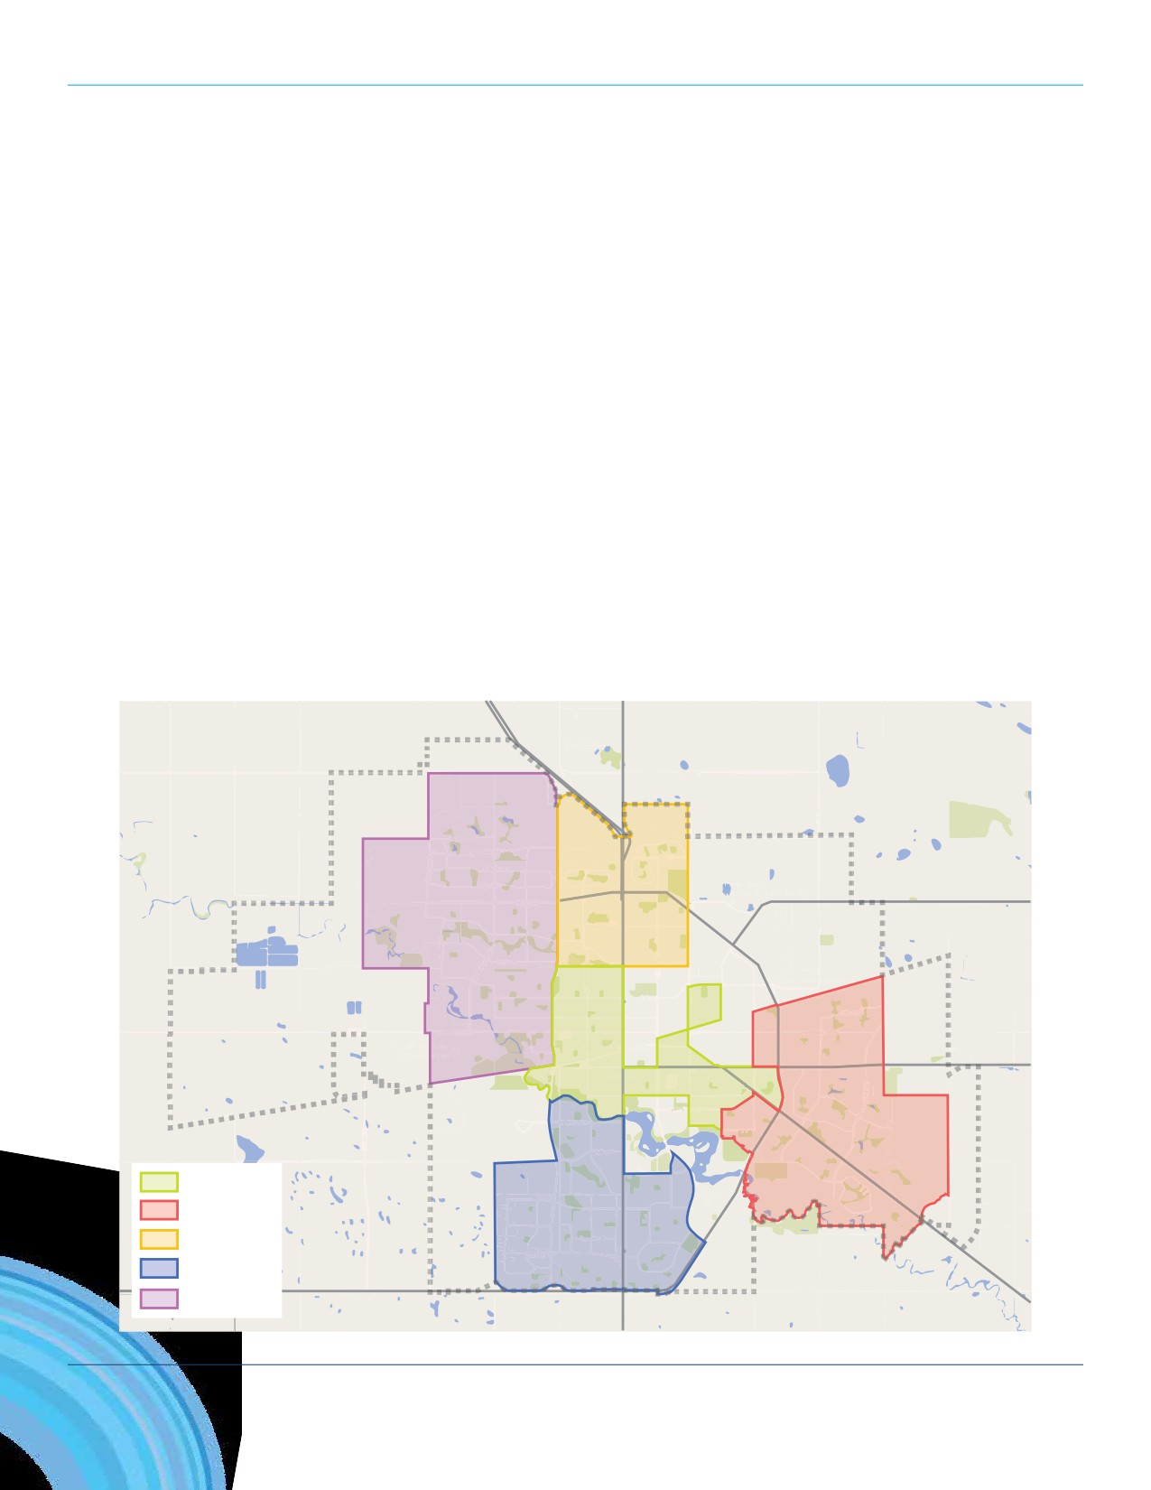SECTION 3: COMMUNITY PROFILE

Demographic Statistics
• City of Regina population (2016): 215,106
• Census metropolitan area population (2016): 236,481
• Percentage of Regina’s population that identifies as Indigenous (2011): 9.9%
• Number of new Canadians that moved to Regina from 2006 - 2011: 8,020
• Median age (2011): 37.3
• Median family income (2010): $84,890
• Percentage of population over the age of 65 (2016): 13.8%²
• Percentage of population under the age of 15 (2016): 18.5%³
In order to further manage recreation service provision, Regina is divided into five recreation zones (see the map). By recreation zone, Regina is most populated in the West and East zones, followed by Central, South and North zones.

West Zone North Zone

Central Zone
East Zone
Central Zone
East Zone
South Zone
North Zone
South Zone
West Zone

2 Provincially the proportion of the population over the age of 65 is 15.5%. (2016).
3 Provincially the proportion of the population under 15 years of age is 19.6% (2016).
13

REGINA RECREATION MASTER PLAN

Further to the five recreation zones throughout the City, there are also a number of Community Associations
that offer a number of local, neighborhood recreation opportunities to residents. The City supports these

Recreation Zone/Community Association
West Zone

Population
(2016)
58,870

Community Associations in a variety of different ways Walsh Acres/Lakeridge/Garden Ridge 13,791

and they are widely considered important stakeholders
in the recreation delivery system. The most populated
Community Association is Arcola East which has 28,485
residents followed by Dewdney East (18,758), Walsh
Acres/Lakeridge/Garden Ridge (13,791), and Alberta Park (13,290).
Sherwood/Mccarthy 9,454
Rosemont/Mount Royal 9,047
Twin Lakes 8,369
Prairie View 4,729
Normanview Residents Group 4,417

Normanview West 2,917
Regent Park 2,858
Mcnab 1,763
Dieppe 1,525

North Zone 24,163
Northeast 7,648
Coronation Park 7,444
Argyle Park 3,712
Uplands 5,359
Central Zone 38,528
North Central 9,581
Al Ritchie 8,102
Cathedral 6,669
Heritage 5,386
Centre Square 3,781
Eastview 1,890
Gladmer Park 2,444
Downtown 675

East Zone 49,953
Arcola East 28,485
Dewdney East 18,758
Boothill 2,710
South Zone 43,592
Albert Park (and Harbour Landing) 22,079
Lakeview 7,727
Hillsdale 7,086
Whitmore Park 6,700
14

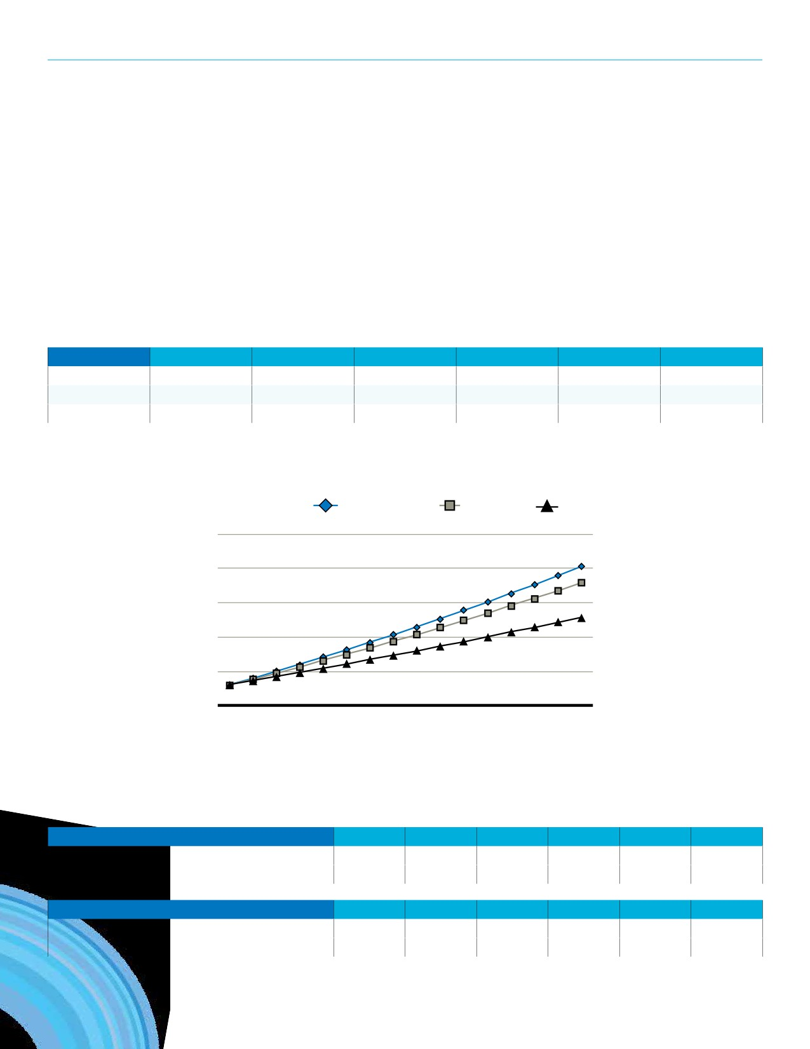SECTION 3: COMMUNITY PROFILE

Population Projections
From 2011 to 2016, Regina’s population increased by 11.4% which is a higher growth rate compared to the 7.7% increase
experienced from 2006 to 2011. Looking back at the last 5, 10 and 15 years, Regina has experienced a 2.3%, 2.0%, and 1.4%
average annual growth respectively. Applying these rates as scenarios over the next 15 years Regina’s population could grow to a total between 264,186 and 301,623 by 2031. See the accompanying table and graph.

Scenario | Annual Growth | Based On | 2016 | 2021 | 2026 | 2031
High | 2.3% | 2011 - 2016 | 215,106 | 240,763 | 269,480 | 301,623
Medium | 2.0% | 2006 - 2016 | 215,106 | 237,501 | 262,229 | 289,530
Low | 1.4% | 2001 - 2016 | 215,106 | 230,359 | 246,693 | 264,186

15 Years Projection Scenarios
City of Regina

High (2.3%) Medium (2.0%) Low (1.4%)
325,000
301,623
300,000
289,530
275,000
264,186
250,000

225,000
215,106
200,000

Previously formulated projections for the City of Regina and the broader Census Metropolitan Area (CMA) are displayed in the
charts below. Based on the projections, by 2031, the Regina area population could surpass 300,000 residents including 250,000 residing in the City.

City of Regina Projections By | 2011 | 2016 | 2021 | 2026 | 2031 | 2041
Hemson Consulting Ltd. (2013)^{A} | 198,380 | 220,060 | 239,590 | 258,130 | 276,080 | 310,030
Derek Murray Consulting and Associates (2010)^{B} | 199,250 | 215,370 | 227,900 | 239,280 | 259,900 | —

CMA Projections By | 2011 | 2016 | 2021 | 2026 | 2031 | 2041
Hemson Consulting Ltd. (2013)^{A} | 216,290 | 240,650 | 262,970 | 284,120 | 324,150 | 343,420
Derek Murray Consulting and Associates (2010)^{B} | 216,530 | 234,170 | 248,280 | 261,220 | 284,500 | —
A City of Regina Population, Housing and Employment Forecasts and Land Needs Analysis to 2041 (2013). Hemson Consulting Ltd. B Population, Employment and Economic Analysis of Regina (2010). Derek Murray Consulting and Associates.
15

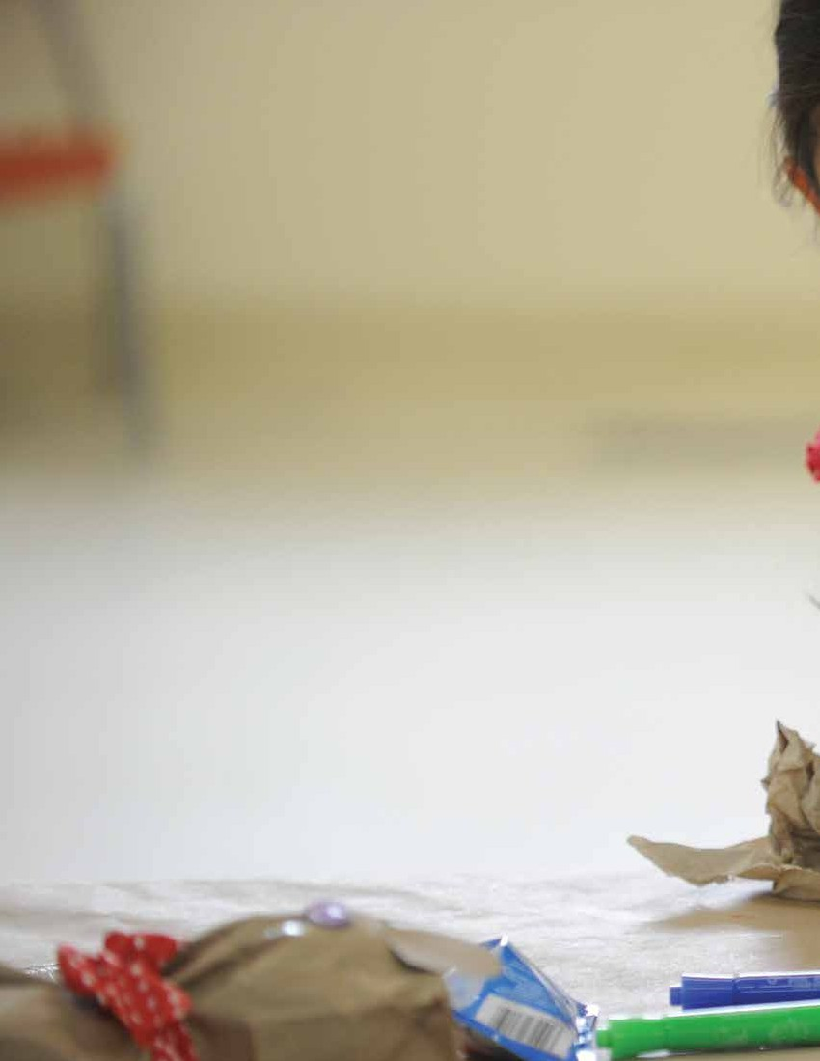
16

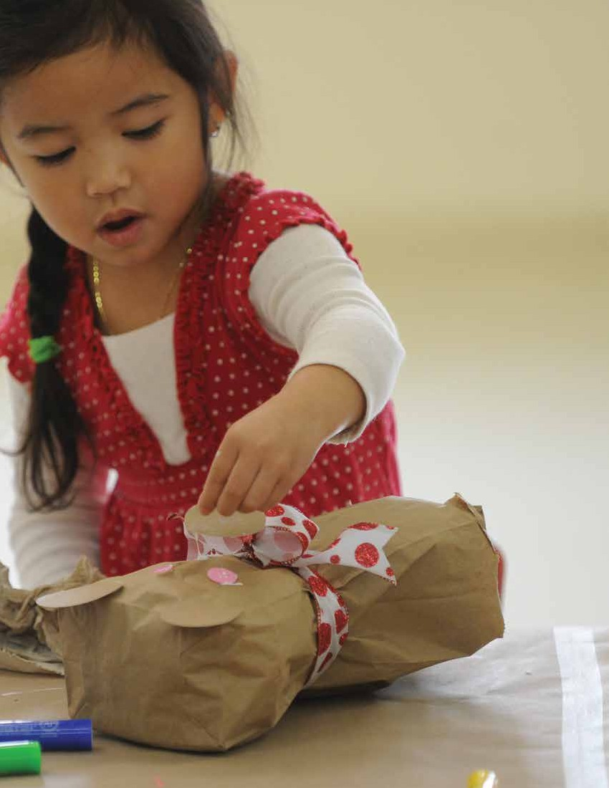

SECTION 4
Background Review
17

REGINA RECREATION MASTER PLAN

SECTION 4
Background Review
Municipal Planning

KEY FINDINGS FROM THIS SECTION
• The Vision for the City of Regina is: Regina will
be Canada’s most vibrant, inclusive, attractive,
sustainable community, where people live in harmony and thrive in opportunity.
• The City has a number of planning documents
already approved and being implemented that
build support and justification for recreation services and are relevant when contemplating future recreation services.
• There are also provincial and national planning
influences that need to be considered such as
the National Framework for Recreation and the Canadian Sport for Life movement.
• The renewed definition of Recreation:
Recreation is the experience that results from
freely chosen participation in physical, social, intellectual, creative, and spiritual pursuits that enhance individual and community wellbeing (A Framework for Recreation in Canada).

A series of municipal plans and studies have been reviewed to
identify references to recreation and justification for provision
and investment and its place in other planning contexts. It is
instructive to review these plans and studies to consider their
recommendations and conclusions and the potential influence
they will have on future services. This section also reviews
pertinent provincial and national level plans and frameworks that illustrate the broader goals of the recreation sector and again, will influence future service provision.
18
Design Regina: Official Community Plan
Purpose
• To manage the city’s growth to 300,000 people and set
the stage for its longer-term development. It provides the
City with direction on where and when new development will happen, how municipal services will accommodate this growth, and other factors affecting Regina citizens’ quality of life, including parks and recreation.
Key Elements
• Vision: Regina will be Canada’s most vibrant, inclusive,
attractive, sustainable community, where people live in
harmony and thrive in opportunity.
• Community Priorities: Develop complete neighbourhoods;
Embrace built heritage and invest in arts, culture, sport
and recreation; Create better, more active ways of
getting around; Promote conservation, stewardship and environmental sustainability; and Achieve long-term financial viability.
• Activity Centres: Areas for active and passive recreation use
that accommodate institutions and social facilities, indoor
and outdoor recreation facilities and other active uses
connected, where feasible, by active transportation links.
Points in the Document that are Pertinent for Recreation Planning
• Goal: Maintain, enhance and extend an interconnected
and accessible open space system.
• Goal: Ensure access to a variety of recreation programs
and services in all neighbourhoods.
»» Multifunctional parks and open spaces
»» Variety of recreation programs and service (direct and/
or indirect delivery)
»» Minimize barriers
»» Consider the needs of vulnerable populations
»» Design spaces for year-round use whenever possible

SECTION 4: BACKGROUND REVIEW

• D7 Parks, Recreation and Open Space
»» Develop complete neighbourhoods
»» Embrace built heritage and invest in arts, culture, sport
and recreation
»» Create better, more active ways of getting around
»» Promote conservation, stewardship and environmental
sustainability; and
»» Achieve long-term financial viability.
Building the Foundation:
Strategic Plan 2014 - 2018
Purpose
• The plan lays out the critical first steps so that the City will
be well-positioned to deliver on the Official Community
Plan in the future.
Key Elements
• Mission: The City of Regina contributes to its citizens’ quality
of life by providing services and infrastructure at a level and
of a quality that is sustainable.
• Values: Performance driven and accountable; Responsive
and respectful; Innovative and creative; focused on excellence.
• Directions: Manage growth; Improve financial viability;
Engage and develop staff; Engage citizens.
Points in the Document that are Pertinent for Recreation Planning
• Objectives:
»» A full-life cycle Asset Management approach is being
used to support infrastructure renewal decisions.
»» Decisions about programs and assets reflect future
service needs
»» Reconcile service expectations against the fiscal
realities of the City.
»» The City is responsive to customers’ needs by meeting
established Customer Service Standards.

Recreation Facility Plan 2010 - 2020
Purpose
• To ensure that investments in sport, culture and recreation
infrastructure occur in a manner that enhances the quality
of life of Regina citizens by meeting the highest priority needs of present and future populations, is aligned with the Official Community Plan (the Regina Development Bylaw No. 7877) and other corporate and community initiatives, and is fiscally responsible.
Key Elements
• Guiding Principles: Outcomes-based and targeted; Fiscally
responsible and financially sustainable; Affordable;
Complementary; Aligned; Clustered; Integrated; Flexible, multi-use, multi-season, multi-generational and
environmentally sustainable design.
• Hierarchy and Distribution of Facilities: City wide level;
Zone level; Neighbourhood level.
Points in the Document that are Pertinent for Recreation Planning
• Strategic Directions:
»» Provide a centrally located city-wide indoor facility to
serve both leisure and competitive aquatic needs with
complementary fitness amenities.
»» Provide smaller community destination facilities in the
north, east and south areas with a connection to other
indoor and outdoor recreation facilities.
»» Provide a city-wide outdoor facility in Wascana
Park with a variety of aquatic and non-aquatic play amenities.
»» Provide outdoor pools in the north, central and south
areas, as well as spray pad facilities throughout the
city at community destination and neighbourhood hub facilities where possible.
»» Provide city-wide facilities that serve visual and
performing arts at the recreation level (beginner to
intermediate).
»» Support advanced/professional theatre and galleries,
where there is a direct benefit back to the community,
through financial support and consulting services.
19

REGINA RECREATION MASTER PLAN

»» Ensure an adequate inventory of ice time is available
in city-wide destination indoor arenas, through
a combination of city-owned/operated as well as community-owned/operated facilities, to enable a base level of participation in ice activities.
»» Provide outdoor skating experiences in a well
distributed manner throughout the city in
conjunction with community destination facilities and neighbourhood hub facilities.
»» Provide a city-wide indoor skateboard facility
with outdoor skateboard facilities and elements
strategically located throughout the city.
»» Provide neighbourhood centres in high needs
neighbourhoods or those with geographic barriers to accessing community destination facilities.
»» Enhance neighbourhood centre facilities as
neighbourhood hub facilities, in a manner that is
complementary to schools which also serve as hub
facilities, through the development of amenities in the surrounding space.
»» Maintain existing centres that are targeted at senior age
segments, with long term plans to ensure all facilities
accommodate the needs of this growing segment of the population.
»» Provide high quality sport and outdoor recreation
facilities at the citywide, community destination and
neighbourhood hub levels through direct delivery and partnerships:
--Municipal Leadership: playgrounds, pathways, spray
pads, athletic fields, ball diamonds, outdoor tennis,
dog parks.
--Community Leadership: indoor tennis, racquet
sports, skiing, floral conservatory.
»» Enable and support community leadership and
involvement in the development, redevelopment and
operation of sport, culture and recreation facilities.

The Open Space Management Strategy
Purpose
• To provide a comprehensive strategy for effectively planning,
managing and sustaining Regina’s open space system.
Key Elements
• The guiding principles are meant to be top of mind in the
decision making process. A few of the guiding principles
are noted below.
»» Recreational open space is an essential element in
promoting community wellness and healthy living. »» A diverse range of recreational open space
opportunities should be accessible to all residents
of Regina regardless of their age, gender, economic
circumstances, cultural background, or ability level. »» Open space should be distributed as equitably as
possible to provide recreation opportunities for citizens in all areas of the city.
»» All areas of the city shall have access to a consistent
quality of parks and recreation opportunities and
facilities.
»» All forms of open space should be managed in an
environmentally sensitive manner.
»» Open space components should be integrated into a
comprehensive system linking parks, pathways and
leisure facilities where desirable and possible.
Points in the Document that are Pertinent for Recreation Planning
• Policy Recommendations:
»» To maximize the benefits of recreational open
space, the City of Regina shall as a goal strive toward
developing an integrated open space system.
»» The City of Regina shall plan and develop park facilities
that are flexible in design, incorporate multiple use opportunities that are capable of accommodating changing demographics and new recreational and sporting trends.
»» The City of Regina shall adopt universal design and
geographic accessibility as the guiding principles in all
future development of play spaces.
20

SECTION 4: BACKGROUND REVIEW

Cultural Plan
Purpose
• To strategize around the Arts, inter-culturalism, and other
cultural assets in meeting the City’s vision to be Canada’s
most vibrant, inclusive, sustainable, attractive community where people live in harmony and thrive in opportunity.
Key Elements
• Goals: Embrace cultural diversity; Strengthen the artistic
and cultural community; Commemorate and celebrate the
City’s cultural heritage.
Points in the Document that are Pertinent for Recreation Planning
• Objectives and Actions:
»» Establish formal processes based on mutual respect
and open communication to sustain engagement with
First Nations and Métis communities in defining and responding to cultural needs and aspirations.
»» Increase awareness of the City’s cultural and recreation
programs to Newcomer populations.
»» Ensure City programs include Newcomers’ perspectives
and cultural needs from development to delivery. »» Develop accommodations through policy and
procedures for diverse community’s cultural practices in City-owned buildings and facilities.
»» Work with Community Associations to explore
opportunities with the City, and other partners, for
programs and events at the neighbourhood level to profile and celebrate the city’s diversity.

»» Create opportunities for mentorship and partnership
programs between established cultural organizations
and emerging ones to enhance vibrancy in City Square. »» Support opportunities, both with City-owned
facilities and those in community, for an incubator or shared space that brings together different cultural organizations and enterprises to spark innovation, cooperation, and new economic activity.
»» Conduct an analysis of City-owned facilities, like
Neighbourhood Centres and the Neil Balkwill Civic Arts Centre, to identify enhancements to better support
cultural programming.
»» Develop cross-media strategies for City-owned cultural
assets; the Neil Balkwill Civic Arts Centre, Civic Art
Collection, City Square.
»» Ensure the inclusion of live/work spaces in new
neighbourhoods.
Outdoor Pools Facility Plan
Purpose
• To develop a long-term facility and operation plan for the
City’s five outdoor pools.
Key Elements
• Three of the five outdoor pools were built in the 1940’s
while the remaining two were built in the 1960’s.
• Annual operating costs are $935,000 and approximately
$200,000 in revenue (75 - 80% subsidization).
Points in the Document that are Pertinent for Recreation Planning
• Five options for moving forward were presented (status
quo, remedial, rebuild, enhanced, and closure).
• Direction expected to be provided in the Recreation
Master Plan.
21

REGINA RECREATION MASTER PLAN

Neighbourhood Support Model
Purpose
• To establish a framework to support a consistent,
coordinated approach to building and sustaining
effective, successful neighbourhood organizations in their work to build and grow healthy, vibrant and engaged neighbourhoods.
Key Elements
• Goals:
»» Intentional, consistent practice of community
development values, activities and tools to build active,
creative engaged neighbourhoods.
»» Citizen-driven community action and change.
»» Development of leaders at the neighbourhood level.
»» Increased organizational capacity of Community
Associations to respond to neighbourhood needs and opportunities.
»» Enhanced sport and recreation programming through
improved city-wide coordination and collaboration of
sport delivery groups.
»» Increased tangible collaboration across sectors
including schools, businesses, community based
organizations and health.
Points in the Document that are Pertinent for Recreation Planning
• Recommendations:
»» Neighbourhood level volunteer education and training
in community development.
»» Delivery of skill and knowledge based training.
»» Ongoing mentorship, coaching and support.
»» Development of new Community Associations in new
subdivisions and neighbourhoods.
»» Support for the amalgamation of Community
Associations where there is expressed need or desire to
increase capacity and effectiveness.
22

Transportation Master Plan
Purpose
• The Transportation Master Plan provides direction for how
to balance investment in transportation infrastructure and
provide all citizens with improved transportation choices.
Key Elements
• Transportation Directions:
»» Offer a range of sustainable transportation choices for all. »» Integrate transportation and land use planning.
»» Elevate the role of public transit.
»» Promote active transportation for healthier communities. »» Optimize road network capacity.
»» Invest in an affordable and durable system.
»» Support a prosperous Regina and region.
Points in the Document that are Pertinent for Recreation Planning
• Direction #4: Promote active transportation for healthier
communities.
»» Goal #1: Active modes of transportation will be
prioritized in City policies and processes.
»» Goal #2: Active modes will be promoted as an integral
part of how Regina residents get to work and school.
»» Goal #3: A comprehensive city-wide bikeway network
will connect people to destinations and activities.

SECTION 4: BACKGROUND REVIEW

Provincial Planning
Saskatchewan Ministry of Parks, Culture, and Sport Plan for 2015 - 2016
The Government of Saskatchewan, Ministry of Parks, Culture, and Sport developed a plan which includes mandate and
mission statements as well as goals and strategies related to recreation service throughout the province

Saskatchewan’s Vision
• To be the best place in Canada to live, to work, to start a
business, to get an education, to raise a family and to build
a life.
Mission Statement
• Contribute to Saskatchewan’s high quality of life,
instill pride and enhance economic growth through
management of the Saskatchewan Provincial Parks system, the provision of arts, culture, sport and tourism opportunities and through stewardship of provincial heritage resources.
Select Goals and Strategies
• Ministry goal: Improve Saskatchewan’s quality of life by
increasing participation in arts, sport, recreation, and
culture and heritage activities.
• Strategy: Increase participation in sport, culture and
recreation activities, especially by children and youth.
• Key actions: Address barriers to participation; target
investment in training and leadership opportunities.

Saskatchewan Parks and Recreation
Association 2014 - 2019 Strategic Plan
The Saskatchewan Parks and Recreation Association (SPRA)
strategic plan outlines the Association’s vision, mission, and
values as well as its long term and intermediate outcomes as
presented below. The City of Regina is a member of the SPRA.

Sector Vision
• We envision a Saskatchewan in which all citizens
have equitable access to recreation experiences that:
Contribute to mental and physical health and wellbeing; result in well rounded, well-adjusted contributing
members of their community; and provide connection and attachment to their community(ies) and environment.
Mission
• SPRA provides leadership, facilitation, programs and
services to enhance the impact of recreation for the
quality of life in Saskatchewan.
Long-term Outcomes
1. SPRA is a strong and effective organization driven by the
needs of its members, providers and the public.
2. The recreation sector is served by informed and highly
competent volunteers and professionals.
3. The delivery network is effective and meets the needs of
Saskatchewan people.
4. Recreation is necessary to the wellbeing of communities,
environments and individuals.
23

REGINA RECREATION MASTER PLAN

SPRA’s Recreation Sector
Public Relations Strategy
SPRA supports its members by increasing awareness and supporting advocacy efforts. Its Recreation Sector Public Relations Strategy is driven by four aims.
1. Establish and strengthen the recreation sector as a
valued contributor and bridge builder in social and
economic development;
2. Secure a position of influence to public agendas and
allocation of public resources;
3. Build and reinforce pride for practitioners and volunteers
in the sector; and,
4. Increase recognition and strengthen public support for
recreation services and infrastructure.
Inter-Municipal Collaboration in Recreation
The Inter-Municipal Collaboration in Recreation is a guide for municipalities in Saskatchewan looking to engage in partnerships with each other. The guide, developed by
the SPRA and the Saskatchewan Urban Municipalities
Association, suggests a series of steps required to lead and
facilitate a partnership agreement. Examples of partnerships
are provided such as regionalized facilities, staffing, and
exchanging services. Being able to identify mutual benefit
is an important early step in the collaboration process.
The guide leads potential partners through a philosophical
understanding of the partnership before presenting tools and
templates to gather data and outline responsibilities.
24

National Planning and Initiatives
A Framework for Recreation in Canada 2015: Pathways to Wellbeing
A Framework for Recreation in Canada provides a vision,
five goals, and foundational values and principles for the
delivery of recreation in Canada. While it is understood that
recreation is a broad term and that local interests, priorities
and needs differ from region to region and in each individual
community, aligning the recreation sector can help build a
stronger case for investment in recreation. The Framework
outlines both a renewed definition and vision for recreation in
Canada and includes priority action items for all stakeholders
involved in recreation provision including, but not limited to,
municipalities, province and federal governments, non-profit
groups, post-secondary institutions, and the private sector.

Definition of Recreation
• Recreation is the experience that results from freely
chosen participation in physical, social, intellectual,
creative, and spiritual pursuits that enhance individual and community wellbeing.
Vision
• We envision a Canada in which everyone is engaged in
meaningful, accessible recreation experiences that foster:
»» Individual wellbeing
»» Community wellbeing
»» The wellbeing of our natural and built environments
Goals
The Framework is organized into five overarching goal areas
1. Active living
2. Inclusion and access
3. Connecting people and nature
4. Supportive environments
5. Recreation capacity

SECTION 4: BACKGROUND REVIEW

Canadian Sport for Life
Canadian Sport for Life (CS4L) is a movement that promotes
quality sport and physical activity. It is led by Sport for Life
Society, a federal not-for-profit society that was incorporated in September 2014 and comprises experts from sport, health, recreation, and academia who are employed as independent contractors, yet work cooperatively to promote the
movement’s goals. The movement introduces two important concepts that influence how recreation and sport activity
should be planned, promoted, organized, and delivered. As
it relates to the provision of recreation, it is important to
consider these two concepts as they define a broader social
good.

Long-Term Athlete Development
• This model is a seven-stage training, competition, and
recovery pathway guiding an individual’s experience in
sport and physical activity from infancy through all phases of adulthood.
Physical Literacy
• This is defined as the motivation, confidence, physical
competence, knowledge, and understanding to value and
take responsibility for engagement in physical activities for life.
Calls to Action
The movement also calls upon municipalities to help the cause through:
• Physical literacy program development;
• Aligning municipal planning and sport strategy
development with CS4L principles;
• Supporting and working with Sport Councils;
• Planning and providing facilities in alignment with CS4L
principles; and
• Aligning access and allocation processes and protocols
with CS4L principles.

Truth and Reconciliation
Reconciliation Canada is an Indigenous-led organization
that envisions a vibrant Canada where all peoples achieve
their full potential and shared prosperity through meaningful relationships, values-based dialogue, leadership and action. Several “calls to action” were outlined in the Truth and
Reconciliation report commissioned by Reconciliation Canada in 2016. Two of these are pertinent to the public delivery of recreation services.

Sports and Reconciliation
• Call to Action 87. We call upon all levels of government,
in collaboration with Aboriginal peoples, sports halls of
fame, and other relevant organizations, to provide public education that tells the national story of Aboriginal
athletes in history.
• Call to Action 88. We call upon all levels of government
to take action to ensure long-term Aboriginal athlete
development and growth, and continued support for the North American Indigenous Games, including funding to host the games and for provincial and territorial team preparation and travel.
25

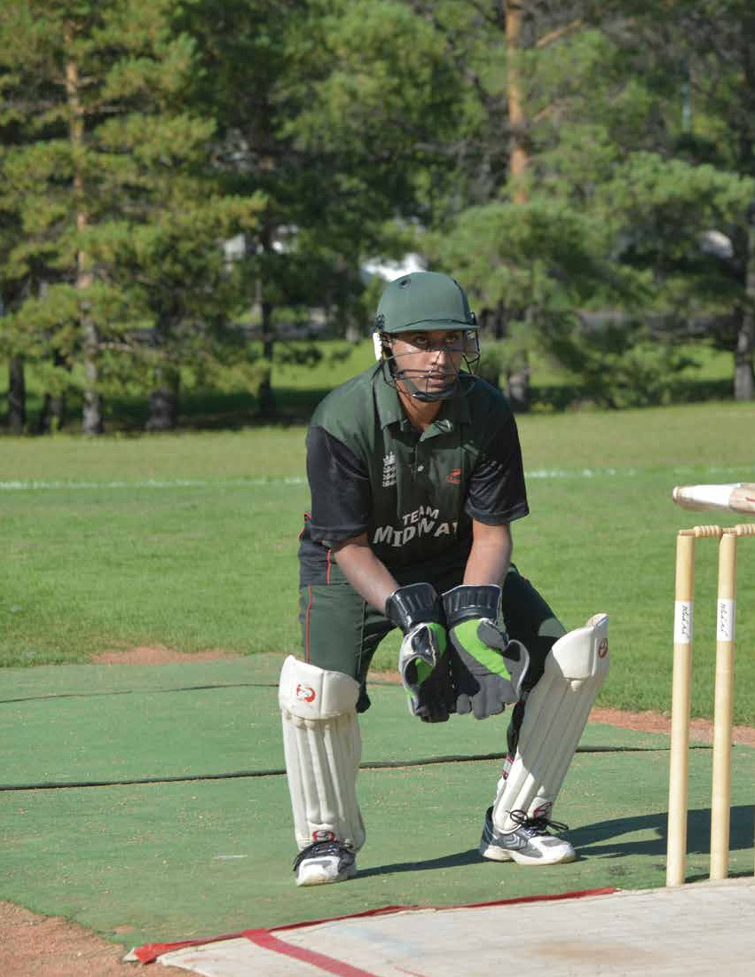
26

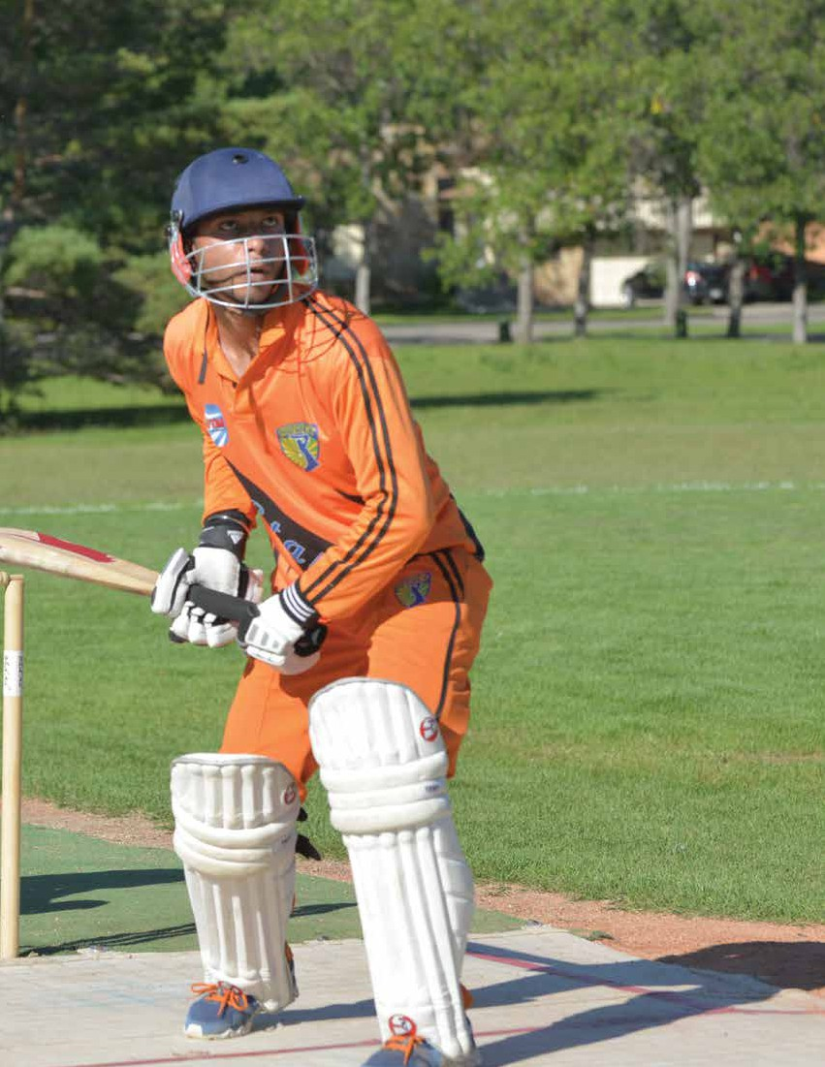

SECTION 5
Facility Inventory
27

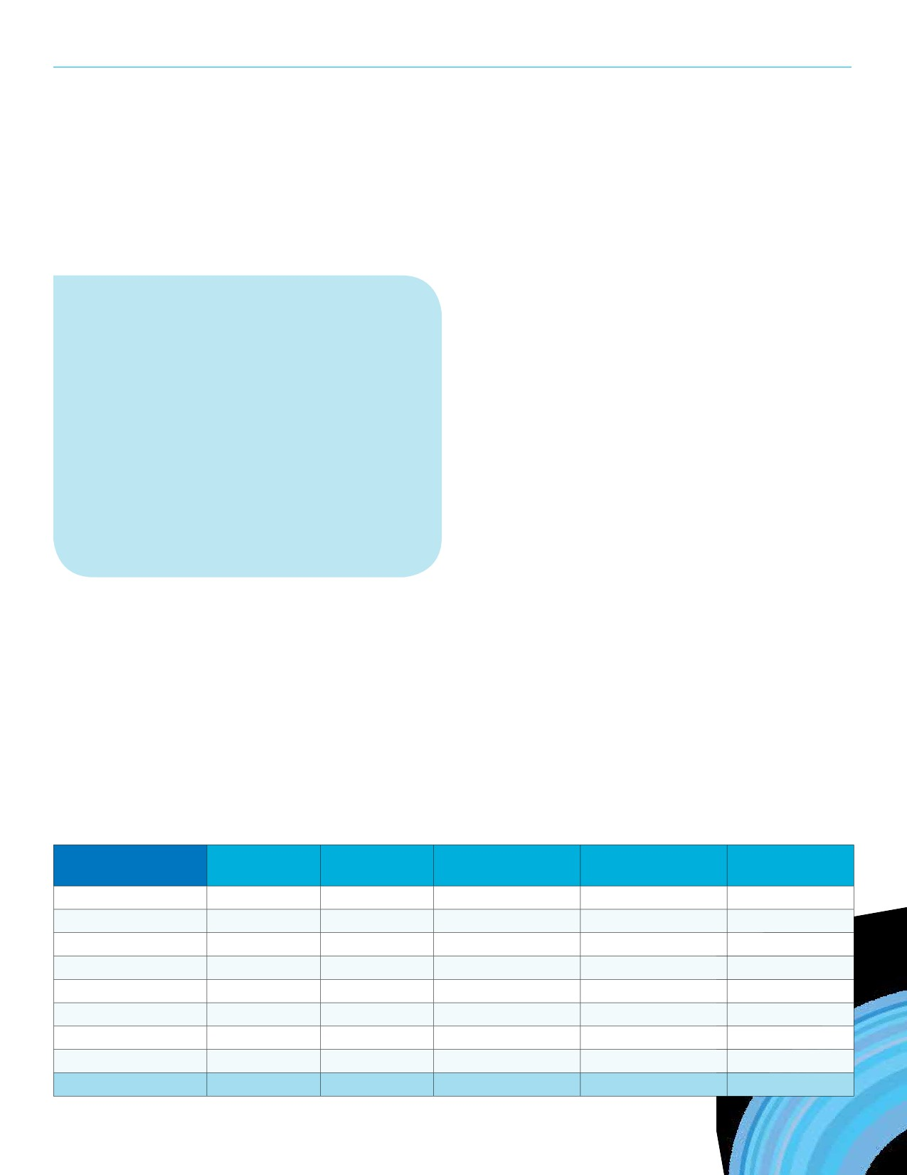REGINA RECREATION MASTER PLAN

SECTION 5
Facility Inventory

The City has a variety of recreation spaces in addition to the assets outlined in this section such as:

KEY FINDINGS FROM THIS SECTION
• Regina’s recreation spaces are aging as they
have an average age of 37 years.
• The replacement value of the City’s recreation
facilities is over $199 million; modernized
replacement value is likely beyond $377 million.
• The City invests over $8 million annually to
operate recreation facilities.
• The average age of the five outdoor swimming
pools is 64 years. Of the five pools, useful life
expectancy ranges from 1 - 5 years.

The City of Regina operates a variety of recreation facilities and support spaces, both indoor and outdoor. Before planning new facilities, it is important to know the context of the City’s existing facilities.
Overview of City Facilities
The average age of the facilities listed below is 37 years.
Collectively they have an estimated replacement value
exceeding $199M if the facilities were rebuilt to their current form. Modernized replacement values, as seen in the next column, represents the cost ($377.5M+) to rebuild Regina’s current inventory of facilities to modern standards.
• 60 outdoor rinks at 40 locations
»» Including the Speed Skating Oval & Victoria Park
• 15 picnic sites
• 40 tennis courts at 17 locations
»» 25 of the 40 courts have pickleball lines
• 163 ball diamonds
• 60 dedicated sports fields
* Note that 48 other passive park spaces throughout the City are also booked as field in some instances.
• 3 skateboard parks
»» Plus 1 skateboard pod (temporary structures)
• 1 outdoor fitness equipment location
»» 13 pieces of equipment
• 29 outdoor basketball courts
• 2 dedicated off-leash dog parks
»» Plus 5 seasonal off-leash dog areas
• Regent Par 3 Golf Course
• Variety of park spaces and natural areas for spontaneous use,
including Wascana Park

Facility Type

Number of Average Age
Facilities (in 2017)

Replacement Value Modern Annual
(As Is) Replacement Value Expenses

Aquatic Centres 3 34 $45,210,592 $100M+ $2,580,782
Ice Arenas 8 43 $56,348,704 $120M+ $2,246,506
Fieldhouses 1 30 $22,964,690 $30M+ $728,631
Arts Centres 1 35 $4,408,155 $15M+ $217,300
Community Centres 12 34 $47,042,402 $60M+ $1,902,011
Spray Pads 15 22 $3,042,342 $7.5M+ $60,820.66
Outdoor Pools 5 64 $11,048,611 $35M+ $881,247
Support Spaces 19 33 $9,004,433 $10M+ $221,281
Total 64 37 $199,069,929 $377.5M+ $8,838,579
28

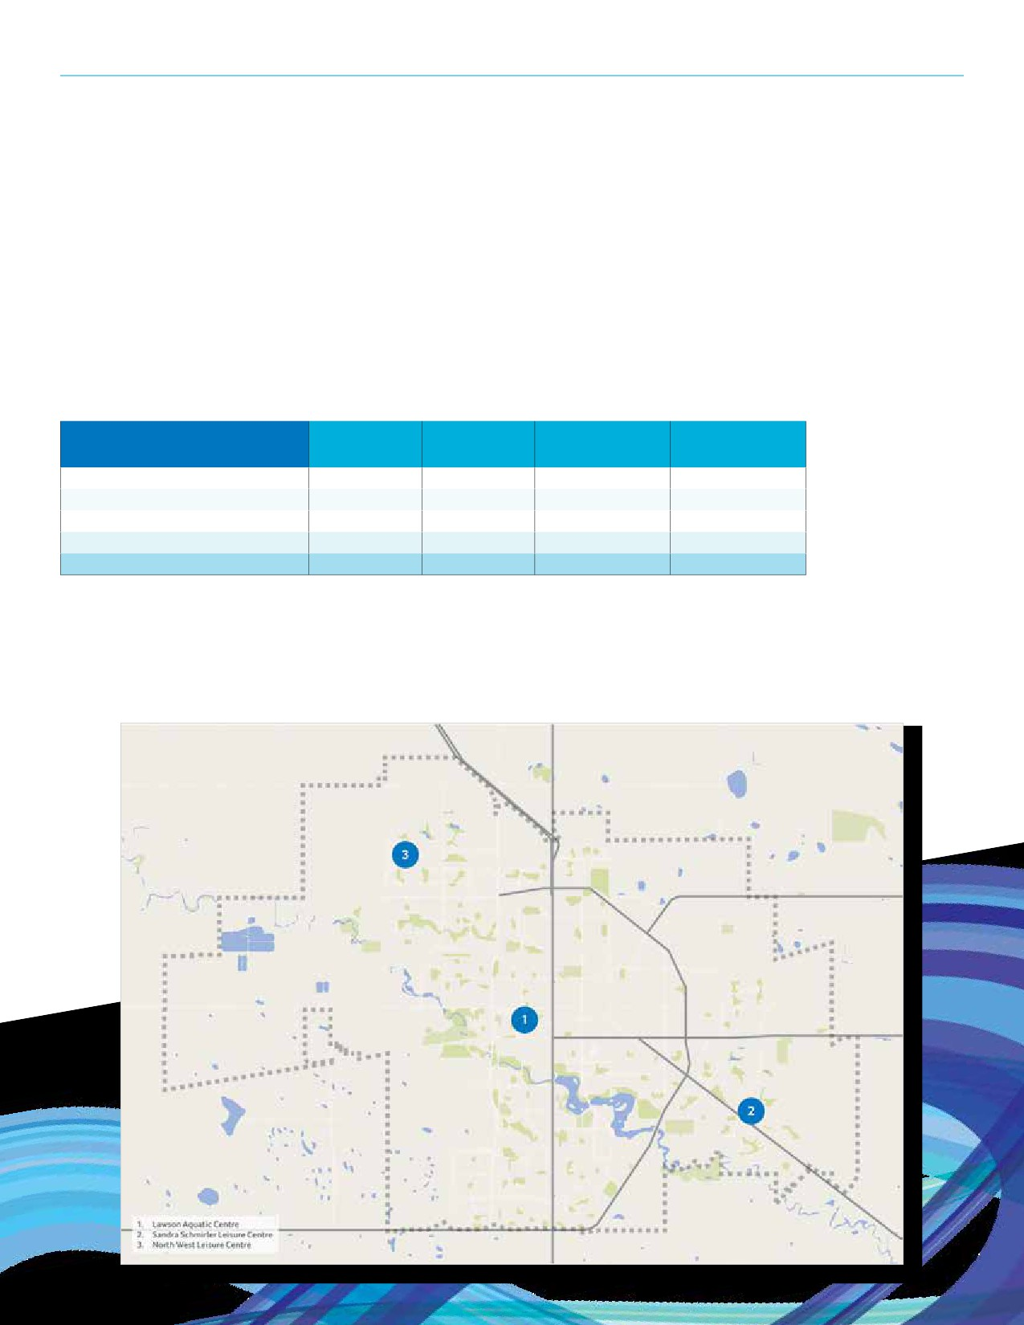SECTION 5: FACILITY INVENTORY

Aquatic Centres
The City operates three indoor aquatic centres. The Lawson Aquatic Centre is the only 50m competition pool in the region and it was built in 1975. The YMCA operates two aquatic centres; a 25 metre pool at the Downtown location and 20 and 10 metre pools at the Northwest YMCA. The University of Regina also operates a 25 metre pool.

Year Age Replacement Annual
Aquatic Centres
Constructed (in 2017) Value Expenses
Lawson Aquatic Centre 1975 42 $18,875,167 $1,050,233
Sandra Schmirler Leisure Centre 1990 27 $16,277,187 $728,952
North West Leisure Centre 1983 34 $10,058,238 $801,597
Average 1983 34 $15,070,197 $860,261
Total — — $45,210,592 $2,580,782
29

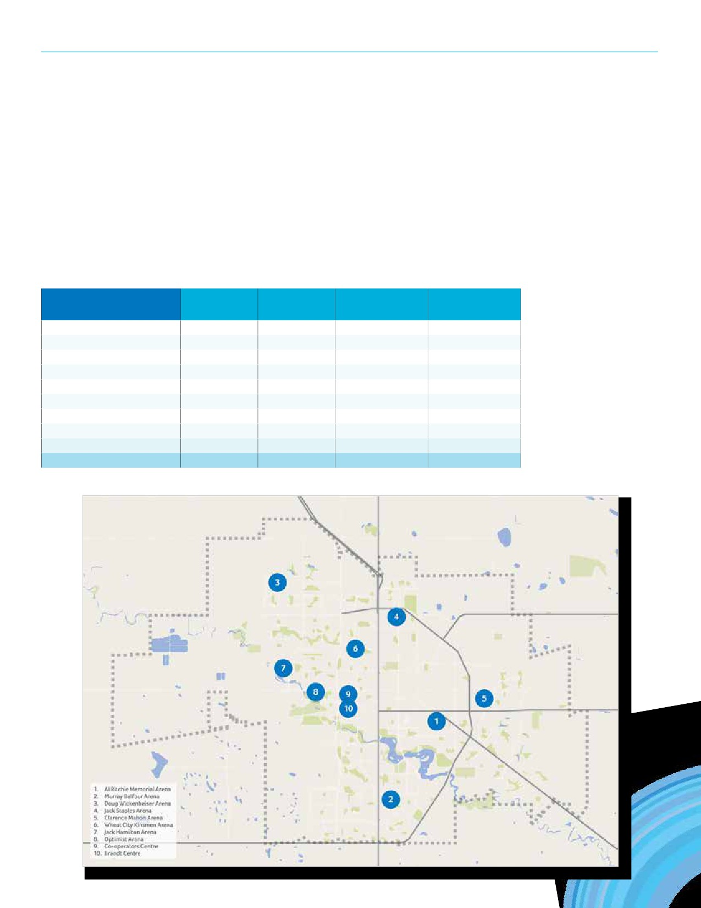REGINA RECREATION MASTER PLAN

Ice Arenas
The City operates eight standalone arenas, six of which were constructed in the 1970’s. The Co-operators Centre, operated by the Regina Exhibition Association Ltd., is the newest ice arena facility in the city and has six regulation sized ice sheets. The Brandt Centre also hosts some community use.

Ice Arenas | Year  Constructed | Age  (in 2017) | Replacement  Value | Annual  Expenses
Al Ritchie Memorial Arena | 1966 | 51 | $8,222,993 | $390,592.25
Murray Balfour Arena | 1976 | 41 | $5,577,679 | $321,506.20
Doug Wickenheiser Arena | 1989 | 28 | $9,360,261 | $284,821.18
Jack Staples Arena | 1971 | 46 | $5,565,668 | $280,301.80
Clarence Mahon Arena | 1976 | 41 | $5,386,788 | $274,288.10
Wheat CityKinsmen Arena | 1970 | 47 | $5,290,006 | $267,259.66
Jack Hamilton Arena | 1975 | 42 | $5,212,052 | $234,264.94
Optimist Arena | 1970 | 47 | $5,472,290 | $193,471.84
Average | 1974 | 43 | $6,260,967 | $280,813.25
Total | — | — | $56,348,704 | $2,246,505.97

30

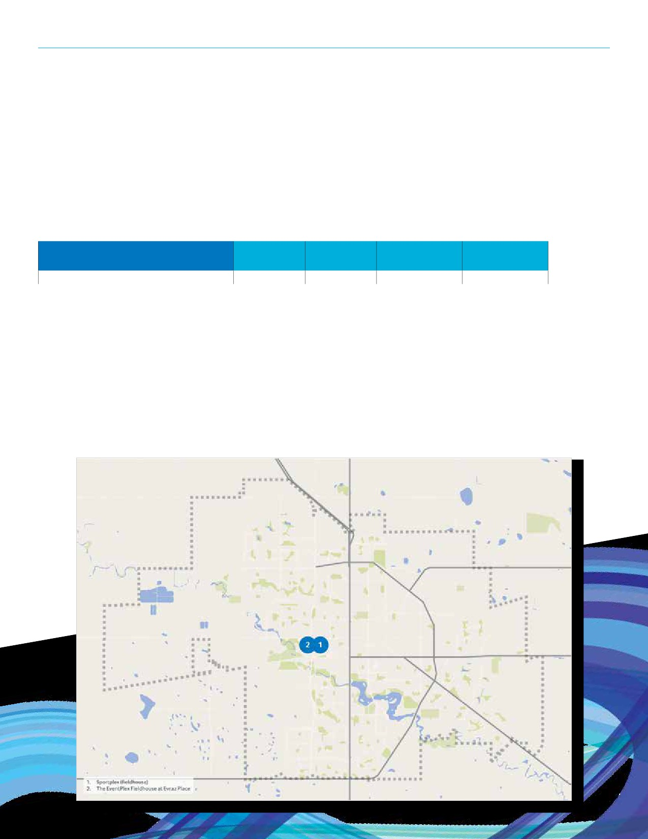SECTION 5: FACILITY INVENTORY

Fieldhouses
The Fieldhouse is a component at the Sportplex and contains a 200 metre indoor track, court space, and fitness equipment.

Fieldhouses | Year  Constructed | Age  (in 2017) | Replacement  Value | Annual  Expenses
Fieldhouse at the Sportplex | 1987 | 30 | $22,964,690 | $728,631

31

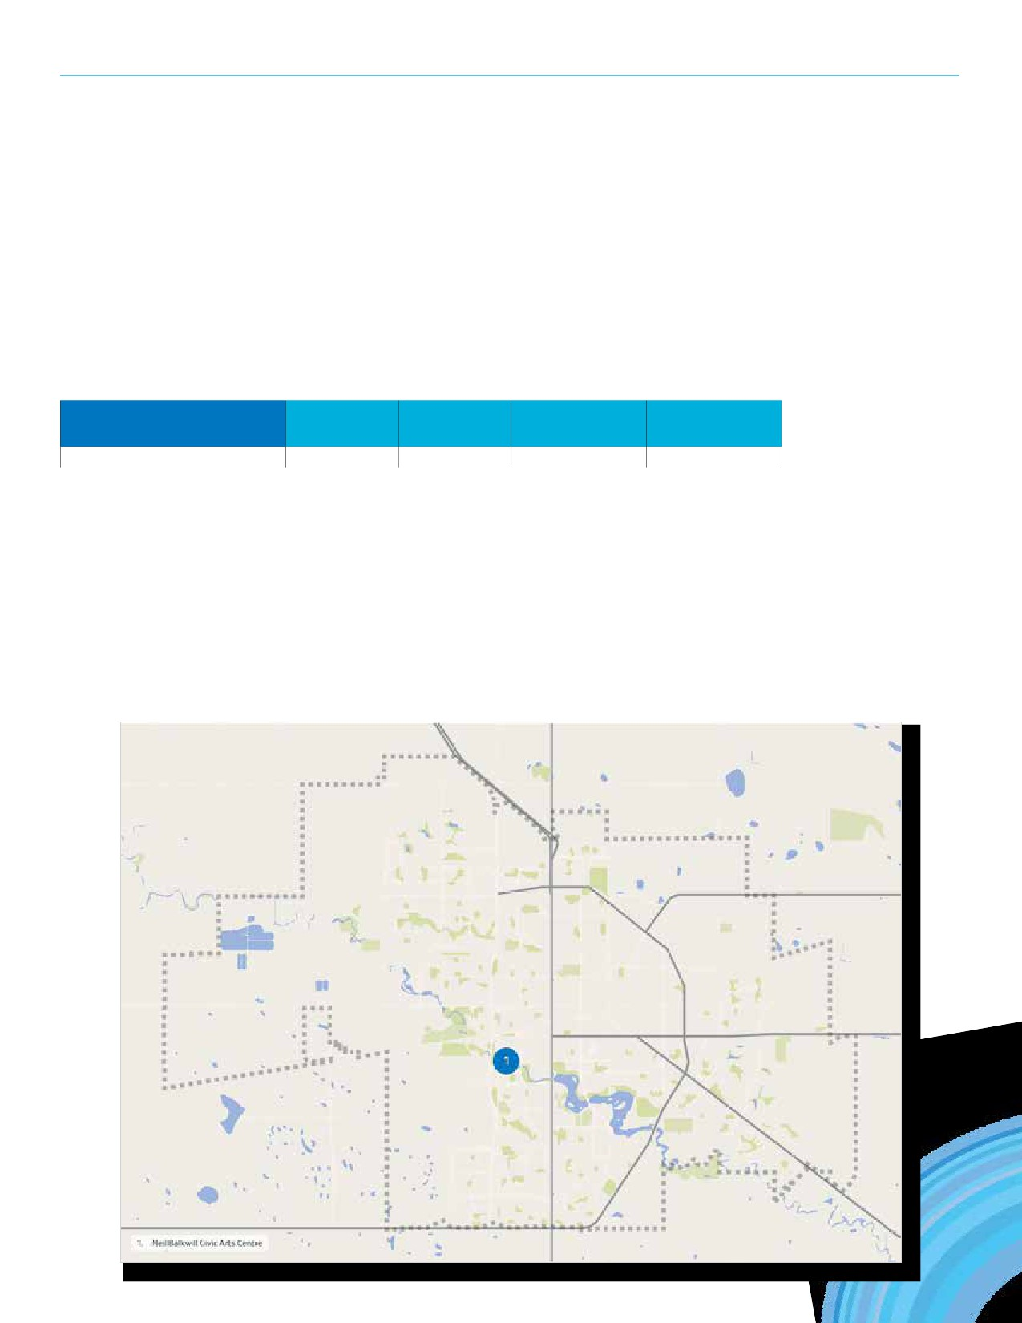REGINA RECREATION MASTER PLAN

Arts Centres
The Neil Balkwill Civic Arts Centre provides a variety of fine arts and craft programs as well as workshops and exhibition spaces. The facility is home to the Art Gallery of Regina.

Arts Centres | Year  Constructed | Age  (in 2017) | Replacement  Value | Annual  Expenses
Neil Balkwill Civic Arts Centre | 1982 | 35 | $4,408,155 | $217,300

32

SECTION 5: FACILITY INVENTORY

Community Centres
The city owns a variety of community centres, some of which are operated in partnership with Community Associations. The estimated replacement value of these facilities is estimated at over $60M.

Community Centres | Year  Constructed | Age  (in 2017) | Replacement  Value | Annual  Expenses
Regina Senior Citizens Centre | 1981 | 36 | $6,657,021 | $261,739
South Leisure Centre | 1986 | 31 | $6,114,893 | $221,469
Core Ritchie Neighbourhood Centre | 1986 | 31 | $3,764,085 | $261,184
mâmawêyatitân centre | 2017 | 0 | $8,800,000 | $641,312
Glencairn Neighbourhood Recreation Centre | 1978 | 39 | $4,161,414 | $118,692
Cathedral Neighbourhood Centre | 1984 | 33 | $3,233,734 | $193,221
Eastview Community Centre | 1993 | 24 | $2,023,323 | $66,818
Arcola East Community Centre | 2000 | 17 | $4,996,842 | $58,013
Argyle Park Community Centre | 1989 | 28 | $1,942,377 | $28,748
Rotary Senior Citizens Centre | 1979 | 38 | $602,707 | N/A*
Uplands Community Centre | 1989 | 28 | $1,871,174 | $26,455
Northeast Community Centre (Imperial School) | 1950 | 67 | $2,874,832 | $24,360
Average | 1983 | 34 | $3,920,200 | $172,910
Total | — | — | $47,042,402 | $1,902,011
* Part of Regina Seniors Citizen Centre.
33

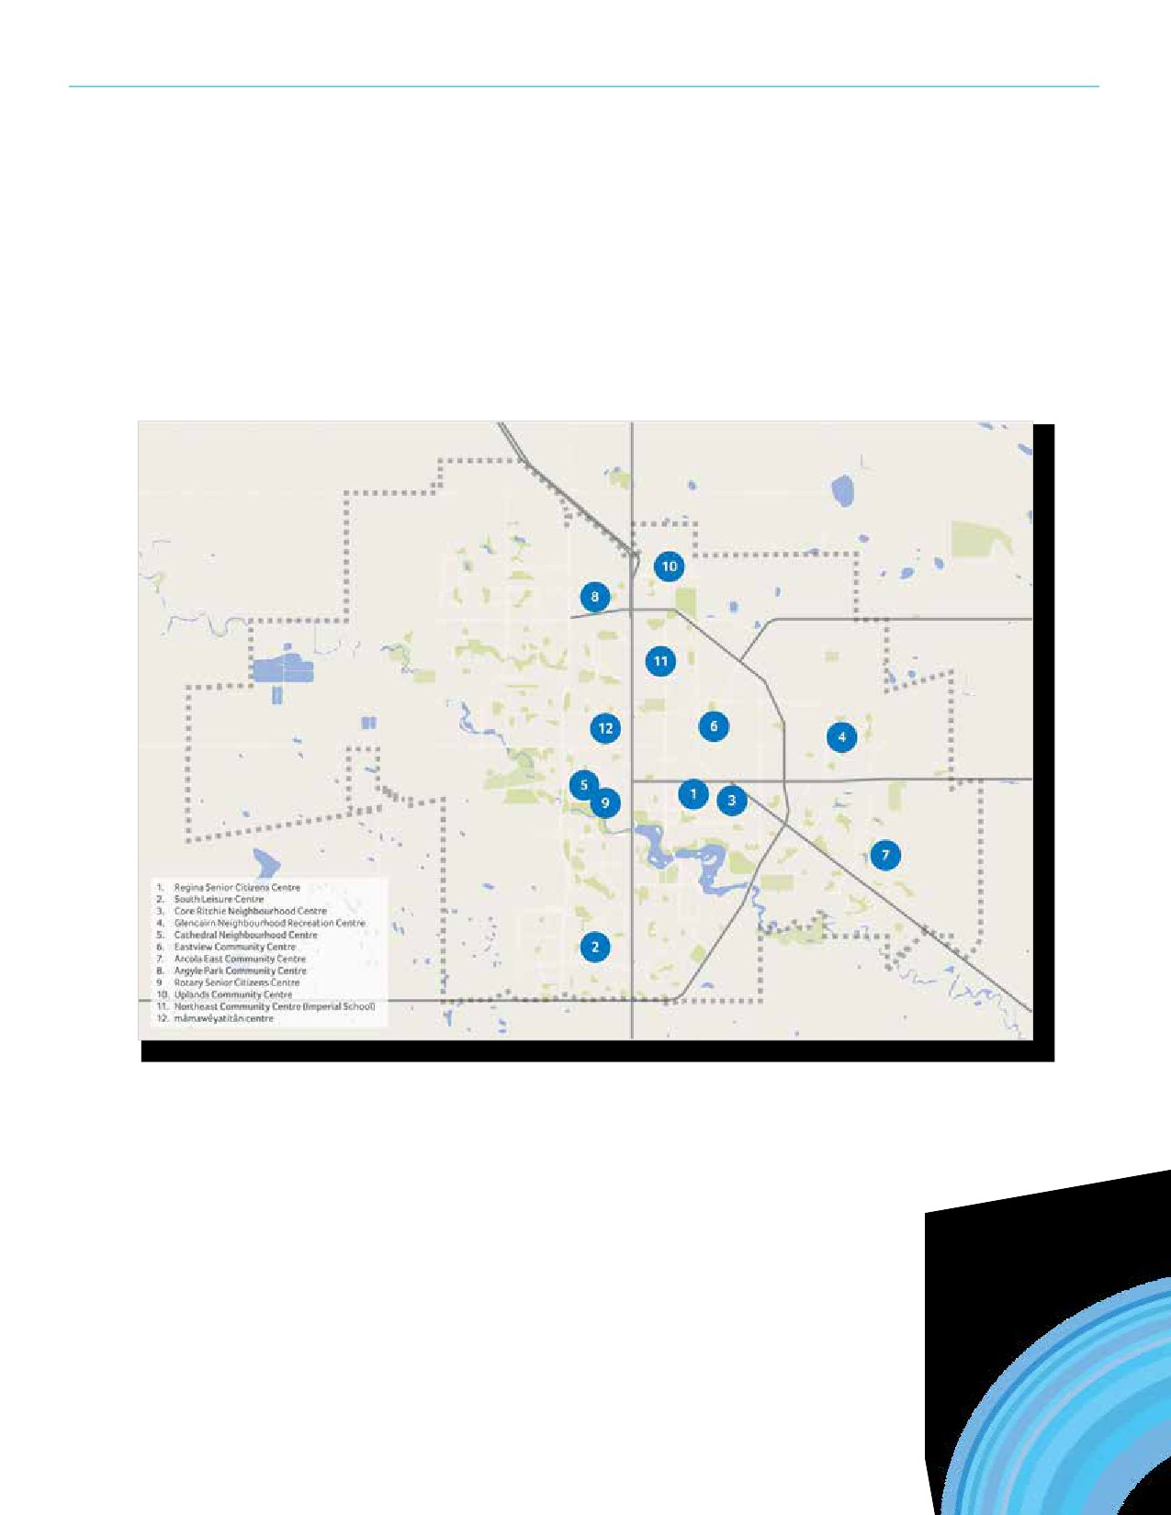REGINA RECREATION MASTER PLAN

Community Centres (Continued)
34

SECTION 5: FACILITY INVENTORY

Spray Pads
There are 15 spray parks in the City’s inventory, including four that were redeveloped in 2017.

Year Age Replacement Annual
Spray Pads
Constructed (in 2017) Value Expenses
Parkridge Park Spray Pad 2017 0 $170,000 $5,516.65
Rosemont Park Spray Pad 1950 67 $118,198.63 $4,911.54
Queen Elizabeth Park Spray Pad 1962 55 $110,819.84 $4,687.23
Maple Ridge Park Spray Pad 2017 0 $230,000.00 $4,249.03
Kinsmen Park North Spray Pad 1958 59 $106,902.73 $3,283.20
South Leisure Spray Pad 1999 18 $132,757.69 $3,243.41
Glen Elm Park Spray Pad 1960 57 $119,826.83 $3,039.95
Kinsmen Park South Spray Pad 2003 14 $279,915.00 $2,985.80
Imperial Park Spray Pad 2010 7 $153,029.96 $2,937.92
Varsity Park Spray Pad 1984 33 $81,628.22 $2,882.50
Eastview Park Spray Pad 2006 11 $104,263.27 $2,799.37
Gocki Park Spray Pad 2017 0 $230,000 $2,748.37
Rick Hansen Spray Pad 2017 0 $180,000 $2,535.69
NWLC Spray Pad 2016 1 $650,000.00 $7,500
SSLC Spray Pad 2016 2 $375,000 $7,500
Average 1995 22 $202,822.81 $4,054.71
Total — — $3,042,342.17 $60,820.66
35

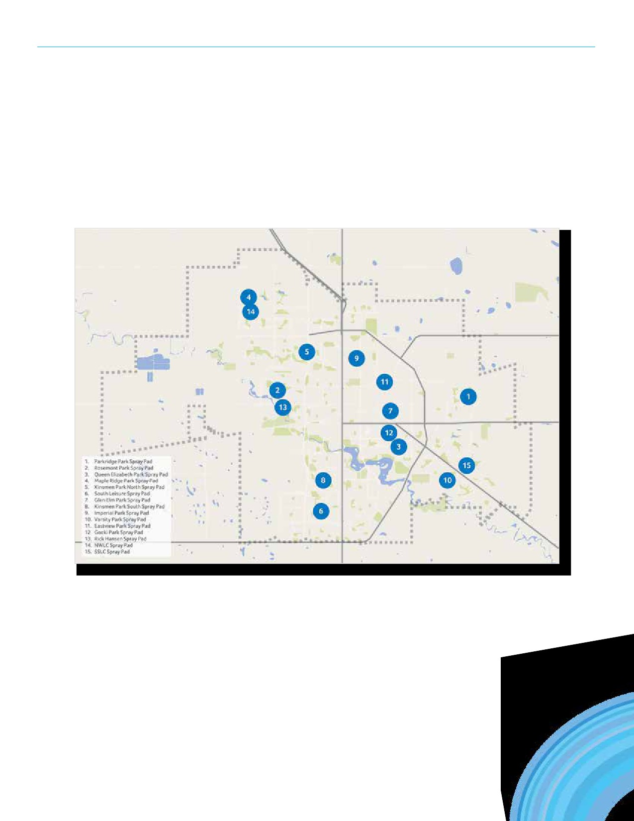REGINA RECREATION MASTER PLAN

Spray Pads (Continued)
36

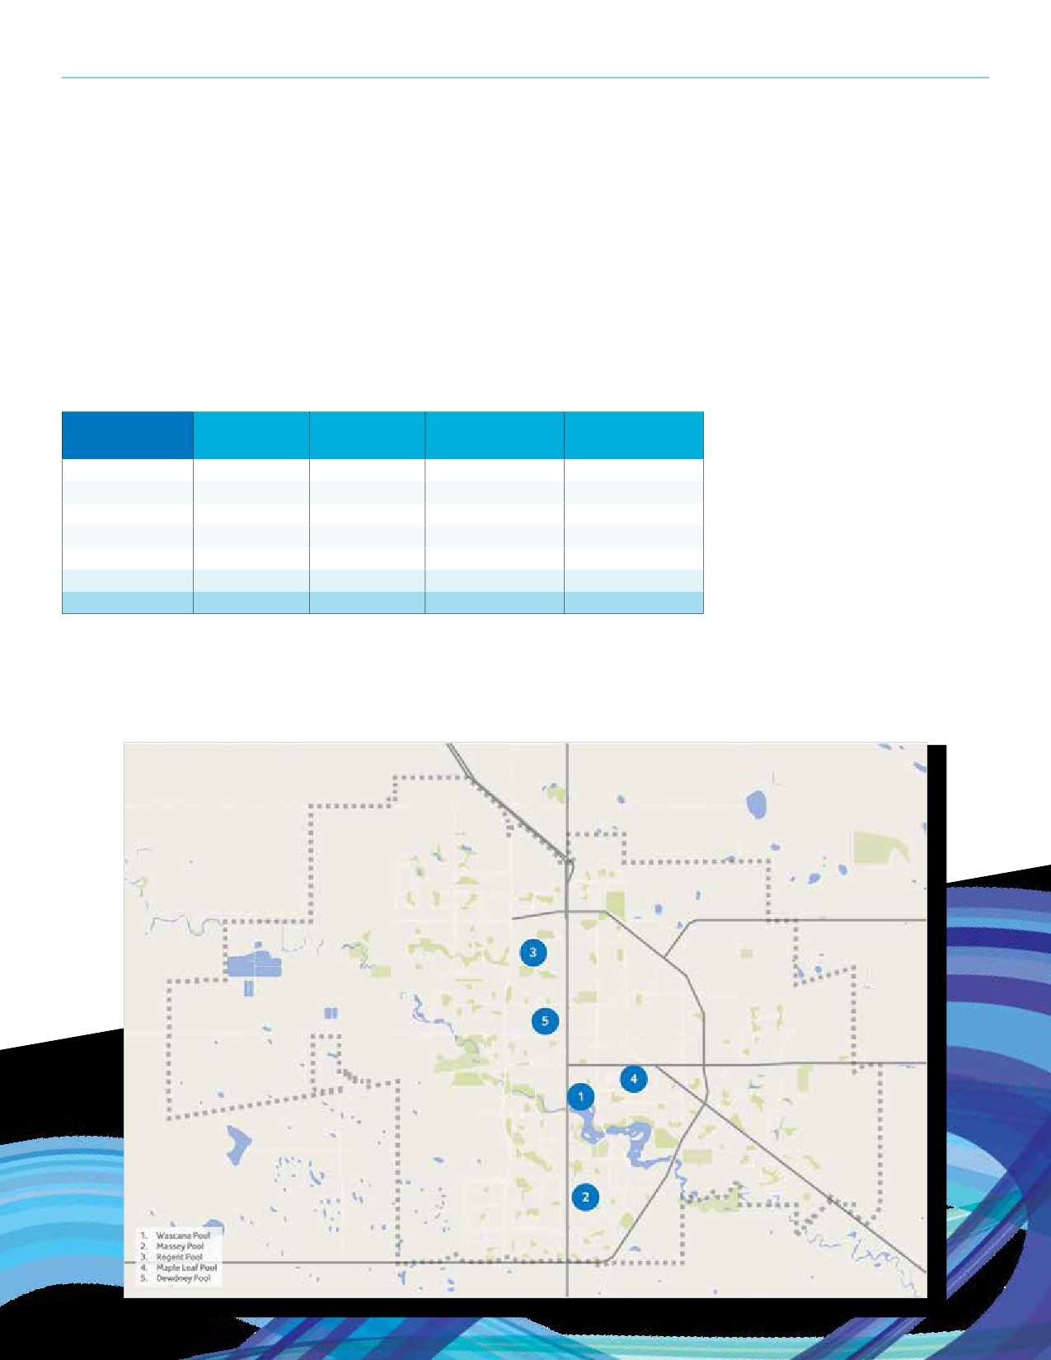SECTION 5: FACILITY INVENTORY

Outdoor Pools
The City operates five outdoor swimming pools. All of which are over 50 years of age, including three that were constructed in
the 1940’s.

Year Age Replacement Annual
Outdoor Pools
Constructed (in 2017) Value Expenses
Wascana Pool 1947 70 $2,432,410 $214,932
Massey Pool 1964 53 $2,861,810 $151,526
Regent Pool 1962 55 $2,717,395 $175,644
Maple Leaf Pool 1946 71 $1,484,047 $176,795
Dewdney Pool 1946 71 $1,552,949 $162,350
Average 1953 64 $2,209,722 $176,249
Total — — $11,048,611 $881,247
37

REGINA RECREATION MASTER PLAN

Support Spaces
A variety of support facilities are used to enhance user experience at recreation and park spaces. Annual expenses for these facilities are nearly $135,000.

Year Age Replacement Annual
Support Spaces
Constructed (in 2017) Value Expenses
Currie Field Clubhouse 1968 49 $812,875 $49,701.40
Kaplan Field Washroom Building 1978 39 $732,946 $18,069.64
Leslie Lawn Bowling Park Clubhouse 1969 48 $543,622 $12,012.05
Kaplan Field Press Box 1977 40 $156,836 $11,345.61
Rick Hanson House Washroom Building 1989 28 $407,458 $11,088.35
Regent Par 3 Golf Course Clubhouse 1965 52 $343,269 $9,097.46
Mount Pleasant Soccer Washroom Building 1977 40 $597,912 $8,306.09
Currie Field Concession Trailer 1995 22 $135,297 $3,964.56
Currie Field Press Box 2004 13 $81,669 $2,604.29
Currie Field Washroom Trailer 1995 22 $213,857 $2,237.55
Canada Games Timekeepers/Storage Building 1988 29 $284,084 $1,765.46
Kinsmen Park South Washroom Building 1960 57 $109,339 $1,589.82
Kiwanis Waterfall Park Washroom Building 1968 49 $187,416 $1,420.73
Grassick Park Washroom Building 1968 49 $124,350 $994.73
Regina Senior Citizens Centre Storage 1999 18 $88,679 $183.71
Douglas Park Storage Building (Bunker) 1974 43 $1,653,243 $120.00
Leslie Lawn Bowling Park Maintenance Building 1992 25 $31,581 $7,956.96
Douglas Park Support Facility 2015 2 $2,500,000 $78,822.72
Average 1984 33 $500,246 $12,293.40
Total — — $9,004,433 $221,281.13
38

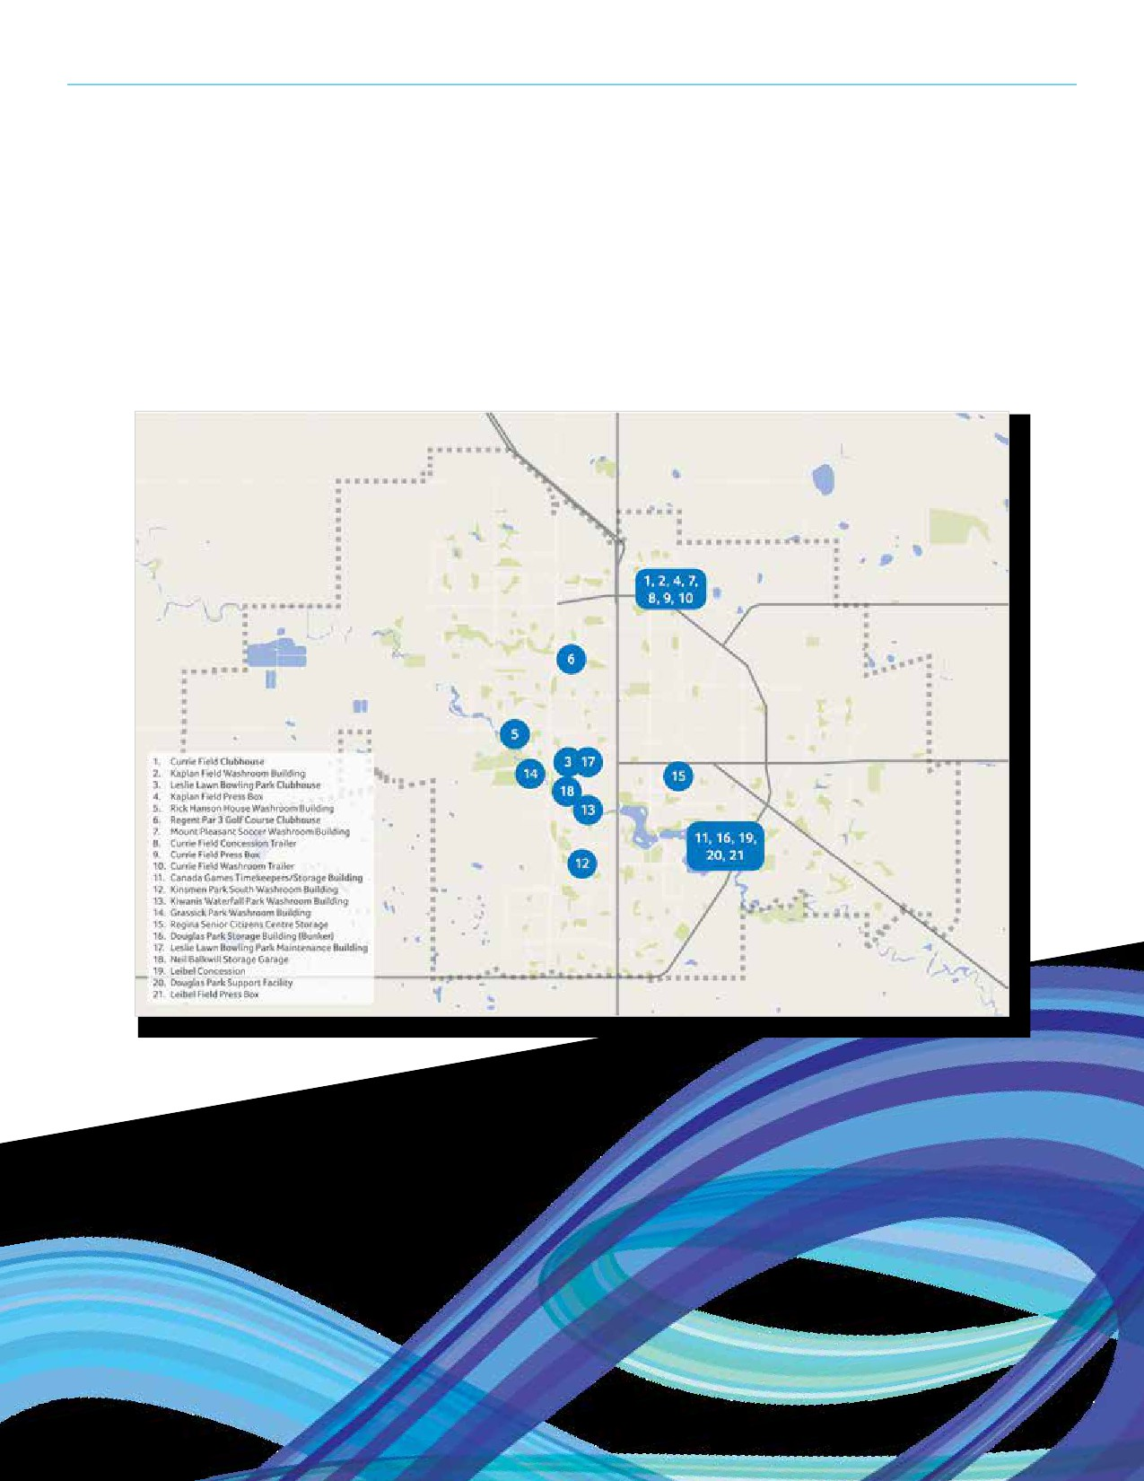SECTION 5: FACILITY INVENTORY

Support Spaces (Continued)
39

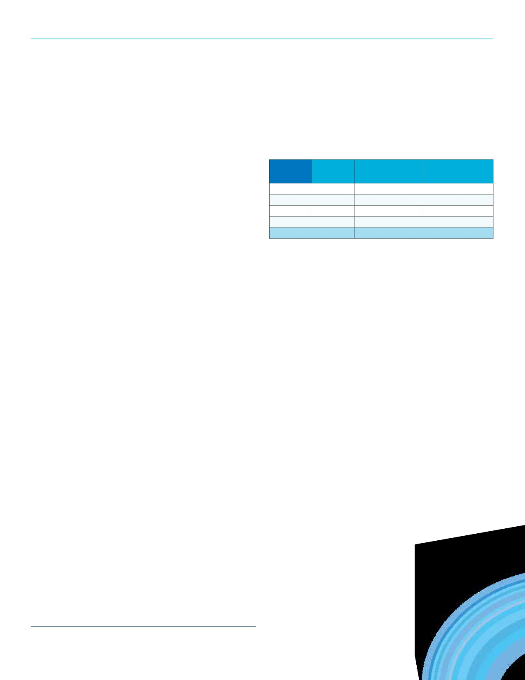REGINA RECREATION MASTER PLAN

Sports Fields
There are 60¹ sports fields in Regina’s inventory categorized
by four field classes. It is important to note that there are also

Field Number Replacement Annual
Class of Fields Value Expenses
1 3 $1,220,000 $38,200

passive park spaces (~49) throughout the City that are booked to 2A 16 $3,360,000 $151,700
field use groups for certain types of activities. The City also offers 2B 25 $4,625,000 $168,300
one artificial turf field which is not included in the table presented. 3 30 $1,014,000 $61,300
In addition to the sports fields, 163 bookable ball diamonds are Total 59 $10,219,000 $419,500
available for structured use.
Classes
Class 1
Fields that serve the entire city by supporting high level play,
at provincial or national levels, of highest development quality and
maintenance requirements, fine or artificial turf, with controlled
access and a full range of support facilities and services.

Class 2a
Supporting moderate to high level of play within the city,
good development quality, with selected support facilities or
services, located adjacent to other city or public facilities.

Class 2b
Supporting moderate to high level of play within the city, good development quality, few support services, typically located in a park or shared open space.

Class 3
Supporting locally based play, moderate to basic development
quality, usually some turf, with limited support facilities.

Class 4
Supporting neighbourhood or other local play, with basic
development, grass or granular surfacing, and no support facilities.
Passive park spaces that have been used for field activities.

1 Numbers do not include Mosaic Stadium, which the community also has
access to.
40

SECTION 5: FACILITY INVENTORY

Tennis Courts
There are 55 tennis courts in Regina’s inventory. Fourteen (14) of which are made of a synthetic surface and 41 have an
asphalt surface.

Court Number Replacement Annual
Type of Courts Value Expenses
Synthetic 14 $1,400,000 $8,300
Surface

Asphalt
• Twenty-three (23) sites with 55 courts. Surface
41 $2,365,000 $24,350

• Of the 23 sites, four have synthetic surface courts. Total 55 $3,765,000 $32,650
• In 2015 operating costs were $23,000 and in 2016 costs
were $32,670.
• Replacement costs are $110,000 for a double asphalt
court site and $200,000 for a double synthetic court site.
41

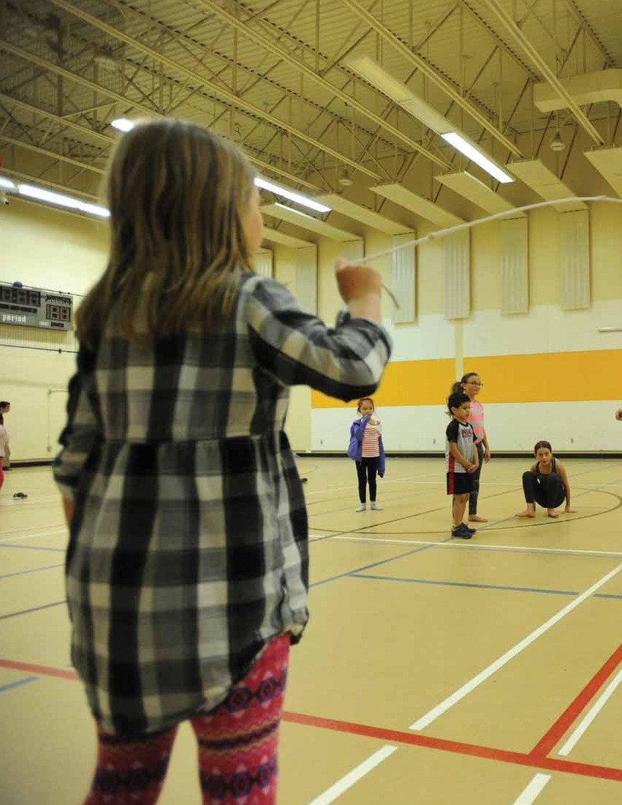
42

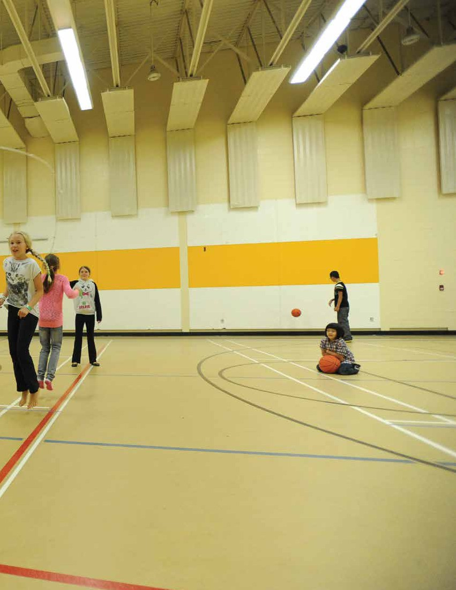

SECTION 6
Facility Utilization
43

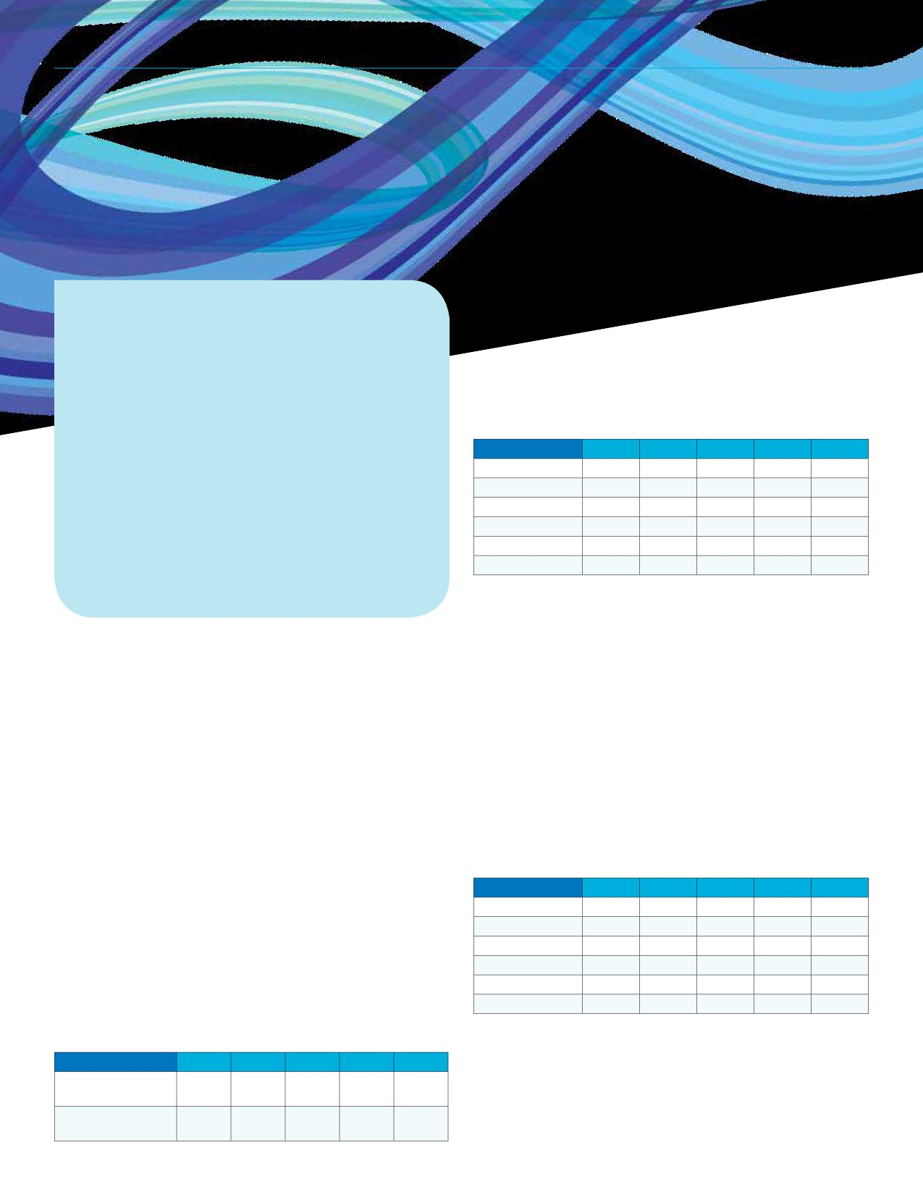REGINA RECREATION MASTER PLAN

SECTION 6
Facility Utilization

Proportion of Bulk Admission Purchases

KEY FINDINGS FROM THIS SECTION
• From 2011 to 2015, monthly/yearly leisure
pass purchases have dropped by 18%, this
trend is especially seen from young adults.
• Prime Ice utilization at City-operated facilities
is approximately 60% which suggests that these ice arenas are underutilized.
• The number of total indoor swims has remained
relatively stable over the past five years with an
average of 572,885 swims from 2011 to 2015.
• There were over 90,000 visits (total) to the City’s
five outdoor pools in 2017, 32,000 of which were free drop-in visits.
• Excess demand exists for swim lessons (wait lists).

Utilization data was gathered from a variety of recreation facilities and is presented herein. Data is recorded differently for each facility and limitations exist for some spaces, specifically spontaneous spaces that do not require bookings or user fees. Understanding existing utilization levels is important to contemplating sustaining existing service levels and also identify areas where excess demand might exist.
Leisure Passes
The Leisure Pass is a monthly pass that grants access to three of the City’s major facilities, North West Leisure Centre, Sandra Schmirler Leisure Centre, and the Sportplex, as well as outdoor pools and skating rinks.
Major Facility Leisure Pass Purchases: 2013 to 2017
The number of bulk admission purchases (10 and 20 packs) has remained stable over the past five years while monthly and yearly pass sales have declined each year. From 2013 to 2017, monthly/yearly pass purchases have dropped by 21%.
Pass Type 2013 2014 2015 2016 2017
Bulk Admission
by Age: 2013 to 2017
From 2013 to 2017 bulk admission purchases have remained
consistent. In 2017, 59% of bulk admission purchases were
made by adults and 28% percent by seniors. Over the past
couple of years, the proportion of adult bulk admissions is
decreasing while the percentage of senior’s is increasing.
Age Category 2013 2014 2015 2016 2017
Adult 66% 67% 65% 63% 59%
Senior 20% 20% 21% 24% 28%
Young Adult 5% 4% 3% 3% 3%
Youth 3% 3% 2% 2% 2%
Child 5% 4% 5% 3% 5%
Family 2% 3% 3% 3% 3%

Proportion of Monthly/Year Pass Purchases by Age: 2013 to 2017
As noted previously, the overall sales of monthly/year passes has been declining over the past five years. Although the
number of purchases in most age categories has declined,
the most significant decline has been with young adults. The
proportion of young adult monthly/year passes was 16% in
2011 before dropping to 11% in 2015, and then down to 7%
in 2017. The number of young adult passes sold in 2011 was
1,974 compared to 1,133 sold in 2015. The proportion of passes
purchased by seniors has increased, but the actual number of
passes purchased has remained stable (1,646 in 2011; 1,692
in 2015).
Age Category 2013 2014 2015 2016 2017
Adult 54% 56% 57% 57% 57%
Senior 16% 17% 17% 19% 22%
Young Adult 15% 13% 11% 9% 7%
Youth 5% 4% 4% 4% 3%
Child 1% 1% 1% 2% 1%
Family 10% 9% 10% 10% 10%
Note: Bulk admissions refers to a pass for a specific number
of admissions while the monthly and yearly passes do not
reference number of admissions but rather a time period over

Purchases
Monthly/
Year Passes
5,421 5,618 5,806 5,647 5,183
10,778 10,058 9,949 9,502 8,516
which admissions are covered. For example a bulk admission may be for 10 or 20 admissions. These admissions could be consumed with a month or over several months.
44

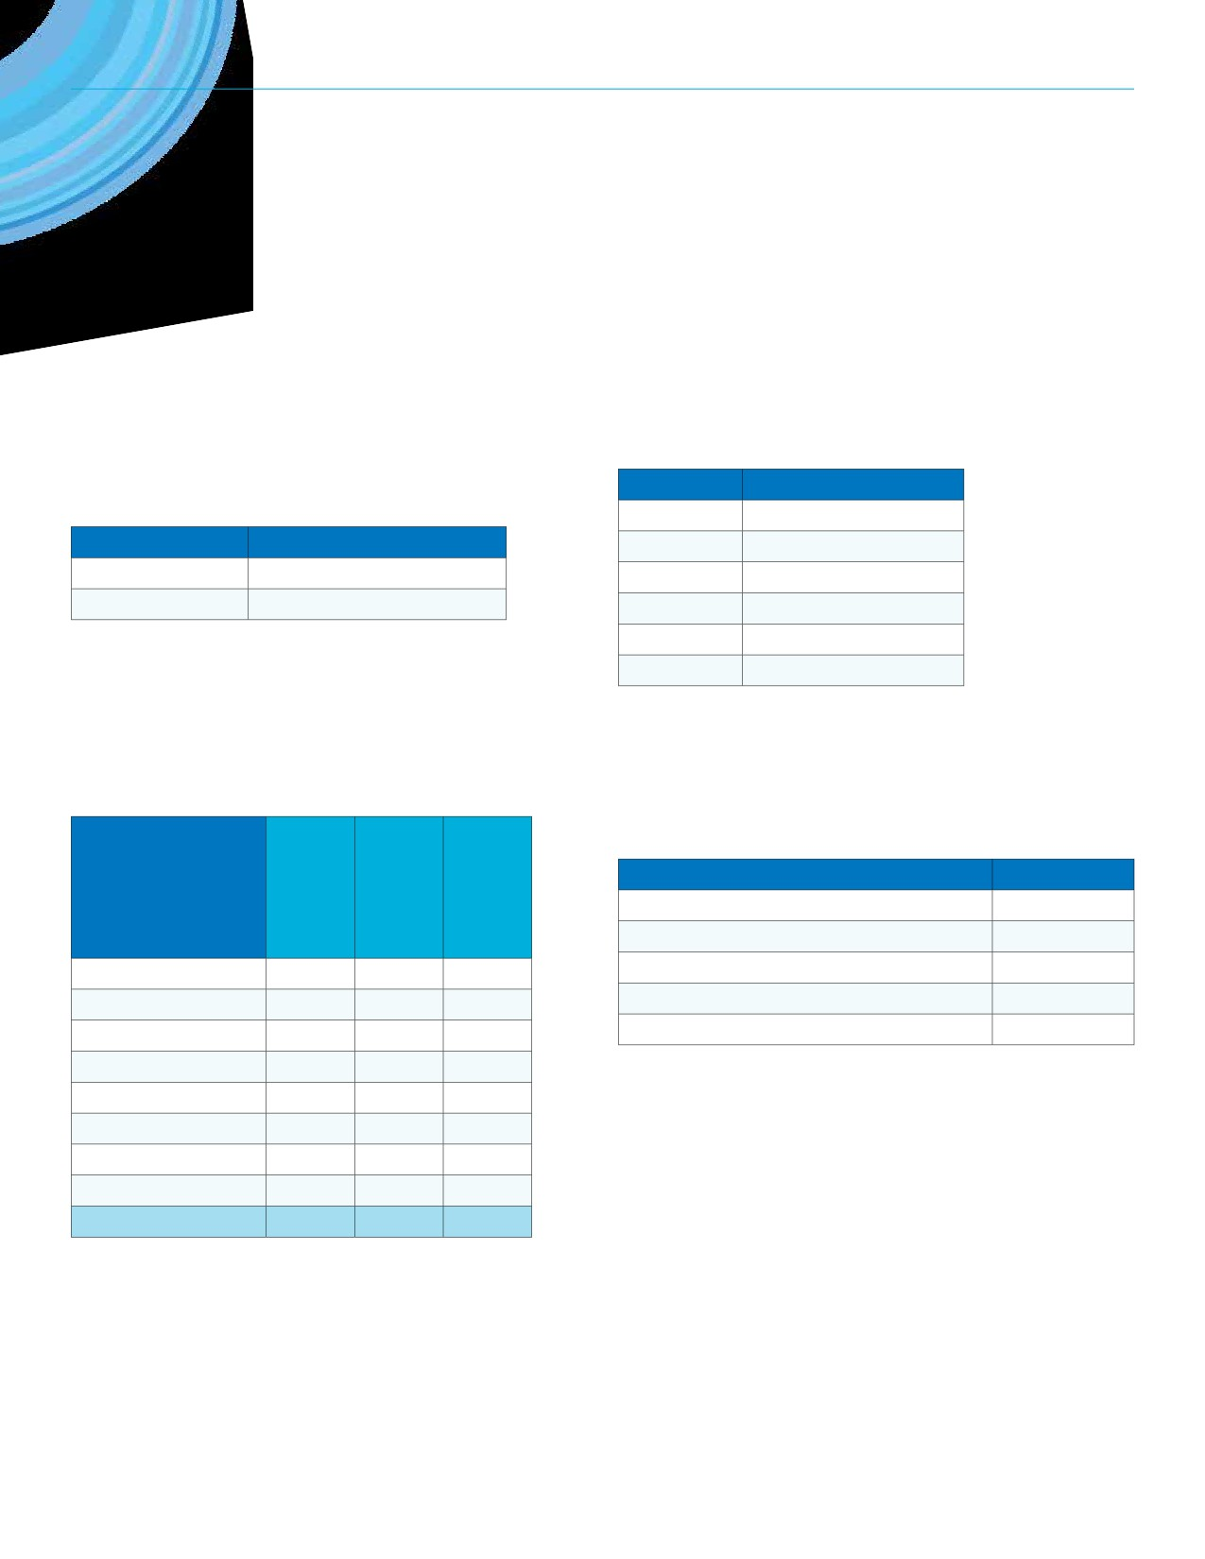SECTION 6: FACILITY UTILIZATION

Ice Arenas
Definition of Prime Ice
The City of Regina defines Prime Ice as 4:00 p.m. to 11:30 p.m. on weekdays and 7:00 a.m. to 11:30 p.m. on weekends.

Day Definition
Monday - Friday 4:00 p.m. to 11:30 p.m.
Saturday - Sunday 7:00 a.m. to 11:30 p.m.

Prime Ice Utilization: 2016 - 2017 Ice Season
During the 2016-2017 ice season, 67% of available Prime Ice was booked at City operated ice arenas. Al Ritchie
received the highest utilization rate (77%) while the Optimist experienced the lowest (52%).

Ice Arena
Al Ritchie 926 1,206 77%
Clarence Mahon 875 1,206 73%
Doug Wickenheiser 890 1,206 74%
Jack Hamilton 796 1,206 66%
Jack Staples 797 1,206 66%
Murray Balfour 829 1,206 69%
Optimist 632 1,206 52%
Wheat City Kinsmen 691 1,206 57%
Total 6,436 9,648 67%

Prime Ice Utilization: Annual Comparison
Utilization of Prime Ice has averaged 71% at City-operated arenas over the past six seasons.

Ice Season Utilization Percentage
2016 - 2017 67%
2015 - 2016 71%
2014 - 2015 69%
2013 - 2014 70%
2012 - 2013 76%
2011 - 2012 75%

Utilization Breakdown: 2017 Dry-Pad Season
Lacrosse is the primary user type during the non-ice season as Queen City Minor Box Lacrosse used 307 dry-pad hours during 2017.

User Group/Type Hours Booked
Queen City Minor Box Lacrosse 307
Sask Caribbean Canadian Association 90
FHQTC First Nations Summer Games 2017 55
Al Ritchie Community Association 8
Sask Lacrosse Association 3
45
Prime Hours
Booked
Prime Hours
Available
Utilization
Percentage

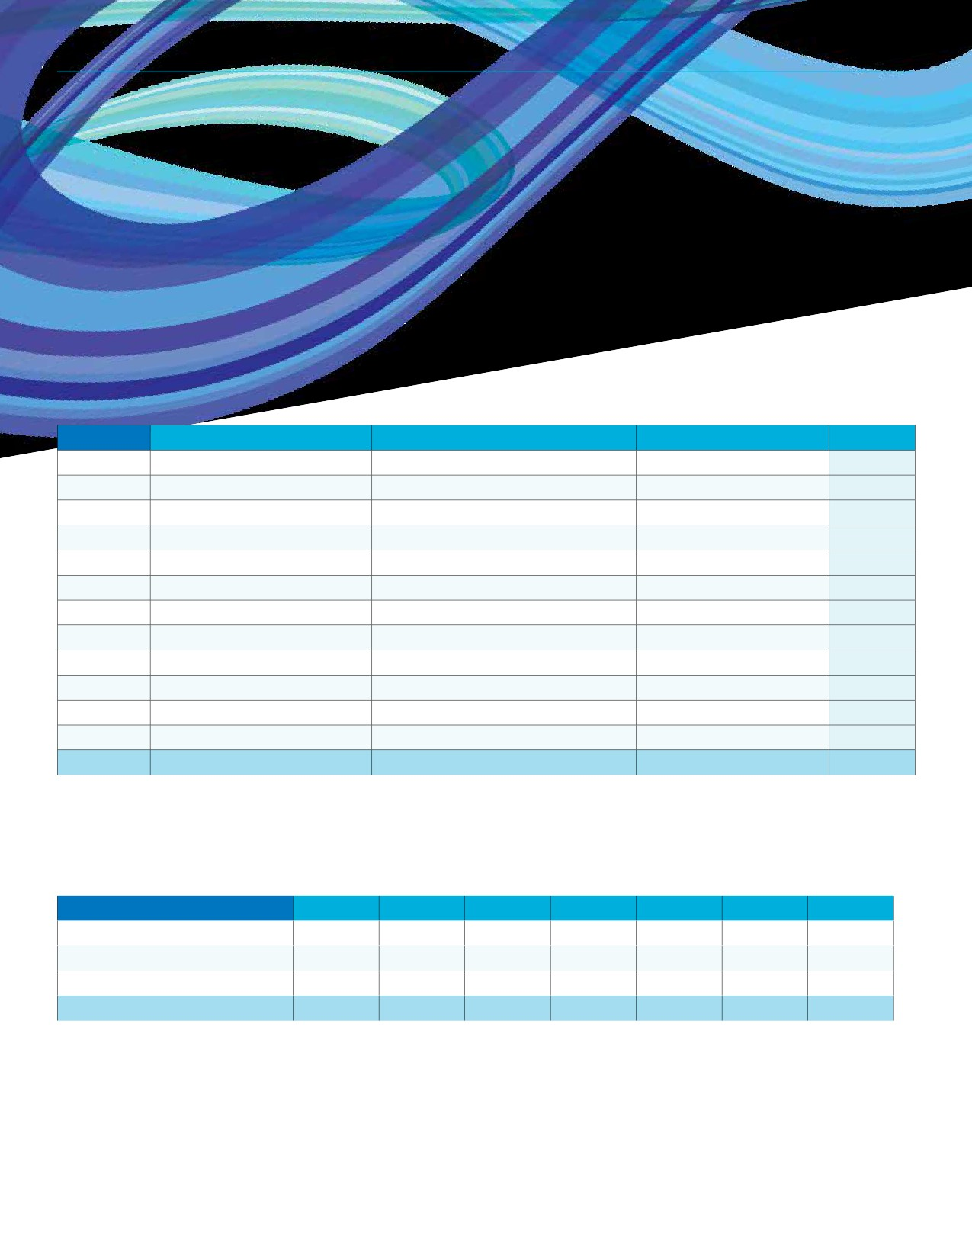REGINA RECREATION MASTER PLAN

Aquatics
Aquatics Utilization: 2017 Visitation
In 2017 there were 579,911 total swims in the City’s pools. Sandra Schmirler Leisure Centre experienced the most visits and the month of February was the busiest on average for the aquatic centres.

Facility North West Leisure Centre Sandra Schmirler Leisure Centre Lawson Aquatic Centre Total
January 15,588 21,464 21,091 59,794
February 17,779 21,673 25,321 57,405
March 13,512 22,370 22,053 67,632
April 13,512 18,376 21,657 55,455
May 13,749 19,937 22,567 51,051
June 4,605 19,198 18,386 42,798
July 3,423 14,043 15,593 38,940
August 11,488 16,008 2,664 31,888
September 12,526 18,131 3,661 42,831
October 15,687 19,739 19,676 52,049
November 12,477 18,244 21,018 52,683
December 10,326 15,114 17,255 42,618
Total 144,672 224,297 210,942 595,144

Aquatics Utilization: Annual Visitation Comparison
Over the past seven years the average amount of total swims was 577,333. The Sandra Schmirler Leisure Centre now
experiences more swims as compared to the Lawson Aquatic Centre; this was not the case in 2011 or 2012.

Facility | 2011 | 2012 | 2013 | 2014 | 2015 | 2016 | 2017
North West Leisure Centre | 141,767 | 157,643 | 128,109 | 157,152 | 155,678 | 150,462 | 147,011
Sandra Schmirler Leisure Centre | 215,941 | 218,725 | 232,821 | 230,328 | 242,108 | 233,549 | 224,297
Lawson Aquatic Centre | 219,852 | 220,751 | 187,957 | 158,233* | 197,358 | 210,649 | 210,942
Total | 577,560 | 597,119 | 548,887 | 545,713 | 595,144 | 594,660 | 582,250

* Pool closures due to air quality issues.
46

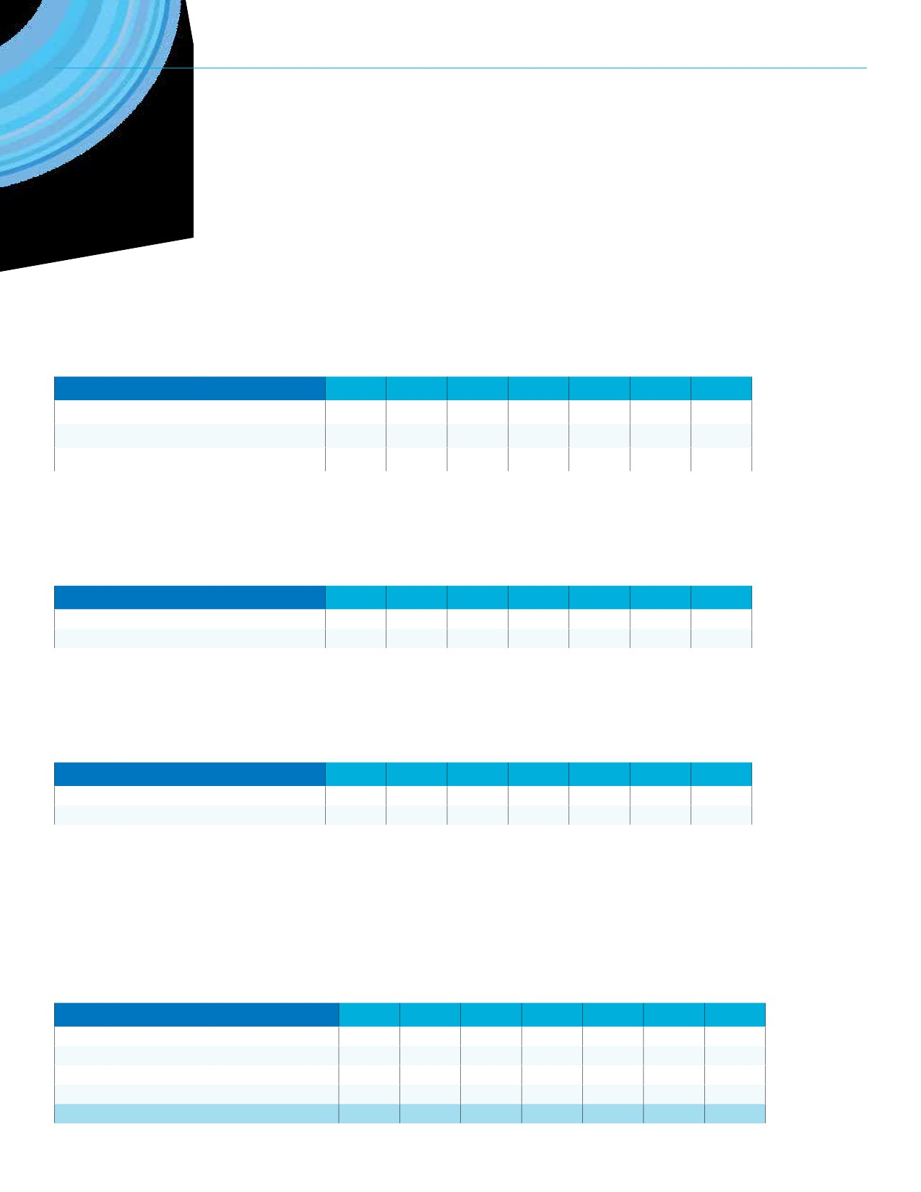SECTION 6: FACILITY UTILIZATION

Lawson Aquatic Centre
In 2016, the Lawson Aquatic Centre was rented for 7,891 hours was the most in the previous seven years. The pool was also used for City programming, both for registered and drop-in programs, for over 4,000 hours in 2015 and 2016. Rentals include pools and other bookable spaces in the facility.

Rental Activity | 2011 | 2012 | 2013 | 2014 | 2015 | 2016 | 2017
City of Regina Registered Program Use | 3,828 | 3,950 | 3,615 | 3,519 | 3,992 | 4,166 | 3,560
City of Regina Drop-in Fitness | 27 | 36 | 125 | 483 | 269 | 88 | 83
Rentals | 5,724 | 5,659 | 4,984 | 5,484 | 6,934 | 7,891 | 6,681

North West Leisure Centre
The number of hours for City of Regina Registered Program Use has remained fairly consistent from 2011 to 2017. The rental
hours include pool, gymnasium, and meeting room rentals.

Rental Activity | 2011 | 2012 | 2013 | 2014 | 2015 | 2016 | 2017
City of Regina Registered Program Use | 4,392 | 4,521 | 4,640 | 4,757 | 4,438 | 4,300 | 4,320
Rentals | 3,138 | 3,492 | 3,156 | 3,503 | 3,613 | 3,616 | 3,635

Sandra Schmirler Leisure Centre
Compared to the Lawson Aquatic Centre, the Sandra Schirmler Leisure Centre is booked less for rentals and more for registered
program use. Rentals hours include pool and multipurpose room rentals. City program use has increase every year since 2011.

Rental Activity | 2011 | 2012 | 2013 | 2014 | 2015 | 2016 | 2017
City of Regina Registered Program Use | 6,439 | 6,722 | 6,992 | 7,123 | 7,356 | 8,963 | 9,225
Rentals | 1,326 | 986 | 738 | 634 | 1,040 | 1,272 | 1,173

Sportplex Fieldhouse
Number of Hours Booked: Annual Comparison
The numbers in the accompanying chart identify booked hours for the Fieldhouse including the walking track, five badminton courts, and four tennis courts. Overall, the number of booked hours gradually increased from 2011 to 2016. In 2017, the Fieldhouse was booked for 10,098 rental hours.

Rental Activity | 2011 | 2012 | 2013 | 2014 | 2015 | 2016 | 2017
City of Regina Drop-In Fitness | 3,783 | 3,558 | 3,815 | 4,144 | 5,316 | 2,852 | 2,881
City of Regina Registered Program Use | 1,864 | 1,482 | 1,893 | 2,003 | 2,210 | 2,993 | 2,712
Court Reservations (Badminton & Tennis) | 9,986 | 10,369 | 11,813 | 11,652 | 11,712 | 12,021 | 10,422
Rentals | 5,100 | 5,171 | 5,135 | 5,170 | 4,727 | 9,630 | 10,098
Total | 20,733 | 20,579 | 22,656 | 22,969 | 23,965 | 27,496 | 26,112

47

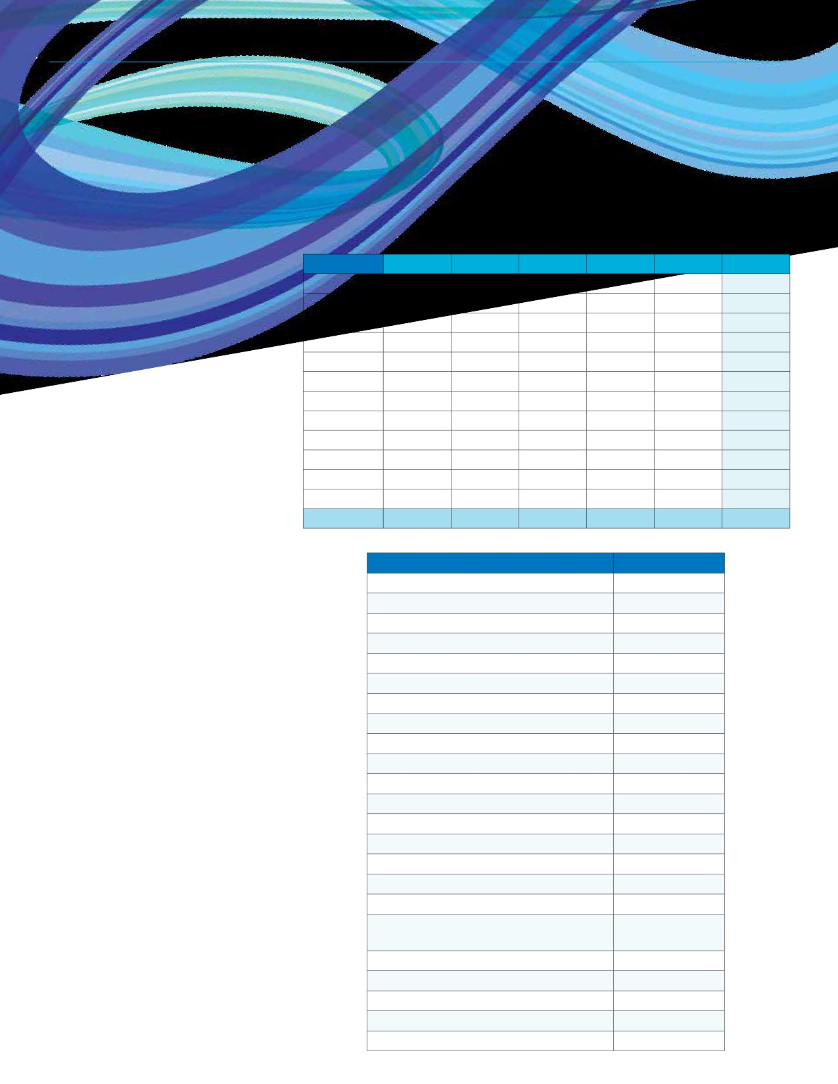REGINA RECREATION MASTER PLAN

Head Counts: Month 2013 2014 2015 2016 2017 Average
Annual Comparison January 28,288 27,576 26,179 26,986 23,489 26,504

Usage of the Fieldhouse is recorded
via head counts. The number of head
February 23,568 26,120
March 25,870 29,449
24,475 24,368 21,431 23,992
31,007 24,890 25,954 27,434

counts recorded has declined each year April 26,997 21,371 19,054 18,051 16,499 20,394

from 2013 to 2017. On average, January
through March receive the most usage
while June through August experience
the least.
May 17,336 14,912
June 8,411 8,719
July 7,323 9,497
August 9,112 8,753
13,952 13,893 13,481 14,715
9,024 8,242 7,644 8,408
8,064 6,927 7,313 7,825
9,990 9,548 8,934 9,267

September 11,568 11,431 11,473 10,998 10,268 11,148
October 16,975 16,413 15,592 16,626 14,142 15,950
November 22,046 22,308 20,993 19,902 19,026 20,855
December 20,855 20,797 18,615 17,789 16,437 18,899
Total 218,349 217,346 208,418 198,220 184,618 219,351

Utilization Breakdown: User Group Hours Booked
2017 Fieldhouse Excel Athletika 1,594
Hours Booked Tennis Saskatchewan 1,041

Excel Athletika was the group that
booked the Fieldhouse the most in 2017
with 1,594 hours followed by Tennis
Saskatchewan (1,041) Saskatchewan
Team Handball (1,034). Organizations
with over 25 hours of Fieldhouse
bookings are displayed in the adjacent
chart.
Sask Team Handball 1,034
Saskatchewan Triathlon Assoc Corp 201
Mosaic Potash Belle Plaine 172
Regina Y Judo Club 151
Saskatchewan Powerlifting Association 137
Sundown Optimist Tennis Club 112
UofR Track and Field Club 94

Independent Soccer Club Incorp. 91
Jaleta Pacers Running Club 84
Wascana Racing Canoe Club 77
Wascana Rhythmic Gymnastics Club 75
Pile of Bones Tennis 72
Special Olympics Regina 61
Regina Thunder Football Club 60
Sask Fencing Assoc 58

Canada West Track & Field Championships
34

Sask Taekwon-Do Federation 33
Sask Brazilian Jiu Jitsu Fed. 32
Church of Jesus Christ Latter Day Saints 30
Best of the West Cheerleading 29
Synchro Saskatchewan 26
48

SECTION 6: FACILITY UTILIZATION

Neighbourhood Centres
Neighbourhood Centre Utilization: 2017 Booked Hours
The Mâmawêyatitân Centre was booked for 17,374 hours and the Albert Scott Community Centre was rented for 9,527 hours.

Facility | Hours Booked
Albert Scott Community Centre | 9,527
Cathedral Neighbourhood Centre | 6,348
Core Ritchie Neighbourhood Centre | 9,299
Glencarin Recreation Centre | 6,282
mâmawêyatitân centre | 17,374
South Leisure Centre | 6,773
Total | 55,603

Arts Centres
Arts Centre Utilization: 2017 Booked Hours
The City conducted 3,396 hours of programming at the Neil Balkwill Civic Arts Centre in 2017.

Facility City of Regina Program Hours
Neil Balkwill Civic Arts Centre 3,396
49

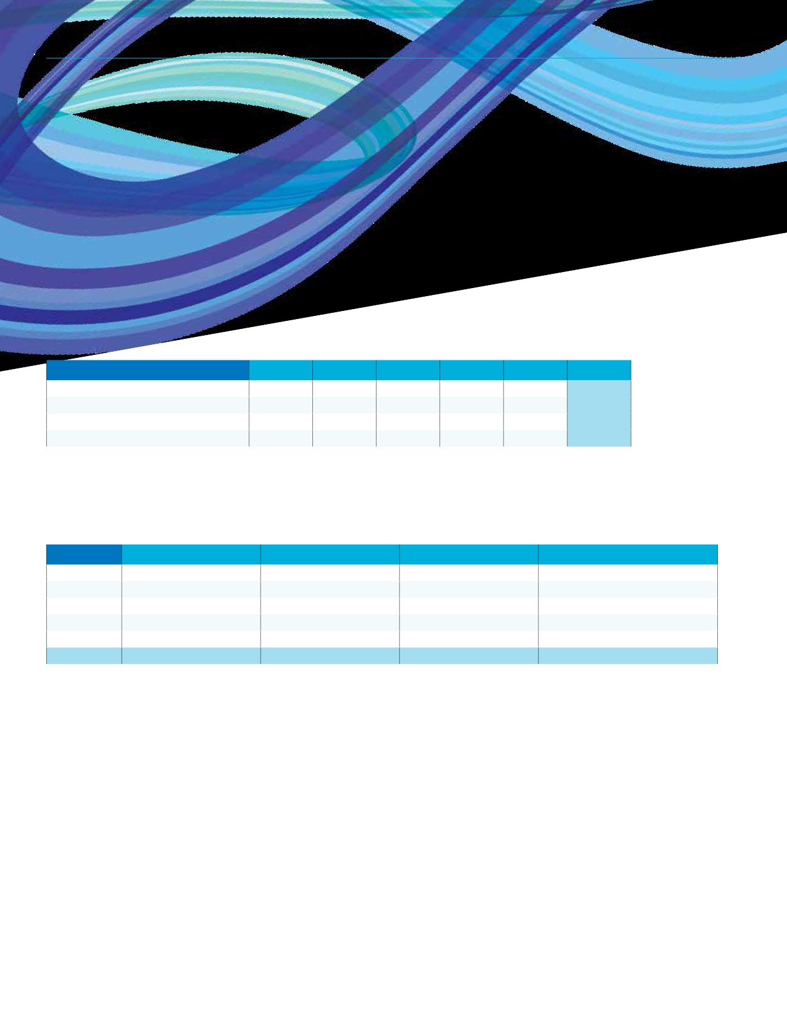REGINA RECREATION MASTER PLAN

Sports Fields
User Groups Averaging Over 1,000 Booked Hours Annually
The Regina Soccer Association, Regina Minor Football, Saskatchewan Cricket Association, and the Regina Rec League are the largest sport field user groups. Regina Minor Football has averaged over 8,000 hours over the past five years including 12,744 booked hours in 2017.

User Group | 2013 | 2014 | 2015 | 2016 | 2017 | Average
Regina Minor Football | 7,059 | 7,886 | 6,801 | 7,046 | 12,744 | 8,307
Regina Cricket Association | 1,840 | 1,648 | 3,014 | 2,884 | 4,536 | 2,784
Regina Soccer Association | 2,701 | 2,734 | 2,733 | 2,538 | 2,288 | 2,599
Regina Rec League | 1,896 | 1,798 | 1,284 | 1,686 | 1,159 | 1,565

Hours Booked by Field Classification in 2017
Forty-two percent (42%) of the fields are Class 1, 2A, and 2B fields; these fields accommodated 15% of booked hours in 2017. As
shown in the chart, 50% of booked hours were scheduled at Class 3 fields in 2017.

Field Class | Number of Fields | Percentage of Fields | Booked Hours in 2017 | Percentage of Booked Hours
1 | 5 | 4% | 1,763 | 4%
2A | 16 | 14% | 2,649 | 6%
2B | 26 | 23% | 2,367 | 5%
3 | 30 | 27% | 22,626 | 50%
4 | 35 | 31% | 16,282 | 36%
Total | 112 | 100% | 45,687 | 100%

Note: Typically, facilities such as ball diamonds and sport fields are booked by sport user groups for an entire season. This is the reason for the high number of hours reported in the tables above. While there may be unused times at these types of facilities, due to the
nature of these season long bookings, we do not know for certain the amount of unused time available at these facilities. However, through the consultation process these organizations have shared information on current usage and participation trends related to their sports, which has been used to inform the recommendations in the Recreation Master Plan.
50

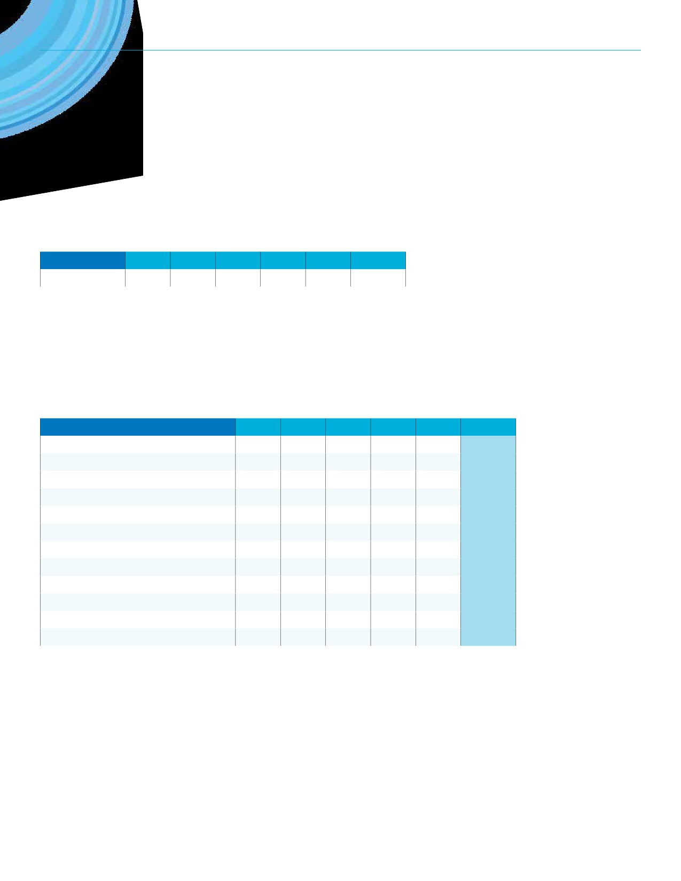SECTION 6: FACILITY UTILIZATION

Total Hours Booked: Annual Comparison 2013 - 2017
On average from 2013 to 2017, the sports fields were booked for 26,192 hours.

Field | 2013 | 2014 | 2015 | 2016 | 2017 | Average
All Sports Fields | 22,861 | 22,030 | 24,243 | 27,402 | 34,423 | 26,192

Ball Diamonds
User Groups Averaging Over 1,000 Booked Hours Annually
Twelve user groups have averaged over 1,000 hours of ball diamond bookings over the past five years. Baseball Regina has
averaged 16,613 booked hours, followed by Regina Rec League (9,471), Regina Minor Softball (7,715), and North Regina Little
League (6,072).

User Group | 2013 | 2014 | 2015 | 2016 | 2017 | Average
Baseball Regina | 15,407 | 15,619 | 17,931 | 17,755 | 16,351 | 16,613
Regina Rec League | 8,664 | 9,505 | 9,917 | 9,539 | 9,732 | 9,471
Regina Minor Softball | 4,099 | 9,324 | 9,607 | 6,468 | 9,079 | 7,715
North Regina Little League | 6,003 | 6,639 | 4,899 | 6,399 | 6,421 | 6,072
Regina Ladies Softball | 3,202 | 3,340 | 5,752 | 5,592 | 5,560 | 4,689
Kiwanis National Little League | 2,685 | 3,426 | 3,402 | 3,855 | 3,792 | 3,432
Great Western Rambler Park Slow-Pitch | 2,924 | 2,535 | 2,149 | 2,157 | 2,228 | 2,399
Regina Optimist Baseball Association | 1,265 | 1,761 | 2,966 | 2,228 | 2,209 | 2,086
Charity Mixed Modified Softball League | 1,581 | 1,421 | 1,675 | 1,209 | 1,515 | 1,480
Central Fun Ball League | 1,130 | 1,305 | 1,714 | 1,441 | 1,732 | 1,464
South Zone Recreation Board | 1,538 | 1,334 | 1,473 | 1,504 | 1,398 | 1,449
North West Sports Association | 919 | 971 | 1,220 | 1,079 | 1,095 | 1,057

Note: Typically, facilities such as ball diamonds and sport fields are booked by sport user groups for an entire season. This is the reason for the high number of hours reported in the tables above. While there may be unused times at these types of facilities, due to the
nature of these season long bookings, we do not know for certain the amount of unused time available at these facilities. However, through the consultation process these organizations have shared information on current usage and participation trends related to their sports, which has been used to inform the recommendations in the Recreation Master Plan.
51

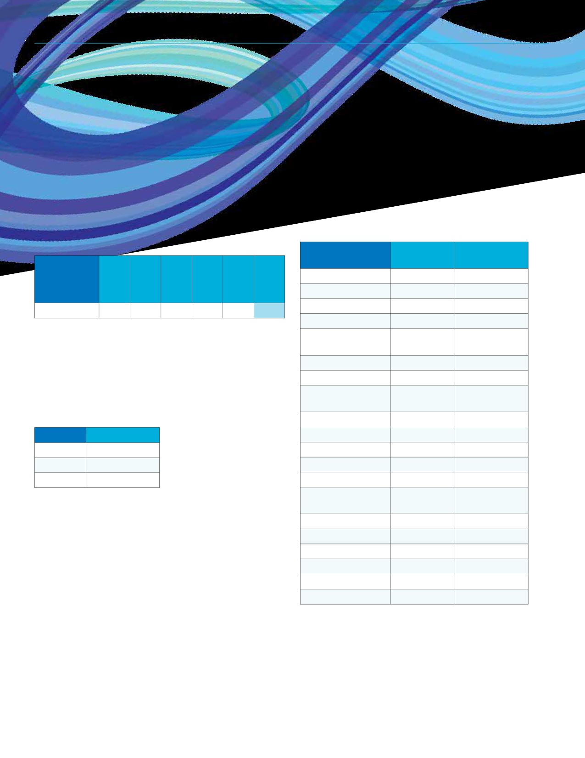REGINA RECREATION MASTER PLAN

Total Hours Booked:
Annual Comparison 2013 - 2017
On average from 2013 to 2017, the ball diamonds were booked for 66,872 hours. Booked hours have increased by 25% over these five years.

Twenty outdoor rinks were booked at least once during the 2015/2016 season. Fairchild Park was booked the most (1,141 hours) followed by McMurchy Park with 501 booked hours. The majority of usage at outdoor rinks is unscheduled, therefore bookings does not reflect overall usage.

Number of Number of

Location
Bookings Hours Booked

Fairchild Park 99 1,141

Diamond
All Diamonds 56,968 67,322

70,493 68,576 71,000 66,872
McMurchy Park 119 501
Lakeview Park 119 389

Outdoor Rinks, Outdoor Pools,
Tennis Courts, and Picnic Sites
Outdoor Rinks: 2017/2018 Bookings
Over the past three years, the number of booked hours and outdoor ice rinks have increased.
Dr. AE Perry School
Marion McVeety
School
University Park
WF Ready School
Wilfrid Walker
School
WH Ford School
120 382
110 330
110 330
110 330
110 330
55 165

Year Booked Hours Gocki Park 25 68
2015 3,892 Rosemont School 11 36
2016 5,147 Leslie Park 13 34
2017 5,482 Imperial School 11 33

Grassik Park
Playground
10 29

Eastview Park 9 23
Glen Elm School 9 23
Stan Oxelgren Park 10 10
Ruth M Buck School 1 5
McNab Park 1 4
Mike Badham Park 3 3
52
2013
2014
2015
2016
2017
Average

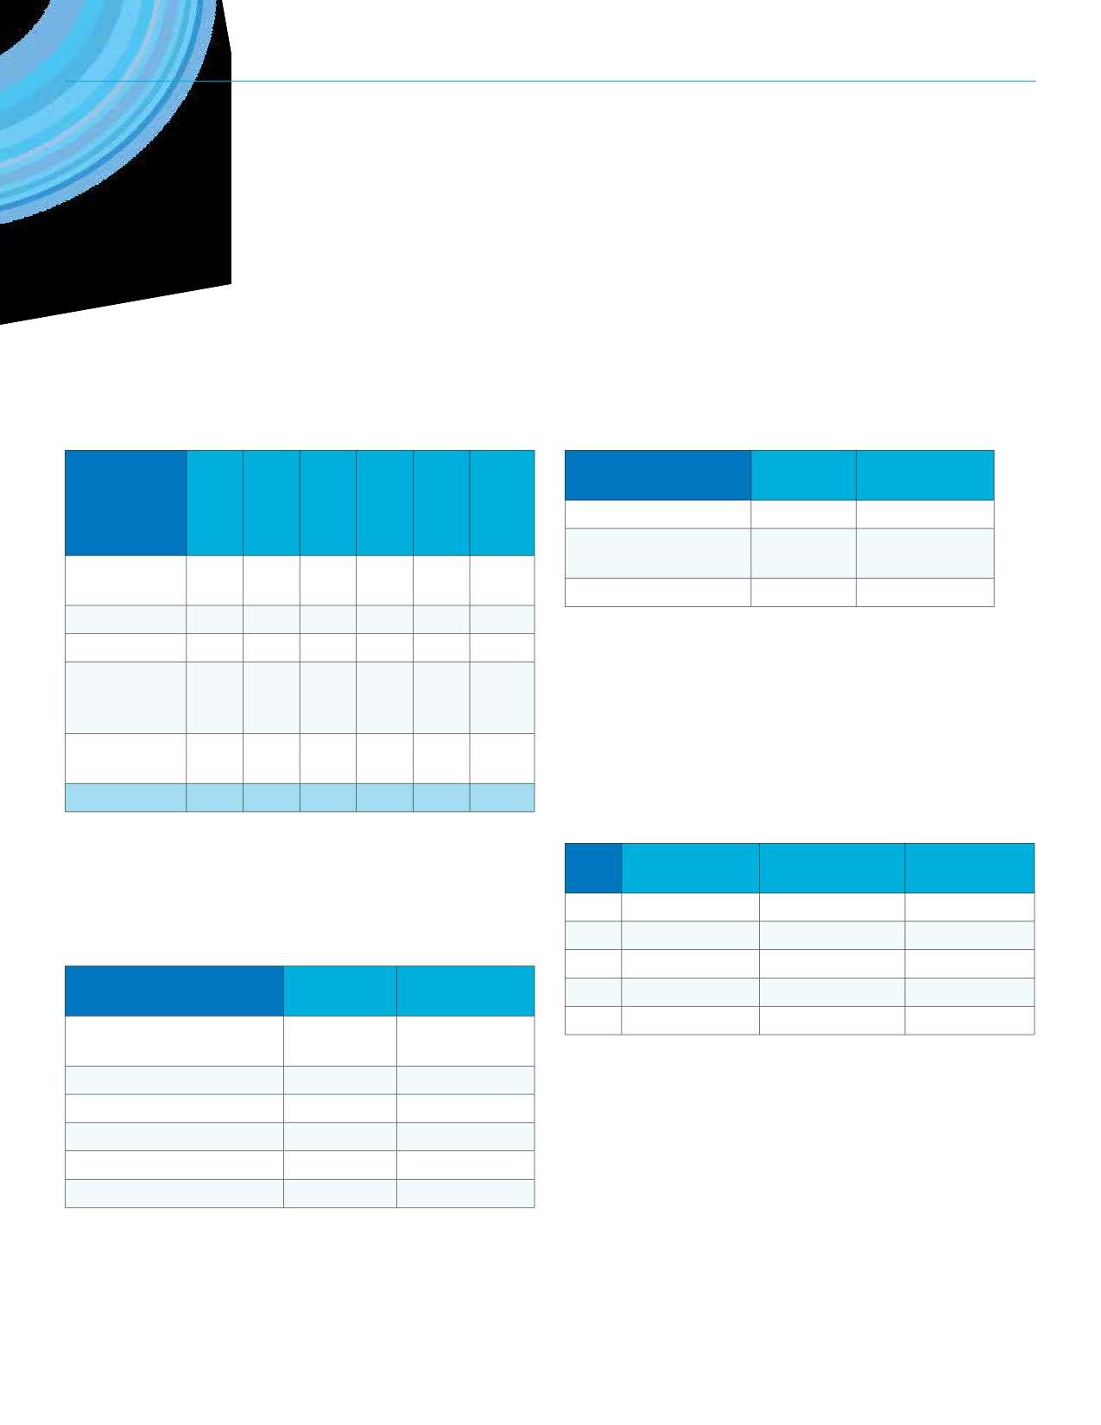SECTION 6: FACILITY UTILIZATION

Outdoor Pools
The City operates five outdoor pools. The following table
explains utilization at these pools in 2017. Nearly 40,000 single
admissions occurred in 2017 in addition to the 33,179 free visits.

Picnic Sites: 2017 Bookings
The picnic site at Kiwanis Park was booked on 42 occasions for 183 hours in 2017. Rick Hansen Park’s picnic site was booked for 137 hours on 26 occasions.

Number of Number of

Location
Bookings Hours Booked

Kiwanis Park 42 183

Usage Type
Single
Admission

0 0 17,313 11,468 10,378 39,159
Rick Hansen Optimist Playground
Kinsmen Park South
26 137
10 51

Members 0 0 3,477 1,287 7,390 12,154

Free Usage
Swim and
Aquacise
Classes
User Group Rentals
9,168 10,317 6,648 3,786 3,260 33,179

0 0 2,393 88 0 2,481

300 0 2,980 2,432 2,983 8,695
City Square Plaza/Victoria Park and FW Hill Mall
City Square Plaza and Victoria Park are well used outdoor
spaces for programming and special events. The number of
bookings and hours booked have varied over the past few

Total 9,468 10,317 32,811 19,061 24,011 95,668

Tennis Courts: 2017 Bookings
years, but attendance has increased to over 550,000 during both 2015 and 2016.

Number of Number of

The two courts at Lakeview Park combined for 750 booked
hours in 2017. The five courts at Douglas Park totaled 475 hours.
Lakeview Par 3 was renewed and pickleball lines were added.
Year
2013
2014
Bookings Hours Booked
459 4,356
436 2,271
Attendance
299,370
323,780

Location
Lakeview Tennis Courts (2 Courts)

Number of Number of
Bookings Hours Booked
250 750
2015 313 3,371 555,821
2016 299 3,211 553,752
2017 353 2,620 328,484

Douglas Park (5 Courts) 328 475
AE Wilson Park (4 Courts) 286 357
Optimist Arena (2 Courts) 36 144
Lakewood Park (2 Courts) 10 16
Gocki Park (2 Courts) 5 5
53
Dewdney
Maple Leaf
Massey
Regent
Wascana
Total

REGINA RECREATION MASTER PLAN

Regina Downtown Business Improvement District is the biggest user of the space in regard to hours booked.

Hours Hours Hours
User Group/Organization Booked Booked Booked
(2015) (2016) (2017)
Regina Downtown Business

Sportplex Fieldhouse
• For the Fieldhouse, the number of booked hours has
gradually increased over the past five years primarily due
to more City of Regina drop in fitness program hours.
• The number of head counts recorded has declined each
year from 2013 to 2017.

Improvement District
1,279 1,133 834
• Excel Athletika, Saskatchewan Team Handball, and Tennis

Regina Farmer’s Market 422 388 402 Saskatchewan are the top three renters of the Fieldhouse.

Regina Folk Festival
Sk Highland Gathering and Celtic Festival
Intercultural Dialogue Institute Regina
230 280 303
115 106 -

73 139 171
Recreation Centres
• The mâmawêyatitân centre, Albert Scott Community
Centre, and Core Ritchie Neighbourhood Centre are rented
the most by external groups.

Street Culture Kids - - 325
Utilization Summary
The following statements summarize the findings of the utilization information presented.
Leisure Passes
• From 2013 to 2017, monthly/yearly pass purchases have
dropped by 21%.
• Bulk admission sales have remained stable.
• Leisure pass purchases by young adults have been
declining over the past five years.
Ice Arenas
• Prime Ice utilization at City-operated facilities is
approximately 62% which suggests that these ice arenas
are well-used but have capacity to increase usage.
Aquatics
• The number of total swims has remained relatively stable
over the past seven years with an average of 577,333
swims from 2011 to 2017.
• The Lawson Aquatic Centre accommodates nearly 6.5 times
more aquatic rental hours than the Sandra Schmirler Leisure
Centre and double the amount at the North West Leisure Centre.
54
Sports Fields
• The Douglas Park and Grassick Park cricket pitches were
each booked more than any other sports fields in 2017.
• Class 1, 2A, and 2B fields account for 26% of the bookable
sports field inventory and they accommodated 46% of all bookings in 2015.
Ball Diamonds
• Booked hours at ball diamonds has increased by 25% from
2013 to 2017.
• Baseball Regina, Regina Minor Softball, Regina Rec
League, North Regina Little League, and Regina Ladies
Softball are the top five user groups in terms of booked
hours over the past five years; 12 different user groups
have averaged over 1,000 booked diamond hours per year over the past five years.

SECTION 6: FACILITY UTILIZATION

Outdoor Rinks, Outdoor Pools, Tennis Courts, and Picnic Sites
• Of the 60 outdoor rinks, only 9 were booked for over
100 hours of scheduled use in 2017/2018, meaning that
outdoor rinks are primarily unscheduled for spontaneous
use.
• There were over 95,000 visits (total) to the City’s five outdoor
pools in 2017, 33,179 of which were free drop-in visits.
• The tennis courts at Lakeview Park and A.E. Wilson Park
were the most booked in 2017 with over 750 and 475
booked hours respectively.
• The picnic sites at Kiwanis Park and Rick Hansen Park were
the only sites booked on over 10 occasions in 2017.
City Square Plaza/Victoria Park and FW Hill Mall
• Regina Downtown Business Improvement District is the
biggest user of the space in regard to hours booked with
834 hours in 2017 and 1,133 hours 2016.
• An attendance of over 550,000 was achieved in 2015 and
2016.
55

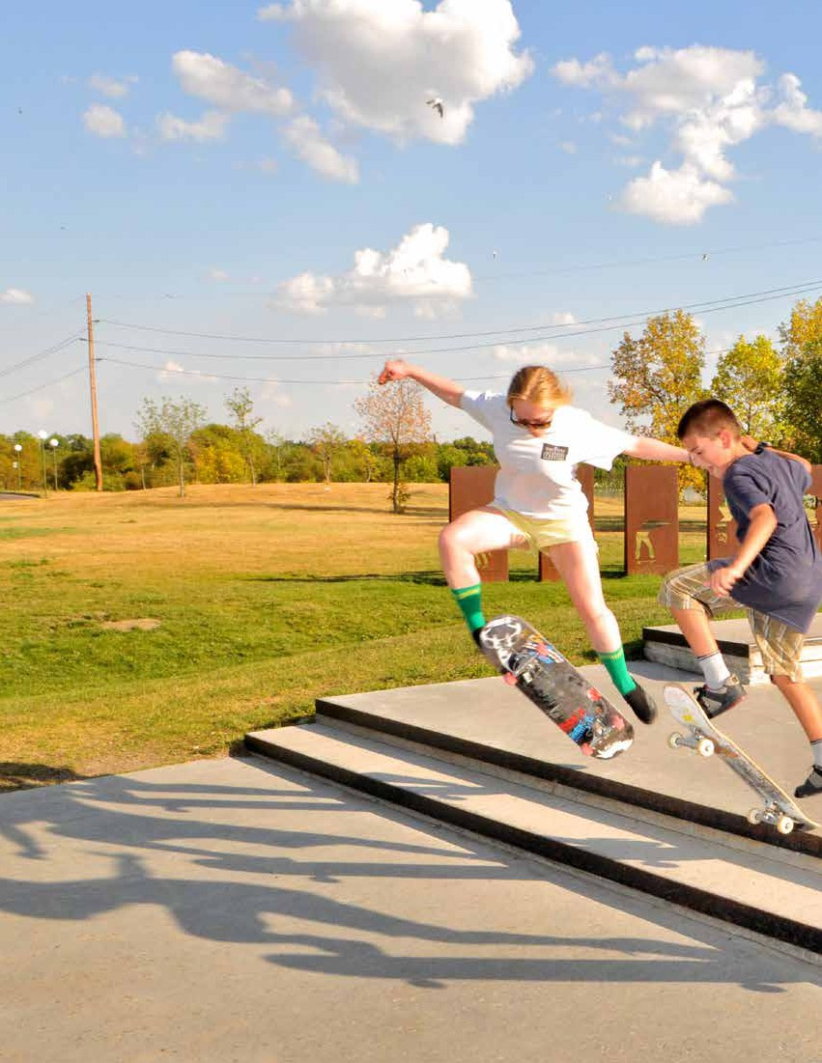
56

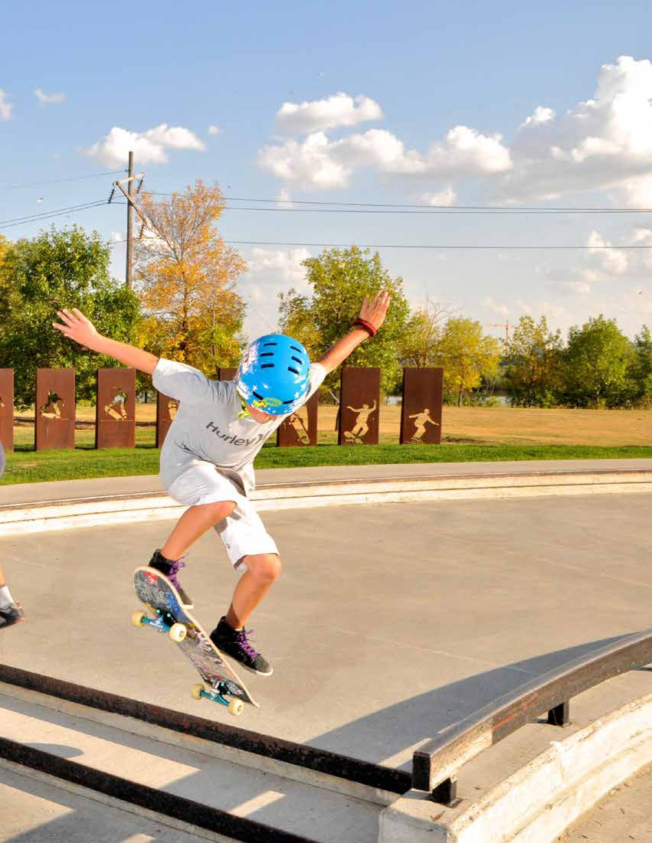

SECTION 7
Program Review
57

REGINA RECREATION MASTER PLAN

SECTION 7
Program Review
Direct Delivery: City of Regina

KEY FINDINGS FROM THIS SECTION
• The City directly and indirectly delivers a variety
of recreation programs. Unaffiliated recreation
opportunities that are provided without any
formal City support are also available to residents.
• Introductory and recreational sport, aquatic
safety, and arts and culture programs are
available for each age category via direct delivery.
• There are no directly delivered nature
interpretation/outdoor education programs.

Many recreation opportunities are available to Regina
residents, including but not limited to programs that are
publicly supported by the City of Regina. Publicly supported opportunities include programs that are directly delivered by City staff and those that are indirectly delivered but
entail some type of public support such as subsidized access to facilities and/or grants to agencies offering programs.
Programs that are not affiliated with the City are recreation opportunities that are not subsidized by the City in any way. Examples include private fitness centres and organizations that program in their own facilities and spaces.
This section mostly focuses on programs that are directly delivered by the City whereas the subsequent section
(Partnership Review) focuses on indirect delivery. However, it is important to note the ever-changing market in recreation program delivery and demand as it may not be necessary to duplicate programs with direct delivery if they are sufficiently provided indirectly or by an unaffiliated organization.
The City directly delivers a variety of registered and drop-in programs such as:
• Aquatics (e.g. lessons, water fitness, lane swim, leisure swim)
• Skating (e.g. public skate)
• Fitness & sports (e.g. personal/group training,
floor hockey, stretching)
• Arts & culture (e.g. 3D printing and design, woodworking,
cooking, graphic novels)
The following chart provides an overview of current program
offerings by typology and age category using the most recent
Leisure Guide published by the City (Summer 2017). As reflected
in the chart, introductory and recreational sport, aquatic
safety, and arts and culture programs are available for each
age category. Aquatic fitness is only available for adults and
seniors and more specialized sport training opportunities are
only offered for children and youth via specific sport programs. Potential gaps in direct programming could include nature interpretation and outdoor education and physical literacy for youth. It is important to note that the identification of these gaps does not necessarily suggest that additional direct programming is required. Other factors to consider in this regard include the appropriateness of programming (e.g. does the age category warrant programming based on the Canadian Sport for Life framework), demand, facility availability, and duplication of indirect and unaffiliated programming.

Program Type
Introductory Sport/

Recreational Sport
a a a a

Direct Indirect
Sport Training
Unaffiliated Introductory Fitness/
Physical Literacy
a a
a

• Delivered by • Delivered by • Not delivered by
City staff partner City or partner
• Located at ogranization organization
Fitness Training a
Aquatic Safety a a a a

City facilities • Supported by the • Not located at Water Fitness a
City (e.g. subsidized City facility or
facility rental, grant publicly subsidized Arts and Culture a a a a
support, etc.) in any way Nature Interpretation/
Outdoor Education
58
Preschool
Children
Youth
Adult/
Senior

SECTION 7: PROGRAM REVIEW

Indirect Delivery: Zone Boards and Community Associations
Programs and opportunities provided by Zone Boards and Community Associations are considered to be delivered indirectly. A number of these programs are promoted in the Leisure Guide; a few examples are as follows.
• Family and Community: community clean up,
family nights, flea market, Tae Kwon Do, BBQ
• Preschool: movement program, art camp, healthy start,
learn to skate
• Children: music, hockey, storytelling, learn to skate
• Adult: yoga, hula hoop, table tennis
• Older Adult: drop-in games, yoga 55+, pickleball
Affordable Fun Program
The Affordable Fun Program provides Regina residents with
financial barriers the opportunity to access City of Regina
recreation facilities as well as arts, culture, recreation and
leisure programs at discounted rates. Leisure passes can be
purchased for 50 per cent off the regular price and residents
can participate in registered programs at 80 per cent off
the regular price, to a maximum of $160 discount per family
member.
59

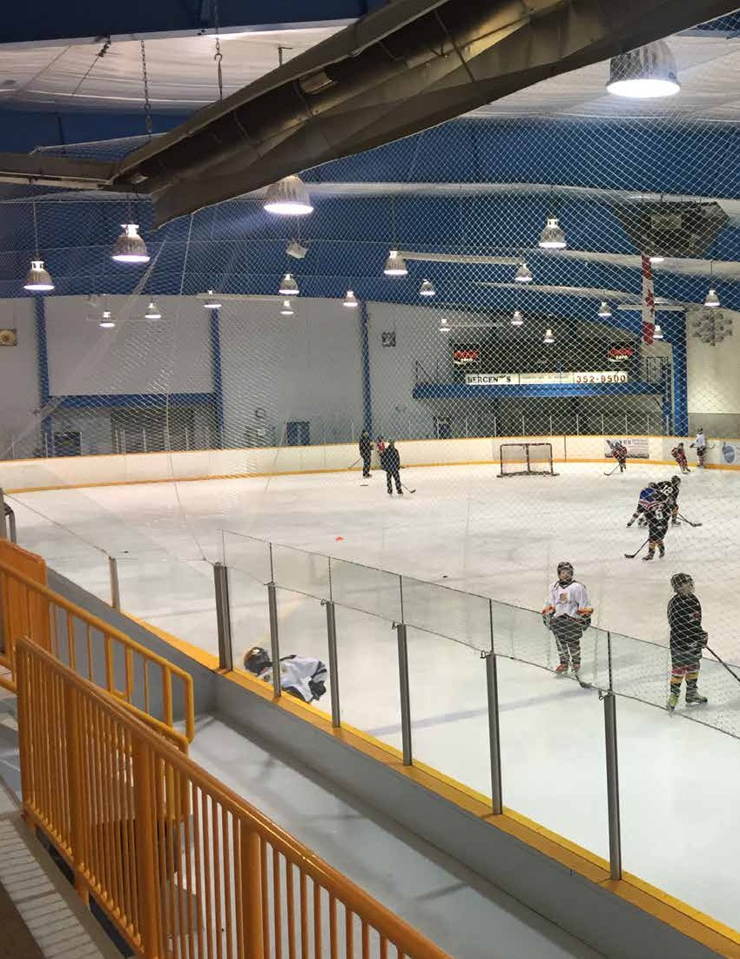
60

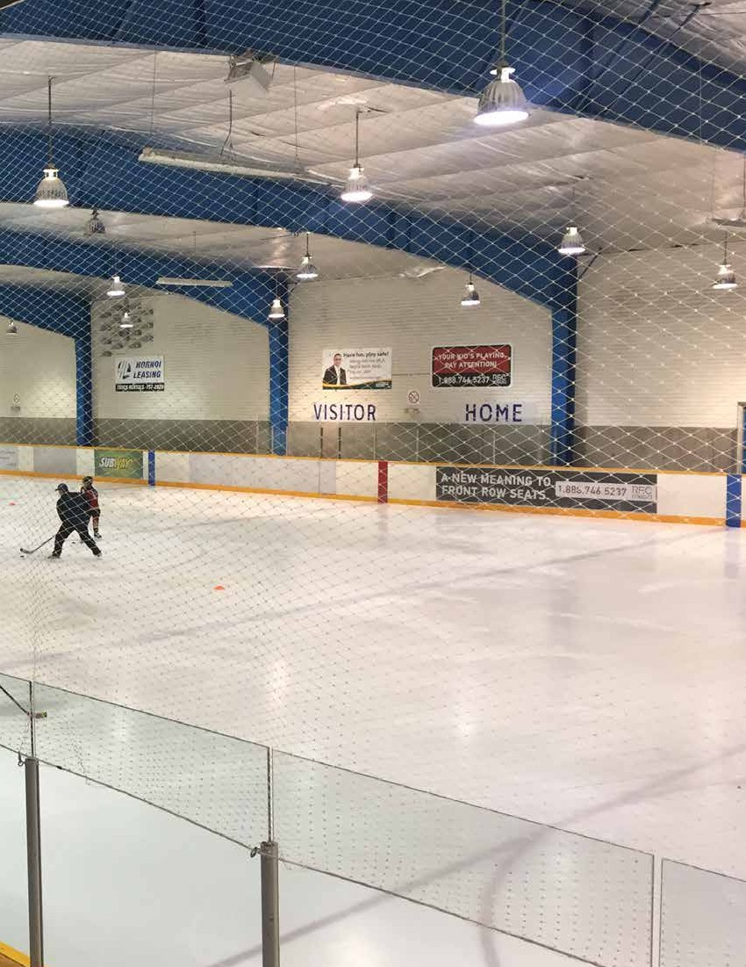

SECTION 8
Partnership Review
61

REGINA RECREATION MASTER PLAN

SECTION 8
Partnership Review

Some of the City’s key partners include Community
Associations, Regina Exhibition Association, Provincial

KEY FINDINGS FROM THIS SECTION
• The City relies on partnerships to deliver
recreation opportunities to residents.
• Partnership agreements in place include, but are
not limited to, facility lease agreements, operating agreements, and joint-use agreements.
• Some facilities are accessible through
operating authority (e.g. RSA controls access to Credit Union EventPlex turf) .
• Limited formal process/policy in place to guide
the selection and development of partnerships
• Key partners include, but are not limited to:
Community Associations, Regina Exhibition
Association, Provincial Capital Commission, school
boards, community groups, sport organizations, Government of Saskatchewan, SPRA.
• Some groups (e.g. YMCA, curling clubs,
skateboard association) have expressed an interest in partnering with the City.

It would not be feasible for the City to directly deliver the
same quantity and quality of opportunities and programs
that are currently offered via its various partners. The City
relies on partnerships to deliver a full spectrum of recreation opportunities to residents.
A primary method in which the City partners with community organizations is via the operation of facilities. Many
organizations rely on City facilities to run programs and
often the rental fees are not at full cost recovery, meaning
that these organizations’ access to facilities is often publicly subsidized. Other methods include the sharing of spaces and financial support (e.g. operating grants, core funding, capital contributions).
62
Capital Commission, school boards, community groups, and
sport organizations. During the consultation portion of the
Recreation Master Plan process, it was identified that some
groups (e.g. YMCA, curling clubs, skateboard association)
have expressed an interest in partnering with the City to
expand programming and facility possibilities.
A variety of partnerships agreements are in place. These
include, but are not limited to, facility lease agreements,
operating agreements, and joint-use agreements. Some
facilities are accessible through an operating authority, such
as the Credit Union EventPlex artificial turf. Although there
are partnership agreements in place, there is limited to no
formal process/policy in place to guide the selection and
development of partnerships.
To maximize its investment in recreation, the City partners with organizations such as:
• Community Associations: to provide neighbourhood level
programming and low cost opportunities
• Schools: to provide community use of gymnasium and
outdoor playing surfaces (e.g. ball diamonds)
• Community Groups: to provide more variety and increased
quality of programming (especially at City facilities)
• Facility Operators: to provide affordable rental rates to
community groups
• Developers: To develop parks and open spaces in new
neighbourhoods through servicing agreements

SECTION 8: PARTNERSHIP REVIEW

Delivering Recreation
Infrastructure and Amenities
Similar to providing programs, there can be different levels of
municipal involvement in delivering recreation infrastructure.
Some recreation facilities and amenities are owned and
operated by the City of Regina, some are supported by the
City but partner operated, and some are not supported by the
City at all. Determining the City’s role for each facility type is
not always a clear and easy decision.

Direct Indirect Unaffiliated

• City owned • City supported/ • Not supported
and operated partner operated by the City
(e.g. Sportplex, (e.g. the (e.g. Tartan and
Sandra Schmirler Co-operators Highland Curling
Leisure Centre, Centre, Credit Clubs, YMCA
stand alone arenas, Union EventPlex, facilities, private
outdoor pools) Arcola East fitness centres)
Community
Centre, ball parks)
63

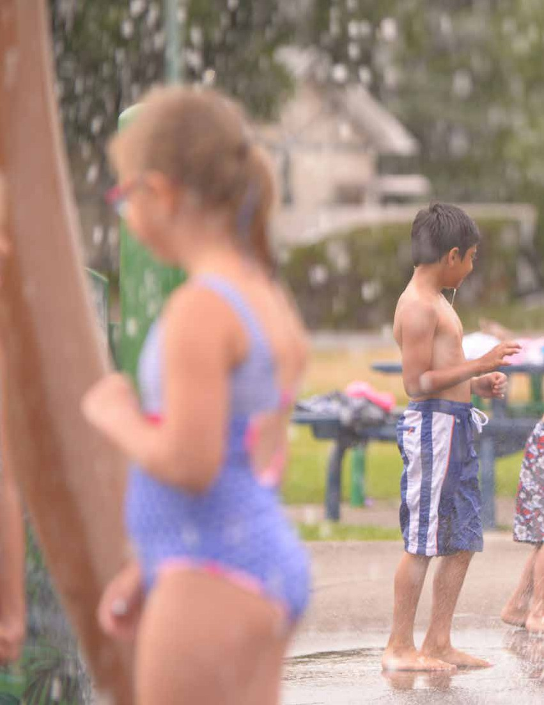
64

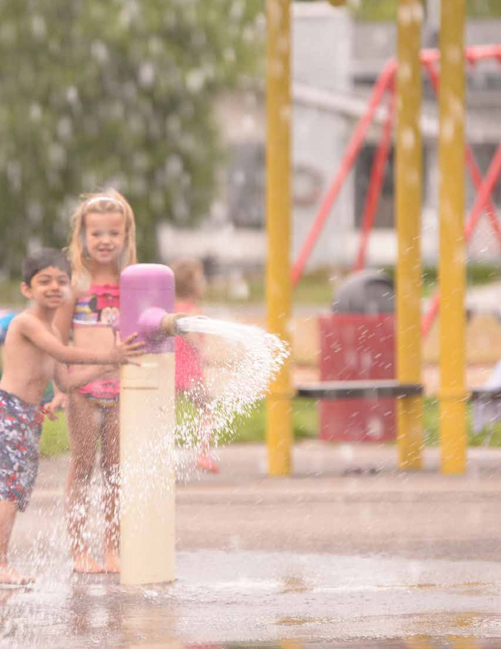

SECTION 9
Trends
65

REGINA RECREATION MASTER PLAN

SECTION 9
Trends
Participation

KEY FINDINGS FROM THIS SECTION
• Unstructured/spontaneous recreation activities
are among the most popular activities (e.g. walking,
bicycling, drop-in sports).
• Recreation is important to residents
of Saskatchewan.
• ParticipACTION assigned a D-rating for “overall
physical activity” of youth and children in Canada.
• Aging infrastructure is a concern Canada-wide.
Compared to other municipal infrastructure types,
sport and recreation facilities are in the worst state.
• Partnerships with non-profit, private and
public sector organizations are key to providing
publicly accessible recreation opportunities.
• Volunteers are vital components of the recreation
delivery system and volunteerism is changing.

A review of trends can help identify leading practices in the
delivery of recreation services as well as emerging or evolving
interests that may be important to consider when planning.
Summarized in the following section are selected trends related to participation, the provision of recreation opportunities
(service delivery), volunteerism, and infrastructure.
Physical Activity and Wellness Levels
The Canadian Health Measures Survey (Statistics Canada) concludes that the fitness levels of Canadian children and youth, as well as adults, have declined significantly between 1981 and 2009. Among youth aged 15 to 19, the percentage who were at an increased or high risk of health problems more than tripled; for adults aged 20 to 39 this percentage quadrupled.
ParticipACTION is a national non-profit organization that strives
to help Canadians sit less and move more. The Report Card on
Physical Activity for Children and Youth is a comprehensive
assessment of child and youth physical activity, taking data from
multiple sources, including the best available peer-reviewed
research, to assign grades for indicators such as overall physical
activity, active play, sleep, and others. The most recent report card
(2016) is a “wake-up call” for children and youth activity levels.
• Only 9% of Canadian kids aged 5 to 17 get the 60 minutes
of heart-pumping activity they need each day.
• Only 24% of 5- to 17-year-olds meet the Canadian
Sedentary Behaviour Guidelines recommendation of no
more than 2 hours of recreational screen time per day.
• In recent decades, children’s nightly sleep duration has
decreased by about 30 to 60 minutes.
• Every hour kids spend in sedentary activities delays their
bedtime by 3 minutes. And the average 5- to 17-year-old
Canadian spends 8.5 hours being sedentary each day.

D-

Overall
Physical Activity
70% of children aged 3 to 4 meet the recommendation of 180 minutes of daily activity at any intensity. However, as the guidelines change to 60 minutes of moderate- to vigorous-intensity physical activity per day for those aged 5 to 17, only 9% are meeting the guidelines.^{2012-13 CHMS}
66

SECTION 9: TRENDS

• Thirty-three percent (33%) of Canadian children aged 5
to 13, and 45% of youth aged 14 to 17, have trouble falling
asleep or staying asleep at least some of the time.
• Approximately one-third (36%) of 14- to 17-year-olds find
it difficult to stay awake during the day.
• Thirty-one percent (31%) of school-aged kids and 26% of
adolescents in Canada are sleep-deprived.
Recreation and Quality of Life
The Saskatchewan Parks and Recreation Association conducted a Recreation and Quality of Life Survey in 2016. Below are key findings from the survey.
• Approximately half (52.2%) of respondents believe that
leisure has become more important to their overall quality
of life in the last 2-3 years, as compared to work.
• Over three-quarters (79.7%) of respondents agree that
green spaces make a large contribution to communities.
• The use of outdoor recreation environments rises
with income.
• Approximately three-quarters (72.8%) of the indoor
recreation facilities used most often are publicly operated.
• Approximately two-thirds (64.2%) agree or strongly
agree that they can afford to participate in most of the recreational activities they want to be part of.

Benefits to the Community

Physical Activity Preferences
The 2013 Canadian Community Health Survey reveals data that provides some insight into the recreation and leisure
preferences of Canadians. The top 5 most popular adult
activities identified were walking, gardening, home exercise, swimming and bicycling. The top 5 most popular youth
activities were walking, bicycling, swimming, running/jogging and basketball.¹
Participation levels and preferences for sporting activities
continue to garner much attention given the impact on
infrastructure development and overall service delivery
in most municipalities. The Canadian Fitness & Lifestyle
Research Institutes 2011 - 2012 Sport Monitor Report
identified a number of updated statistics and trends pertaining to sport participation in Canada.²
• The highest proportion of Canadians prefers non-competitive
sports or activities. Nearly half (44%) of Canadians preferred
non-competitive sports while 40% like both non-competitive and competitive sports. Only 8% of Canadians prefer
competitive sports or activities and 8% prefer neither competitive nor non-competitive sports.
• Sport participation is directly related to age. Nearly three-
quarters (70%) of Canadians aged 15 - 17 participate in sports,
with participation rates decreasing in each subsequent
age group. The largest fall-off in sport participation occurs
between the age categories of 15 - 17 and 18 - 24 (~20%).

When asked to rate the benefits that Recreation Programs, Outdoor Environments and Indoor Faciltiies have on their communities, over half of our survey respondents rated the following benefits as important or very important:

76.1% 67.8% 65.5% 59.0% 57.5% 55.3%
Encouraging Providing positive Attracting visitors Helping build Making the Attracting business
healthy lifestyles opportunities for youth to your community stronger links within community visually and economic
the community attractive development

1 Statistics Canada:
http://www.statcan.gc.ca/daily-quotidien/140612/dq140612b-eng.htm
2 Canadian Fitness & Lifestyle Research Institutes 2011 - 2012
Sport Monitor: http://www.cflri.ca/node/78
67

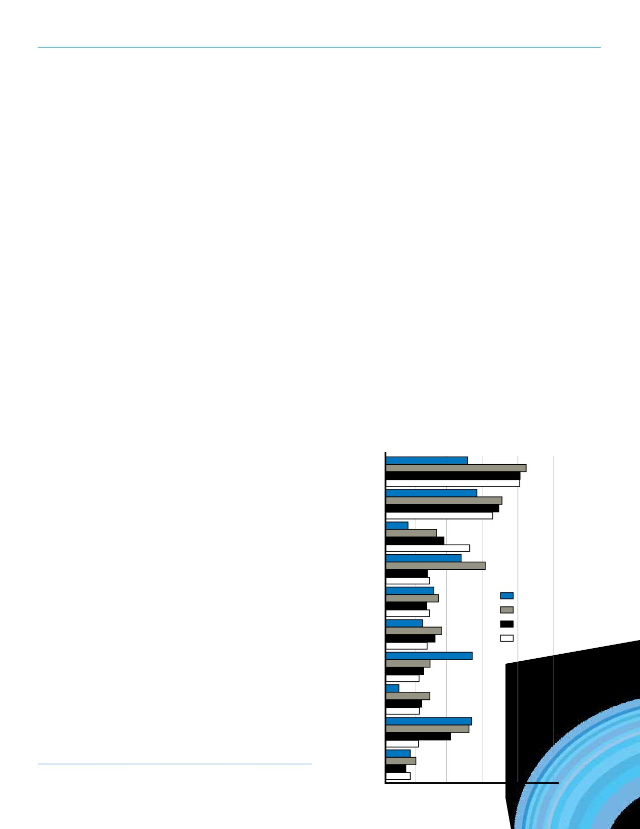REGINA RECREATION MASTER PLAN

• In contrast to children and youth populations (in
which gender participation rates are relatively equal),
substantially more adult men (45%) than adult women (24%) participate in organized sport.
• Participation in sport is directly related to household
income levels. Households with an annual income of
greater than $100,000 have the highest participation
levels, nearly twice as high as households earning between
$20,000 and $39,999 annually and over three times as
high as households earning less than $20,000 annually.
• The highest proportion of sport participants play in
“structured environments.” Just under half (48%) of
sport participants indicated that their participation
occurs primarily in organized environments, while 20%
participate in unstructured or casual environments; 32%
do so in both structured and unstructured environments.
• Community sport programs and venues remain important.
The vast majority (82%) of Canadians that participate in sport do so within the community. Approximately one-fifth (21%) participate at school while 17% participate in sports at work. A significant proportion (43%) also indicated that they participate in sporting activities at home.
A research paper entitled “Sport Participation 2010”
published by Canadian Heritage also identified a number
of trends pertaining to participation in specific sports. The
following graph illustrates national trends in active sport
participation from 1992 - 2010. As reflected in the adjacent
graph, swimming (as a sport) has experienced the most
significant decrease while soccer has had the highest rate of
growth while golf and hockey remain the two most played
sports in Canada. Note: Data includes both youth, amateur,
and adult sport participants.³

The Paper further identifies a number of broad participation trends related specifically to sport focused participation utilizing Statistics Canada data from the 2010 Federal Census and the General Social Survey. Broader trends effecting overall sport participation noted by the Paper include:
• National sport participation levels continue to decline.
In 2010, 7.2 million or 26% of Canadians age 15 and
older participated regularly in sport; this represents a 17% decline over the past 18 years.
• The gender gap in sport participation has increased.
• Sport participation decreases as Canadians age; the most
significant drop off occurs after age 19.
• Education and income levels impacts impact sport participation.
Canadians with a University education and those making
more than $80,000 annually have the highest rates of sport participation.

Active Participation Rate
1992 - 2010

Golf

Ice Hockey

Soccer

Baseball

1992
Volleyball
1998
2006
Basketball

2010

Skiing (Downhill)

Cycling

Swimming

Badminton

3
Government of Canada: http://publications.gc.ca/collections/

collection_2013/pc-ch/CH24-1-2012-eng.pdf
5% 10% 15% 20% 25%
68

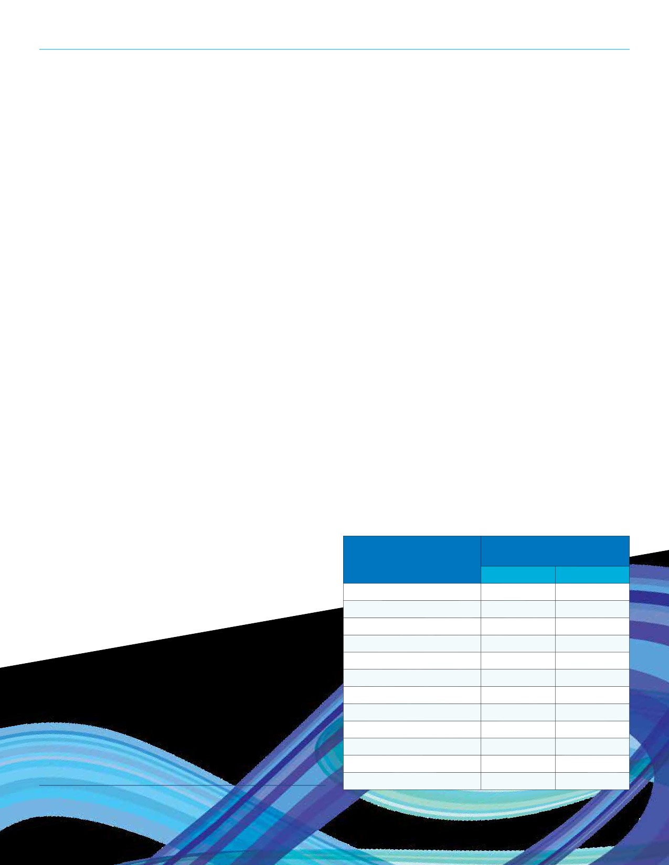SECTION 9: TRENDS

• Established immigrants participate in sport less than
recent immigrants and Canadian born.
• Students (15 years and older) participate in sport in
greater numbers than any labour force group.
• Participation is highly concentrated in a few sports.
Participants in golf, ice hockey, and soccer tend to prefer these three sports and have less diversity in their overall sporting pursuits than participants of other sports.
• Women are more likely than men to have a coach. Female
sport participants tend to use the services of a coach more often than male sport participants and this difference
appears to increase with age.
• The most important benefit of sport participation is
relaxation and fun. Relaxation and fun were ranked as
being important by 97% of sport participants.
• A lack of time and interest are the main reasons for not
participating in sport.
Aboriginal Youth
Growth of the Aboriginal youth in urban Saskatchewan
stresses the concern of a demographic with an unfortunately
disproportionate level of illness. In a study conducted by
Kerpan, S. (2015)⁴, the physical activity beliefs and behaviours
of urban Aboriginal youth were investigated. Results revealed

Programs of intergenerational and unstructured family based physical activity are a potential way to encourage all ages
of Aboriginal peoples to become more active. Unstructured physical activity costs little, and it can often be done at home or close to home, and is a preference that is relevant to the non-Aboriginal Saskatchewan population.
Unstructured Recreation
There is an increasing demand for more flexibility in timing and
activity of choice for recreational pursuits. People are seeking
individualized informal pursuits that can be done alone or in
small groups, at flexible times, often near or at home. This does
not eliminate the need for structured activities, but instead
suggests that planning for the general population is as important
as planning for traditional structured use environments.
The Canadian Fitness and Lifestyle Research Institute conducts
a Physical Activity Monitor (PAM) survey that tracks physical
activity and sport participation among Canadians. Additionally,
the telephone survey tracks changes in physical activity patterns
over time, along with factors influencing participation. The 2014 -
15 PAM asked 18 and older Canadians about the type of physical
activities they participated in 12 months prior to the survey.
This is a breakdown of the 10 most common activities by gender.

Proportion Participating

4 themes: Activity in the Previous 12 Months
• Group physical activity preference Men Women
• Focus on the family Walking for exercise 80% 88%
• Traditional physical activity Gardening or yard work 80% 69%
• Location of residence as a barrier Bicycling 55% 43%

These findings could be used to improve current
programming or develop new programming that builds on the
strengths that are present in the community. Offering group
physical activity programs while incorporating traditional
activities could be an excellent way to make participants feel
more comfortable and increase their sense of identity. In
addition, involving family promotes cultural values and gives
youth more access to safe transportation to and from the
program.
Social Dancing 33% 45%
Ice Skating 34% 24%
Exercise classes or aerobics 15% 39%
Yoga or tai chi 15% 39%
Golfing 33% 13%
Baseball or softball 23% 12%
Basketball 21% 11%
Ice hockey 21% 4%

Football 18% 4%
4 Kerpan, S., & Humbert, L. (2015). Playing Together: The Physical Activity
Beliefs and Behaviors of Urban Aboriginal Youth. Journal Of Physical Activity & Health, 12(10), 1409-1413
69

REGINA RECREATION MASTER PLAN

Flexibility and Adaptability
Recreation and parks consumers have a greater choice of activity
options than at any time in history. As a result, service providers
are being required to ensure that their approach to delivery is
fluid and is able to quickly adapt to meet community demand.
Many municipalities have also had to make hard decisions on
which activities they are able to directly offer or support, versus
those which are more appropriate to leave to the private sector
to provide.
Ensuring that programming staff and management are current on trends is important in the identification and planning of programming. Regular interaction and data collection (e.g. customer surveys) from members are other methods that service providers use to help identify programs that are popular and in demand. The development of multi-use spaces can also help ensure that municipalities have the flexibility to adapt to changing interests and activity preferences.
Barriers to Participation
Research and available data supports that many Canadians face
barriers that impact their ability to reap the numerous physical,
social, and mental benefits that are accrued from participation

Providing Recreation Opportunities
A number of organizations play a key role in providing
recreation and parks opportunities for residents. In a typical community, the municipality, the school system, community organizations, and the private sector all play a vital role in providing opportunities. Identified as follows are a number of key considerations and factors that continue to influence the delivery of recreation and related services in many
communities and regions.
Partnerships
Partnerships in the provision of recreation and parks opportunities
are becoming more prevalent. These partnerships can take a number
of forms, and include government, not-for-profit organizations,
schools and the private sector. While the provision of recreation
and parks services has historically relied on municipal levels

Cost of Enrollment Fees 61%
Cost of Equipment 52%
Child Lacks Interest in Sports 42%
Location of Programs/Clubs/

in recreation and leisure pursuits. Understanding these barriers can help service providers identify strategies to mitigate issues and encourage participation.
The adjacent graph (adapted from the 2014 CIBC - KidSport Report) reflects barriers to participation in sport for 3 to 17 year olds in Canada. The cost of enrollment, the cost of equipment, and a lack of interest were identified as the top 3 barriers.
70
Facilities is Inconvenient
Work Commitments of Parents/Guardians
The Time of Day/Day of Week of
Program is Inconvenient
Organized Sports are Too Competitive/
Too Much Focus on Winning
Lack of Awareness of the Programs
Available in the Community
Other Family Commitments
of Parents/Guardians
Limited Access to Good
Quality Sports Facilities
Organized Sports are
Becoming Too Violent
Parent/Guardian Lacks
Interest in Sports
Parental Under-Involvement
Poor Coaching/Leadership
Parental Over-Involvement
Facilities/Programs are Not Accessible
for Children with Disabilities
26%
25%
23%
19%
15%
14%
13%
9%
8%
7%
7%
6%
5%

SECTION 9: TRENDS

of the government, many municipalities are increasingly looking to form partnerships that can enhance service levels and more efficiently lever public funds.
Examples of partnerships include facility naming and
sponsorship arrangements, lease/contract agreements,
the contracted operation of spaces, entire facilities, or
delivery of programs. According to one study⁵over three-
quarters (76%) of Canadian municipalities work with schools in their communities to encourage the participation of
municipal residents in physical activities. Just under half of
Canadian municipalities work with local non-profits (46%),
health settings (40%), or workplaces (25%) to encourage
participation in physical activities amongst their residents.
Seventy-six percent (76%) of municipalities with a population
of 1,000 to 9,999 to 80% of municipalities over 100,000 in
population have formed agreements with school boards for
shared use of facilities. In fact since 2000, the proportion
of municipalities that have reported working with schools, health settings, and local non-profit organizations has
increased by 10% to 20%.
Changing Demographics
The Saskatchewan Parks and Recreation Association
partnered with McNair Business Development Inc. to
conduct a study in 2014 about the demographic changes
in Saskatchewan. The study used statistics from the 2011
Statistics Canada Census. Below are key findings of their
report.
Saskatchewan has experienced a demographic shift in its population over the last 10 years and indications show that this trend will continue. Two major trends are:
• Continued growth of the First Nations and Metis youth
demographic
• Increased immigration
Saskatchewan is home to 11% of the Aboriginal identity
population in Canada. Aboriginal people make up 16% of
the total population of Saskatchewan and 10% of the total
population of Regina. Aboriginal people have a large youth
demographic, as over half (54%) residing in Saskatchewan
were under the age of 25; compared with 30% of the
non-Aboriginal population. A high youth demographic of

5 “Municipal Opportunities for Physical Activity” Bulletin 6: Strategic
partnerships. 2010, Canadian Fitness & Lifestyle Research Institute.

Aboriginal people parallels a more alarming statistic; of all Saskatchewan children in foster care in 2011, 87% were Aboriginal children.
Immigration has been a main driver of the linear growth of the Saskatchewan population that began in the mid-2000s. An example from July 2012 to July 2013 shows the most
significant contributors to population growth:
• +5,400 from natural growth
• +9,500 from international migration
• +1,800 from interprovincial migration
A large figure for natural growth can be attributed to second generation baby boomers. However, it is unlikely that the
natural growth statistic will remain at that level for the next ten to twenty years. Taking this and immigration trends into consideration, the population is predicted to reach 1.2 million by 2020 and 1.3 million by 2025.
Social Inclusion
The concept of social inclusion is becoming an issue
communities are addressing. While always an important issue, its significance has risen as communities have become more diversified through immigration.
Social inclusion is about making sure that all children and adults are able to participate as valued, respected, and
contributing members of society. It involves the basic notions of belonging, acceptance, and recognition. For immigrants, social inclusion would be manifested in full and equal
participation in all facets of a community including economic,
social, cultural, and political realms. It goes beyond including
“outsiders” or “newcomers.” In fact social inclusion is about
the elimination of the boundaries or barriers between “us”
and “them.”⁶ There is a recognition that diversity has worth unto itself and is not something that must be overcome.⁷
While issues of social inclusion are pertinent for all
members of a community, they can be particularly relevant
for adolescents of immigrant families. Immigrant youth
can feel pulled in opposite directions between their own

6 Omidvar, Ratna, Ted Richmand (2003). Immigrant Settlement and Social
Inclusion in Canada. The Laidlaw Foundation.
7 Harvey, Louise (2002). Social Inclusion Research in Canada: Children
and Youth. The Canadian Council on Social Development’s “Progress of
Canada’s Children”.
71

REGINA RECREATION MASTER PLAN

cultural values and a desire to “fit in” to their new home.
This tension can be exacerbated in those situations in which
parents are experiencing stress due to settlement. Children
living in families which are struggling are more likely to
be excluded from some of the aspects of life essential to
their healthy development. Children are less likely to have
positive experiences at school, less likely to participate in
recreation, and less likely to get along well with friends, if they
live in families struggling with parental depression, family
dysfunction, or violence.⁸
Financial barriers to participation in recreation, sport, and

Sport Tourism
Sport Tourism is often a driver of partnerships and
infrastructure development. Available 2014 Statistics Canada
data indicates that the sports tourism industry in Canada is
worth $5.2 billion dollars. In contrast to other segments of the
tourism industry, sport tourism in Canada continues to grow
and is largely driven by the domestic, overnight market. Note:
The following chart has been adapted from the Canadian
Sport Tourism Alliance.

Volume: Person Visits

cultural activities continue to exist for many Saskatchewan Sport Tourism
residents. Understanding the potential benefits that can
result from engaging citizens in a broad range of activities Canada: Same-Day
2011 2012 Change
9,235,000 8,598,000 -6 9%

and programs, municipalities have undertaken a number Canada: Overnight 8,954,000 9,903,000 10 6%
of initiatives aimed at removing financial barriers. Current Canada: Total 18,189,000 18,501,000 1.7%
initiatives being led or supported by many municipalities
include the Canadian Parks and Recreation Association’s U S A 499,500 501,800 0 5%
‘Everybody Gets to Play’ program, KidSport, and JumpStart. Overseas 366,300 371,800 1 5%

Community Development
The combined factors of decreasing support from other levels of
government, increasing demand for new and exciting recreation
infrastructure and programs, and the changing nature of the
volunteer has led many municipalities to adopt a community
development focus in service delivery. This, in addition to the
direct delivery of recreation facilities and programs, includes the
facilitation of empowering local non-profit groups to operate
facilities and/or offer programs to residents thereby levering
public resources and providing more value for public investment.
Community development is the process of creating change through a model of greater public participation; the engagement of the entire community from the individual up. The concept of community development has a broader reach than just the delivery of recreation and parks programs and facilities; it is commonly understood to be the broader involvement of the general public in decision making and delivery. Community development in recreation delivery encompasses supporting and guiding volunteer groups to ultimately become self-
sufficient while providing facilities and programs.

8 Harvey, Louise (2002). Social Inclusion Research in Canada: Children
and Youth. The Canadian Council on Social Development’s “Progress of
Canada’s Children”.
72
Total 19,054,800 19,374,600 1.7%

Many municipalities, including Regina, are reacting to the
growth and opportunities associated with sport tourism
by dedicating resources to the attraction and retention of
events. The emergence of sport councils (or similar entities) is a trend that is continuing in many communities and regions. These organizations often receive public support and are
tasked with building sport tourism capacity and working
with community sport organizations and volunteers in the
attraction and hosting of events. Some municipalities also
dedicate internal staff resources to sport tourism through the creation of new positions or re-allocation of roles.
Sport tourism generates non-local spending in a community
and region (economic impact), can offset operating costs
of facilities (through rentals), and can enhance community
profile at the provincial, national, and international level.
Sport tourism can also generate opportunities for local
athlete development and can lead to varying forms of
community legacy such as infrastructure development and endowment funds.
While sport tourism can be highly beneficial to a community, it is important to consider a number of factors when
allocating resources in order to ensure that investment
provides positive and long-lasting impacts. This is especially

SECTION 9: TRENDS

the case when considering the pursuit of larger scale events
and competitions. Best practices that should be followed
include:
• Infrastructure investment (enhancement or new
development) needs to be sustainable and beneficial to a
wide array of residents.
• Volunteer capacity needs to be accurately assessed and
deemed appropriate.
• The pursuit of events needs to be strategically aligned
with community values and goals.
Volunteerism
Volunteers continue to be vitally important to the planning and delivery of numerous events and programs. Identified as follows are a number of pertinent trends in volunteerism that may impact or have relevancy to the delivery of programming and facility operations. Findings are from the 2010
Canada Survey of Giving, Volunteering and Participating: Saskatchewan data tables.⁹
• Saskatchewan resident volunteer at a higher rate (58.2%)
than the national average (47.0%).
• The highest volunteer rate in Saskatchewan is among
adults aged 35 to 44 (67.0%) followed by ages 25 to 34
(62.0%) and ages 15 to 24 (58.0%).
• Although seniors (65 years and older) had the lowest
volunteer rate (51.3%), they had the second highest
median of annual volunteer hours (68 hours on average per year).

9 Data compiled by Statistics Canada. http://www.statcan.gc.ca/pub/89-
649-x/2011001/tbl/tbl29-eng.htm

The following are nine current trends in volunteerism as identified by Volunteer Canada.¹⁰
• Much comes from the few. While 47% of Canadians
volunteer, over one-third (34%) of all volunteer hours were
contributed by 5% of total volunteers.
• The new volunteer. Young people volunteer to gain work
related skills (Canadians aged 15 - 24 volunteer more than
any other age group). New Canadians also volunteer to develop work experience and to practice language skills. Persons with disabilities may volunteer as a way to more fully participate in community life.
• Volunteer job design. Volunteer job design can be the
best defense for changing demographics and fluctuations
in funding.
• Mandatory volunteering. There are mandatory volunteer
programs through Workfare, Community Service Order
and school mandated community work.
• Volunteering by contract. The changing volunteer
environment is redefining volunteer commitment as a
negotiated and mutually beneficial arrangement rather than a one-way sacrifice of time by the volunteer.
• Risk management. Considered part of the process of
job design for volunteers, risk management ensures the organization can place the right volunteer in the appropriate activity.
• Borrowing best practices. The voluntary sector has
responded to the changing environment by adopting
corporate and public sector management practices including standards, codes of conduct, accountability and transparency measures around program administration, demand for evaluation, and outcome measurement.
• Professional volunteer management. Managers of
volunteer resources are working toward establishing an
equal footing with other professionals in the voluntary
sector.
• Board governance. Volunteer boards must respond to
the challenge of acting as both supervisors and strategic
planners.

10 Alberta Heritage Community Foundation. http://www.abheritage.ca/
volunteer/index.html
73

REGINA RECREATION MASTER PLAN

Infrastructure
As discussed, places and spaces for recreation activity to
occur are important in facilitating activity and achieving
community benefit. Most often, municipalities are looked
upon to provide publicly accessible recreation infrastructure for activities to occur at.
Aging Infrastructure
The recently released Canadian Infrastructure Report Card¹¹ included an assessment and analysis of the state of sport and recreation facilities in Canada. The report revealed a number of concerns and issues that will impact the delivery of sport and recreation infrastructure over the next number of years. Key findings from the report included the following.
• The Report Card demonstrates that Canada’s
infrastructure, including sport and recreation facilities,
is at risk of rapid deterioration unless there is immediate investment.
• The average annual reinvestment rate in sport and
recreation facilities is currently 1.3% (of capital value)
while the recommended target rate of reinvestment is
1.7% - 2.5%.
• Almost 1 in 2 sport and recreation facilities are in
‘very poor’, ‘poor’ or ‘fair’ condition and need repair or
replacement.
• In comparison to other municipal infrastructure assessed
in the Report Card, sport and recreation facilities were in
the worst state and require immediate attention.
• The Report Card indicated that the extrapolated
replacement value of sport and recreation facilities in ‘poor’ or ‘very poor’ condition is $9 billion while those in ‘fair’ condition require $14 billion.
Multi-Use Spaces
Recreation and parks facilities are being designed to
accommodate multiple activities and to encompass a variety
of different components. The benefits of designing multi-
use spaces include the opportunity to create operational
efficiencies, attract a wide spectrum of users, and procure
multiple sources of revenue. Providing the opportunity for

11 http://www.canadainfrastructure.ca/downloads/Canadian_
Infrastructure_Report_2016.pdf
74

all family members to take part in different opportunities simultaneously at the same location additionally increases convenience and satisfaction for residences.
Creating spaces within a facility that are easily adaptable and
re-configurable is another growing trend observed in many
newer and retrofitted facilities. Many performing arts venues
are being designed in such a manner that staging, seating,
and wall configurations can be easily changed as required.
Similarly, visual arts spaces such as studios and galleries are
being designed in a manner that allows them to be used for
a multitude of different art creation and display purposes.
Gymnasium spaces and field house facilities are being
designed with adjustable barriers, walls, bleachers, and other amenities that can be easily set-up or removed depending on the type of activity or event.
Integrating Indoor and Outdoor Environments
A new concept in recreation infrastructure planning is to
ensure that the indoor environment interacts seamlessly with
the outdoor recreation environment. This can include such
ideas as indoor/outdoor walking trails, indoor/outdoor child
play areas, and indoor/outdoor aquatics facilities. Although
there are a number of operational issues that need to be
considered when planning indoor/outdoor environments (e.g.
cleaning, controlled access, etc.) the concept of planning
an indoor facility to complement the site it is located on
(and associated outdoor amenities included) as well as the
broader community parks and trail system is prudent and will
ensure the optimization of public spending on both indoor
and outdoor recreation infrastructure. Integrating indoor
and outdoor environments can be as “simple” as ensuring
interiors have good opportunities to view the outdoors.
Ensuring Accessibility
Many current recreation and cultural facilities are putting a significant focus on ensuring that user experiences are comfortable including meeting accessibility requirements and incorporating designs that can accommodate various body types. Programming is made as accessible as possible via “layering” to provide the broadest appeal possible to intellectual preferences.

SECTION 9: TRENDS

Meeting the needs of various user groups is also an
important aspect of accessibility. Incorporating mobile
technologies, rest spaces, child-friendly spaces, crafts
areas, and educational multi-purpose rooms for classes and
performances is an emerging trend. Accessibility guidelines
set by governments, as well as an increased understanding
of the needs of different types of visitors is fueling this
trend. Technology is also being embraced as a modern
communication tool useful for effectively sharing messages
with younger, more technologically savvy audiences.
Revenue Generating Spaces
Facility operators of community facilities are being required to find creative and innovative ways to generate the revenues needed to both sustain current operations and fund future expansion or renovation projects. By generating sustainable revenues outside of regular government contributions,
many facilities are able to demonstrate increased financial sustainability and expand service levels.
Lease spaces provide one such opportunity. Many facilities are creating new spaces or redeveloping existing areas
of their facility that can be leased to food and beverage
providers and other retail businesses. Short term rental
spaces are another major source of revenue for many
facilities. Lobby areas, programs rooms, and event hosting spaces have the potential to be rented to the corporate sector for meetings, team building activities, holiday parties, and a host of other functions.
Social Amenities
The inclusion of social amenities provides the opportunity for multi-purpose community recreation facilities to maximize the overall experience for users as well as to potentially
attract non-traditional patrons to the facility. Examples of
social amenities include attractive lobby areas, common
spaces, restaurants and cafeterias, spectator viewing areas, meeting facilities, and adjacent outdoor parks or green space. It is also becoming increasingly uncommon for new public
facilities, especially in urban areas, to not be equipped with public wireless Internet.
Another significant benefit of equipping facilities with social amenities is the opportunity to increase usage and visitation to the facility during non-peak hours. Including spaces such as public cafeterias and open lobby spaces can result in

local residents visiting the facility during non-event or non-
program hours to meet friends or is simply a part of their daily routine. Many municipalities and non-profit organizations
have encouraged this non-peak hour use in order to ensure that the broader populace perceives that the facility is
accessible and available to all members of the community.
Food Options in Recreational Facilities
In 2010, the Public Health Nutritionist Working Group of
Saskatchewan developed a resource guide for creating food
policies at worksites and recreation facilities. Saskatchewan
is one of the five provinces in Canada that have published
guidelines or policy making ‘tool kits’ to help recreation
centres improve their food environment. Albeit a good
resource, it is up to the business or facility to use the guide
to adopt healthier food policies. In studies, patrons of
recreational facilities have indicated interest in healthier food
options, but there are mixed results when operators institute
policies.
A success story for instituting a health food initiative exists in the City of St. Albert’s Recreation Facilities. The City of St. Albert partnered with Alberta Recreation and Parks
Association to request vendors to create a plan for healthy food implementation. The plan required the vendors to
provide 20% choose most often foods, 80% choose sometime foods and 0% choose least often foods (based on Alberta
Nutrition Guidelines for Children and Youth). The success
of this initiative was represented by profit stabilization of
vendors and businesses that offered the healthy food options. Additionally, the City of St. Albert received positive media
support for providing healthy options in recreation facilities and patrons were making better food choices.
Another successful initiative was conducted in Edmonton
when a healthy fast food vendor (Moo’s) in Kinsmen Sports
Centre strategically promoted and marketed their healthy
products to generate customer demand. A specialized menu
was created, tailoring the items to athletes, coaches and
trainers who frequented the facility. The menu consisted of 85% healthy choices based on the Alberta Nutrition
Guidelines for Children and Youth. The success was identified by the demand for the healthy menu items which resulted
in the ability to expand the business to develop a seasonal kiosk and concession stands at other recreation facilities throughout Edmonton.
75

REGINA RECREATION MASTER PLAN

Urban Parks Systems
A well-balanced inventory of park spaces and amenities is
required to achieve all the potential benefits that parks can
provide. The sum of each individual park within a municipality creates an urban parks system, including both constructed parks and protected natural areas as well as the linkages
between them.
Benefits of Parks and Outdoor Spaces
Research supports that individuals continue to place a high value on the availability and quality of parks, trails, and
outdoor spaces. A 2013 Canadian study commissioned by the
TD Friends of the Environment Foundation found that nearly
two-thirds of respondents (64%) indicated that local parks
were “very important” to them and their family. Additionally,
68% of Canadians are concerned about the loss of green
space in their community.¹²
Another 2011 study of over 1,100 parents of 2 to 12 year olds
in the United States, Canada, and the United Kingdom found
that the more time a family spends together at a playground,
the greater their overall sense of family wellbeing. Three-
quarters also wished that their family had time to visit a playground more often.¹³
Parks and outdoor spaces also play a key role in helping to
combat “nature deficit disorder” amongst children and youth.
This phrase, first coined by Richard Louv in his bestselling book
“Last Child in the Woods,” suggests that children are becoming
estranged from nature and natural play, which results in a
number of cognitive, physical, and developmental issues.

12 TD Friends of the Environment Foundation survey. Conducted by
Ipsos Reid (2013).
13 Harris Interactive (2011). Playgrounds Increase Sense Of Family
Well-Being. Washington, District of Columbia. Foresters.
76

While all residents benefit from the availability of quality park spaces, a significant amount of research and attention has
been given to the myriad of benefits that result from children and youth being able to play and interact in outdoor settings. Findings include:
• Children who play regularly in natural environments show
more advanced motor fitness, including coordination,
balance and agility, and they are sick less often.¹⁴
• Exposure to natural environments improves children’s
cognitive development by improving their awareness, reasoning, and observational skills.¹⁵
• Children who play in nature have more positive feelings
about each other.¹⁶
• Outdoor environments are important to children’s
development of independence and autonomy.¹⁷
• Children with views of and contact with nature score
higher on tests of concentration and self-discipline. The greener, the better the scores.¹⁸

14 Grahn, P., Martensson, F., Llindblad, B., Nilsson, P., & Ekman, A., (1997).
UTE pa DAGIS, Stad & Land nr. 93/1991 Sveriges lantbruksuniversitet, Alnarp.
15 Pyle, Robert (1993). The thunder trees: Lessons from an urban wildland.
Boston: Houghton Mifflin.
16 Moore, Robin (1996). Compact Nature: The Role of Playing and Learning
Gardens on Children’s Lives, Journal of Therapeutic Horticulture, 8, 72-82
17 Bartlett, Sheridan (1996). Access to Outdoor Play and Its Implications for
Healthy Attachments. Unpublished article, Putney, VT
18 Taylor, A.F., Kuo, F.E. & Sullivan, W.C. (2002). Views of Nature and Self-
Discipline: Evidence from Inner City Children, Journal of Environmental
Psychology, 22, 49-63

SECTION 9: TRENDS

Active Transportation
Active transportation refers to any form of human-powered transportation, such as walking, cycling, using a wheelchair, in-line skating, or skateboarding.¹⁹ In 2011 in Canada, 5.7% of commuters walked to work regularly while 1.3% cycled, accounting for over one million Canadians.²⁰ The City’s Transportation Master Plan outlines a number of key intentions for active transportation throughout the City in the future.
A generational trend is that younger professionals are using active modes of transportation more now than ever. A number of factors are contributing to this such as people are becoming more environmentally conscious, financial limitations (active transportation is generally a cheaper mode of transportation), and a trend is occurring in which people are moving back from the suburbs into urban communities in which places of work are closer in proximity to place of residence.
Urban parks encourage active traffic through its boundaries if they are adjacent to a roadway or can provide a shortcut through the community. Pathway systems that connect
neighbourhoods across the municipality are becoming
increasingly important to accommodate alternative methods
of transportation. Multi-use pathway systems are often seen
as being a given with park design as they facilitate a wide
range of recreational use and serve a transportation function.
Relationships should be constantly analyzed to enhance
pathway systems such as the amenities on pathways and
user numbers, lighting and its effects on night usage, and
the surface material and the types of usage (e.g. bicycling,
walking). An analysis of why certain pathways receive high
usage can be applied to other corridors that do not attract as much active traffic volume. Gathering utilization data with trail trackers is a practice that municipalities are beginning to undertake on a regular basis.

19 Public Health Agency of Canada. http://www.phac-aspc.gc.ca/hp-ps/
hl-mvs/pa-ap/at-ta-eng.php
20 Statistics Canada. 2011. Commuting to Work. https://www12.statcan.
gc.ca/nhs-enm/2011/as-sa/99-012-x/99-012-x2011003_1-eng.cfm

Preserving Heritage and Culture
Preserving and further developing the historical aspects
of an urban parks system embed the importance of these
spaces within the community and increase resident interest and utilization. Municipalities can showcase the history
of a community via its prominent community builders and significant events from the past by dedicating the name of a park, including interpretative information, and displaying art installations that contribute to a sense of place.
Aspects of culture can be celebrated and persevered in
parks. In Chinese gardens, for example, plants are carefully selected for their symbolic association and installed to dictate the arrangement of spaces. The idea that a garden should
invite aesthetic appreciation and the enjoyment of nature is important to Chinese park visitors, but may not be limited to a single culture. Festival venues, art displays, amphitheatres, and garden features are examples of culture infrastructure in urban parks that can set a municipality apart by providing identity-defining features and iconic places.
77

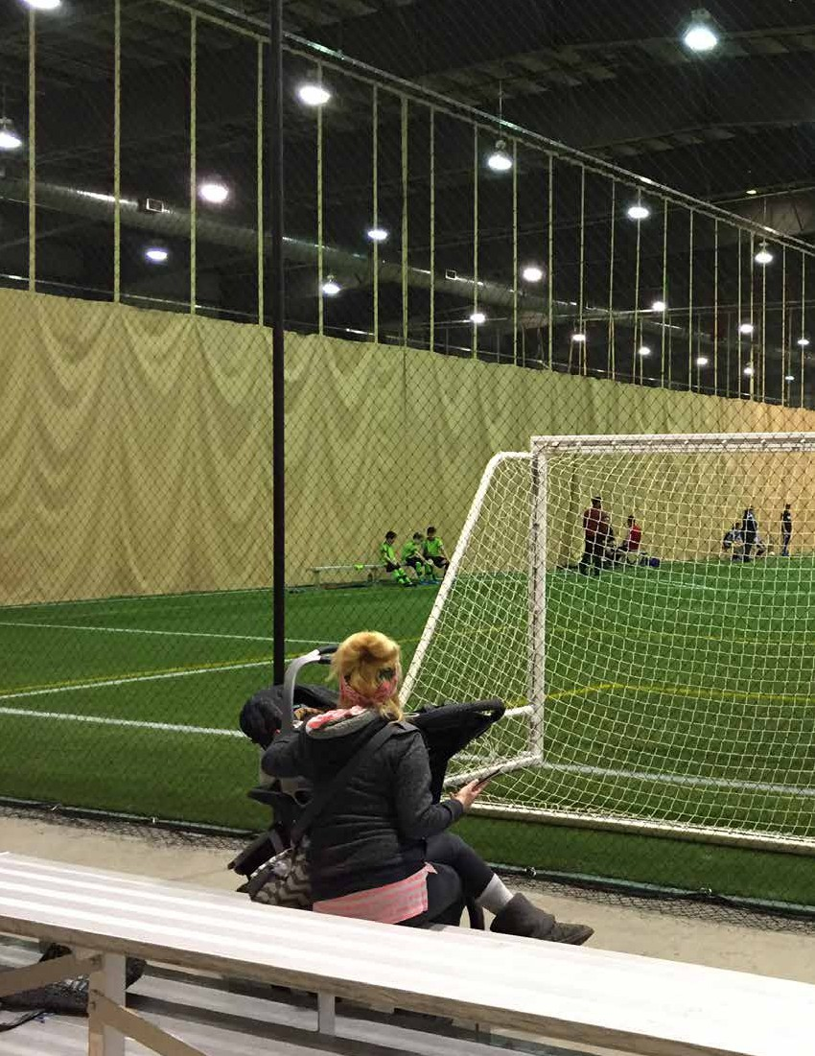
78

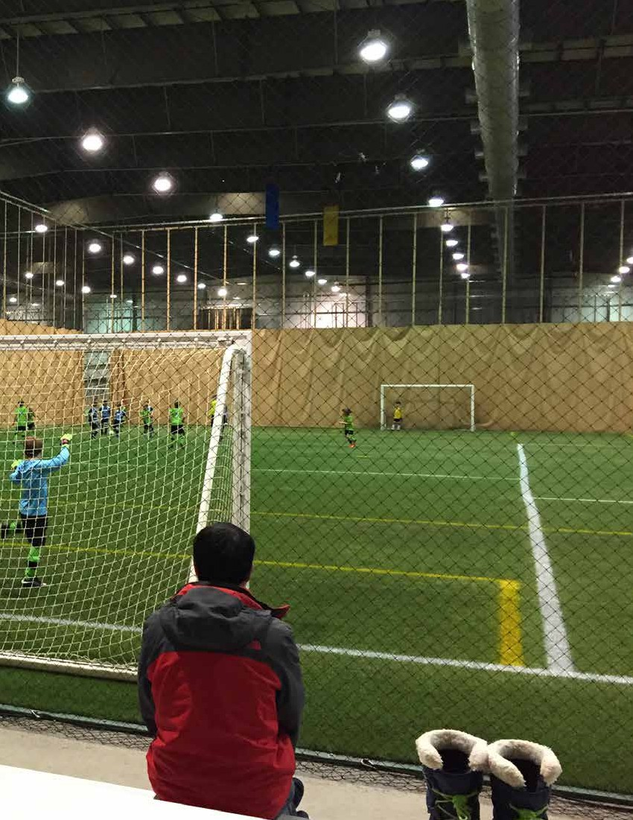

SECTION 10
Leading Practices
79

REGINA RECREATION MASTER PLAN

SECTION 10
Leading Practices

• Safety and risk management

KEY FINDINGS FROM THIS SECTION
• Partnership frameworks are used to guide the
development and accountability of partnership
in a formalized process.
• In most cases, both financial and non-financial
supports are provided by municipalities to
neighbourhood community associations.
Non-financial supports include assistance with
strategic planning sessions and templates,
with promotions and marketing, volunteer
recognition and recruitment, training
opportunities, and networking opportunities.
• Regina provides proportionately more indoor
ice sheets per capita than comparable cities and less indoor aquatics centres.

A review of leading practices was conducted to provide
additional insight into key topics. Partnerships, community associations, volunteer support, and outdoor pools were
identified as key topics early on in the research process to
be examined further. The approaches to each topic were
identified by contacting other similarly sized municipalities in western Canada combined with previous knowledge brought forth by the consulting team.
Partnership Frameworks
Partnership frameworks are used to guide the development of
partnerships as well as to keep them accountable. A number
of criteria are considered to determine whether a potential
partnership is worthwhile and ethical to pursue.
Partnership criteria could include:
• Alignment with municipal planning vision, values, goals, etc.
• Type of organization (non-profit, private company)
• Provides additional/diverse variety of opportunities
• Capital cost savings
• Operating cost savings
• Enhances health and wellness of individuals
• Provides social and wellness benefits to the community
80
• Access and affordability
• Equity and fairness
• Sustainable approach
• Competency of the organization (clear demonstration
of business/feasibility planning)
Community Associations
Community associations are still considered an integral
part of the recreation delivery system. Specific ways to
support community associations differ slightly as funding
can be provided in tiers (such is the case in Regina), flat
rate (the same amount of core funding to each community
association), per capita (based on population), or other/
combined methods (e.g. expressed need, demographics,
utilization).
The amount and quality of non-financial support methods does differ between municipalities. Methods to support community associations include:
• Providing a clear base level of support to all community
associations
• Capital and operating grants
• Cover facility costs (utilities, insurance)
• Major facility enhancements
• Non-financial supports
»» Strategic planning sessions and templates »» Assistance with promotions and marketing »» Assistance with website, newsletters
»» Contracted instructors list
»» Presentation and interpretation of census data »» Volunteer recognition and recruitment
»» Training opportunities
»» Networking opportunities

SECTION 10: LEADING PRACTICES

Supporting Volunteerism
Since most recreation opportunities are provided
by volunteers, supporting volunteerism is critical.
Communication initiatives are imperative to help link people
with opportunities and vice versa as well as for recognizing
volunteers. The recognition of volunteers is a nice touch to
remind the individuals that their efforts make a difference.
Communicating recognition to the general public is also a
strategy to spread the word about volunteer opportunities.
Investing in volunteerism can take place in many ways as
described below.
Methods to support volunteerism include:
• Recognition events
• Recognition communiqués
• Opportunity postings
• Having and updating a database/list of potential
volunteers to email opportunities
• Training and development opportunities
• Communicate the benefits of volunteering and explain
how it makes a difference in the community
• Benefits for volunteers (e.g. discount to some programs/
facilities)

Outdoor Pools
Aging infrastructure is an issue for many municipalities with
outdoor pools. Reinvestment often includes the introduction
of contemporary leisure components to existing pools as well
as the development of water spray parks. There is limited
investment in new outdoor pool infrastructure as investment is often made to maintain the existing number of outdoor
pools as opposed to sustaining the provision ratio (number of
residents per pool). In addition, there is less focus placed on
programming pool time with organized swim clubs as weather
can be unreliable and user group expectations are rising in
regard to facilities and amenities (e.g. water temperature, equipment storage, deck size).
Investment in outdoor aquatics includes:
• Enhanced leisure amenities
• Sustaining existing number of outdoor pools
• Limited investment in new/additional outdoor pools
• Introduction of new/additional water spray parks
81

REGINA RECREATION MASTER PLAN

Inventory Benchmarking
Looking at five similarly sized cities in western Canada,
a benchmarking of major recreation facility types (ice
arenas, indoor aquatic facilities, outdoor swimming pools) was conducted to analyze how Regina compares in regard to the number of facilities provided and provision ratio (number of people per facility).
Regina has slightly less ice sheets compared to the average,
less indoor aquatics facilities, and slightly more outdoor pools.
Since the average population is significantly higher than
Regina’s please refer to the next chart for provision ratios.

Population Indoor Aquatics Indoor 50M
Municipality Ice Sheets Outdoor Pools
(2016) Facilities (City) Pools
Edmonton 932,546 32 17 5 5
Lethbridge 92,729 6 3 1 2
Red Deer 100,418 6 4 0 1
Saskatoon 233,222 11 4 2 4
Winnipeg 705,224 34 13 5 10
Average 412,828 18 8 3 4
Regina 215,106 15 3 1 5

In regard to the provision ratios, Regina provides more ice
sheets than the comparable cities (one sheet per 14,340
residents compared to one sheet per 23,193 residents).
Regina’s provision ratio of indoor aquatic facilities is higher
(more residents per facility) than all the comparable cities
while the opposite is true for outdoor pools.

Population Indoor Aquatics Indoor 50M
Municipality Ice Sheets Outdoor Pools
(2016) Facilities (City) Pools
Edmonton 932,546 29,142 54,856 186,509 186,509
Lethbridge 92,729 15,455 30,910 92,729 46,365
Red Deer 100,418 16,736 25,105 — 100,418
Saskatoon 233,222 21,202 58,306 116,611 58,306
Winnipeg 705,224 20,742 54,248 141,045 70,522
Average 412,828 23,193 50,345 158,780 93,825
Regina 215,106 14,340 71,702 215,106 43,021
82

SECTION 10: LEADING PRACTICES
83

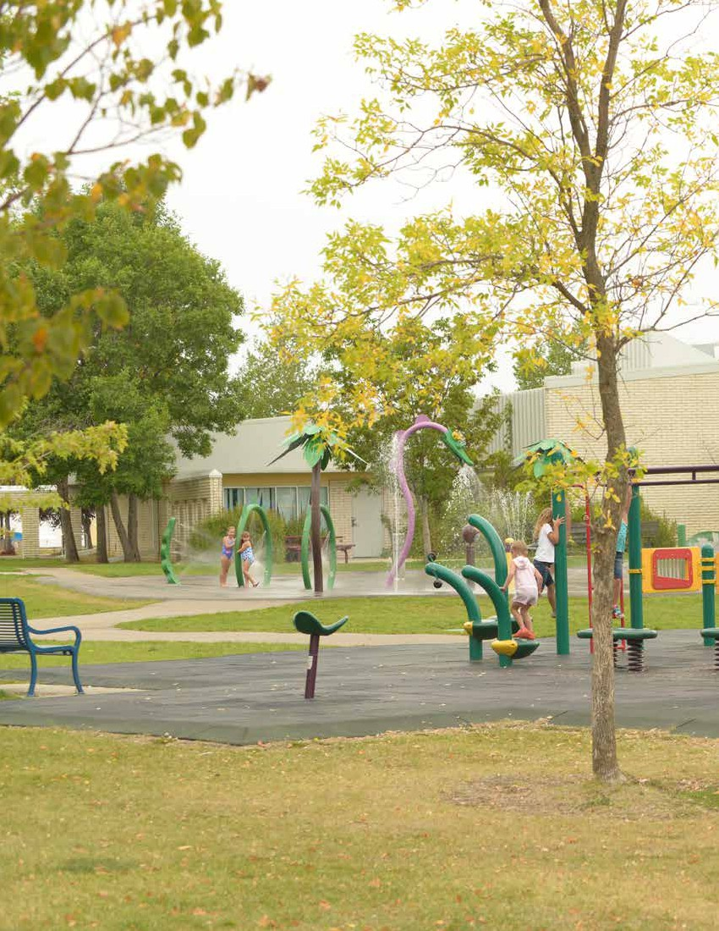
84

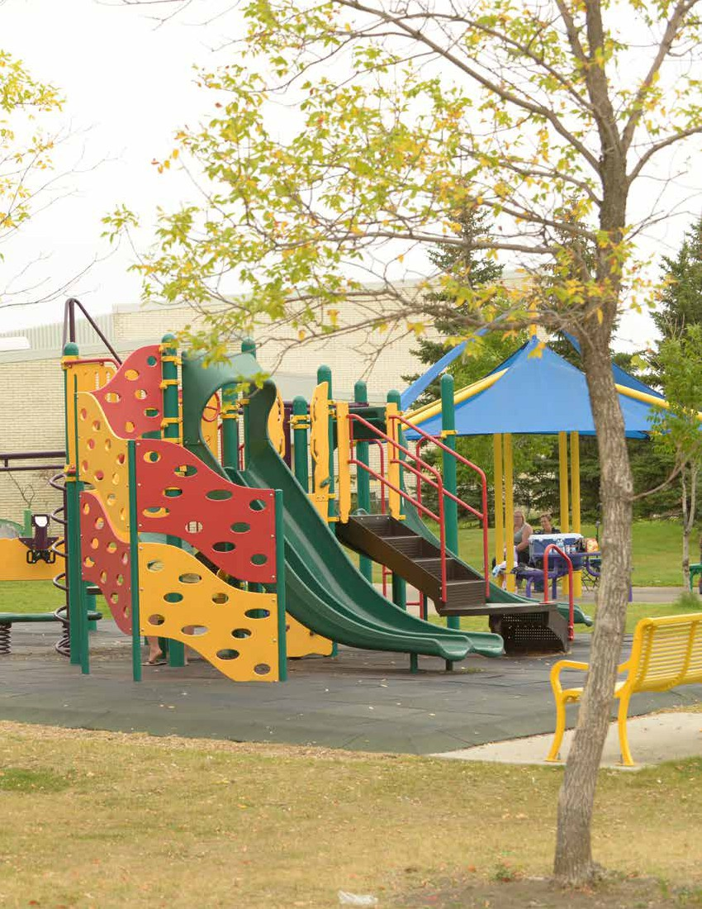

SECTION 11
Consultation
85

REGINA RECREATION MASTER PLAN

SECTION 11
Consultation

Stakeholder interviews and focus group discussions
were convened as well. These meetings included some of

KEY FINDINGS FROM THIS SECTION
• The most utilized recreation spaces among
residents are spontaneous outdoor assets
(walking/running trails and pathways, passive parks, City Square Plaza/
Victoria Park, playgrounds).
• Lack of quality spaces and not being able
to get access to spaces are the top challenges
for community groups.
• Among youth, leisure pools and outdoor
swimming pools were the top indoor and
outdoor needs respectively.

A variety of consultation mechanisms were conducted to
engage residents and stakeholder in Regina. A telephone
survey generated input from the 600 households in the
Regina area. Households were randomly called to participate
in the survey. Soft quotas were employed to ensure appropriate
levels of representation from the recreation zones. Additionally
soft quotas were utilized to ensure there was appropriate
representation from age segments. The soft quotas were based
on population data for Regina. In addition to the telephone
survey, an online survey was fielded to enable all Regina residents the opportunity to participate in the survey. The online survey also enabled residents from outside the city but within the market area to participate. A further 1,391 full and partial responses were collected online. The findings from the two surveying methodologies are presented separately.
Organized community groups were also surveyed. Utilizing contact lists provided by the City of Regina, groups were
invited to participate in the survey through an email. The email
included a link to the online survey; a hard copy of the group
questionnaire was attached to the email as well. In total 558
groups were invited to participate with 185 responses received.
See the appendices to see the list of groups from whom a
response was provided.
86
the organized groups that were invited to participate in the
community group survey. Other key stakeholders were invited
into this process as well—organizations such as community
partners. Refer to the appendices to see the list of participants.
A youth survey was conducted in the schools to understand the needs of youth in the community. The public, Catholic, and private school jurisdictions in Regina were approached by the City to request participation of their students in
this Master Planning process. Once approval was granted, individual schools and teachers were able to opt into the process. In total over 600 responses were gathered from students in over 30 schools.
Finally two public events were convened to provide a venue
for members of the public to discuss the study with members
of the project team and to provide some thoughts. The main
outcome from these two events was further promotion and
encouragement for participation in the online resident survey.

SECTION 11: CONSULTATION

Mechanism | Description | Responses/Participants
Household Survey | A statistically representative survey of City residents.  Telephone and online survey results were collected.  Subsegment analysis of the telephone survey  was incorporated. | 600 Responses from telephone survey;  1,391 Responses from online survey
Community Group Survey | Online survey (with hard copy available upon request)  for community groups such as sport organizations,  schools and service clubs. | 185 Responses (including 25 schools;  16 community associations)
Stakeholder Interviews/  Focus Group Discussions | In-person interviews with key stakeholders in the  community. Supplementary telephone interview were  also conducted. | 57 sessions convened with 132  participants representing 116 groups.
Youth Survey | Hard-copy and online survey to gather the opinions  and needs of students and youth. | 615 responses gathered from 32 schools
Open Houses | Display panels exhibited to promote the engagement  opportunities to residents. | Two open houses were conducted in the  consultation phase of the research.

Household Survey

Subsegment analysis allowed biases and trends to be

identified from the responses of each question. Where

A household survey was conducted by RC Strategies+PERC
in conjunction with the City of Regina to gather the public’s
thoughts and preferences regarding recreation. The survey
was organized to identify residents’ perspective on the
current and future state of recreation in the City. The survey was conducted via telephone¹ and a target of 600 responses was achieved resulting in overall findings that are statistically representative of city residents with a margin of error of
±4.0% 19 times out of 20.²
Respondents from the telephone survey were asked a series of personal questions to categorize them into certain subsegments. The telephone survey findings were then examined according to those subsegments, which included residency according to recreation district, household composition, income distribution and others.

1 Numbers were randomly dialed and included cell phone numbers.
2 This means that if the survey was fielded twenty times, on nineteen
occasions the findings would be within 4.0%. These findings are considered representative of city residents.
appropriate, the significant findings from the subsegment analysis will be presented. The survey results are presented in the order the questions were asked.
A web version of the questionnaire was also available on the City`s website to provide the opportunity to all residents
(including those in the broader market area) to share their thoughts. Over 1,300 full and partial findings were gathered through this mechanism. Findings from the online survey are presented for selected questions where responses are markedly different.
The graphs displayed herein represent findings from the telephone survey.
87

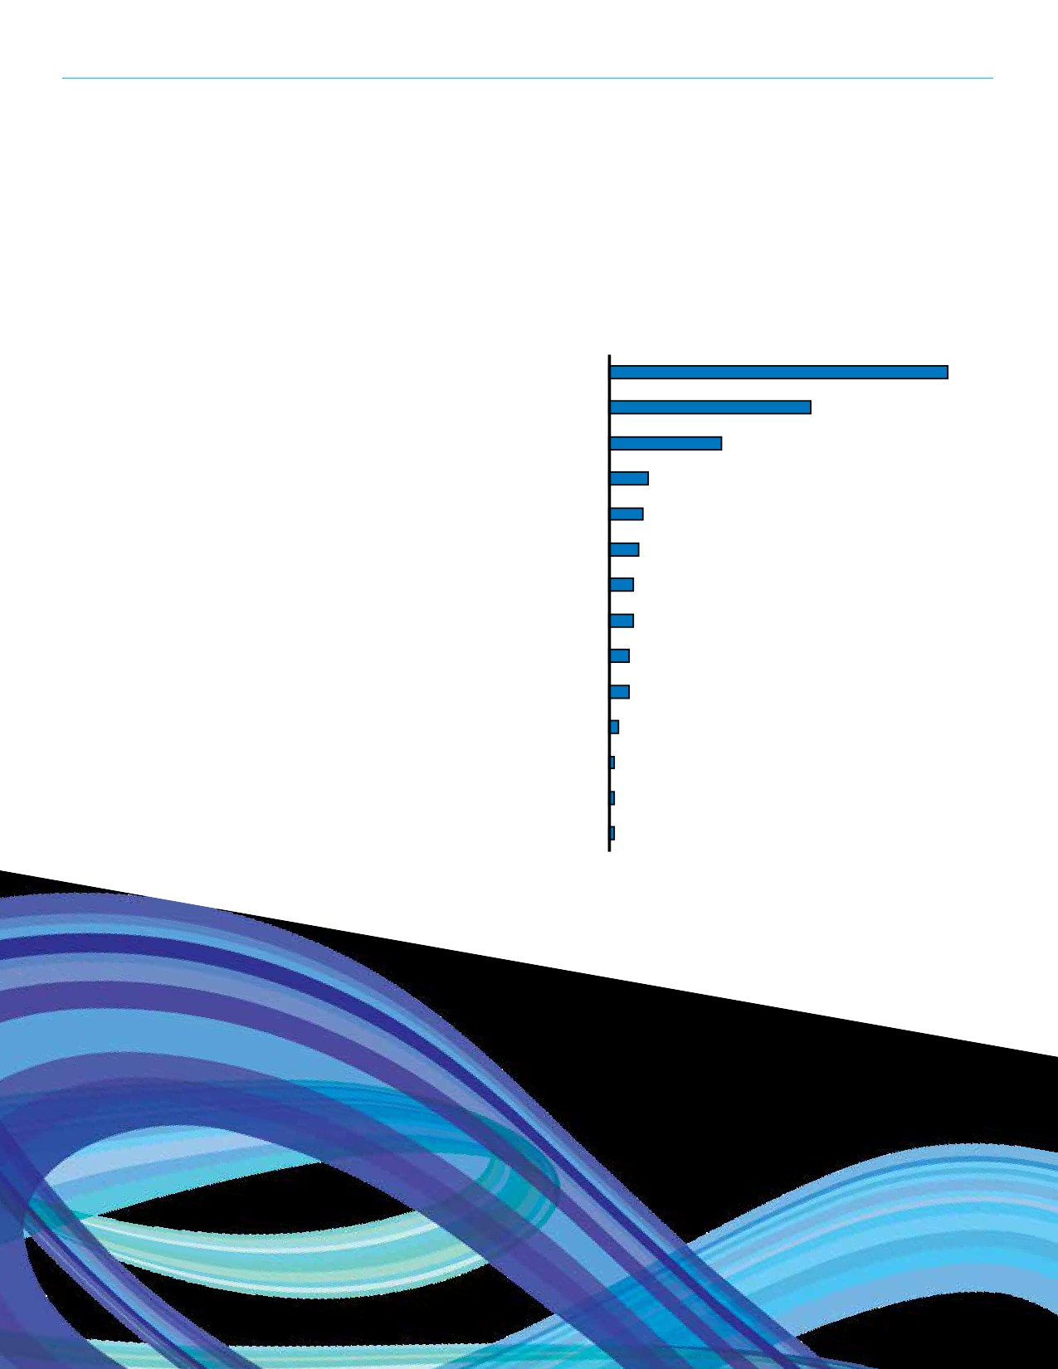REGINA RECREATION MASTER PLAN

Top of Mind Thoughts
To begin the survey, respondents were asked to indicate the main reasons
that the members of their households
participate in recreation activities. As
illustrated in the accompanying figure,
approximately two-thirds (69%) of
respondents indicated health reasons.
For fun (41%) and to socialize (23%)
were the next most commonly cited
reasons for participation in household
recreation activities. Refer to the graph for other responses.
Subsegment Findings
• Respondents with a household
income of $60 - $105k (72%) and
greater than $105k (80%) were more
likely to participate in recreational
activities than respondents with a
household income of less than $60k
(58%).
• Respondents with children 9 years
of age and younger in the home
were more likely to participate in recreational activities (52%) for fun than those without children in the home (36%).
Web Survey Results
Respondents were allowed to choose all
reasons they participated in recreation
activities. Top reasons are listed here:
• For fun (81%)
• Health reasons (76%)
• Relax/relieve stress (55%)
• To enjoy the outdoors/get fresh air
(54%)
88

Reasons for Participating in Recreation
Health reasons 69%
For fun 41%
Socializing 23%
To get away 8%
Relax/relieve stress 7%
To enjoy the outdoors/get fresh air 6%
Improve skills or knowledge 5%
Enjoy a challenge 5%
Something different than work 4%
Learn new things 4%
Help the community 2%
Unsure 1%
Satisfy curiosity 1%
To be creative 1%

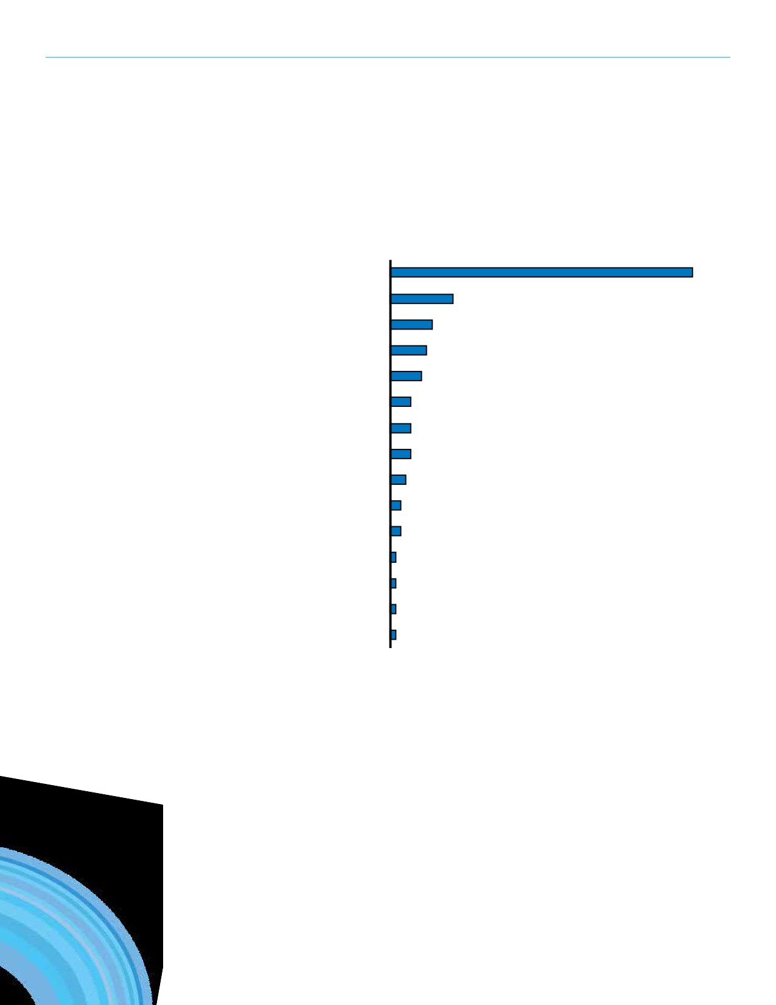SECTION 11: CONSULTATION

Description of Facilities, Programs and Events
Respondents were then asked to
describe the City of Regina’s recreation
facilities, programs and events.
A majority of respondents (58%)
commented that the City’s recreational
offerings were good/adequate. The
next most cited comments included:
Excellent (12%); Lacking (8%); Diverse
(7%); and Needs improvement (6%).

Description of Facilities, Programs, and Events

Good/Adequate
Excellent 12%
Lacking 8%
Diverse 7%
Need improvements 6%
Accessible 4%
Not enough diversity 4%
Affordable 4%
Expensive 3%
Convenient 2%
Inconvenient 2%
Overcrowded 1%
Outdated 1%
Active 1%
Underutilized 1%

58%
89

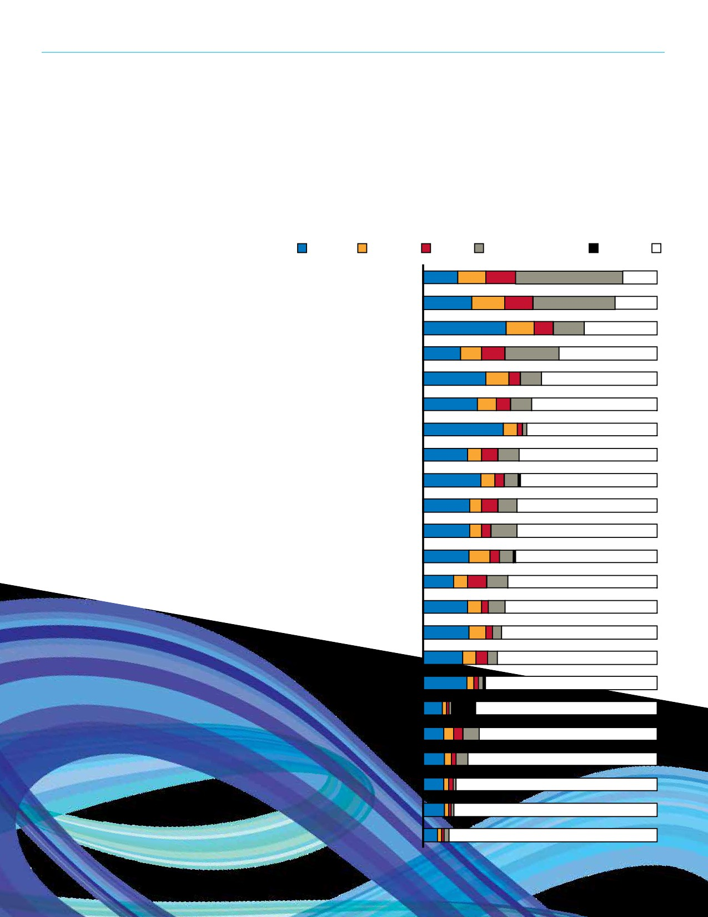REGINA RECREATION MASTER PLAN

Current Usage/Visitation
Respondents were presented with a list of
some recreation facility types owned by
the City. For each type they were asked to
indicate the number of times a household
member has used or visited it as an active
participant in the previous year. Walking/
running trails and pathways were used
by a large majority of households (85%).
In fact almost half (46%) used the trails
and pathways twenty-one or more times.
Similarly, the passive parks including
natural areas were used by 82% of
households. Other facilities that were used
by at least half of households included:
and City Square Plaza/Victoria Park
(69%); playgrounds (52%); and the Sandra
Schmirler Leisure Centre (50%). See the
accompanying graph for additional details.
Subsegment Findings
• Residents with an annual household
income greater than $105k reported
using arenas significantly more (55%) than those with an annual income
of $60k - $105k (39%) and less than $60k (32%).
• Respondents aged 18 - 40 reported
using Neighbourhood Recreation
Centers significantly more (53%) than those aged 61 and over (39%).
• Residents with an annual household
income greater than $105k reported using Playgrounds significantly more (70%) than those with an annual
income of $60k - $105k (56%) and less than $60k (51%).
• Those with tenure of 6 - 15 years in the
community used playgrounds more
(70%) than those with over 16 years tenure in the community (54%).
• Residents with an annual household
income greater than $105k (91%)
and between $60k - $105k (91%)
reported using Walking/running trails
and pathways significantly more than
households with an income of less
than $60k (77%).
90

Utilization of Recreation Spaces

1 - 5 Uses 6 - 10 Uses 11 - 20 Uses 21+ Uses Unaware/Never Heard of It Did Not Use

Walking/running trails and pathways 15% 12% 13% 46% 0% 15%

Passive parks including natural areas 21% 14% 12% 35% 0% 18%

City Square Plaza/Victoria Park 35% 12% 8% 13% 0% 31%

Playgrounds 16% 9% 10% 23% 0% 42%

Sandra Schmirler Leisure Centre 27% 10% 5% 9% 0% 50%

Neighbourhood Recreation Centres 23% 8% 6% 9% 0% 53%

Picnic shelters/facilities 34% 6% 2% 2% 0% 55%

Field House (at Elphinstone Street) 19% 6% 7% 9% 0% 59%

EventPlex (Evraz Place) 25% 6%4%6% 1% 59%

Lawson Aquatic Centre 20% 5%7% 8% 0% 60%

Arenas 20% 5%4%11% 0% 60%

Spray parks 20% 9% 4%6% 1% 61%

Sports fields 13% 6% 8% 9% 0% 63%

North West Leisure Centre 19% 6%3%7% 0% 65%

Outdoor pools 20% 7%3% 4% 0% 67%

Outdoor rinks 17% 6%5%4% 0% 69%

Neil Balkwill Civic Arts Centre 19% 3% 2% 2% 1% 74%

Canada Games Athletic Complex 8% 2% 1%1%10% 76%

Ball diamonds 9% 4%4%7% 0% 76%

Dog parks 9% 3% 2% 5% 0% 80%

Outdoor tennis courts 9% 2%2% 1% 0% 86%

Regent Park Par 3 golf course 9% 2% 1% 1% 0% 86%

Skateboard parks 6% 2% 1% 2% 0% 88%

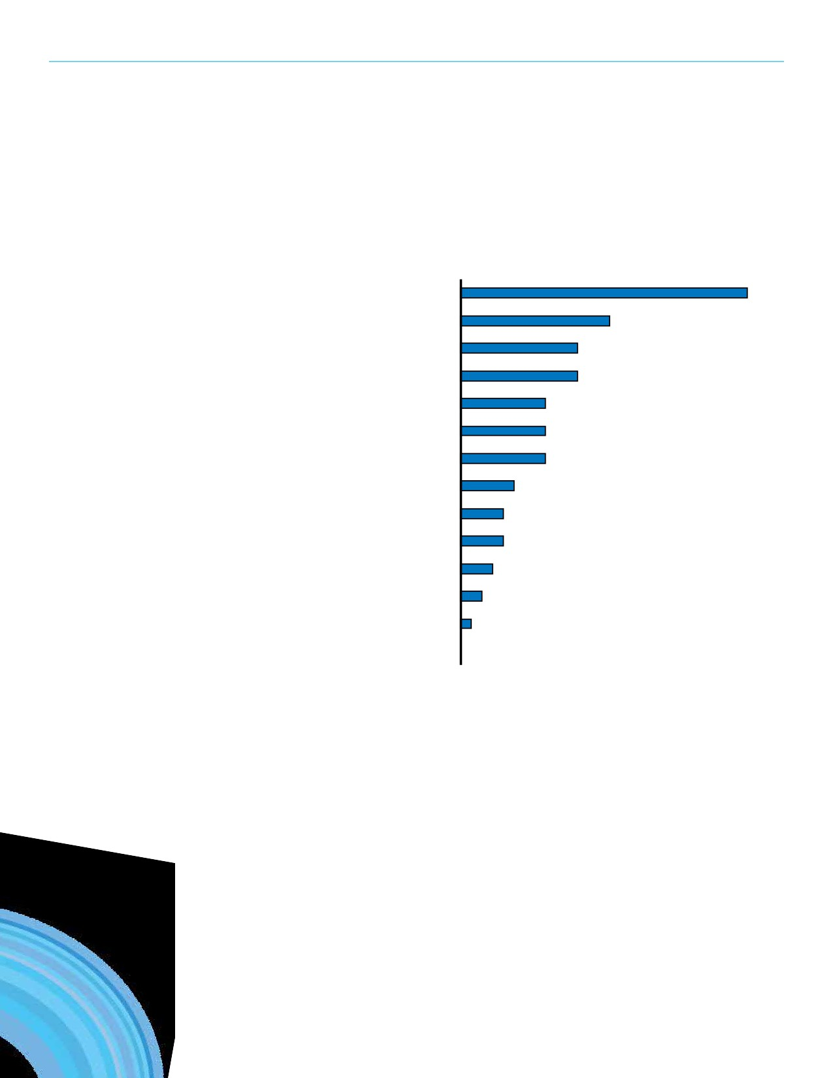SECTION 11: CONSULTATION

Barriers to Participation
Households were asked to identify
what, if anything prevents them
or anyone in their household from
participating in recreation programs and activities in Regina. Twenty-seven percent (27%) of respondents reported being busy with other activities as
the largest barrier to participation. Additionally, fourteen percent (14%) of respondents reported health
issues, illness and injury as their most significant barrier to participation. Distance/access and cost/price were also significant barriers.
Subsegment Findings
• Busy with other activities was
a more reported barrier for
respondents aged 18 - 40 (32%) and 41 - 60 (31%) than respondents aged 61 and over (13%).
• Cost/price (admission/equipment)
was a more significant barrier for
those with children in the house (17%) than those without children in the house (8%).
Web Survey Results
• Overcrowded facilities (35%)
• Lack of facilities (33%)
• Cost/price (30%)
• Distance/access (25%)

Busy with other activities
Health issues/illness/injury
Distance/access
Cost/price
Timing
Don't have the ability
Lack of motivation
Weather

Lack of facilities

Overcrowded facilities
Unaware of some opportunities
Age
Poor facilities
Registration process

Barriers to Participation
27%
14%
11%
11%
8%
8%
8%
5%
4%
4%
3%
2%
1%
0%
91

REGINA RECREATION MASTER PLAN

Amount of Travel
Time Acceptable
Respondents were asked what amount
of travel time to recreational facilities
they deemed to be acceptable before
it was a barrier to their attendance.
While twenty-one percent (21%) of
respondents stated that travel time to
a recreation facility is not a barrier to
participation, a larger proportion (28%) commented that travel time beyond
15 minutes (one way) would serve as a
barrier. Approximately two-thirds (64%)
of respondents felt that travel time up

What amount of travel time is acceptable?

46-60 min (one way) 5%

31-45 min (one way) 10%

15 -30 min (one way)

Up to 15 min (one way)

I do not think travel time is a barrier

28%

36%

to 30 minutes one way was acceptable.
Subsegment Findings
• Respondents residing in the North
Zone expressed they are more
willing to travel to recreation
facilities (36%) significantly more
than all other recreation zones.
Web Survey Results
• Fifty-eight percent (58%) of
respondents are willing to travel
between 15 and 30 minutes one
way before considering travel time a barrier.
92
to using recreation facilities 21%

Willingness to Travel
Respondents were then asked if they would be willing to travel farther to use some
recreation facilities but not others. This question looked to indicate if preference would take precedent over the length of time it would take to get to a facility. It was found
that over two-thirds (68%) of respondents are willing to travel to use some recreation facilities over others.
Subsegment Findings
• Residents with 0 - 5 year’s tenure in the community reported being more willing
to travel farther for different facilities (85%) than those with over 16 years
tenure in the community (70%)

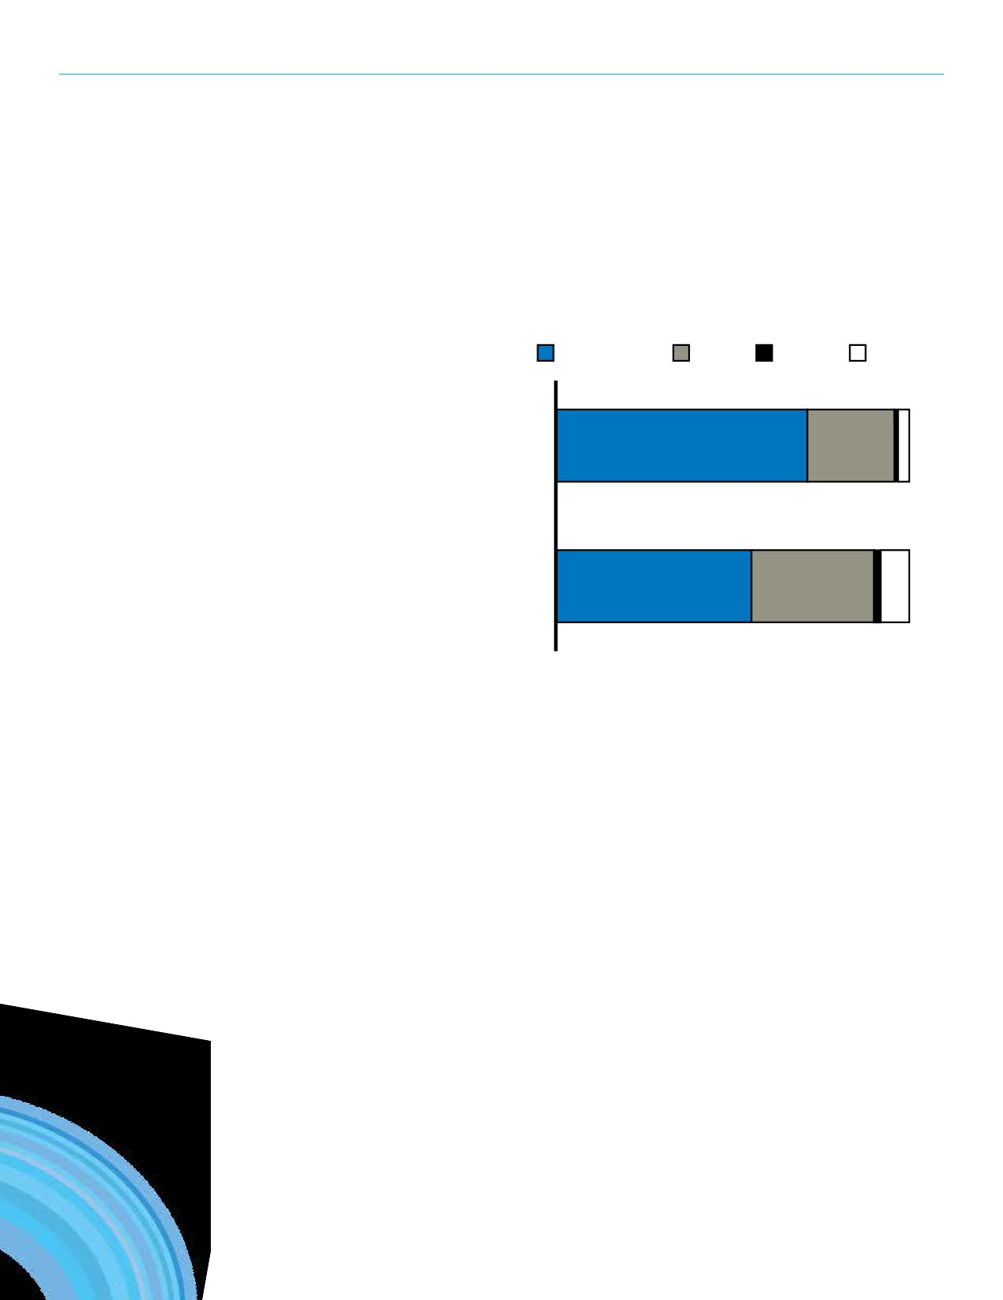SECTION 11: CONSULTATION

Level of Agreement Statements
For the statements about recreation in
the accompanying chart, respondents
were asked to what extent they agree or
disagree with the statements. Ninety-
seven percent (97%) agree that the
community as a whole benefits from
the recreation programs and services
in Regina. Additionally, seventy-two
percent (72%) strongly agreed with that
statement. Ninety-one percent (91%)
agree that the recreation programs and
services in Regina are important to their
quality of life.
Subsegment Findings
• For the statement regarding
recreation as a benefit to quality
of life, those with no seniors in the
home more strongly agreed (60%)
than those with seniors in the home
(49%).
Web Survey Results
• The degree to which online
respondents agreed with the
recreation statements was similar to those who responded to the
household survey.
• Web survey participants were
more likely to strongly agree that
recreation programs and services are important to their quality of life (62% strongly agreed) and that the community benefits of recreation programs and services (81%
strongly agreed).

Strongly Agree

The community as a
whole benefits from the
recreation programs and
services in Regina.

The recreation programs
and services in Regina
are important to my
quality of life.

Recreation Statements

Somwhat Agree Unsure

72%

56%

Disagree

25%1% 3%

35% 2% 8%
93

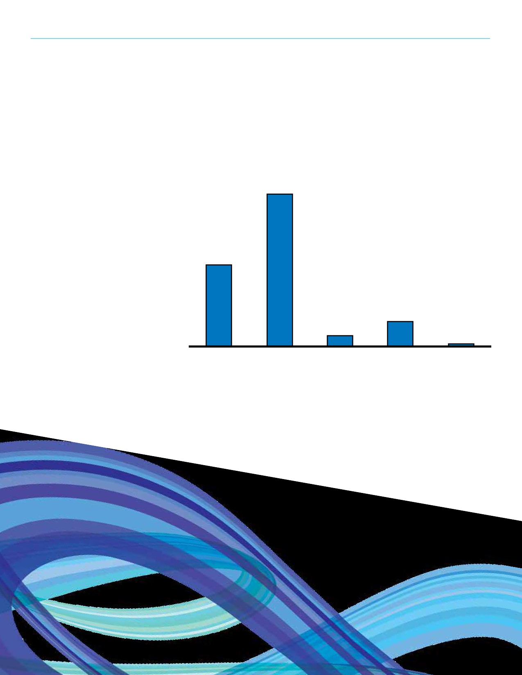REGINA RECREATION MASTER PLAN

Satisfaction with Recreation Programs and Services
In reference to the existing recreation programs and services, respondents were asked about their level of
satisfaction. It was found that eighty-
six percent (86%) of households are
satisfied with the current recreation
programs and services currently offered in Regina (30% very satisfied; 56%
somewhat satisfied).
Reasons for Being
Satisfied/Dissatisfied
According to the response of the above answer, respondents were then asked to identify why they were satisfied/
dissatisfied with the current recreational

Satisfaction with Recreation Programs and Services
56%

30%

9%
4%

Very Somewhat Unsure Somewhat

1%
Very

programs and services. The most reported reasons for satisfaction are a good
variety of programs (19%) and excellent
programs and services (17%). Those who
reported being dissatisfied with current
recreational services reported a lack of
availability (12%), general programs (8%)
and facilities (8%).
Subsegment Findings
• Respondents with an annual
household income greater than
$105k, expressed that the City
offers a good variety of programs
significantly more (25%) than those with an annual income less than
$60k (13%).
• Residents aged 61 and over
expressed that the City has excellent
programs and services significantly
more (23%) than those aged 18 - 40.
94
Satisfied Satisfied
Dissatisfied Dissatisfied

SECTION 11: CONSULTATION

Need for New and/or Upgraded Recreation Facilities
When asked to identify if there is a need for new and/or upgraded recreation
facilities to be developed in the City of Regina, there was a mixed response. Over half (54%) said “Yes “and forty-
one percent (41%) said “No”.
Subsegment Findings
• Residents with longer tenure in
the community said no (44%)
significantly more times than those
with short tenure in the community
(26%).
• Respondents aged 18 - 40
expressed a need for new and/or
upgraded facilities significantly
more (62%) than those aged 61 and over (44%).
Web Survey Results
• A large proportion of respondents
(87%) said there is a need for new /
upgraded recreation facilities, 9% were unsure, and only 5% said there is no need.

Need for New and/or Upgraded Recreation Facilities

41%
No
5%
Unsure
54%
Yes
95

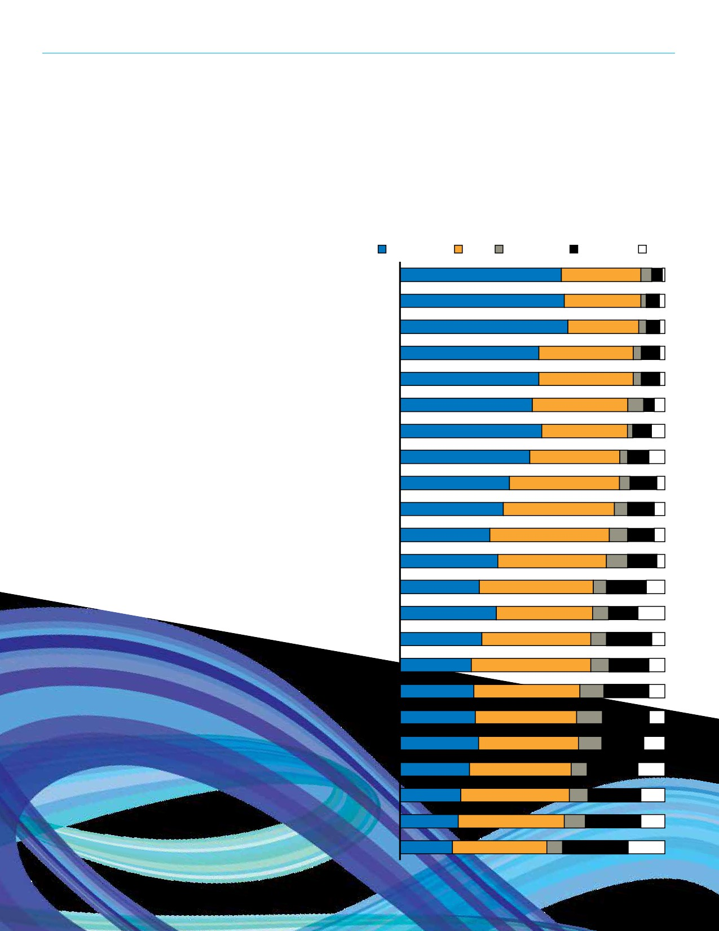REGINA RECREATION MASTER PLAN

Indoor Priorities
Respondents who think facilities should be developed (and those who were
unsure) were then asked to identify
their levels of support for various
indoor and outdoor facilities. Of the
59% of respondents who answered
“yes” or “unsure”, the most support for indoor facilities was provided for: youth centres (91%), indoor leisure swimming pools (91%), and senior’s centres/
facilities (91%). By order of most
strongly supported indoor components,
the top was senior’s centres/facilities
(64%). The next most cited were: Indoor
leisure swimming pools (62%); Youth
centres (61%); Support amenities (53%);
Indoor walking/running track (53%);
and Fitness/wellness facilities (53%).
Subsegment Findings
• Those with no children in the home

Support for Indoor Spaces

Strongly support Somewhat support Unsure Somewhat oppose Strongly oppose

Youth centres 61% 30% 4%4% 1%

Indoor leisure swimming pools 62% 29% 2% 5%2%

Seniors centres/facilities 64% 27% 3% 5% 2%

Support amenities 53% 36% 3% 7% 2%

Indoor walking/running track 53% 36% 3% 7% 2%

Indoor child playgrounds 50% 36% 6% 4%4%

Fitness/wellness facilities 53% 32% 2% 7% 5%

Child minding 49% 34% 3% 8% 6%

Ice surfaces for leisure skating use 41% 41% 4% 10% 3%

Gymnasium type spaces 39% 42% 5% 10% 4%
Arena facilities for ice
34% 45% 7% 10% 4%

listed curling as much more of a priority (37%) than those without children in the home (18%).
• Respondents with an annual
household income of less than $60k
strongly supported child minding as
a priority significantly more (63%)
than those with households incomes
$60k - $10k (44%) and greater than
$105k (45%).
and dry floor use summer
Year round indoor flat surfaces

Indoor climbing wall

Aboriginal Cultural/Ceremonial room

Multipurpose program/meeting rooms

Gymnastics studio

50 metre competition swimming pools

25 metre competition swimming pools

Curling rinks

Indoor skateboard facility

Indoor tennis

Dance studio

Social/banquet facilities

37% 41% 8% 11% 3%

30% 43% 5% 15% 7%

36% 36% 6% 11% 10%

31% 41% 6% 17% 5%

27% 45% 7% 15% 6%

28% 40% 9% 17% 6%

29% 39% 10% 18% 6%

30% 38% 9% 16% 8%

26% 38% 6% 19% 10%

23% 41% 7% 20% 9%

22% 40% 8% 21% 9%

20% 36% 6% 25% 14%
96

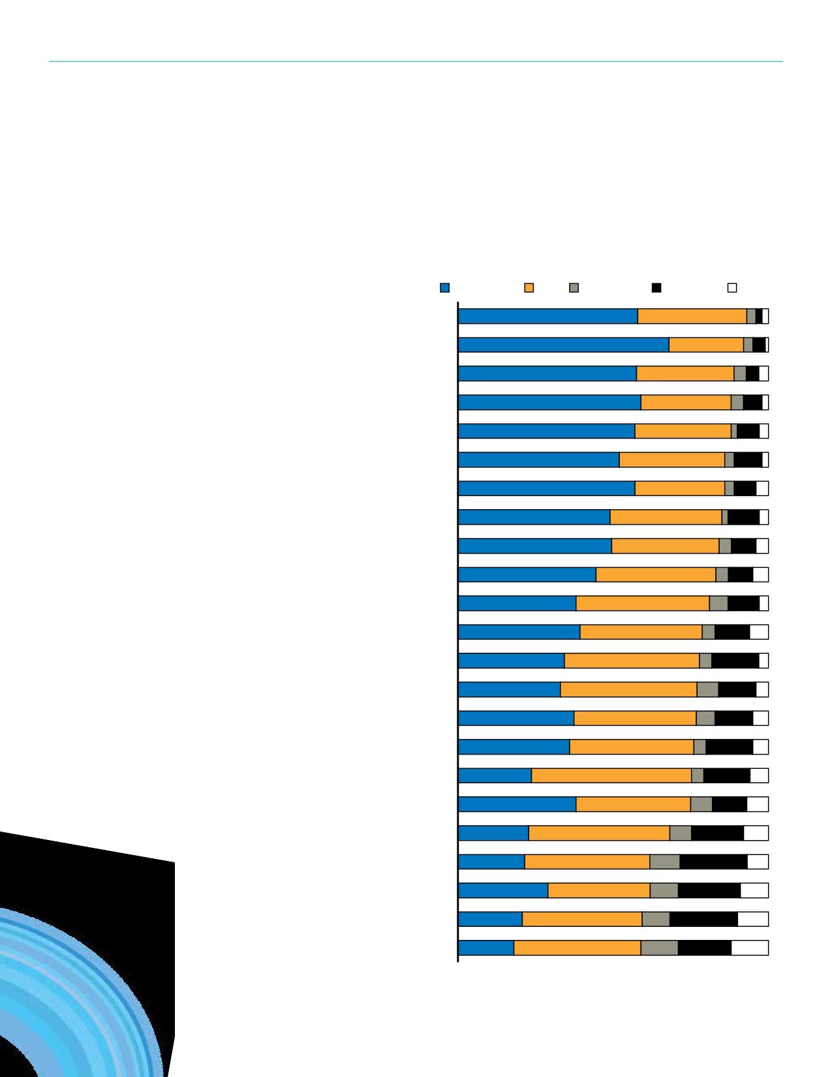SECTION 11: CONSULTATION

Outdoor Priorities
Considering outdoor facility
components those receiving the
greatest amount of total support
included: support amenities for sport
facilities (such as lighting, parking,
seating and washrooms) (93%),
children’s playgrounds (92%) and
shared use trail network/systems
(88%). By order of most strongly
supported outdoor components the
top is children’s playgrounds (68%).
The next highest strongly supported
amenities were cited as: Community
gardens (59%); Support amenities for
sport facilities (58%); Shared use trail
network/system (57%);Passive parks
(including natural areas) (57%); and
Hiking/walking amenities (57%).
Subsegment Findings
• Respondents with no seniors in
the household strongly supported
shared use trail networks/systems significantly more (62%) than
households with seniors (46%).

Support for Outdoor Spaces

Strongly support Somewhat support Unsure Somewhat oppose Strongly oppose

Support amenities for sport facilities 58% 35% 3% 2% 2%

Children’s playgrounds 68% 24% 3%4% 1%

Shared use trail network/system 57% 31% 4%4% 3%

Community gardens 59% 29% 4%_{6%} 2%

Passive park (including natural areas) 57% 31% 2% 7% 3%

Sport fields (grass) 52% 34% 3% 9% 2%

Hiking/walking amenities 57% 29% 3% 7% 4%

Picnic areas 49% 36% 2% 10% 3%

Water spray parks 50% 35% 4% 8% 4%

Outdoor swimming pools 45% 39% 4% 8% 5%

Outdoor basketball courts/sport courts 38% 43% 6% 10% 3%

Outside festival venue/amphitheatre 39% 39% 4% 11% 6%

Track and field spaces 34% 43% 4% 15% 3%

Bike parks (BMX, mountain bike) 33% 44% 7% 12% 4%

Ball diamonds 37% 39% 6% 12% 5%

Boating facilities (non-motorized) 36% 40% 4% 15% 5%

Skateboard parks 24% 52% 4% 15% 6%

Dog off leash parks 38% 37% 7% 11% 7%

Outdoor tennis courts 23% 46% 7% 17% 8%

Sand/beach sand volleyball courts 22% 41% 10% 22% 7%

Outdoor fitness equipment 29% 33% 9% 20% 9%

Sport fields (artificial turf) 21% 39% 9% 22% 10%

Cricket fields 18% 41% 12% 17% 12%
97

REGINA RECREATION MASTER PLAN

Improvements to Programming
Recognizing that there are a number
of organizations that offer recreation
and parks programs to city residents,
respondents identified improvements
to existing programs. Accommodating
more participants (16%), greater
variety (14%) and affordability (13%)
were the highest reported answers
for improvements to new or existing
programs.
Subsegment Findings
• Accommodating more participants
was more important for household
with children (24%) compared to those without children (12%).
• A greater variety of programs was
more important to households that
make less than $105k (20%) than
those that make over $105k (9%).
• Those who said “Yes” to new/
upgraded facilities opted for
greater variety of programs (19%)
significantly more than those
who voted “No” to new/upgraded
facilities (9%).
Web Survey Results
The top five reported suggestion to
programming for the web survey were
distinct from the household survey.
1. More convenient schedule (41%)
2. Greater variety (40%)
3. Accommodate more participants
(39%)
4. More affordable (36%)
5. Improved marketing of programs
(44%)
98

Improvements to Programming

Accommodate more participants

Greater variety

More affordable

Improved marketing of programs

More convenient schedule 10%

Offered more frequently 7%

Enhanced content 7%

Better instruction 4%

16%
14%
13%
12%

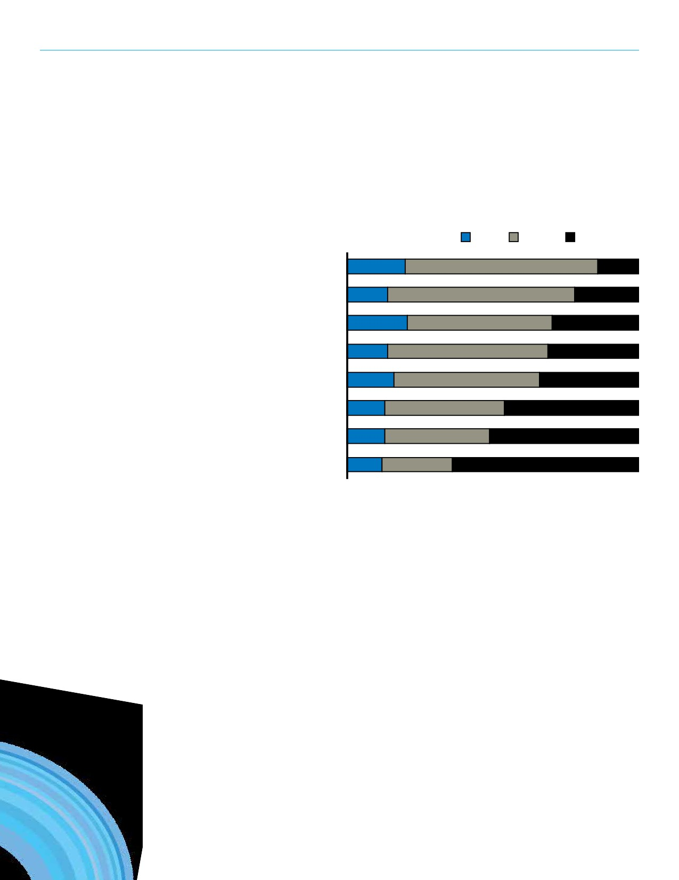SECTION 11: CONSULTATION

Adequacy of Programming
For each of the groups, respondents
were asked to identify if the existing
recreation programs are adequate for
multiple groups. Recreation programs
for people with disabilities (20%) and
for youth (21%) were expressed as being inadequate by approximately one-fifth of survey respondents.
Subsegment Findings
• Respondents with no children in the
home expressed inadequacy with
recreation program significantly more (23%) than those with children in the home (11%).
• Respondents with over 16 years
tenure in the community reported
recreation programs being adequate significantly more (38%) than those with 6 - 15 years tenure (22%).
Web Survey Results
• Indigenous peoples: 15% said the
programming is adequate while 13%
said inadequate.
• Children (0 - 12 yrs): 38% said the
programming is adequate while 24%
said inadequate.
• Families: 35% said the programming
is adequate while 31% said
inadequate.
• Adults (20 - 64 yrs): 49% said the
programming is adequate while 31%
said inadequate.

Adequacy of Existing Programs

Inadequate Unsure Adequate

People with Disabilities 20% 66% 14%

New Immigrants 14% 64% 22%

Youth (13-19 yrs) 21% 50% 30%

Indigenous Peoples 14% 55% 31%

Seniors (65+) 16% 50% 34%

Children (0-12 yrs) 13% 41% 46%

Families 13% 36% 51%

Adults (20-64yrs) 12% 24% 64%
99

REGINA RECREATION MASTER PLAN

Availability of Program Types
Respondents that described the existing recreation programs for any one group as inadequate were then asked to identify what
programs/program types should be more available. The most commonly cited programming need for each group are noted below.

Child (0 - 12 years) Program Priorities Family Program Priorities
• More programs (general) (21 mentions) • More programs (general) (32 mentions)
• Sports (general) (11 mentions) • Swimming (11 mentions)
• Swimming (10 mentions) • Better access to programs (6 mentions)
• Fitness (general) (9 mentions) • Ice rinks/Rink time (5 mentions)
• Better access to programs (9 mentions) • Sports (general) (5 mentions)
Youth (13 - 19 years) Program Priorities People with Disability Program Priorities
• More programs (general) (57 mentions) • Better access to facilities (38 mentions)
• Sports (general) (21 mentions) • More programs (general) (21 mentions)
• Art (9 mentions) • Disability accessible programs (17 mentions)
Adult (20 - 64 years) Program Priorities New Canadian Program Priorities
• Better access to programs (14 mentions) • Language (28 mentions)
• More programs (general) (12 mentions) • Mentor programs (16 mentions)
• Fitness (general) (11 mentions) • Cultural (12 mentions)
• Art (8 mentions)
Indigenous Program Priorities
Seniors (65+ years) Program Priorities • More programs (general) (24 mentions)
• More programs (general) (29 mentions) • Cultural (23 mentions)
• Fitness (general) (18 mentions) • Better access to programs (13 mentions)
• Social programs (18 mentions)
• Better access to programs (10 mentions)
100

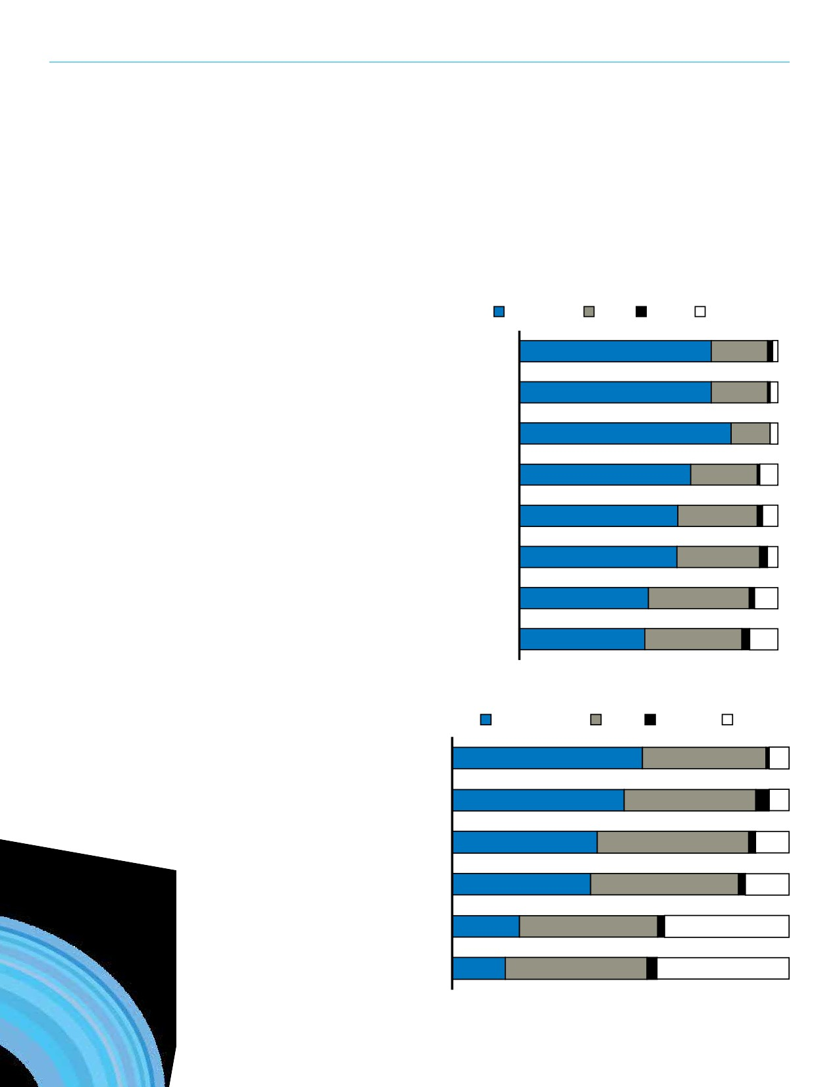SECTION 11: CONSULTATION

Development and Delivery of Recreation Programs, Services, and Facilities
For each of the following statements in the accompanying chart, respondents were asked to indicate their level of
agreement. Ninety-seven percent
(97%) of respondents agree with the
first 3 level of agreement statements.
The first two statements stress the
importance of recreation as a facet to
building community and collaboration between communities. Eighty two
percent (82%) of respondents strongly
agreed that recreation is a must have

Development and Delivery of Recreation
Programs, Services, and Facilities

Strongly agree Somewhat agree Unsure Disagree

Where possible, the municipalities in the
Regina region should work together to provide 75% 22% 2%2%
recreation opportunities for residents.

Recreation helps strengthen and bring 75% 22% 1%3%
the community together.

Recreation is a “must have” service. 82% 15%0 3%

It is important to maintain or upkeep our
existing facilities before we consider 67% 26% 1%7%
developing new ones.
Where possible, facilities should be developed 62% 31% 2%6%

service, which was the most strongly agreed with statement.
considering their impact on the environment.

Recreation contribute to civic pride in Regina.

Residents can benefit even if they do not
use recreation services directly.

Recreation contributes to the local economy by
attracting new residents and visitors.

61% 32% 3%4%

50% 39% 2%9%

49% 38% 3%11%

Site Selection Criteria
Respondents were presented with a series of criteria that could be
used when identifying a location for

Site Selection Criteria

Very important Somewhat important Unsure Unimportant

Being close to

a potential recreation facility. As
illustrated in the accompanying figure,
the primary criteria is proximity to
residential areas (94% of respondents
identified it as very important (57%) or
somewhat important (37%). Availability
of land, and in an area where the city
is growing or plans to grow were also
indicated as important for determining
a potential location.
Subsegment Findings
• Respondents from the Central Zone
reported proximity to residential
areas (67%) as very important significantly more than those from the North Zone (43%).
residential areas

Availability of land

In an area where the city is
growing or planned to grow

Central location for users

On major streets and roadways

Being close to other
recreation facilities
57% 37% 1%6%

51% 39% 4%6%

43% 45% 2%10%

41% 44% 2% 13%

20% 41% 2% 37%

16% 43% 3% 40%
101
%

REGINA RECREATION MASTER PLAN

Tax Support and User Fees
The City of Regina recreation
programs and facilities are paid for
by a combination of tax support
(including property taxes) and fees
paid by users. When asked to share
their opinion regarding tax support
and user fees, seventy-two percent
(72%) and sixty-nine percent (69%) of
households indicated to maintain the
current level of tax support and user
fees respectively. For tax support, 20%
are in support of an increase; 8% are in
support of a decrease. For user, fees,
16% promoted increase while 15%
chose decrease.
Web Survey Results
• Over one-third (41%) said they
would be willing to increase their
level of tax support to fund a new facility.
• Approximately one-quarter (22%)
of respondents indicated that they
would support an increase in user
fees.
102

Increase, Maintain, or Decrease Level of Tax Support

72%
Maintain
8%
Decrease
20%
Increase

Increase, Maintain, or Decrease Level of Tax Support

15%
Decrease
69%
Maintain
16%
Increase

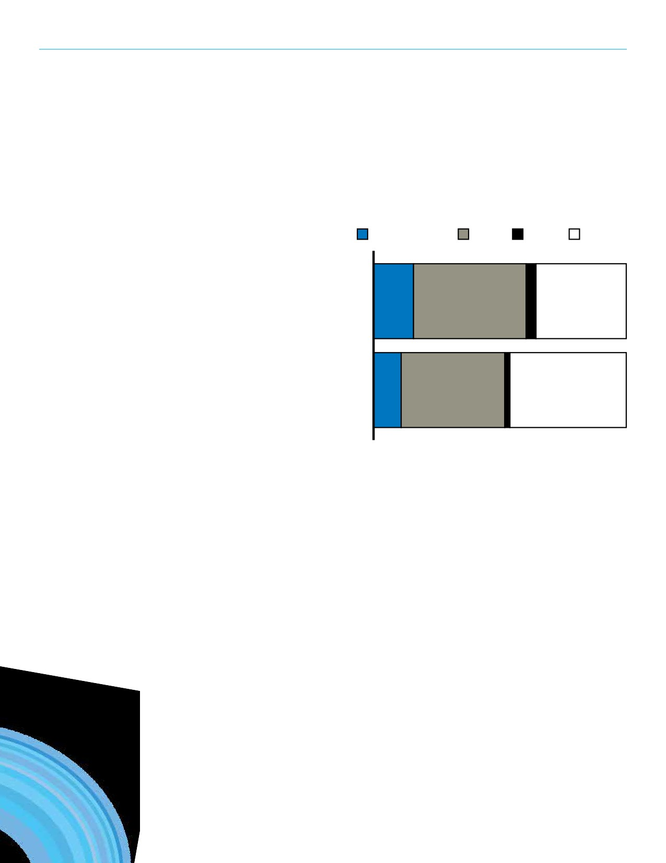SECTION 11: CONSULTATION

Property Tax Statements
Considering recreation programs and facilities, residents were asked if they support or oppose an increase in property taxes. Specifically,
respondents were asked to what degree they would support an increase in

Property Tax Statements

Strongly support Somewhat support Unsure Oppose

Services your

property taxes for recreation services that their household members would, or would not use. The majority of
respondents support (16% strongly
support; 45% somewhat support)
increasing property taxes for services that household members use. However, some respondents still reported they would support (11% strongly support; 41% somewhat support) an increase
in property taxes for services that are important to the community that your household might not use.
Web Survey Results
• Almost three-quarters (72%) said
they would support (32% strongly
support) and 40% somewhat
support) a property tax increase
for services their household would use. Over half (57%) said they would support (18% strongly and 39%
somewhat) an increase in property taxes for services that are important to the broader community but that their households may not use.
household
members use

Services that are important
to the broader community
but that your household
members may not use or
would seldom use.
16% 45% 4% 36%

11% 41% 2% 46%
103

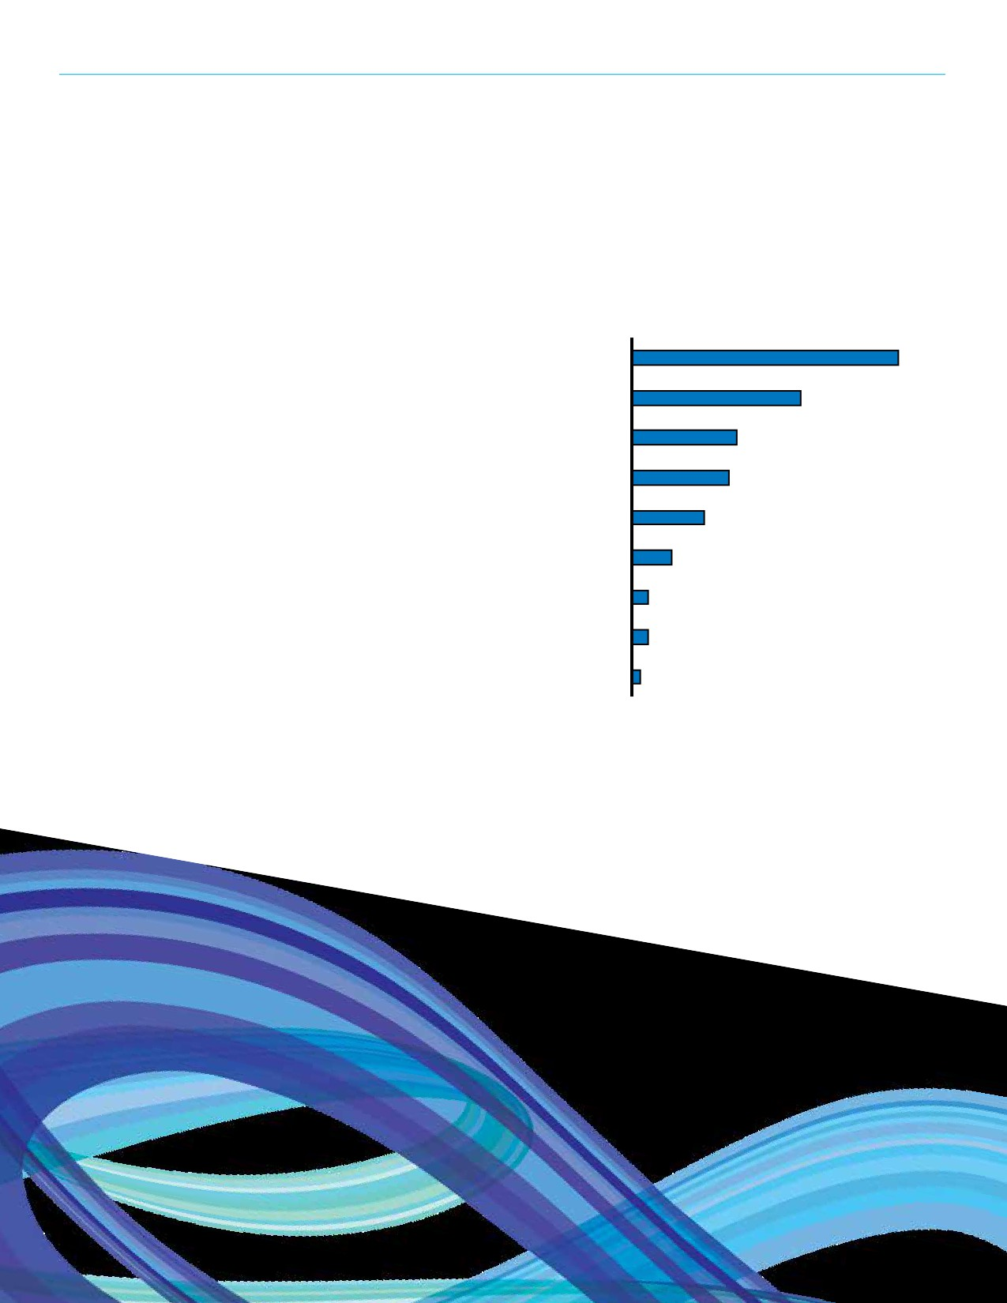REGINA RECREATION MASTER PLAN

Information Source for Recreation Services and Opportunities
Respondents were asked to identify
their main sources of information
regarding recreation and parks services and opportunities in the City of Regina. One-third of (33%) of respondents
selected the Leisure guide as the top
method for information. Internet/
online was the second most reported
source of information (21%). Brochures, pamphlets, newsletters and the City of Regina website were identified as the next best methods, respectively.
Subsegment Findings
• Respondents who have over 6 years
of tenure in the community (36%)
prefer the leisure guide significantly more than those with less than 6
years tenure in the community (13%)
• Residents who own their own home
(36%) prefer the leisure guide
significantly more than those who rent (19%)
• For the respondent who chose
Internet/online generally as their
main source of information, 29%
were aged 18-40 and 22% were
aged 41-60, both of which are
significantly more than those aged
61 and over (7%)
Web Survey Results
• Leisure Guide (76%)
• City website (57%)
• Internet/online generally (52%)
• Word of mouth/referral from
someone (51%)
104

Preferred Sources of Information
Leisure Guide 33%
Internet/online generally 21%
Brochures, pamphlets, newsletters 13%
City website 12%
Word of mouth/referral from someone 9%
Local newspapers 5%
TV 2%
Recreation/community centre 2%
Radio 1%

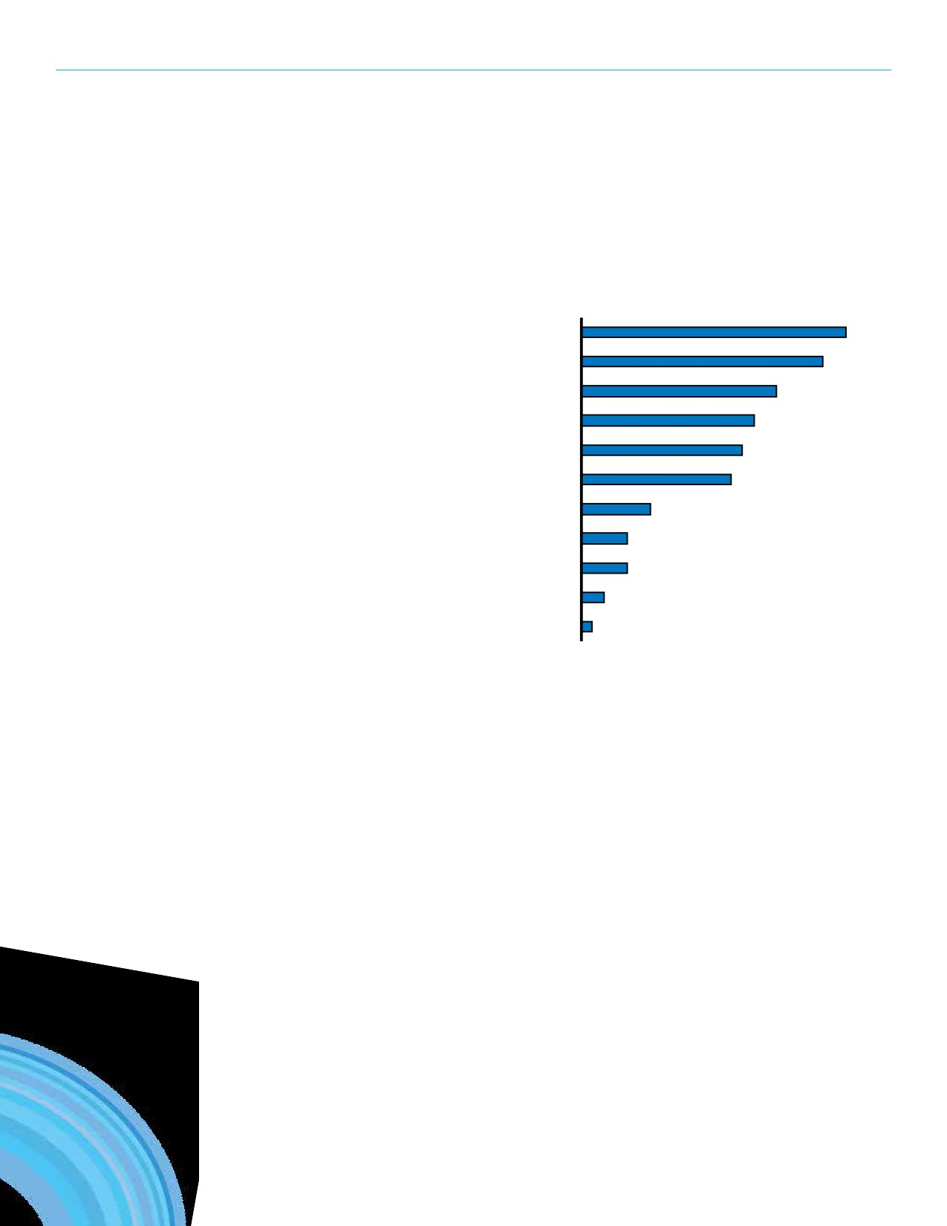SECTION 11: CONSULTATION

Sources of Information
Households were then asked to identify their other sources of information for information about recreation and parks opportunities. The internet/online
was the strongest reported alternative source of information about recreation and parks services in Regina (23%).
Subsegment Findings
• The internet or online generally was
more popular for those with children
in the home (34%) than those without children (18%)
• Residents with seniors in the home
reported using the newspaper for
information (20%) significantly more than residents without seniors in the home (9%)

Other Sources of Information

Internet/online generally
Word of mouth/referral from someone
Leisure Guide
City website
Brochures, pamphlets, newsletters
Local newspapers
Recreation/community centre 6%
TV 4%
Radio 4%
Library 2%
Communication through the schools 1%

23%
21%
17%
15%
14%
13%
105

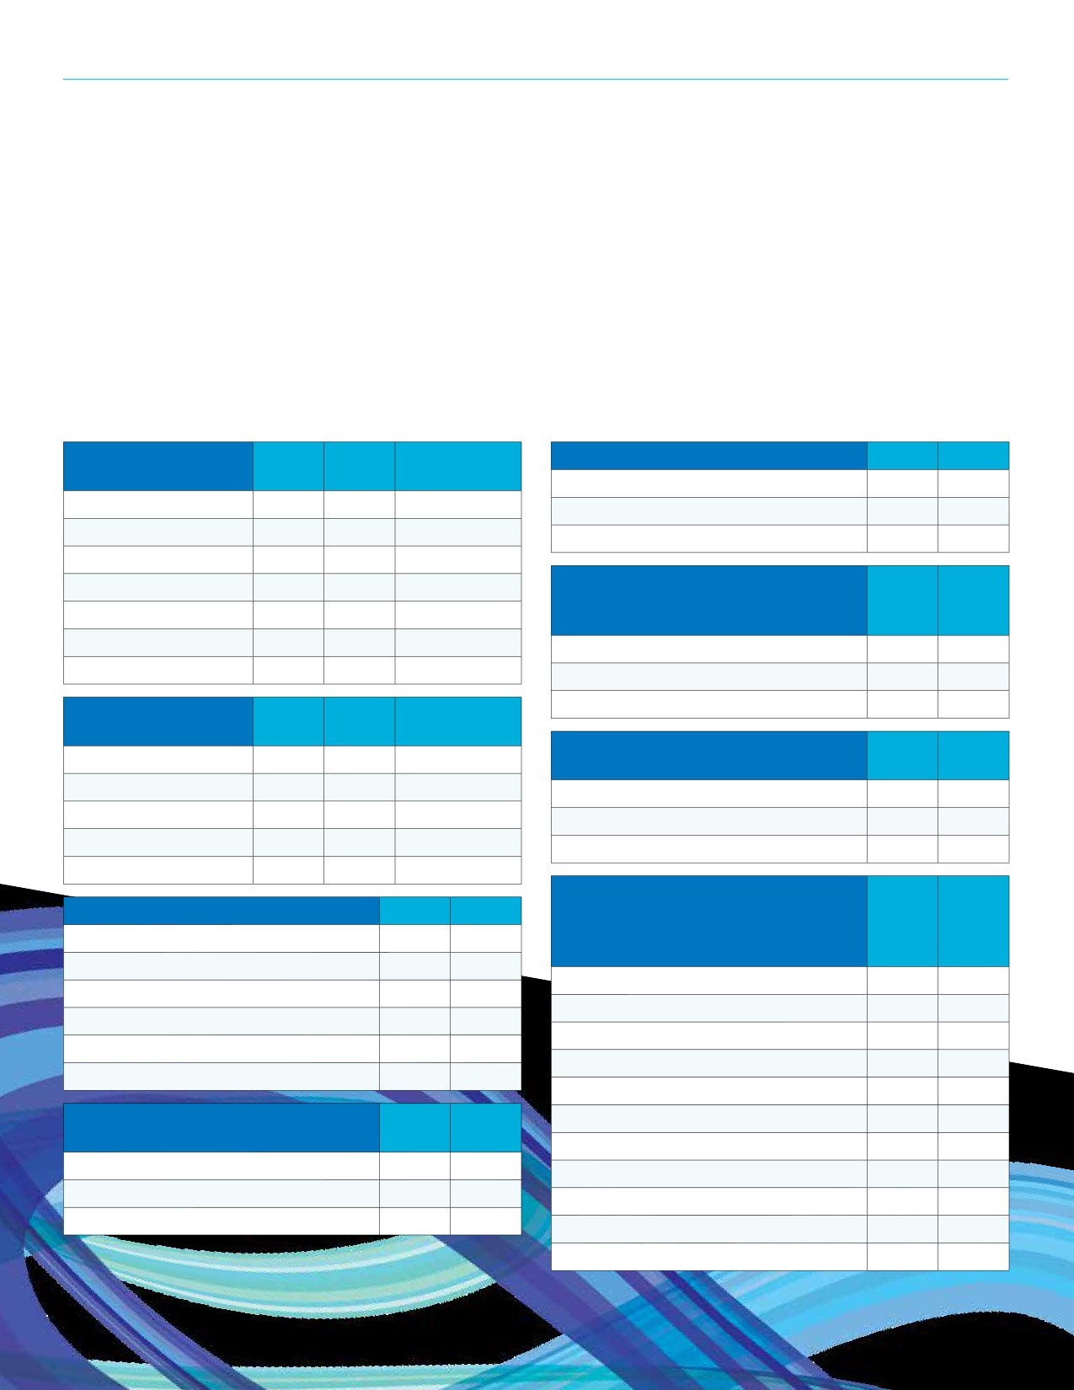REGINA RECREATION MASTER PLAN

Respondent Profile
Population demographic information ensures the integrity of the survey responses. It is essential that the responses and figures are representative of Regina as a whole. The following demographic information of respondents illustrates the demographic components of Regina to maintain that there are no discrepancies.

Household
Composition

Phone Online Actual Regina

Do you own or rent your home? Phone Online
Own 84% 87%

0 - 9 years 14% 24% 13% Rent 15% 13%
10 - 19 years 11% 14% 11% Don't know/refused 1% 0%

20 - 29 years 13% 12% 15%
30 - 39 years 14% 22% 15%
40 - 59 years 26% 23% 26%

Have members of your household
immigrated or resettled in Canada Phone Online within the past 3 years?

60 - 69 years 13% 5% 10% Yes 4% 3%
70+ years 9% 1% 9% No 96% 97%

Respondents by
Recreation Zone
Central

Phone Online Actual Regina
18% 17% 18%
Unsure
Do you or members of your household
consider yourself/themselves Indigenous?
0% 1%

Phone Online

East 24% 24% 23% Yes 11% 7%
North 12% 8% 11% No 88% 92%
South 20% 25% 20% Unsure 1% 2%
West 27% 23% 23%
Which of the following categories

How long have you lived in Regina? Phone Online
Less than 1 year 2% 2%
1 - 5 years 10% 11%
6 - 10 years 8% 13%
11 - 15 years 8% 10%
16 - 20 years 9% 10%
More than 20 years 63% 55%
best describes the total annual income, before taxes, of all members of your household in 2015?
Less than $30,000
$30,000 to just under $45,000
$45,000 to just under $60,000
$60,000 to just under $75,000
$75,000 to just under $90,000
Phone Online

7% 3%
6% 4%
12% 6%
9% 8%
10% 9%

Do you expect to reside in Regina for the next 5 years?
Yes
No
Unsure
Phone Online
94% 90%
4% 2%
2% 8%
$90,000 to just under $105,000 7% 10%
$105,000 to just under $120,000 7% 10%
$120,000 to just under $135,000 4% 7%
$135,000 to just under $150,000 4% 7%
$150,000 and over 16% 23%

Don't know/refused 19% 15%
106

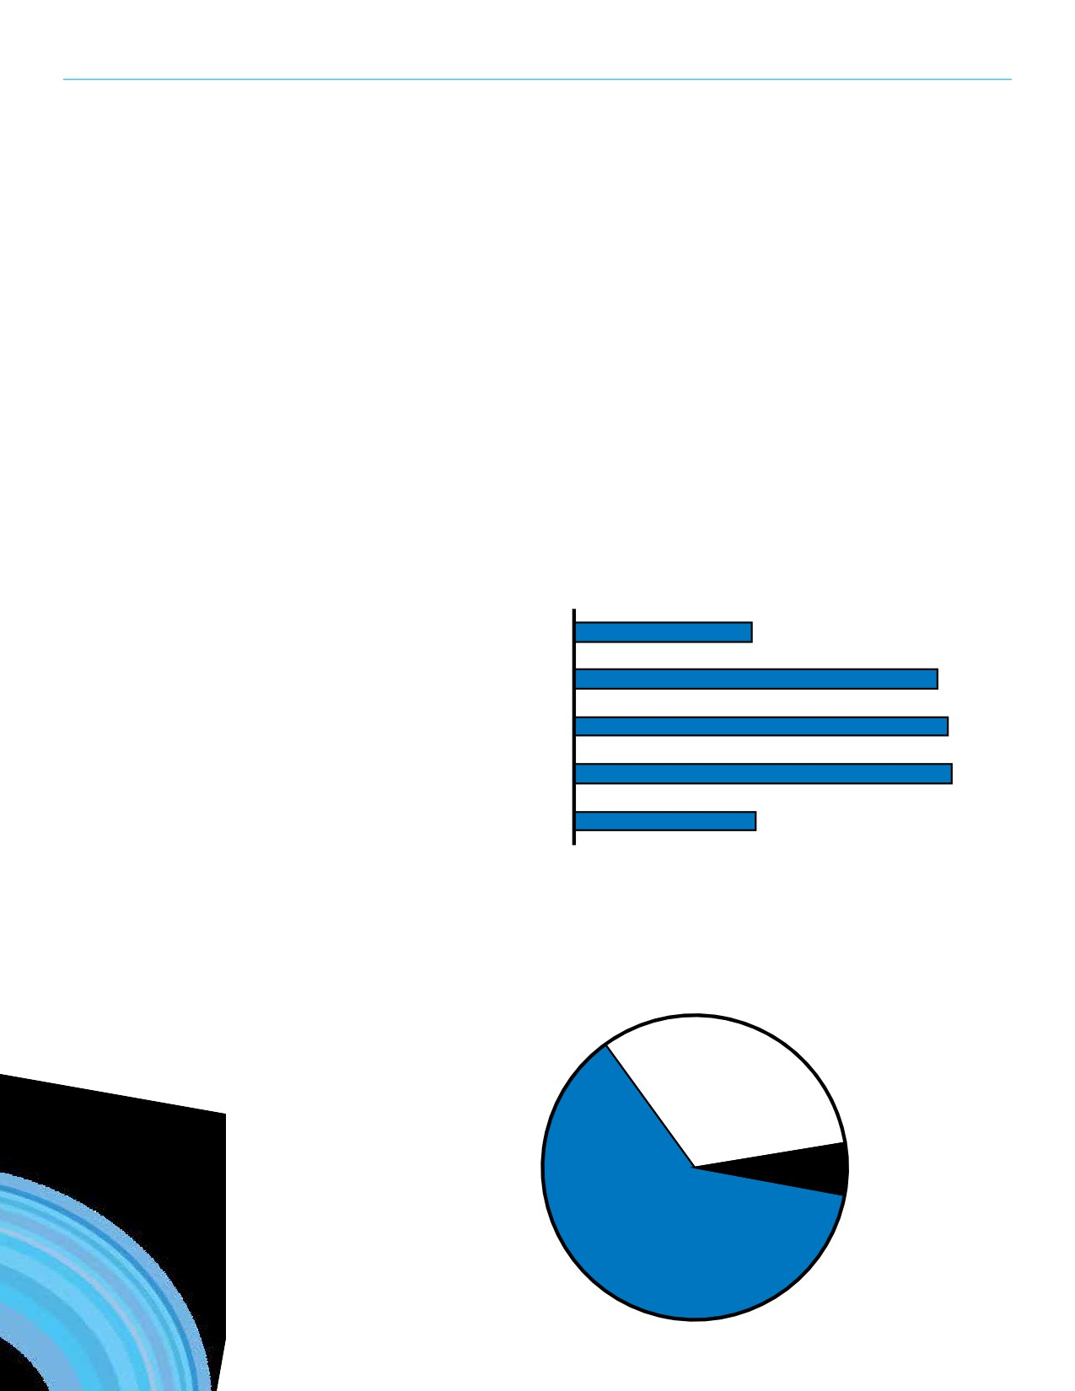SECTION 11: CONSULTATION

Stakeholder Group Survey
Community and cultural organizations in Regina were emailed an invitation to participate in a survey intended to collect information about the organizations that deliver recreation in Regina. The survey addressed the recreation needs and issues of the community organizations. The invitations included a link to an online version of the questionnaire: a hardcopy version of the questionnaire was also available. One hundred eighty-five (185) groups responded to the survey (558 were invited to participate). The results capture their individual perspective therefore they are not statistically representative of all organizations in Regina.

Community Organization Information
Of the organizations that submitted
a response to the survey, 69% have
adult participants, 69% have teen
participants and 67% have youth

Pre-school (Ages 0 - 5)

Youth (6 - 12)

Age of Participants
40%
67%

participants.

Expectations for Growth
Approximately two-thirds (62%)
of groups expect their participant
numbers to grow over the next couple of years. Thirty-two percent (32%)
expect to remain stable and six percent
(6%) expect to decline.
Teen (13 - 17) 69%
Adult (18 - 59) 69%
Senior (60+) 40%

Expectation for Participant Numbers

32%
Remain
Stable
6%
Decline
62%
Grow
107

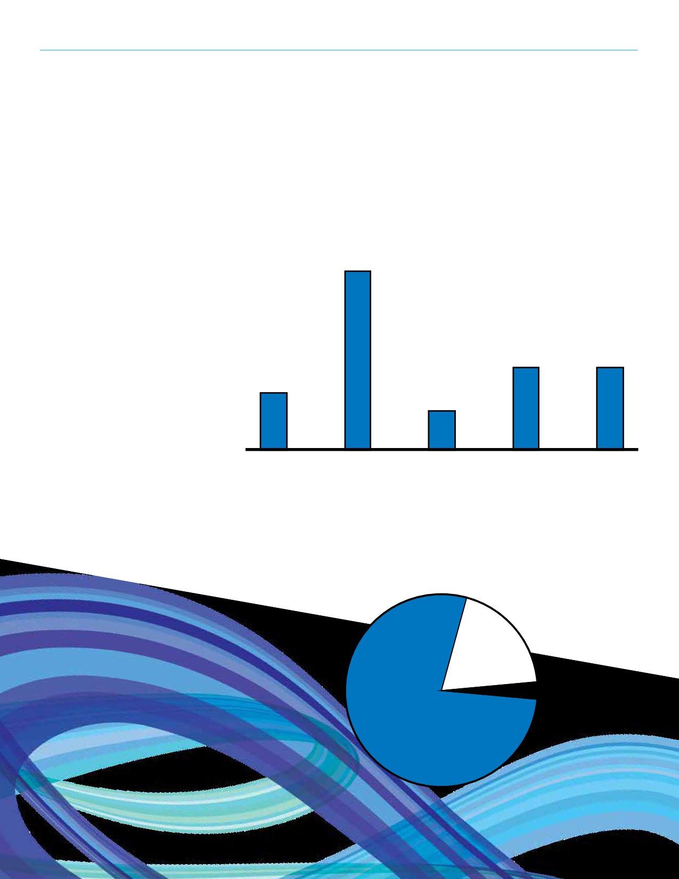REGINA RECREATION MASTER PLAN

Facilities and Spaces
Respondents were asked the extent to which they agree that “the current recreation facilities and spaces
in Regina meet the needs of our
organization.” Over half of respondents
agreed with that statement (13%
strongly agree; 41% somewhat agree).

13%

Strongly
agree

New and Improved
Recreation Spaces
Groups were then asked if there is a
need for new and/or upgraded facilities
or spaces (indoor and/or outdoor) to
be developed in Regina. Over three-
quarters (78%) of the groups responded
“yes” (78%) and 19% were unsure.

“The current recreation facilities and spaces
in Regina meet the needs of our organization.”
41%

19% 19%
9%

Somewhat Unsure Somewhat Strongly
agree disagree disagree

Need for New/Enhanced Recreation Facilities

19%
Unsure
3%
No

78%
Yes
108

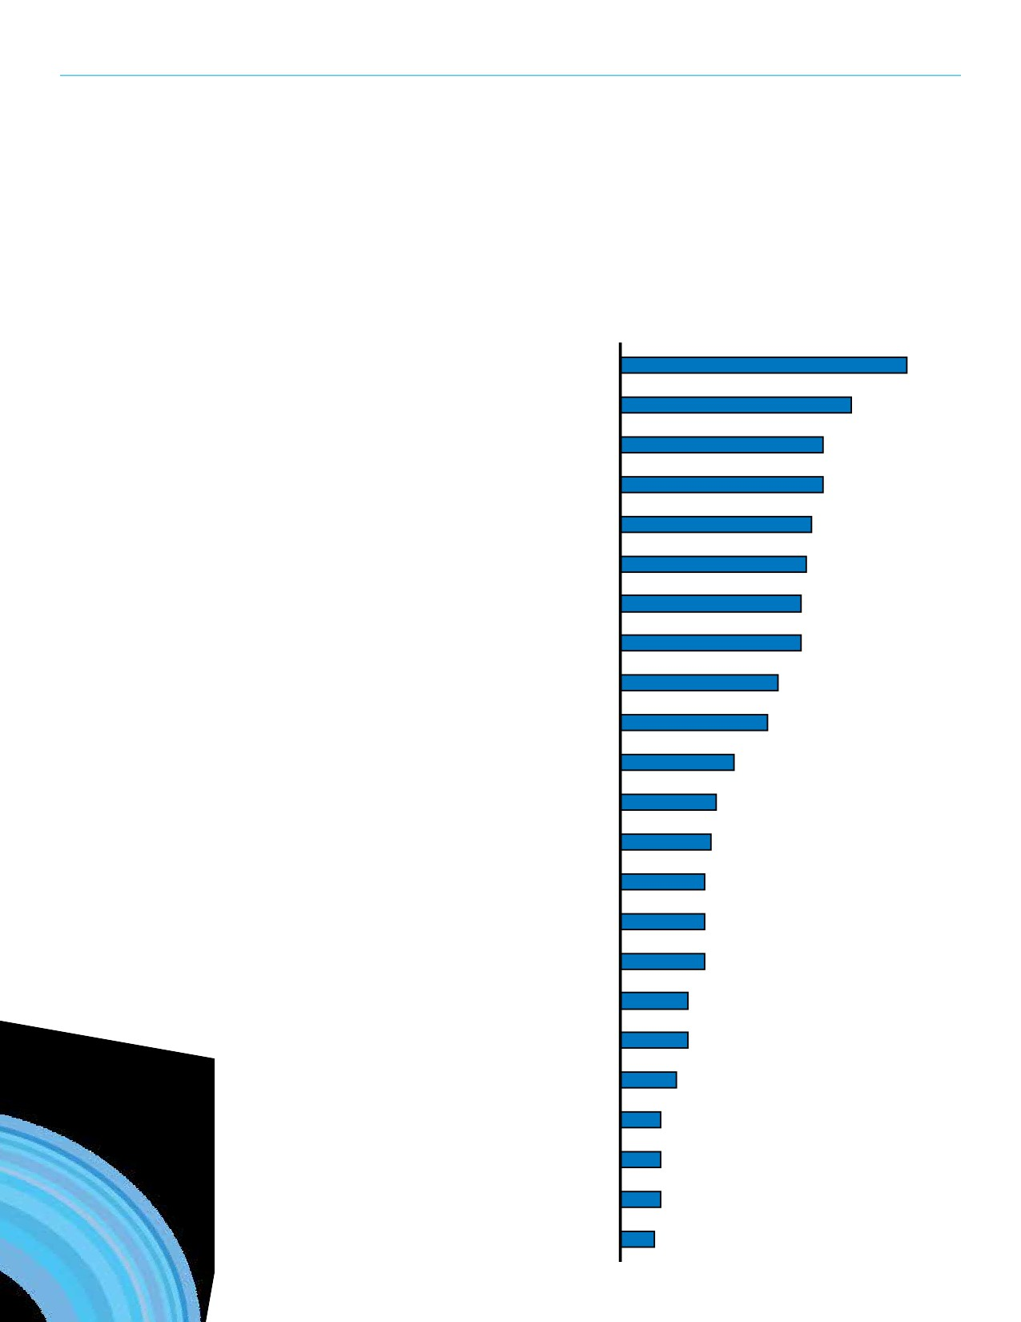SECTION 11: CONSULTATION

Indoor Priorities
Respondents were asked to select up
to five indoor recreation and leisure
facilities or spaces that should be more
readily available or enhanced in Regina
to satisfy their organization’s needs.
The top 3 priorities were multipurpose
program/meeting rooms (33%), support amenities (27%), and indoor leisure
swimming pools (24%).

Indoor Priorities

Multipurpose program/meeting rooms

Support amenities

Year round indoor flat surfaces

Indoor leisure swimming pools

Youth centres

Indoor child playgrounds

Gymnasium type spaces
Fitness/wellness facilitie
(e.g. exercise/weight room)
Aboriginal Cultural/Ceremonial rooms

Indoor walking/running tracks
Arena facilities for ice and
dry floor use in the summer

33%
27%
24%
24%
22%
22%
21%
21%
18%
17%
13%

Social/banquet facilities 11%
Ice surfaces for leisure skating use 11%
Child minding 10%
Indoor climbing walls 10%
50 metre competition swimming pools 10%
Seniors centres/facilities 8%
25 metre competition swimming pools 8%
Dance studios 7%
Indoor tennis facilities 5%
Indoor skateboard facilities 5%
Curling rinks 5%
Gymnastics studios 4%
109

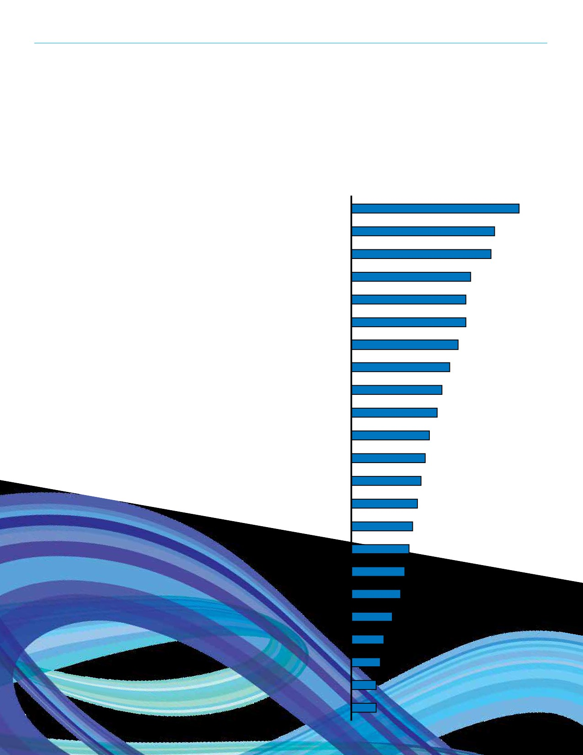REGINA RECREATION MASTER PLAN

Outdoor Priorities Outdoor Priorities
The same question was then asked for
outdoor spaces. Support amenities Support amenities for sport facilities 30%
for sport facilities (such as lighting,
parking, seating, washrooms) was Outside festival venues/amphitheatres 26%
the most common response (33%)
followed by outside festival venues/ Community gardens 25%
amphitheatres (26%) and community
gardens (25%). Children’s playgrounds 21%
Outdoor swimming pools 20%
Sport fields (grass) 20%
Passive parks (including natural areas) 19%
Track and field spaces 18%
Water spray parks 16%
Picnic areas 15%
Outdoor fitness equipment 14%
Outdoor basketball courts/sport courts 13%
Hiking/walking amenities 12%
Shared use trail network/system 12%
Sport fields (artificial turf) 11%
Dog off leash parks 10%
Ball diamonds 10%
Bike parks (BMX, mountain bike) 9%
Boating facilities (non-motorized) 7%
Sand/beach sand volleyball courts 6%
Cricket fields 5%
Outdoor tennis courts 4%
Skateboard parks 4%
110

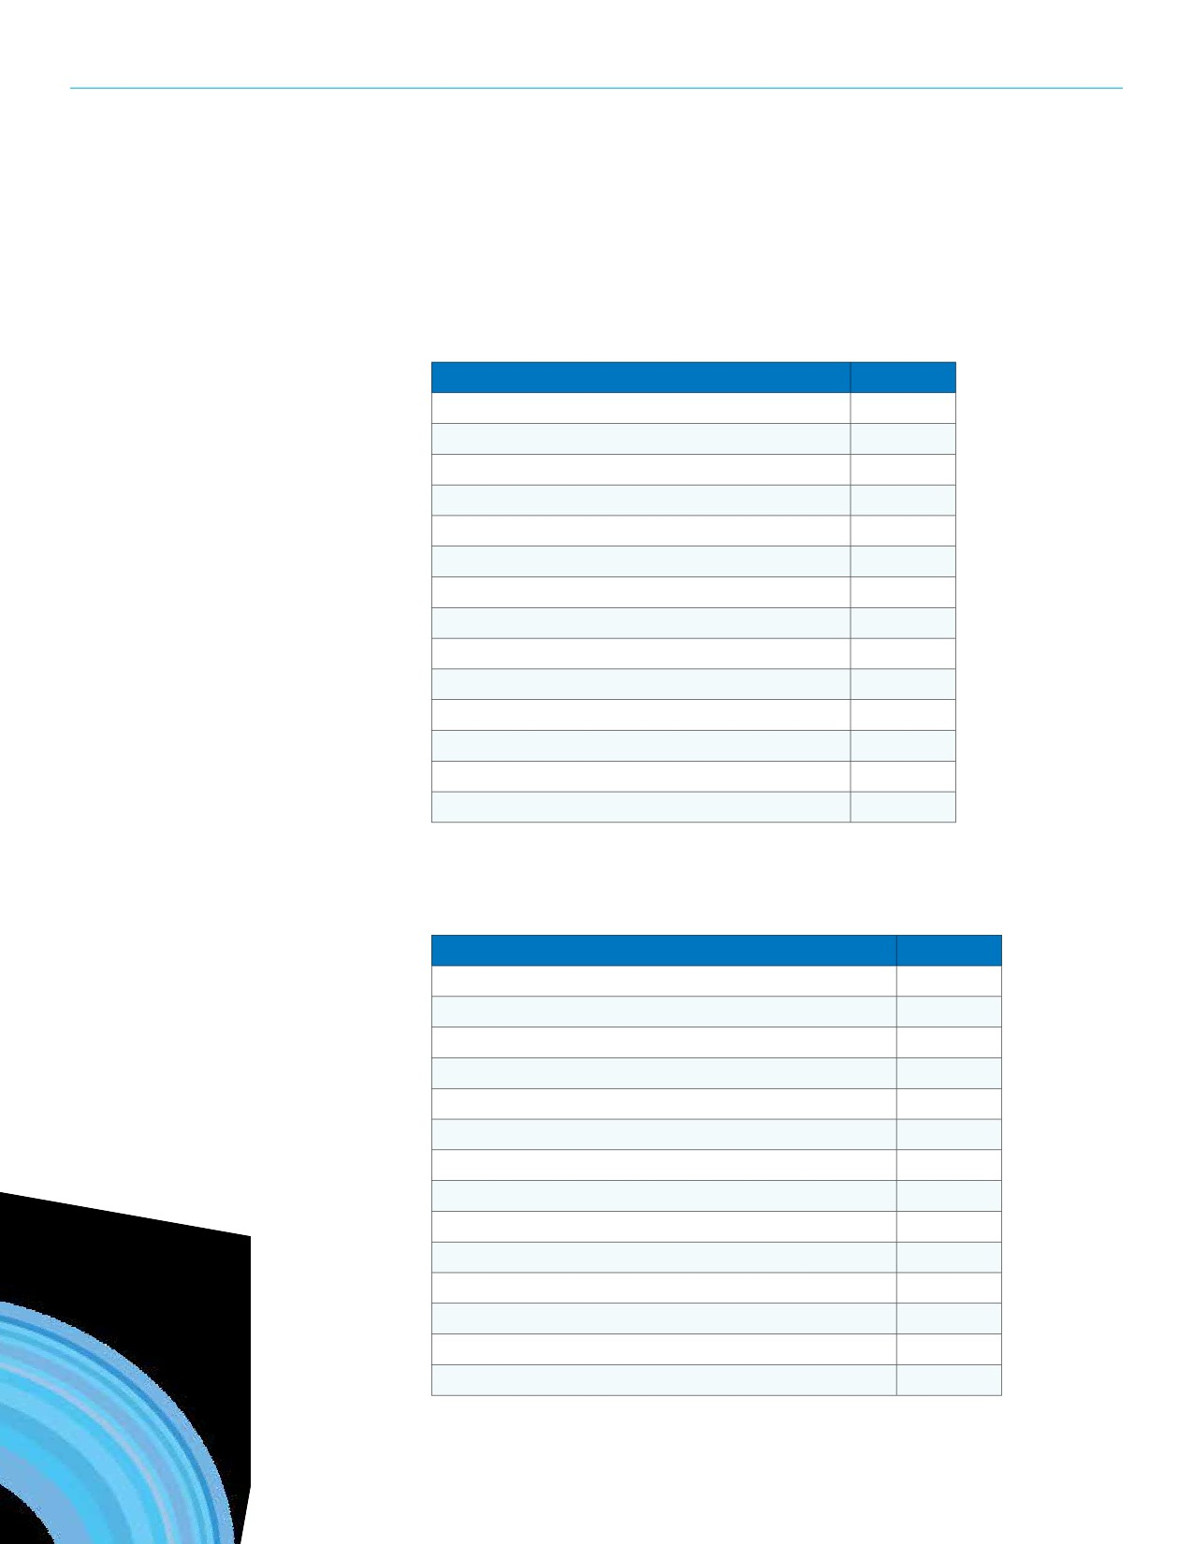SECTION 11: CONSULTATION

Challenges Challenge Mentions

Groups were asked to write in their main challenges as they deliver programs.
In total, 159 respondents identified
their challenges. The top challenges
Lack of quality/suitable recreation spaces 44
Can't get access to recreation spaces 38
Lack of facilities and recreation spaces 28

are a lack of quality or suitable spaces Rental fees are too high 24
(44 mentions), difficulties in accessing Lack of funding 17
certain recreation spaces (38), and
a lack of recreation spaces (28). Transportation is a barrier 15

Challenges that were mentioned by at least four groups are displayed in the accompanying chart.
Lack of volunteers 14
Difficult to promote opportunities 11
Unreliable bookings at City facilities 7

Lack of parking 6
Lack of storage space 4
Facility accessibility is an issue 4
Communication with City staff can be improved 4
Lack of meeting spaces 4

Support Needs

Considering the challenges the groups identified, the groups were then
asked what the single most important action is that the City of Regina could provide to help their organization
meet its programming needs. Out of
the 153 comments, over one-third (53
mentions) of responses mentioned
the need for new recreation facilities
and spaces. Fourteen (14) comments
described that the scheduling and
allocation process for facility rental
times should be revisited and ten (10)
comments expressed the need to
enhance current facilities and spaces.
Recurring comment themes with three
or more mentions are displayed in the
Support Mentions
Development of new recreation spaces 53
Allocation of recreation spaces 14
Enhance existing recreation spaces 10
Ensure rental rates are reasonable 9
Assistance with promotions 9
Funding support 9
Maintenance of spaces 8
Help small groups get access to spaces 6
Ensure accessibility of facilities and programs 6
Better communication between City and groups 5
Maximize partnerships 5
Increase transportation options to recreation facilities 5

chart. Offer more programs 4
Access to storage space 3
111

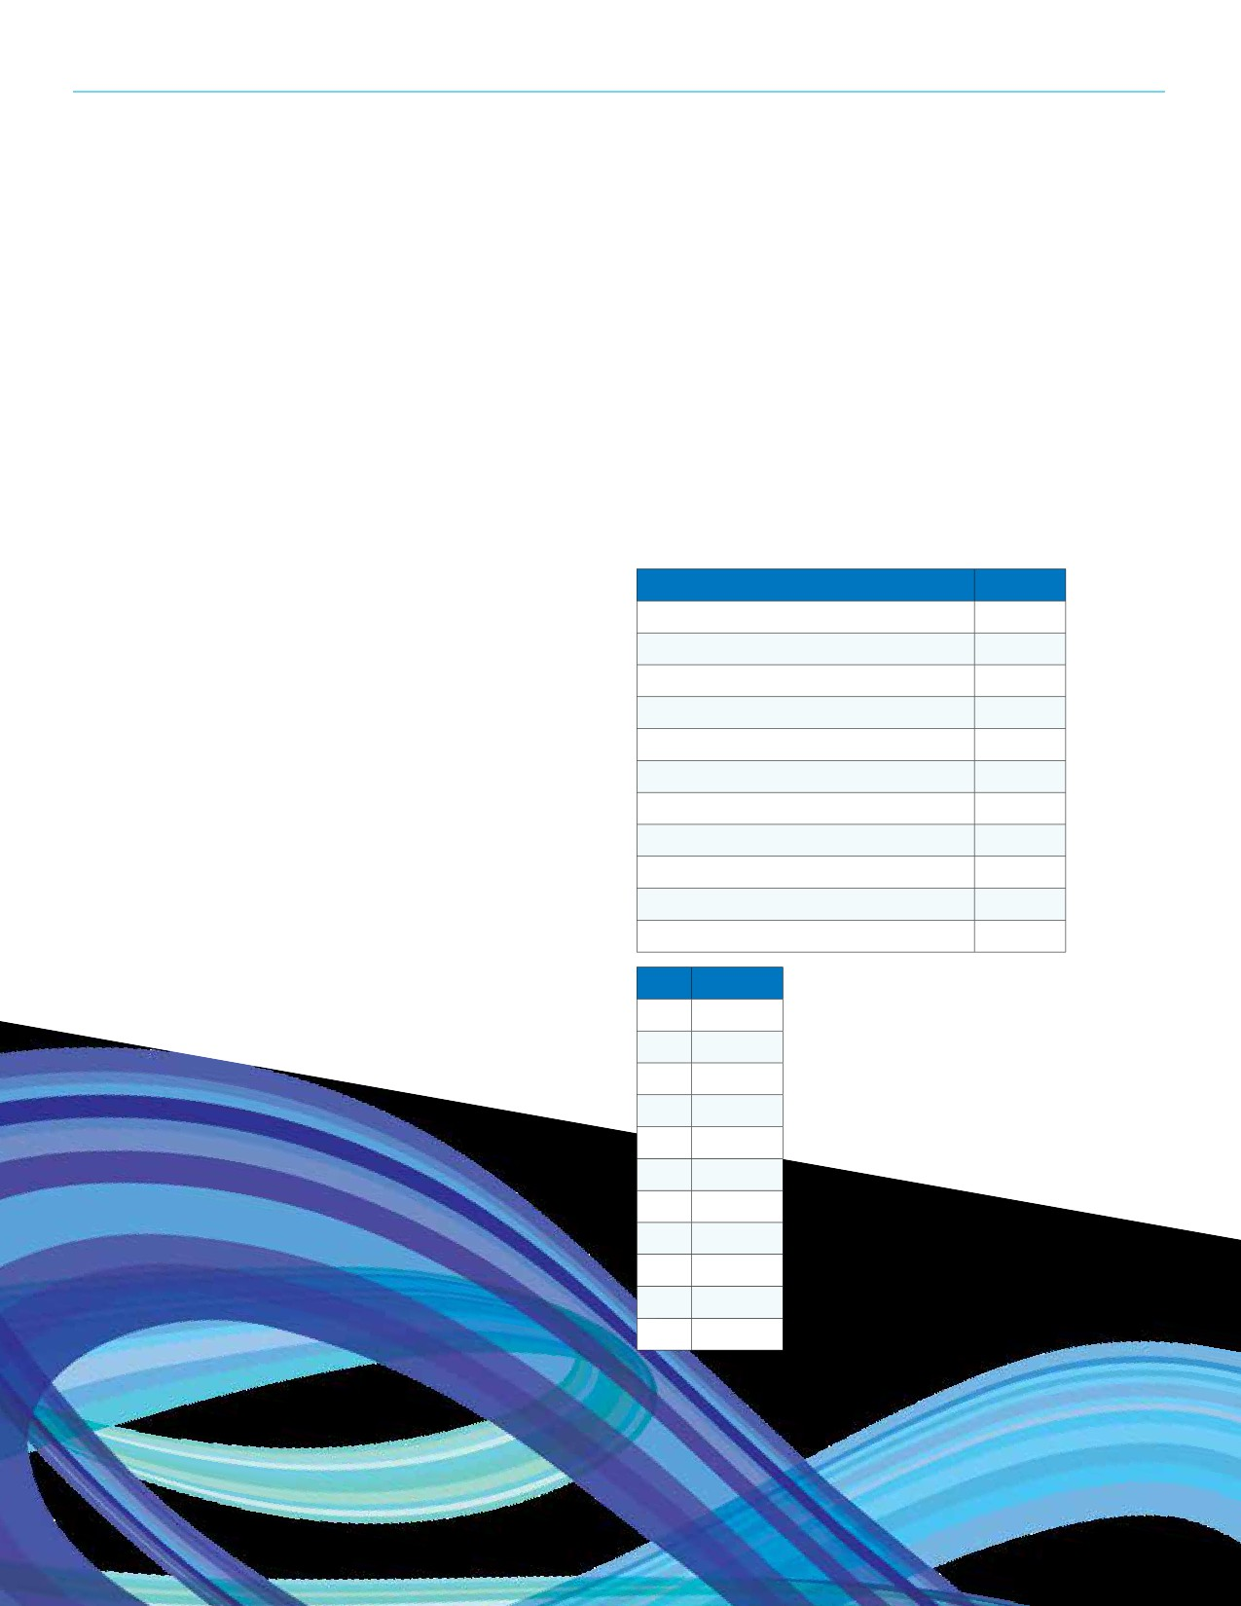REGINA RECREATION MASTER PLAN

General Comments
Finally, respondents were encouraged to provide any
other comments they had relating to recreation services
and opportunities in Regina. Seventy-five comments were
provided covering a wide range of topics. A few of the
groups appreciated the opportunity to provide feedback
and are grateful to the City for its services and efforts. It
was suggested that more dialogue could occur between the
City and groups and that the City should play a large role
in supporting volunteer groups that provide recreation
opportunities to its residents. Partnerships with social
groups were also encouraged as recreation is important in
ensuring the social health and wellbeing of the community.
Many of the respondents reiterated their wishes for new
and enhanced facilities. Some want multiple component
recreation facilities while others called for geographic
balance of spaces throughout the city. A focus on tournament
hosting was brought forth, including the proper planning
of facilities and amenities to support such events. It was
mentioned that organizations could grow and take on
more participants if it weren’t for a lack of infrastructure.
More pride could be placed into facilities and it was noted
that other communities in the province have higher quality
facilities than in Regina.

Youth Survey
A survey was conducted to gather the perspective of youth in Regina. In total, 615 responses were submitted from children and youth, 95% of whom reside in the City of Regina. The
majority (82%) of respondents are between the ages of 11 and
14. Thirty-two (32) schools were represented including 168 responses (30%) from Regina Christian School.
School Percent
Regina Christian School 30%
St. Francis Community School 12%
Walker Elementary School 8%
Henry Braun Elementary School 7%
Ecole Wilfred Walker 7%
Marion McVeety Elementary School 5%
Regina Huda School 5%
Dr. A.E. Perry Elementary School 4%
Argyle Elementary School 4%
St. Jerome Elementary School 4%
Schools with less than 20 responses^{A} 16%
A Seven Stones Community School; Judge

In terms of programming, a couple of the groups said that
there is a need to help facilitate opportunities for low
income children and families. Perhaps more focus on low
cost and free activities. Similarly, it was mentioned that it is tough for non-profit organizations to keep program fees at a minimum if rental fees keep increasing.
Another comment suggested that there should be healthier food options in recreation facilities. A couple groups asked the City to justify why some activities are publicly supported while others are not. One group recognized that there are many needs in the City and they are not sure what the best approach is to paying for these needs.
112
Age Percent
9 <1%
10 3%
11 16%
12 23%
13 32%
14 12%
15 2%
16 4%
17 3%
18 3%
19+ 2%
Bryant Elementary School; Rainbow
Youth Centre Road to Employment; Thom
Collegiate; Albert Community School; Scott
Collegiate; Ecole Elsie Mironuck Community
School; Douglas Park Elementary School;
Ecole Centennial Community School; Ethel
Milliken Elementary School; George Lee
Elementary School; Archbishop M.C. O’Neill
Catholic High School; W.H. Ford School;
Arcola Community; Balfour Collegiate; Ecole
Connaught Community School; Cornwall
Altenative School; Ruth Pawson School;
St. Matthew School; St. Timothy School;
St. Angela Merici School; St. Catherine
Community School.

SECTION 11: CONSULTATION

Recreation Participation
Respondents were asked to select all the activities they participated in over the last 12 months. The five activities participated in by over half of the
respondents were walking/jogging
(70%), swimming/diving (66%), indoor
gymnasiums sports (61%), BBQ/picnics/
social gatherings (60%), and camping
(53%).

Recreation Participation
Walking/jogging
Swimming/diving
Indoor gymnasium sports
BBQ/picnics/social gatherings
Camping
Field sports (e.g. soccer, football)
Fitness (e.g. cardio, weights)
Boating (kayak, canoe, paddleboards)
Track and field
Community events (e.g. Canada Day)
Dog walking/dog agility
Hiking

70%
66%
61%
60%
53%
46%
45%
44%
44%
41%
35%
35%

Tobogganing 32%
Dance 30%
Ice skating program 29%
Curling 29%
Skateboarding/BMX/scootering 29%
Boating (motorized) 28%
Cycling/mountain biking 27%
Agricultural (e.g. horseback riding, rodeo) 24%
Wildlife watching/nature appreciation 23%
Alpine (downhill) skiing/snowboarding 23%
Gardening 20%
Cross country skiing/snow shoeing 19%
Tennis 19%
Gymnastics 18%
Softball/baseball/slo pitch 18%
Hockey (structured/league) 17%
Yoga 16%
Golf 16%
Rollerblading/inline skating 15%
Mountain/rock climbing 15%
Group exercise (boot camp, aerobics) 14%
Snowmobile/ATV riding 13%
Cricket 7%
Lawnbowling 6%
Pickleball 6%
Disc golf 5%
113

REGINA RECREATION MASTER PLAN

Barriers to Participation
Busy with other activities (52%) and cost/price/equipment (48%) were the top barriers to participation in recreation programs or activities. Approximately one-third of
respondents believe that lack of
motivation (33%), being unaware
of some opportunities (32%), and
distance/access (31%) are barriers to participation.

New and Improved
Recreation Spaces
Seventy percent (70%) of respondents believe that new facilities need to be built or some existing facilities need to be improved in Regina and one-quarter are unsure (25%).
114

Barriers to Participation
Busy with other activities 52%
Cost/price (admission/equipment) 48%
Lack of motivation 33%
Unaware of some opportunities 32%
Distance/access 31%
Health issues/illness/injury 18%
Lack of facilities 17%
Overcrowded facilities 16%
Poor facilities 13%
Don’t have the physical ability 13%

In Regina, do you think new facilities need to be built
or some existing facilities need to be improved?

25%
Unsure
5%
No
70%
Yes

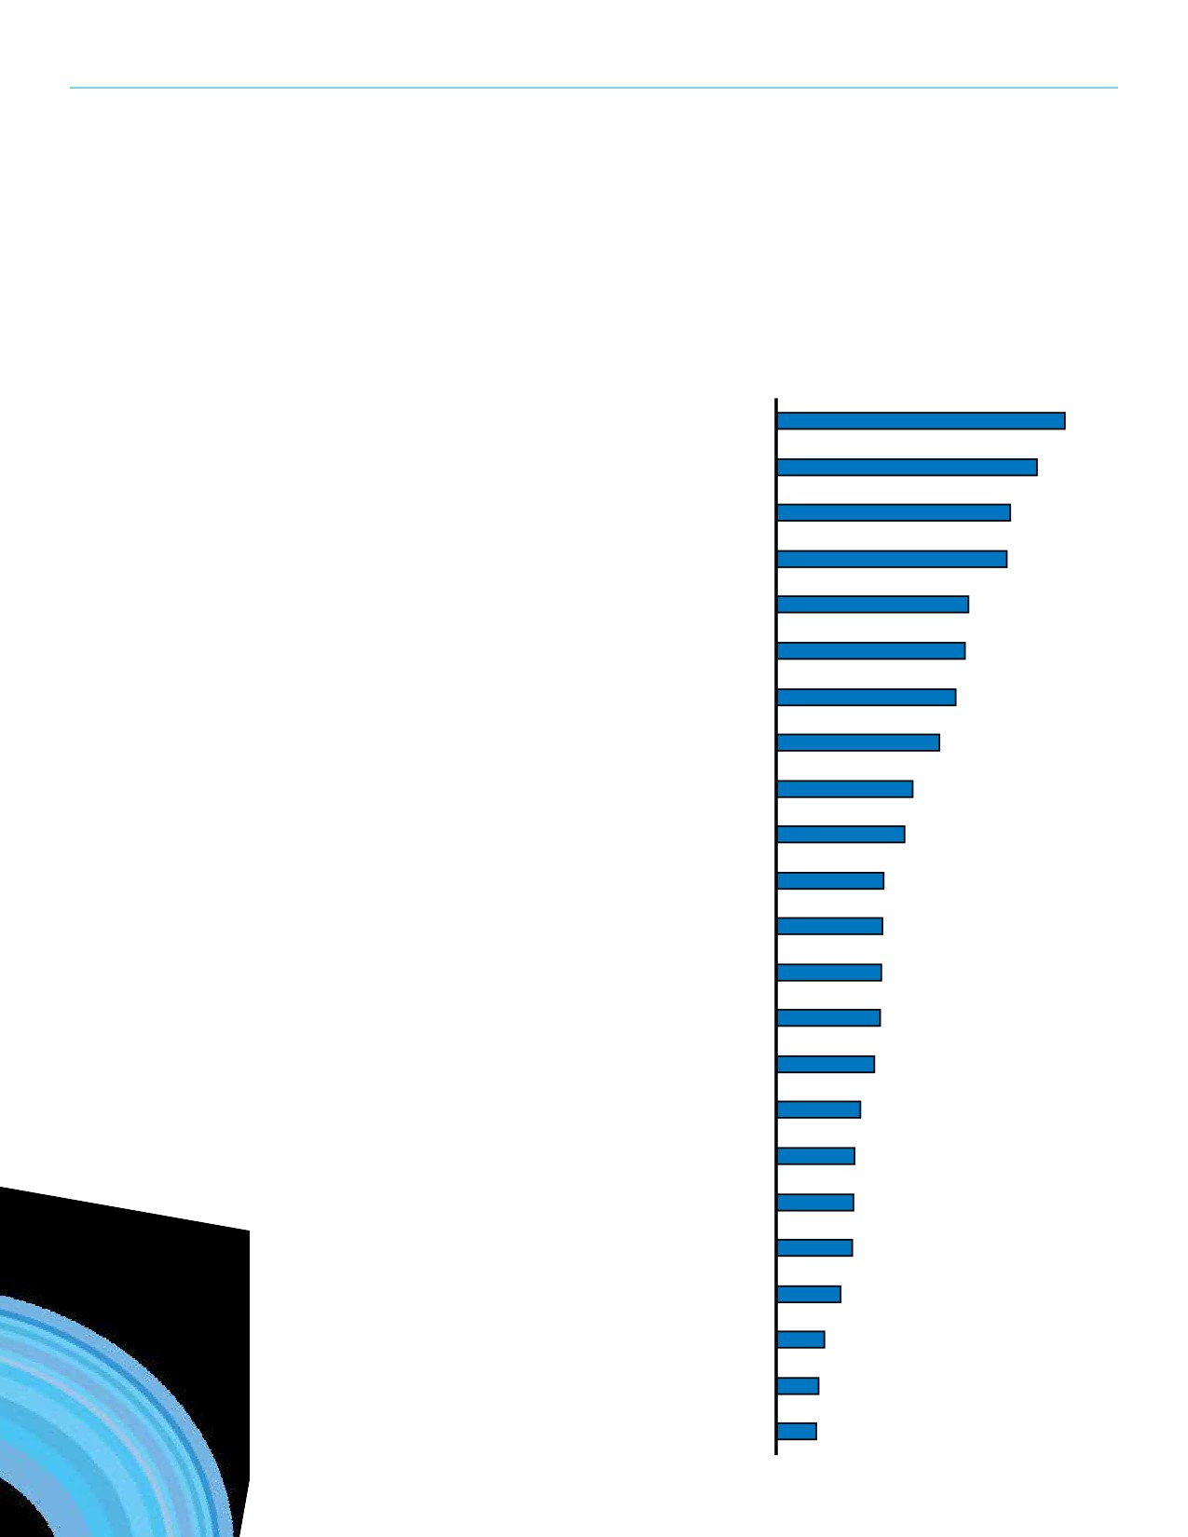SECTION 11: CONSULTATION

Indoor Priorities
The respondents who responded “yes” or “unsure” to the previous question were asked to indicate their top five indoor and outdoor priorities for
recreation facilities that should be built or improved in Regina. The top indoor priorities were indoor leisure swimming pools (40%), indoor climbing walls
(36%), indoor child playgrounds (32%),
and fitness/wellness facilities (32%).

Indoor Priorities

Indoor leisure swimming pools

Indoor climbing walls

Indoor child playgrounds

Fitness/wellness facilities

Gymnasium type spaces

Youth centres

Indoor walking/running tracks

Ice surfaces for leisure skating use

Indoor skateboard facilities

Arena facilities for ice and dry floor use

Year-round indoor flat surfaces

Dance studios

Support amenities

Child minding

50 metre competition swimming pools

Gymnastics studios

Curling rinks

25 metre competition swimming pools
Indoor tennis facilities
Aboriginal Cultural/Ceremonial rooms

40%
36%
32%
32%
27%
26%
25%
23%
19%
18%
15%
15%
15%
14%
14%
12%
11%
11%
11%

(to host talking circles, elder groups, smudges, 9%
prayer ceremonies, and other ceremonial events)
Seniors centres/facilities 7%
Social/banquet facilities 6%
Multi-purpose program/meeting rooms 6%
115

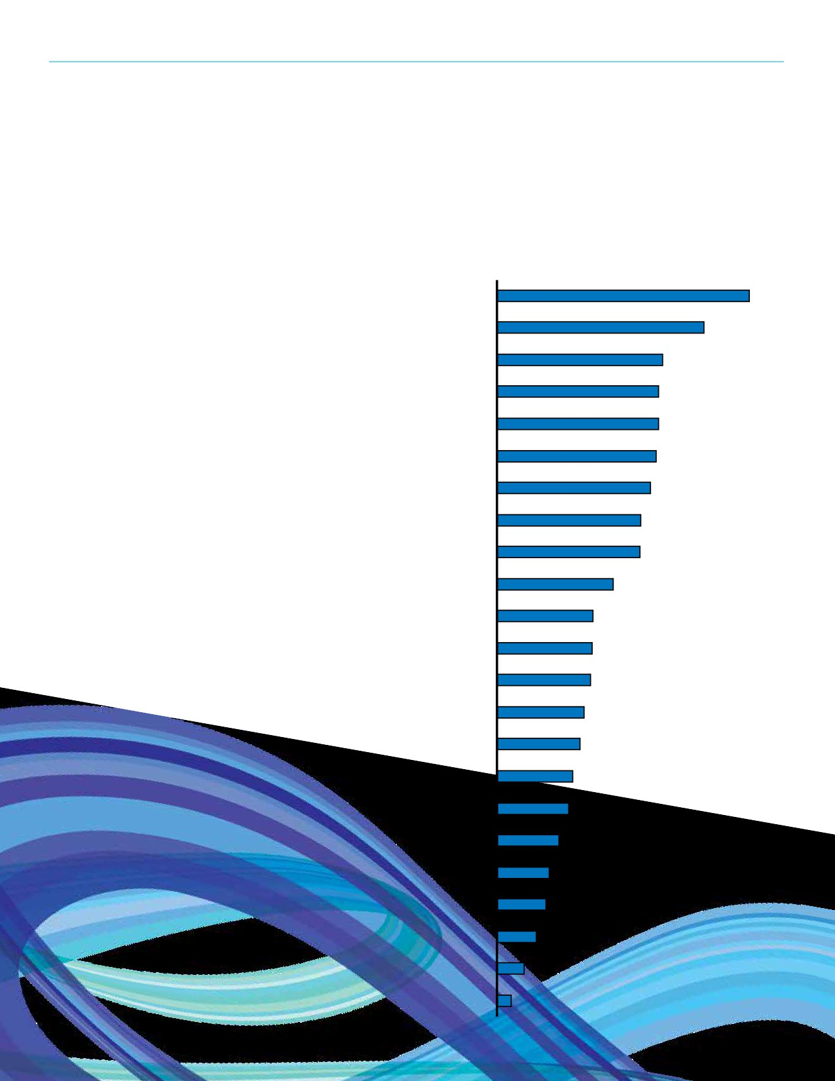REGINA RECREATION MASTER PLAN

Outdoor Priorities
For outdoor recreation spaces, outdoor swimming pools (44%) and water spray parks (36%) were indicated by over
one-third of respondents. Twenty-nine percent (29%) of respondents would

Outdoor Priorities

Outdoor swimming pools 44%

Water spray parks 36%

like to see bike parks. Please refer to the graph for the complete list.
116

Bike parks (BMX, mountain bike)

Dog off leash parks

Outdoor basketball courts/sport courts

Sand/beach sand volleyball courts

Track and field spaces

Picnic areas

Sport fields (grass)

Children’s playgrounds

Outside festival venues/amphitheatres

Skateboard parks

Sport fields (artificial turf)

Passive parks (including natural areas)

Hiking/walking amenities

Outdoor fitness equipment

Boating facilities (non-motorized)

Ball diamonds

Community gardens

Outdoor tennis courts

Support amenities for sport facilities

Shared use trail network/system

Cricket fields
29%
28%
28%
28%
27%
25%
25%
20%
17%
17%
16%
15%
15%
13%
13%
11%
9%
9%
7%
5%
3%

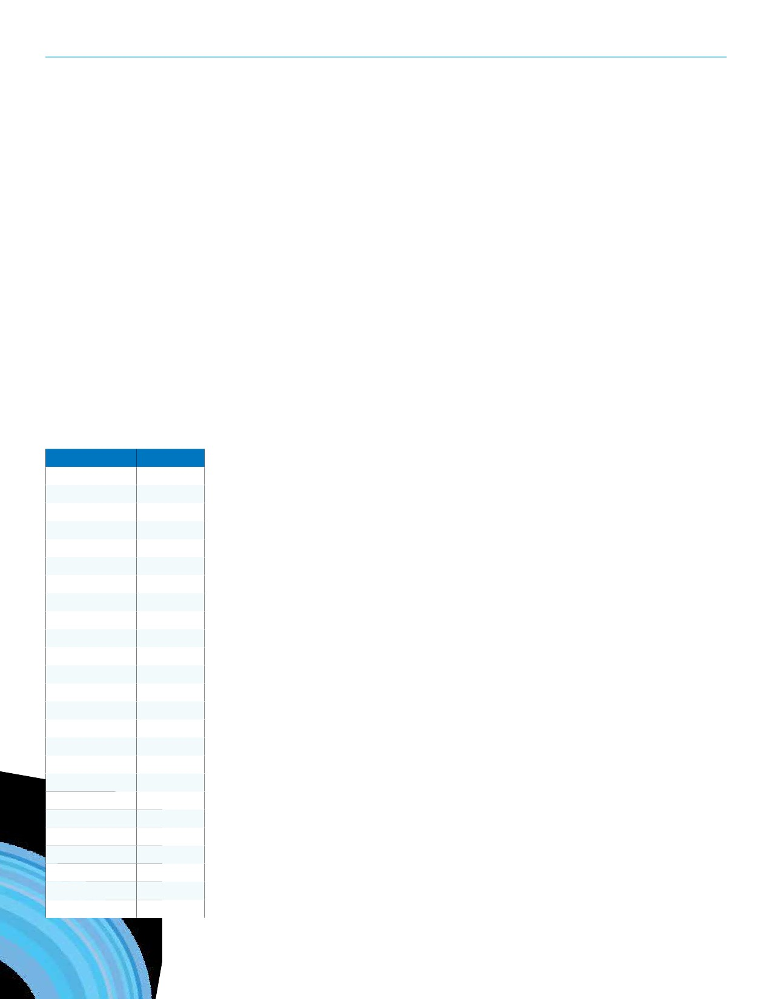SECTION 11: CONSULTATION

Programs
Respondents were asked to list any
recreation programs that they do not
participate in now but would like to.
Fifty (50) respondents mentioned
basketball as a program they would like to participate in while forty
(40) mentioned soccer. Swimming
(29), volleyball (26), dance (23), and
gymnastics (23) rounded off the top five wanted program types. Program types with five or more mentions are listed in the adjacent charts.

General Comments
Finally, respondents were invited to provide any other comments they had
regarding the future of recreation services in Regina. A majority of the comments
provided reiterate their desire for a new recreation space or program as noted
previously in the survey. Other comments included the need to maintain current
facilities better, including washroom cleanliness. A need for more affordable
programs and community events was mentioned. It was also suggested that there
should be more spaces for youth to hang out, facilities should be accessible for all
and have interesting designs, and outdoor art displays would be nice as well.

Program Type | Mentions
Basketball | 50
Soccer | 40
Swimming | 29
Volleyball | 26
Dance | 23
Gymnastics | 23
Football | 20
Hockey | 19
Skating | 19
Baseball | 17
Tennis | 15
Agricultural | 13
Badminton | 13
Rock climbing | 11
Softball | 11
Skateboarding | 10
Art | 8
Curling | 8
Music | 8
Lacrosse | 7
Martial arts | 7
Track and field | 7
Fitness | 6
Yoga | 6
Flag Football | 5

117

REGINA RECREATION MASTER PLAN

Stakeholder Interviews
Discussion sessions and meetings were held with local
stakeholders to get a well-rounded perspective on recreation
in Regina. These sessions offered a chance for stakeholders
to provide input into the Master Plan process by presenting
their assessments of recreation in Regina including what is
working well, what challenges are being dealt with, as well
as suggestions for improvements and supports to enhance
recreation provision.
A broad range of community groups, organizations, and
partners were invited to participate in the discussion sessions and meetings. Participants included those that provide direct recreation programming to Regina residents such as community associations, minor sports associations, adult recreation leagues, seniors’ groups, and partner organizations. Advocacy groups, cultural organizations, and other public groups were invited to provide input for the Master Plan.
In total, 57 sessions were convened (one-on-one and small groups) with 132 participants representing 116 organizations. A complete list of participating stakeholders can be found in the Appendix. Themes that emanated from the discussions are presented below.
While many of those interviewed commented on the age of
Regina’s recreation infrastructure, it was the condition and
maintenance of those facilities that was a point of focus.
It is recognized that older facilities inherently are not in as
good a condition as newer ones. However the condition of some
facilities was considered in need of improvement. Specific facility
types that were highlighted during the discussions included:
outdoor rinks, outdoor pools, ball diamonds, and rectangular fields.
The number of these facilities was regarded as generally sufficient;
the condition of them generally however was not uniform and
required attention. Curling clubs and track and field venues were
cited. Playgrounds and spray pads received varying reviews with
some saying conditions were fine. Some maintenance issues have
resulted due to multiple uses of a space—this is particularly true
with outdoor fields. Spontaneous, unstructured use can create
wear on a field that is not consistent with a sports’ use. Setting
maintenance standards or communicating existing standards to
user groups would help create an expectation for maintenance.
In turn it would help users understand the importance of their
fees in the maintenance of facilities. Some people felt that the
City puts a lower emphasis on maintenance of its facilities than
it should and rather expends its attention on newer spaces.
118

Through conversation with stakeholders several infrastructure gaps were identified. These included the following:
• Indoor aquatics, particularly a program, deep tank.
While there were some comments about the need for more
leisure aquatic spaces, it was the rectangular tank for aquatic groups that was considered the most pressing need.
• Outdoor turf fields. These fields enable more use during a
set period of time—they also extend the season.
• Skateboard parks. The city had an indoor park but it was
removed with the development of the new stadium. There is one privately run indoor skateboard park however
another is needed. This type of venue provides space for youth with a wide variety of backgrounds. Skateboarding has been established for such a long tenure that it attracts adults as well. In particular the north central part of
Regina was seen as an appropriate location. A bowl was also suggested.
• Performing arts venues. While Community Centre facilities
are available for performing arts, they are not considered
conducive for performances.
• Bike paths throughout Regina. This facilitates connectivity
across the city and to recreation facilities.
• Spray parks. They offer great spontaneous use
opportunities and require no lifeguards.
• Additional green passive space to accommodate
spontaneous unstructured use. As the warehouse district grows green space is increasingly being desired by both residents and the business community.
• Group support space such as meeting space and storage
• Fenced dog off leash areas
• Large multiplex hubs—these become community
gathering spaces as they draw many people in for many
different activities including social gathering.
More generally, a need was expressed for recreation facilities in economically disadvantaged areas of Regina. People
in these areas are typically more challenged in accessing recreational space. As such many felt it incumbent upon the City to ensure these neighbourhoods had recreational space in the neighbourhood or near enough so that transportation would not be a barrier.

SECTION 11: CONSULTATION

When it comes to planning for recreation spaces there were numerous suggestions. It was felt that including user groups in the planning of space would help strengthen
the relationship between the City and the groups. It would
also demonstrate the challenges associated with facility
development. Multiplex space can help activities promote
themselves to non-participants and provide spectator
opportunities. Dry land training space is a suitable companion to dedicated space. In fact looking for complementary
amenities would help maximize the use of spaces (for example a climbing wall in a skatepark facility would serve a broad
group with similar interests.) Facilities should be planned as well considering their abilities to attract and host events. In some instances small adjustments or amenity groupings would enable the hosting of a tournament or event.
Recreation service provision responsibilities extend beyond the City of Regina. In fact there are many other providers
in the community. The University of Regina provides spaces and programs as does the YMCA. It is also important to
understand the plans of such organizations. For example, the
University of Regina is considering the development of a new
arena to expand the Centre for Kinesiology Health and Sport.
There are many private providers as well that offer fitness
opportunities. It is important to acknowledge the broad spectrum of recreation providers in the community. In some instances the City does not have to provide a service if the marketplace has sufficient providers.
There are a number of barriers that impact the ability of
some residents to access recreational opportunities. These
include transportation barriers. These could be addressed by
enhancing the trail system, by recognizing that people want
to access opportunities using non motorized means, and by
considering facility provision in light of established public
transportation networks. It also suggests that transportation
and recreation planning can and should occur simultaneously.
Cost was identified as a barrier. While there are programs in
place to help address affordability, some felt the City has an
obligation to provide recreation to the most economically
disadvantaged. Culture and language is a barrier as well.
Some of this is obvious such as with promotions in an
unfamiliar language. Other times it is more subtle with a lack
of cultural understanding or even a lack of a strong welcome.

Neighbourhood level recreation opportunities was
considered important. Providing recreation opportunities
close to people’s homes is seen as important. For one it
helps mitigate any transportation barriers that may exist.
For another it helps strengthen a community as people are
recreating in the areas in which they live. Neighbourhood
needs include parks and pathways, tree canopies, and
playgrounds amongst other things. The need for outdoor
rink space and community program spaces was seen as
important. In fact it was suggested that each neighbourhood
have an identified list of amenities. The role of the community
association was championed as well. Efforts to support and
strengthen these valuable community building, recreation
delivering, volunteer driven organizations are needed.
As the city becomes more diverse and customers present
a broad array of needs and challenges, it is important for
the City to ensure staff are continually and appropriately
trained. This would include knowing how to deal with patrons
with special needs. It would help staff work with those from
many different cultures including the Indigenous community.
And it would help staff effectively and sensitively deal with
issues of gender that are becoming more commonplace.
Continued and enhanced promotion of the benefits of
recreation, the opportunities to recreate, and healthy
lifestyles is needed. The Leisure Guide was recognized as a
valuable resource but a greater and more effective presence online would be beneficial. Effective communication should also consider the audience. As such if a particular group
or segment is the desired audience for a message than
consideration is needed to the most effective messaging
and channel. Specific promotional efforts are needed for
both newcomers to the community as well as those in the
Indigenous community. The offering of healthy food choices
in City facilities would not only provide healthy choices but it
would also communicate the importance of a healthy lifestyle.
Meeting attendees opined about recreational programming. They commented that programming needed to be affordable to “knock down” financial barriers. Programming needs to be accessible considering all barriers from physical accessibility to scheduling and so on. Some also suggested that the
City’s role in programming is to provide introductory level
programming and those that focus on physical literacy. The
Long-Term Athlete Development (LTAD) model should be
utilized with a focus on Active Start and FUNdamental stages.
It was further discussed that there are many in the community
119

REGINA RECREATION MASTER PLAN

who can provide more advanced programming therefore
the City should stick with the introductory levels. In terms of
direct programming ideas for the City suggestions included:
youth and the arts; youth leadership; career programming;
activities that reflect the interests of newcomers; healthy
lifestyles.
An improvement to some City processes was suggested. Some challenges were identified with the booking of
facilities. Challenges with communication between the City
and user groups as well as within the City itself presented
difficulties for user groups to book facilities. The process
to the users groups did not always appear to be efficient
nor effective. A lack of confidence was expressed by some
meeting attendees in the processes to access facilities.
Group representatives spoke of the impacts on regular
programming and tournament hosting. In addition some
occasions were described during which space was unoccupied yet it was unavailable for booking. Improved processes,
communications, and transparency was sought. Related was the notion that the allocation of space favoured some groups over others. A level of confusion was apparent. Enhanced
communication between the City and its user groups would help ameliorate these issues.
Communication improvements between the City and other volunteer organizations were suggested. While the City
values the work of these organizations in delivering services to its residents, it is not always apparent. There is a level of misunderstanding about how the City makes some of its
decisions including funding. These comments are not to suggest that there is a distrust of the City however greater and more open communication would help strengthen the relationship groups have with the City and would bolster existing partnerships.
Some meeting attendees felt that the City of Regina was
well positioned to assume a leadership role, to be a true
champion and advocate for recreation that could be emulated by others in the province. Linking the National Recreation
Framework to programming was one way to do this. As
well the City could influence the Saskatchewan Urban
Municipalities Association to take a stance to support the
enhancement of recreation and wellness in a community.
120

Greater support to community and volunteer groups would be welcome. Volunteer groups are a significant player in the delivery of recreation in Regina. While these groups generally function quite well even with a lack of resources in some
instances, some felt it important that the City provide greater supports than it currently does. From assisting groups in
securing suitable program and support spaces to recognizing
and championing volunteer groups, the City has the ability
to help volunteer organizations be sustainable. In fact some
groups are better positioned to serve segments of the city
than even the City is able to do. As such support for these
groups can significantly leverage the resources of the City in providing recreational and community building programs to segments of the community. Other specific supports include: promoting activities through City communication channels; providing templates for communication tools; sharing
information on demographics; assist with strategic and business planning; and providing training on grant writing, board development, and best practices.

SECTION 11: CONSULTATION
121

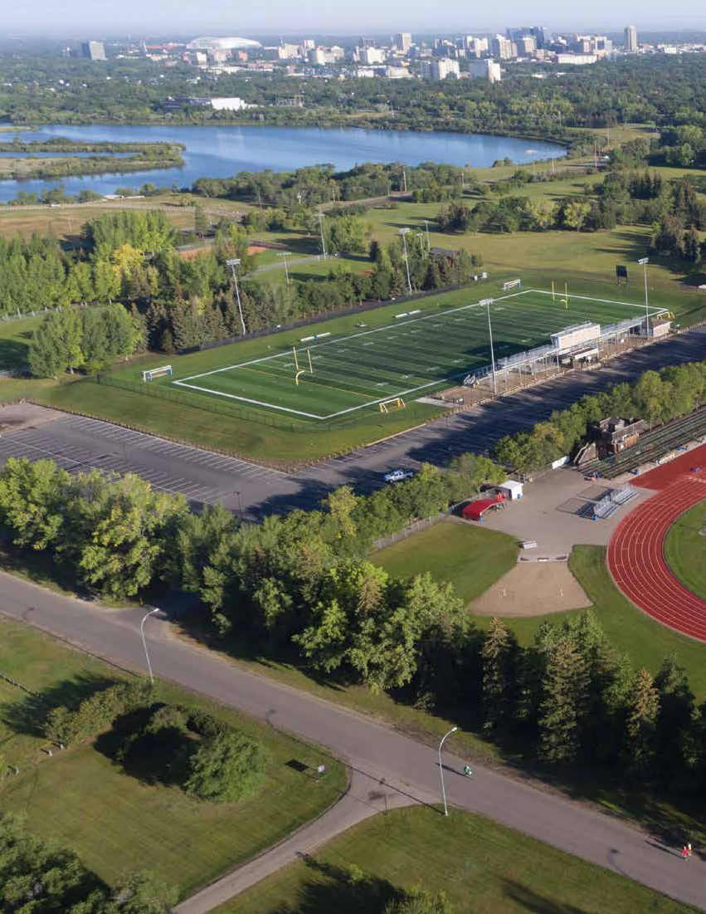
122

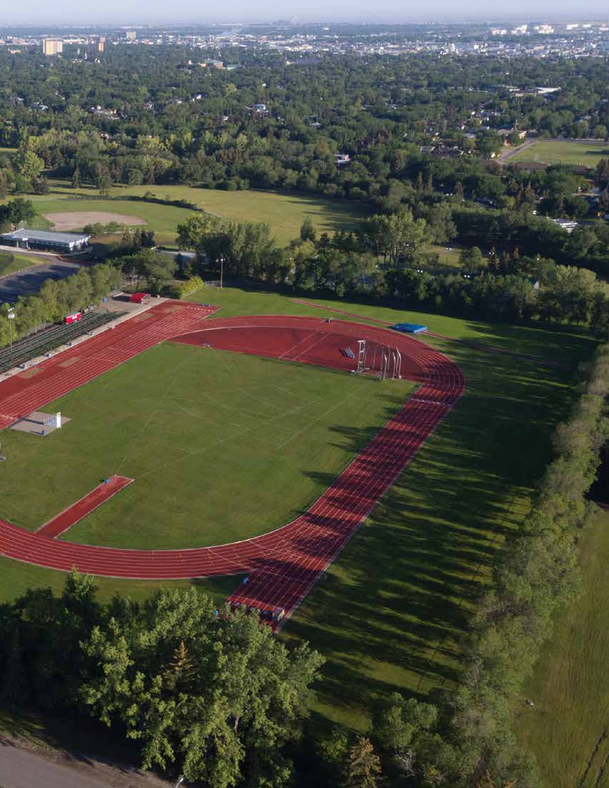

SECTION 12
Summary and Considerations
123

REGINA RECREATION MASTER PLAN

SECTION 12
Summary and Considerations

The intention of the State of Recreation research report is
to outline information about trends, existing facilities and
spaces, resident and stakeholder preferences and other data
to set the planning context for a City of Regina Recreation
Master. In general, the following statements summarize
overall research findings.
• Recreation is important and key to success of the City;
there is a need to articulate the benefits and strategic
alignment further.
• Recreation opportunities in the City are a product of
the public, non-profit and private sectors; Partnerships
between the City and other groups will be key moving forward.
• Volunteers are integral to many aspects of recreation in
the City; there may be ways to bolster volunteerism.
• Residents experience barriers to participation; more
benefit could be achieved through current investment and efforts related to recreation services and facilities.
• Recreation facilities (indoor and outdoor) are aging
and decisions will need to be made about sustaining, repurposing, or decommissioning service levels.
• Demands for new or enhanced facilities and spaces are
emerging but the City cannot afford to meet all demands.
Aside from these high level, overarching findings, the
following summary statements have been taken from each
section of the report. It is important to note that these
statements, as well as other more detailed information
throughout this report, will feed into the actual Recreation
Master Plan in the initial development of the Plan and as it is
being implemented.

Benefits of Recreation
• Recreation is essential to personal health and wellbeing.
• Recreation builds strong families and healthy
communities.
• Green spaces are essential to environmental and
ecological wellbeing.
124

Community Profile
• The city’s population continues to grow. The 2016 census
identifies a population of 215,106 residents which is an
11.4% increase from 2011.
• By 2031, it is possible that the City of Regina could be
serving over 300,000 residents.
• The City is a regional hub serving a CMA population of 236,481.
• 8,020 new Canadians moved to Regina from 2006 - 2011.
• Nearly 10% of Regina’s population identifies
as Indigenous (2011).
• The City is split into 5 Recreation Zones and 27/30
Community Associations.
• Community Association populations range from 675 to 28,485.

Background Review
• The Vision for the City of Regina is: Regina will be Canada’s
most vibrant, inclusive, attractive, sustainable community,
where people live in harmony and thrive in opportunity.
• The City has a number of planning documents already
approved and being implemented that build support and justification for recreation services and are relevant when contemplating future recreation services.
• There are also provincial and national planning influences
that need to be considered such as the National Framework
for Recreation and the Canadian Sport for Life movement.
• The renewed definition of Recreation: Recreation is the
experience that results from freely chosen participation in physical, social, intellectual, creative, and spiritual
pursuits that enhance individual and community wellbeing (A Framework for Recreation in Canada).

Facility Inventory
• Regina’s recreation spaces are aging as they have an
average age of 37 years.
• The replacement value of the City’s recreation facilities is
over $199 million; modernized replacement value is likely
beyond $377 million.
• The City invests over $8 million annually to operate
recreation facilities.
• The average age of the five outdoor swimming pools is 64 years
Of the five pools, useful life expectancy ranges from 1 - 5 years.

SECTION 12: SUMMARY AND CONSIDERATIONS

Facility Utilization
• From 2013 to 2017, monthly/yearly leisure pass purchases
have dropped by 21%, this trend is especially seen from
young adults.
• Prime Ice utilization at City-operated facilities is approximately
67% which suggests that these ice arenas are underutilized.
• The number of total indoor swims has remained relatively
stable over the past seven years with an average of 577,333 swims from 2011 to 2017.
• There were over 95,000 visits (total) to the City’s five outdoor
pools in 2017, 33,179 of which were free drop-in visits.
• Excess demand exists for swim lessons (wait lists).

Program Review
• The City directly and indirectly delivers a variety of
recreation programs. Unaffiliated recreation opportunities
that are provided without any formal City support are also available to residents.
• Introductory and recreational sport, aquatic safety, and
arts and culture programs are available for each age
category via direct delivery.
• There are no directly delivered nature interpretation/
outdoor education programs.

Partnership Review
• The City relies on partnerships to deliver recreation
opportunities to residents.
• Partnership agreements in place include, but are
not limited to, facility lease agreements, operating
agreements, and joint-use agreements.
• Some facilities are accessible through operating authority
(e.g. RSA controls access to Credit Union EventPlex turf) .
• Limited formal process/policy in place to guide the
selection and development of partnerships
• Key partners include, but are not limited to: Community
Associations, Regina Exhibition Association, Provincial
Capital Commission, school boards, community groups,
sport organizations, Government of Saskatchewan, SPRA.
• Some groups (e.g. YMCA, curling clubs, skateboard association)
have expressed an interest in partnering with the City.

Trends
• Unstructured/spontaneous recreation activities are
among the most popular activities (e.g. walking, bicycling,
drop-in sports).
• Recreation is important to residents of Saskatchewan.
• ParticipACTION assigned a D-rating for “overall physical
activity” of youth and children in Canada.
• Aging infrastructure is a concern Canada-wide. Compared
to other municipal infrastructure types, sport and
recreation facilities are in the worst state.
• Partnerships with non-profit, private and public sector
organizations are key to providing publicly accessible
recreation opportunities.
• Volunteers are vital components of the recreation delivery
system and volunteerism is changing.

Leading Practices
• Partnership frameworks are used to guide the
development and accountability of partnership in a
formalized process.
• In most cases, both financial and non-financial supports
are provided by municipalities to neighbourhood
community associations. Non-financial supports include assistance with strategic planning sessions and templates, with promotions and marketing, volunteer recognition
and recruitment, training opportunities, and networking opportunities.
• Regina provides proportionately more indoor ice sheets per
capita than comparable cities and less indoor aquatics centres.

Consultation
• The most utilized recreation spaces among residents are
spontaneous outdoor assets (walking/running trails and
pathways, passive parks, City Square Plaza/Victoria Park, playgrounds).
• Lack of quality spaces and not being able to get access to
spaces are the top challenges for community groups.
• Among youth, leisure pools and outdoor swimming pools
were the top indoor and outdoor needs respectively.
125

Regina.ca

